[BUXTON / MICROSOFT COLLECTION](http://research.microsoft.com/en-us/um/people/bibuxton/buxtoncollection/default.aspx)

[home](http://research.microsoft.com/en-us/um/people/bibuxton/buxtoncollection/default.aspx) | [explore](http://research.microsoft.com/en-us/um/people/bibuxton/buxtoncollection/browse.aspx) | associated narratives | [about | acknowledgments](http://research.microsoft.com/en-us/um/people/bibuxton/buxtoncollection/acknowledgements.aspx) | [contact](http://research.microsoft.com/en-us/um/people/bibuxton/buxtoncollection/contact.aspx)

**Grandjean Sténotype**

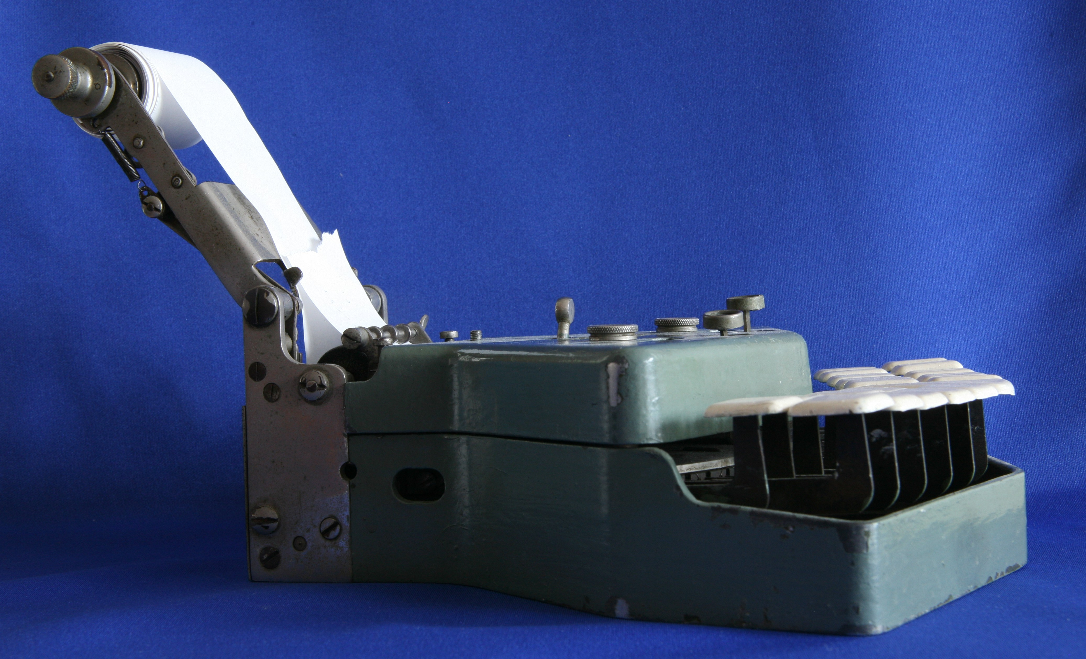

Short Description: The Sténotype is a reminder of how deep the roots are in terms of ways of entering text ⎯ in this case, by using chording key sets.

Bill Buxton’s Notes

To come

.

Device Details

Company: Grandjean | Year: 1910 | Original Price (USD): XXXX

Degrees of Freedom: N/A

Dimensions (L x W x H): XXX x XXX x XXX (mm)

Key Words

Primary: Chord Keyboard

Secondary: Reference Object, Keyboard

Links

* ??? broken: <http://www.archivesnationales.culture.gouv.fr/camt/fr/se/fiche9/fiche9-4.html>
* ??? broken: <http://www.galleryofshorthand.org/historyofmachines.htm> l
* [Stenotype Grandjean](https://microsoft-my.sharepoint.com/personal/bibuxton_microsoft_com/Documents/Buxton%20Collection/Collection/Priority%20kbd%20show/Grandjean%20Stenotype/Steno_Stenotype_Grandjean.pdf)
* X: <http://youtu.be/aqHG5lwDo8I>
* X: <http://youtu.be/WQ52H7D3b30>
* X: <http://youtu.be/OGz_GSChwG4>

|  |  |  |
| --- | --- | --- |
| **Image** | **File Name** | **Caption** |
|  | Steno_0296.JPG | Upper-front view of the Grandjean Sténotype. |
|  | Steno_0300.JPG | Side view of the Grandjean Sténotype. |
|  | Steno_0302.JPG | Close-up side view of the Grandjean Sténotype. |
|  | Steno_Stenotype_Grandjean.jpg |  |
|  | Steno_Grandjean_Stenotype_Ad_1924.jpg | 1924 Advertisement Grandjean Sténotype, Paris |
|  | Steno_Grandjean_Stenotype_Ad2.jpg | Print Advertisement from the December 1925 issue of the French periodical, *Vendre,* including an example of short transcription from phonetic script. |
|  | Steno_Grandjean_Stenotype_Ad3.jpg | 1930 Print Advertisement from the May 1930 issue of the French periodical, *Vendre.* |
|  | Steno_1925_Advertisment.jpg | 1925 Ad Stenotype Grandjean 8 Rue Gaillon Boss Dictation Secretary Paris VEN4 ([source](https://www.periodpaper.com/products/1925-ad-stenotype-grandjean-8-rue-gaillon-boss-dictation-secretary-paris-office-174267-ven4-153)) |