[BUXTON / MICROSOFT COLLECTION](http://research.microsoft.com/en-us/um/people/bibuxton/buxtoncollection/default.aspx)

[home](http://research.microsoft.com/en-us/um/people/bibuxton/buxtoncollection/default.aspx) | [explore](http://research.microsoft.com/en-us/um/people/bibuxton/buxtoncollection/browse.aspx) | associated narratives | [about | acknowledgments](http://research.microsoft.com/en-us/um/people/bibuxton/buxtoncollection/acknowledgements.aspx) | [contact](http://research.microsoft.com/en-us/um/people/bibuxton/buxtoncollection/contact.aspx)

**Matias Half Keyboard for Palm**

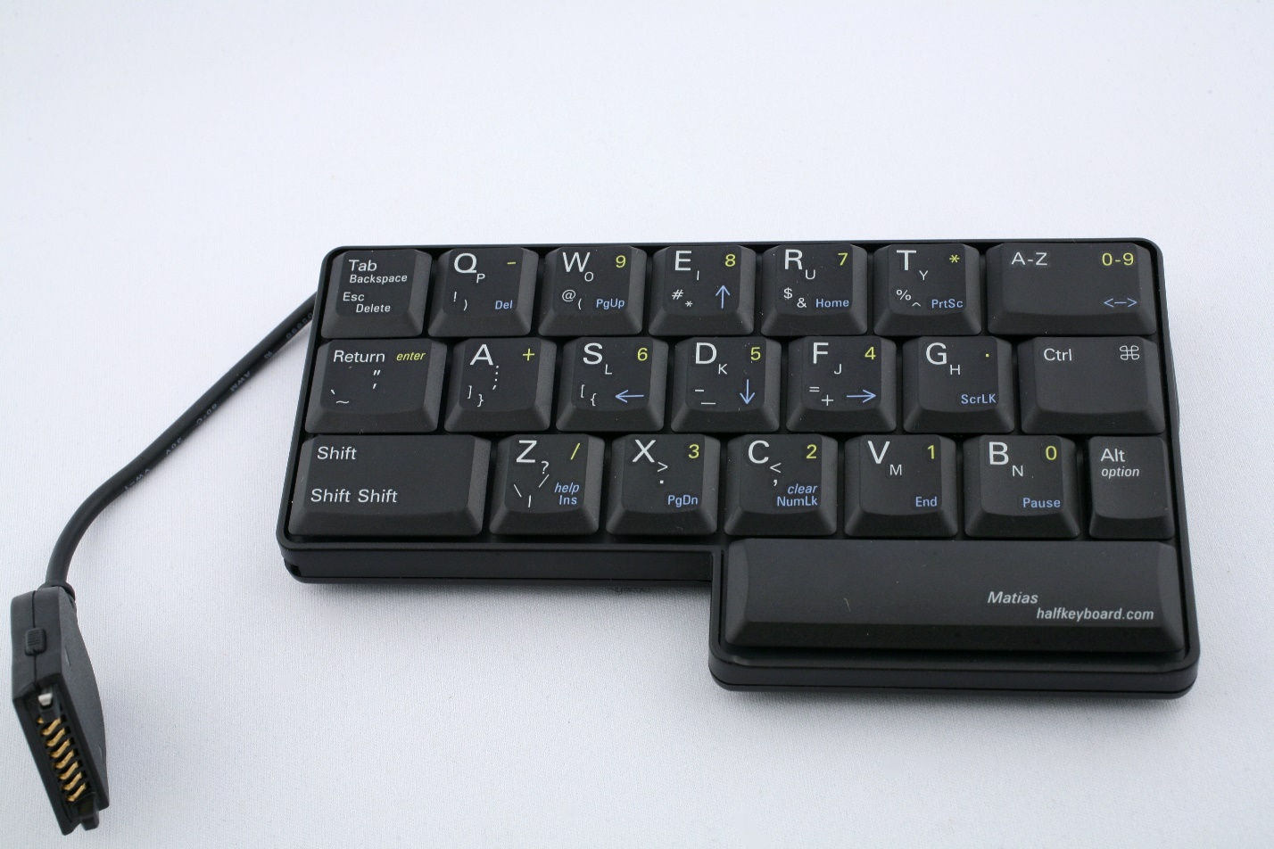

Short Description: Sometimes seemingly crazy ideas work. Edgar Matias came to my group with a strange notion: to make a half-sized QWERTY keyboard which nevertheless would have full-sized keys. Conceptually, his idea was to cut a conventional QWERTY keyboard in half, and type with only one hand on that half. By activating a special mode key, the keys of the missing side of the keyboard would just map, mirror image, onto the existing half. It turns out that the idea worked. Quite well, in fact, and touch typists are able to adapt to it rather quickly.

Bill Buxton’s Notes

Worked with full keyboard, using only one half – thus enabling one-handed typing with either hand, using only ½ the keyboard in either case – just a different half. Thus, financial accessibility achieved as well as accessibility to comparatively fast one-handed typing. Available for Palm m100, III, V, VII Series, Handspring, PC (Windows and Linux), and Macintosh (USB).

The keyboard in the photo is designed to accommodate one-handed typing with the left hand. As such, it is intended for right-handed users. That may seem counter-intuitive; however, the reason is that right-handed people typically use their right hand to operate the mouse, for example. Thus, typing with the left hand enables each hand to remain in “home” position for its respective task, thereby reducing hand movement between devices.

Device Details

Company: Matias Corp. | Year: 2001 | Original Price (USD): $99.00

Degrees of Freedom: NA

Dimensions (L x W x H): 147 x 15 (mm)

Key Words

Primary: Keyboard

Additional: NA

Links

* Half-Keyboard Announcement: <https://web.archive.org/web/20010203124800/http://halfkeyboard.com:80/product/index.html>
* [Matias Half Keyboard Manual](https://microsoft-my.sharepoint.com/personal/bibuxton_microsoft_com/Documents/Buxton%20Collection/Collection/Shot/Matias%20One%20Hand%20Kbd/Matias_Kbd_Manual.pdf)
* [Half-QWERTY: Typing With One Hand Using Your Two-handed Skills](https://microsoft-my.sharepoint.com/personal/bibuxton_microsoft_com/Documents/Buxton%20Collection/Collection/Shot/Matias%20One%20Hand%20Kbd/Matias_CHI94.pdf)
* [Human Computer Interation: One-Handed Touch Typing on a QWERTY Keyboard](https://microsoft-my.sharepoint.com/personal/bibuxton_microsoft_com/Documents/Buxton%20Collection/Collection/Shot/Matias%20One%20Hand%20Kbd/Matias_HCI.pdf)
* powerpoint
* you tube link

|  |  |  |
| --- | --- | --- |
| **Image** | **File Name** | **Caption** |
|  | Matias_Top_View.JPG | Matias Half Keyboard for one-handedtTyping using the left hand. |
|  | Matias_Back_View.JPG | Back view of the Matias Half Keyboard |
|  | Matias_Case.JPG | Matias Half Keyboard in carrying case. |
|  | Matias_Kbd_Manual.jpg | The original 2001 manual for the Matias Half Keyboard for Palm and Handspring PDAs. |
|  | Matias_Halfkeyboard_Manual.jpg | This is a revised Manual for the Half Keyboard from 2007. It is included for those interested in how documentation evolves. |
|  | Matias_CHI94.jpg | A Snapshot of Part of the First Page of a 1994 Paper Describing an Early Study Evaluating the Half Keyboard Performance. |
|  | Matias_HCI.jpg | A snapshot of the first page of a 1996 journal article providing greater detail on the performance typing with one hand on the half keyboard. |