[BUXTON / MICROSOFT COLLECTION](http://research.microsoft.com/en-us/um/people/bibuxton/buxtoncollection/default.aspx)

[home](http://research.microsoft.com/en-us/um/people/bibuxton/buxtoncollection/default.aspx) | [explore](http://research.microsoft.com/en-us/um/people/bibuxton/buxtoncollection/browse.aspx) | associated narratives | [about | acknowledgments](http://research.microsoft.com/en-us/um/people/bibuxton/buxtoncollection/acknowledgements.aspx) | [contact](http://research.microsoft.com/en-us/um/people/bibuxton/buxtoncollection/contact.aspx)

**Xerox PARC 5-Key Chord Keyboard**

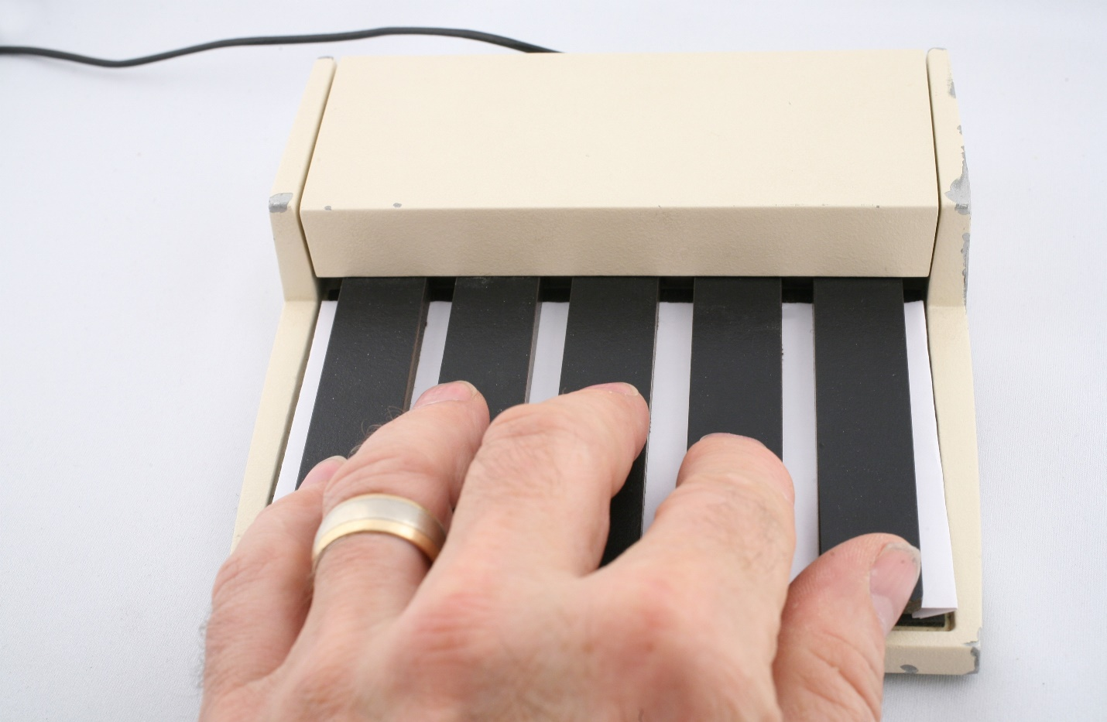

Short Description: This five-button chord keyboard was modeled on the keyboard developed by Doug Engelbart, and publicly demonstrated in his 1968 “Mother of all demos”. It was fitted to the first Xerox Alto computers, with an accompanying 3-button mouse,and like with Engelbart, it was intended for use by the non-mouse hand. This enabled each hand to be in “home position” on two different, but complementary devices, thus keeping core functionality such as text entry, editing, invoking special functions, etc. efficiently “in hand”.

Bill Buxton’s Notes

This device grew out of pioneering work undertaken at the Augmentation Research Center of the Stanford Research Institute (SRI) in the 1960s. This is the work which laid much of the foundation for the Graphical User Interface (GUI), also known as WIMP (Windows, Icons, Mouse, Pointer) interfaces which dominated interaction design from the l980s right up to the present.

This work was mainly driven by Douglas Engelbart, with strong contributions from William English, and was called the NLS System (oN-Line System). Its first major public demonstration took place at the annual Fall Joint Computer Conference in San Francisco December 9th, 1968. Its impact was such that one of the pioneers of computer graphics, Andries van Dam, referred to it as “The Mother of All Demos”, a name which has stuck. Watch the video in the references section and you will see why.

In the realm of human-computer interaction, the NLS system developed by Engelbart and English (1968) is important to our discussion. This is the project that introduced the mouse, and therefore had a huge impact on multiple generations of computer users. What is easily missed, however, is that the goals of this work had nothing to do with improving access to computing for casual users or making computers easy to use. Rather, they were designing a system with which highly trained operators could reach their full potential. By analogy, they were designing a violin for a virtuoso performer, rather than a player of the 2005 videogame *Guitar Hero,* which is kind of like guitar karaoke for the amateur. It is somewhat ironic, therefore, that the mouse was adopted by novices far faster and enthusiastically than by the power-users targeted by the NLS project. For a long time, they clung to keyboard-based command-line interfaces.

Stepping back, from the perspective of input, the NLS system pursued a bi-manual approach that employed three main devices:

1. A conventional QWERTY keyboard
2. A three-button mouse
3. A five-button chord Keyboard.

These are illustrated in Figure 1.

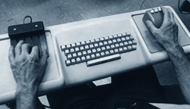

Figure 1: The NLS Input Devices

This image is a frame from the film of the “Mother of all demos”, the demonstration of Engelbart and English’s work that accompanied their classic 1968 paper at the Fall Joint Computer Conference.[1] Left-to-right one sees the left hand on the chord keyboard, the QWERTY keyboard in the middle, and the mouse in the right hand. Note that the mouse is not the original one-button wooden mouse shown in Figure 5 of Chapter 2. Rather, it is a three-button mouse – a fact which is important to our discussion.

The use of the mouse and QWERTY keyboard was similar to that common to the graphical user interfaces that have been around since the early-to-mid 1980s. The mouse was typically operated by the dominant hand and used for spatial tasks such as graphically pointing and selecting. The QWERTY keyboard was used for sustained text entry. It is in the five-button chording keyboard that we begin to encounter something less familiar. Since there are a few surprises here, I’m going to go into a bit of detail about its use.

With just a keyboard and a mouse, the two most typical strategies for entering text are:

1. Bring both hands to the QWERTY keyboard and type quickly, then have one hand move back to the mouse to perform pointing, selection or dragging tasks.
2. Keep one hand on the mouse, and type very slowly by tapping on the keyboard using the hand not operating the mouse.

The 5-key piano-like chording keyboard was developed to provide a third alternative – one that enabled text to be entered with the one hand to remain on the mouse and the other on the chord keyboard.

On the plus side, by enabling the hands to remain in “home position” on the mouse and chord keyboard, the transaction cost of moving the hands back and forth between them and the accompanying standard QWERTY keyboard (the “homing time”) was eliminated. For skilled users, this was significantly faster than option (b) above, typing with one hand on the QWERTY keyboard.

On the other hand, typing in this manner was still significantly slower than option (a), typing with both hands on the QWERTY keyboard. Hence, the savings offered by this option (c) only occurred when typing short bits of text. For longer blocks of text, the cost of moving to and from the conventional keyboard was easily made up for by the increased typing speed.

Despite my describing this third option in terms of the bi-manual simultaneous use of mouse and keyboard, Engelbart & English (1968) refer to it as “one-handed typing.” This description gives cause to dive more deeply into what was going on, since it has given rise to a mistaken belief that typing in this mode employed only the chord keyboard, and that the role of the mouse was solely for complementary spatial pointing related tasks. That is not accurate.

Yes, many things could be typed using just one hand using the 5-button keyboard. But so to can a violinist play music using only one of the four strings on the instrument. While some music can be played, the full repertoire cannot. Likewise, using a chord keyboard to access the full character set found on a standard QWERTY keyboard, *using only a single chord for each character*, this mode of entering text requires seven keys, just as the violin needs four strings. Used alone, the keys of the 5-button chord keyboard are simply not adequate for the task.

Why? Five binary keys mean that only 25-1 = 31 different characters can be entered. So, as he designed it, yes, Engelbart could enter the 26 lower-case letters of the alphabet and five other characters: comma, period, semicolon, question mark, and SPACE using just the five keys of the chord keyboard.

However, to enter the rest of the character set - such as the upper-case letters of the alphabet, digits, numerical operations, additional punctuation and special characters - two more buttons were required. These were provided by the left and middle buttons of the three-button mouse.

In effect, Engelbart used a virtual 7-button chord keyboard split over two different physical devices, and effectively, a 1-button mouse. This gave him access to a full repertoire of 27-1 = 127 different characters. The question is, how did he map the chord combinations onto the character set?

The short answer – at least for those with some background in computer science – is that he used a clever variation of 7-bit ASCII. The table in the accompanying figure will help provide a more complete explanation.

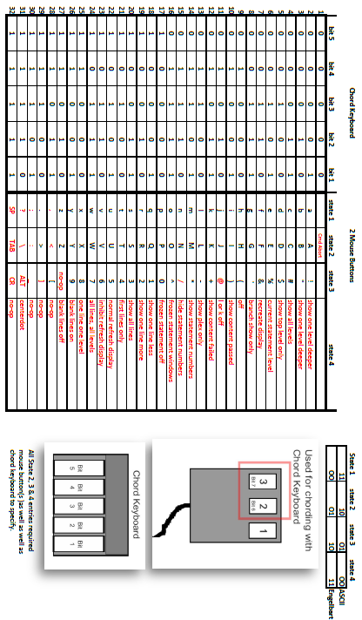

Engelbart and English Chord Keyboard Encoding Scheme

This table shows how the 5 buttons on the chord keyboard and 2 mouse buttons were used to enter text. (Based on Engelbart, 1973).

The main table in the Figure has 32 rows.

* Each of the 32 rows in the main table represents one of the unique combinations in which the five buttons of the chord keyboard can be depressed.
* Each of the five left-most columns corresponds to one of the five buttons on the chord keyboard.
* A “1” in a cell indicates that the key associated with that column is depressed in the chord associated what that specific row. For example, the key associated with the left-most column is only depressed in the chords represented by rows 17 to 32. Likewise, the top row indicates the situation where none of the five keys are depressed.
* If only the chord keyboard is used, the character that is entered for any of the 31 possible chords (rows 2 –32) is shown in the corresponding row in the 6th column, labeled “State 1”.
* If the middle mouse button is depressed, the character entered is determined by which, if any, of the 5 chord keyboard buttons are also depressed, and is indicated in the corresponding row in the 7th column, labeled “State 2”.
* If the left mouse button is pushed, it works the same way, except the character entered is indicated in the corresponding row in the column labeled “State 3”.
* Finally, if both the left and middle mouse buttons are depressed simultaneously, then the character is likewise determined by which, if any, of the 5 chord keyboard buttons are depressed, and indicated in the corresponding row in the column labeled “State 4”.

To wrap up the explanation of how the buttons of the chord keyboard and the mouse relate to the table:

* The illustration on the Chord Keyboard at the bottom right of Figure 3 indicates which bit (1-5) is associated with which key, and therefore which key corresponds to each of the first five columns in the table.
* The illustration of the mouse in the middle right of the figure shows the labelling of the buttons (1-3), and which of the seven bits (6 & 7) is mapped to which button. These two bits do not map directly into columns in the table, hence the next point.
* For the readers who are computer scientists: the small table at the top on the right-hand side shows how Engelbart remapped the meaning of bits 6 and 7, compared to 7-bit ascii. This was clever, since it gave him access to the lower-case alphabet using only the 5 least significant bits, i.e., using just the buttons on the chord keyboard.

Using the limited character set available with just the 5-button chording keyboard, Engelbart was reported to have been able to achieve a typing speed of 35 words per minute with his right hand, and 25 words per minute with his left. It is also reported that it took him about 10 hours to reach 10 words per minute (Noyes, 1983).

Remember, the speeds reported above included only 31 of the 127 of the full character set. His typing speed would have been slower if he was employing both hands, and it would take far more than 10 hours to learn them all. However, there was always the option to revert to the QWERTY keyboard – which was frequently done. As stated in Engelbart and English (1968):

* *One-handed typing with the handset is slower than two-handed typing with the standard keyboard. However, when the user works with one hand on the handset and one on the mouse, the coordinated interspersion of control characters and short literal strings from one hand with mouse control actions from the other yields considerable advantage in speed and smoothness of operation.*
* *For literal strings longer than about ten characters, one tends to transfer from the handset to the normal keyboard.*
* *Both from general experience and from specific experiment, it seems that enough skill to make its use worthwhile can generally be achieved with about five hours of practice. Beyond this, skill grows with usage.*

Given the historical importance of this system, I have gone into so much detail about the text entry because it is so difficult to extract from the literature. By the same token, the exercise helps build a stronger sense of how important such details are in terms of the ultimate user experience. No matter how good any of the chord keyboards discussed look or feel mechanically, the complexity of the encoding scheme – how long it takes to learn, the proneness of error, or the speed of entry, may dominate the value.

Finally, the 5-button chord keyboard was not only used for entering text. At Xerox PARC, where this particular example originated, its buttons were also used as function keys. That is, special functions were assigned o specific individual keys, or combinations of keys. Furthermore, these function keys were sometimes used in combination (either in sequence or chording) with other keys on the QWERTY keyboard – which retained the bimanual benefits, but this time between the two keyboards, rather than the 5-button keyboard and the mouse which Englebart demonstrated.

This type of usage can be seen in the video demo by Larry Tessler of the Gypsy text editor, accessible from the link below. Furthermore, an explanation of the use of the chord keyboard, referred to as the “five-key keyset” in the document, by the description of *Gypsy* in the 1975 report by Tessler and Mott, accessed from the link below.

Device Details

Company: Xerox PARC | Year: 1973 | Original Price (USD): NFS

Degrees of Freedom: 0

Dimensions (L x W x H): 147 x 147 x 33 (mm)

Key Words

Primary: Chord Keyboard

Additional: Keyboard

Links

* The Mother of All Demos: A video of Engelbart’s influential demo at the Fall Joint Computer Conference, December 9th, 1969. Besides being the first broad introduction of the mouse, it also was the first large unveiling of the 5-button chord keyboard: <https://web.stanford.edu/dept/SUL/library/extra4/sloan/MouseSite/1968Demo.html>
* Butler Lampson & Chuck Thacker, Xerox Alto History: <https://history-computer.com/ModernComputer/Personal/Alto.html>
* Tesler, Larry & Timothy Mott (1975). [Gypsy: The Ginn Typescript System](https://microsoft-my.sharepoint.com/personal/bibuxton_microsoft_com/Documents/Buxton%20Collection/Collection/Shot/Xerox%20PARC%205-key%20Chord%20Kbd/Gypsy_The_Ginn_Typescript_System_Apr75.pdf). Technical report, Xerox Palo Alto Research Center. (Also available here.)
* powerpoint
* In this short video from the Computer History Museum, Larry Tesler demonstrates cut, copy and paste using the Gypsy text editor which he and others developed for the Alto Computer at Xerox PARC. Notice that in this example, he is using his “mouse” hand on the QWERTY keyboard, and the other on the 5-button chording keyboard: <https://www.youtube.com/watch?v=Dhmz68CII9Y>

|  |  |  |
| --- | --- | --- |
| **Image** | **File Name** | **Caption** |
|  | PARC_ChdKbd_Hand.JPG | Around 1973 Xerox Palo Alto Research Center (PARC) began building 5-button keyboards to use with their experimental in-house workstations, starting with the Alto. As was the accompanying mouse, these were very much com based on those used with Englebart’s NLS system. |
|  | PARC_ChdKbd_Quarter.JPG | Overhead View of Xerox PARC 5 Key Piano-Like Chord Keyboard. |
|  | PARC_ChdKbd_Side.JPG | Side View of Xerox PARC 5 Key Piano-Like Chord Keyboard. |
|  | PARC_ChdKbd_Front.JPG | Front View of Xerox PARC 5 Key Piano-Like Chord Keyboard. |
|  | PARC_ChdKbd_Back.JPG | Back View of Xerox PARC 5 Key Piano-Like Chord Keyboard. |
|  | PARC_ChdKbd_Bottom1.JPG | Bottom View of Xerox PARC 5 Key Piano-Like Chord Keyboard. |
|  | PARC_ChdKbd_Bottom2.JPG | Detailed Back View of Xerox PARC 5 Key Piano-Like Chord Keyboard Showing Identification Plate. |
|  | Engelbart_bimanual_MOAD.jpg | Screen snap of Engelbart keyboard and mouse from MOAD video. |
|  | PARC_Chord_Encoding.png | Engelbart and English encoding scheme for typing using the NLS 5-Button chord keyboard. This table shows how the 5 buttons on the chord keyboard and 2 mouse buttons were used to enter text. |

1.