[BUXTON / MICROSOFT COLLECTION](http://research.microsoft.com/en-us/um/people/bibuxton/buxtoncollection/default.aspx)

[home](http://research.microsoft.com/en-us/um/people/bibuxton/buxtoncollection/default.aspx) | [explore](http://research.microsoft.com/en-us/um/people/bibuxton/buxtoncollection/browse.aspx) | associated narratives | [about | acknowledgments](http://research.microsoft.com/en-us/um/people/bibuxton/buxtoncollection/acknowledgements.aspx) | [contact](http://research.microsoft.com/en-us/um/people/bibuxton/buxtoncollection/contact.aspx)

**TASA Model 55 ASCII Keyboard**

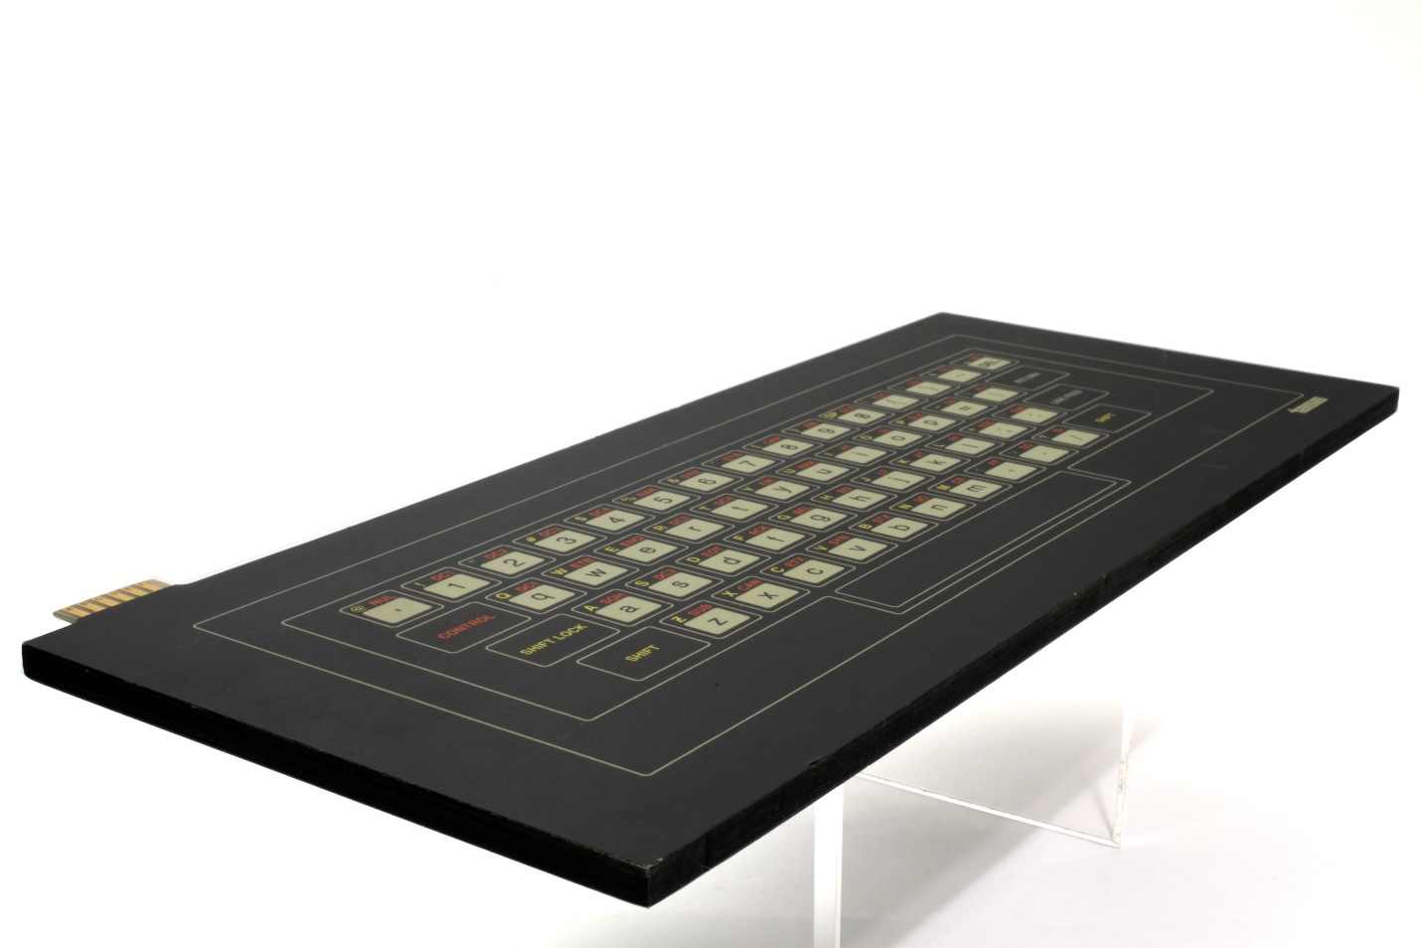

Short Description: This touch-sensitive keyboard is especially suited for super clean environments, such as hospitals, and those which are just the opposite. The reason is that, being completely flat, there are no crack or gaps where dirt or bacteria can accumulate. This same property enables it to be easily cleaned. However, the reason that I got this keyboard because it was silent – there are no mechanical key-clicks. Hence, for example, it enabled me to soundlessly enter data to my digital musical instrument during a concert or while recording.

Bill Buxton’s Notes

This is a solid-state touch-sensitive keyboard with no moving parts. Because its surface is flat, the only way one knows that it is a QWERTY keyboard is by the graphical representation on its surface. One types by placing one’s fingers on pictures of keys, rather than physical/mechanical keycaps. Because of the lack of the tactile feedback associated with conventional keyboards, as expected, typing speed and/or accuracy will be compromised with this keyboard.

And yet, this keyboard brings real value in certain situations, and in so doing, it provides a good example of the rule: *Everything is best for something and worst for something else.*

Because the is especially suited for super clean environments, such as hospitals, and those which are just the opposite. The reason is that, being completely flat, there are no crack or gaps where dirt or bacteria can accumulate. This same property enables it to be easily cleaned. However, the reason that I got this keyboard because it was silent – there are no mechanical key-clicks. Hence, for example, it enabled me to soundlessly enter data to my digital musical instrument during a concert or while recordingThis is one of a number of capacitive touch-sensing input devices produced in the period around 1981 by Touch Activated Switch Arrays (TASA). The others included a touch-sensitive linear controller, the Ferinstat, which could function as a linear slider/fader, for applications such as audio or process control. These came in two lengths and are [included in the collection](../../../Collection%20in%20production/1%20To%20Shoot/TASA%20Ferinstat/Bill%20Notes%20Ferenstat.docx). There were also the Model 16 Micro Proximity Keyboards, which were 16-button keyboards, arranged in a 4x4 array of touch-sensitive buttons that included a touch-sensitive numerical keypad. They also demonstrated a small, capacitive touch-sensitive touch pad, not unlike what one sees on today’s laptops, for example.

Device Details

Company: TASA (Touch Activated Switch Arrays) | Year: 1979 | Original Price (USD): $80.00

Degrees of Freedom: 0

Dimensions (L x W x H): 382.27 x 158.75 x 8.255 (mm)

Key Words

Primary: Keyboard

Additional: Touch Pad

Links

* Web link
* [TASA Brochure](C:\\Users\\bibuxton\\OneDrive - Microsoft\\Buxton Collection\\Collection\\Shot\\TASA Keyboard\\TASA_Kbd_Brochure.pdf)
* [ISA81 Article: Solid State Controls for the Harsh Environment](C:\\Users\\bibuxton\\OneDrive - Microsoft\\Buxton Collection\\Collection\\Shot\\TASA Keyboard\\TASA_ISA81_Article.pdf)
* [TASA Keyboard US Patent 1981](C:\\Users\\bibuxton\\OneDrive - Microsoft\\Buxton Collection\\Collection\\Shot\\TASA Keyboard\\TASA_Kbd_US_Patent.pdf)
* [TASA Price List](C:\\Users\\bibuxton\\OneDrive - Microsoft\\Buxton Collection\\Collection\\Shot\\TASA Keyboard\\TASA_Price_List_1981.pdf)
* [TASA Model 55 Solid State ASCII Touch Keyboard Advertisment, *Wireless World,* November 1979, p. 41](-%09http:/www.americanradiohistory.com/Archive-Wireless-World/70s/Wireless-World-1979-11.pdf)*.*

|  |  |  |
| --- | --- | --- |
| **Image** | **File Name** | **Caption** |
|  | TASA\_Kbd\_Angle.JPG | TASA Model 55 Solid State ASCII Touch Keyboard, Angle View from Above. |
|  | TASA\_Kbd\_Front.JPG | TASA Model 55 Solid State ASCII Touch Keyboard, Top View. |
|  | TASA\_Kbd\_Back\_1.JPG | TASA Model 55 Solid State ASCII Touch Keyboard, Full Bottom View. |
|  | TASA\_Kbd\_Back\_2.JPG | TASA Model 55 Solid State ASCII Touch Keyboard, Partial Bottom View with Serial Number. |
|  | TASA\_Kbd\_Brochure.jpg | First Page of TASA Model 55 Solid State ASCII Touch Keyboard Brochure. Click on image to view brochure. |
|  | TASA\_ISA81\_Article.jpg | Cover for: Abler, A.A. (1981). Solid State Control for the Harsh Environment – A Technological Breakthrough. Preprint, ISA’81 Fall Conference and Exhibit. Click on image to view preprint. |
|  | TASA\_Price\_List\_1981.jpg | TASA 1981 Price List. |
|  | TASA\_Kbd\_US\_Patent.jpg | US Patent 4,288,786, Sept. 8, 1981, for TASA Solid State Keyboard technology. Click on image to view patent. |
|  | TASA\_Kbd\_WirelessWorld\_Ad.png | TASA Model 55 Solid State ASCII Touch Keyboard Advertisment, *Wireless World,* November 1979, p. 41*.* |