68th New York Volunteer Infantry Regiment
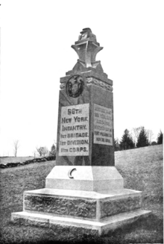
Monument to the 68th New York Infantry, at Gettysburg, Pennsylvania.
Active | July 22, 1861 – November 30, 1865
Type | Infantry
Nickname(s) | "Cameron Rifles", "Second German Rifle Regiment"

________________________________________________________
Trial version converts only first 100000 characters. Evaluation only.
Converted by «HTML to RTF .Net» 5.3.7.1.
(Licensed version doesn't display this notice!)
- Get license for the «HTML to RTF .Net»

