**HV Tail glueing**

(please go through carefully and check the boxes )

* Place the sensor on the jig with the strip side facing down.
* The arrow on the sensor should be on the same side as the HV tail, thus pointing as indicated in picture 1.
* Push the sensor towards the stops as indicated in picture 1.
* Secure the sensor by switching on the vacuum.
* Place the HV tail:
  + The hole in the HV tail fits through the middle pin (pin2, see picture 2).
  + Push the HV tail leg towards pin1, secure it with the green pusher and fasten the screw.
* Apply glue:
  + Lift the HV tail with tweezers.
  + Apply a drop of glue on the tail below the bond pad.
  + When lowering the tail onto the sensor backplane make sure the tail is still in position.
* Slide the aluminum weight piece onto jig. The nose should push the HV tail down on the wire bond pad position as shown in picture 3.
* Let the glue cure.
* Remove the sensor with the HV tail from the jig by:
  + Lifting the weight piece,
  + un-fastening the screw of the pusher and moving the pusher aside,
  + carefully remove the three pins,
  + lift the sensor with a vacuum tool.

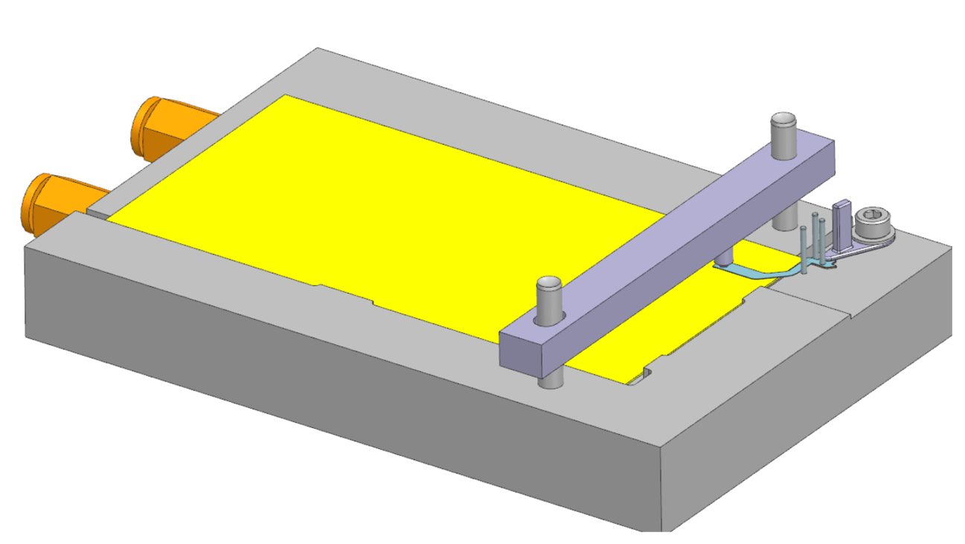

stops

Picture 1

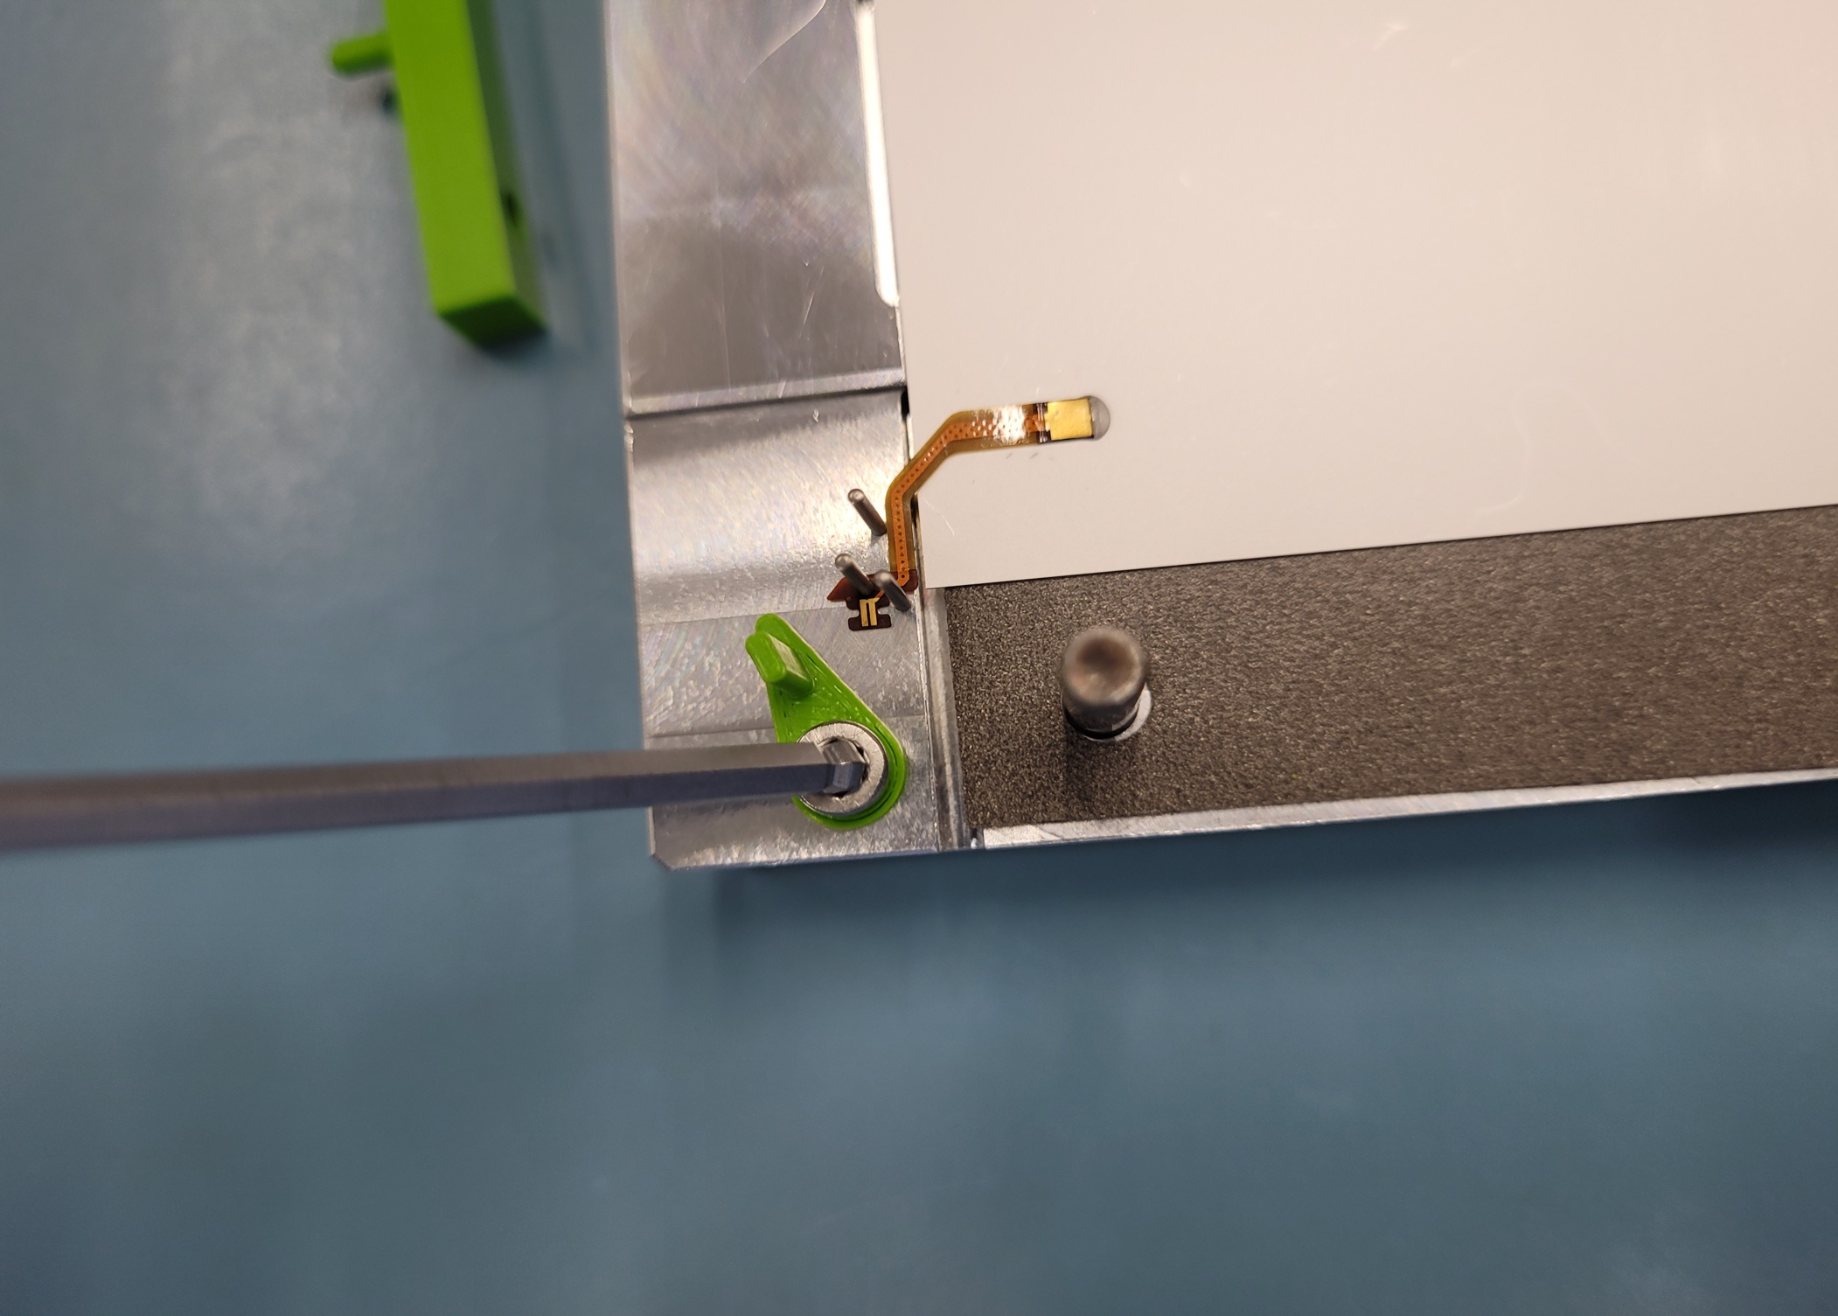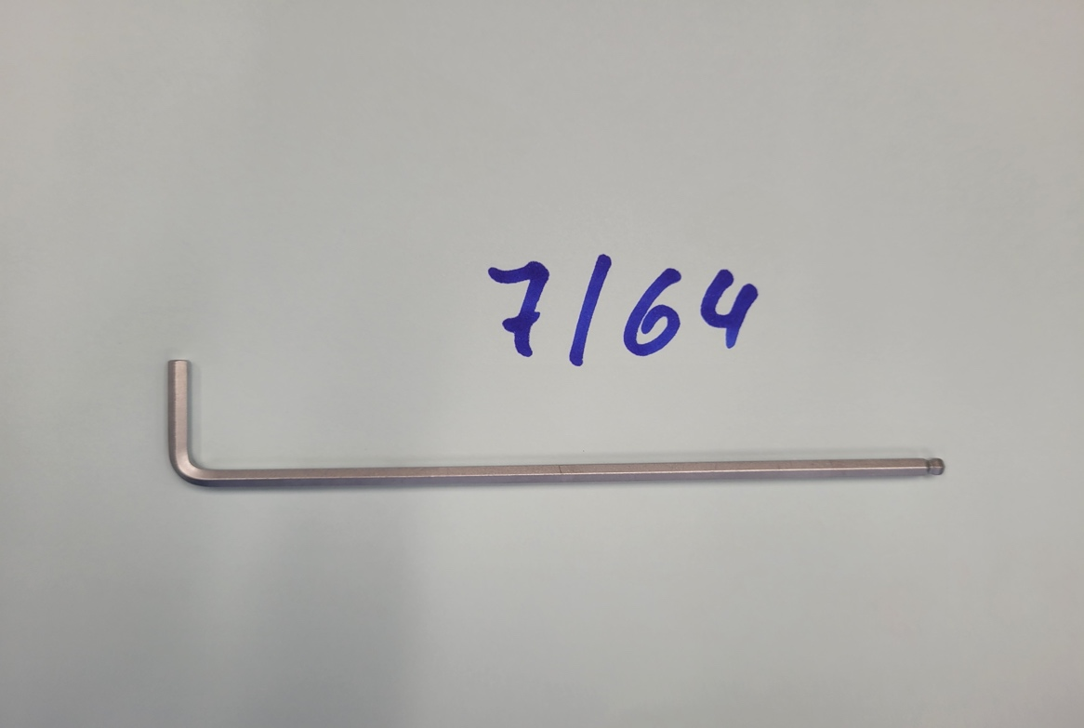

pin1

pin2

pin3

Picture 2

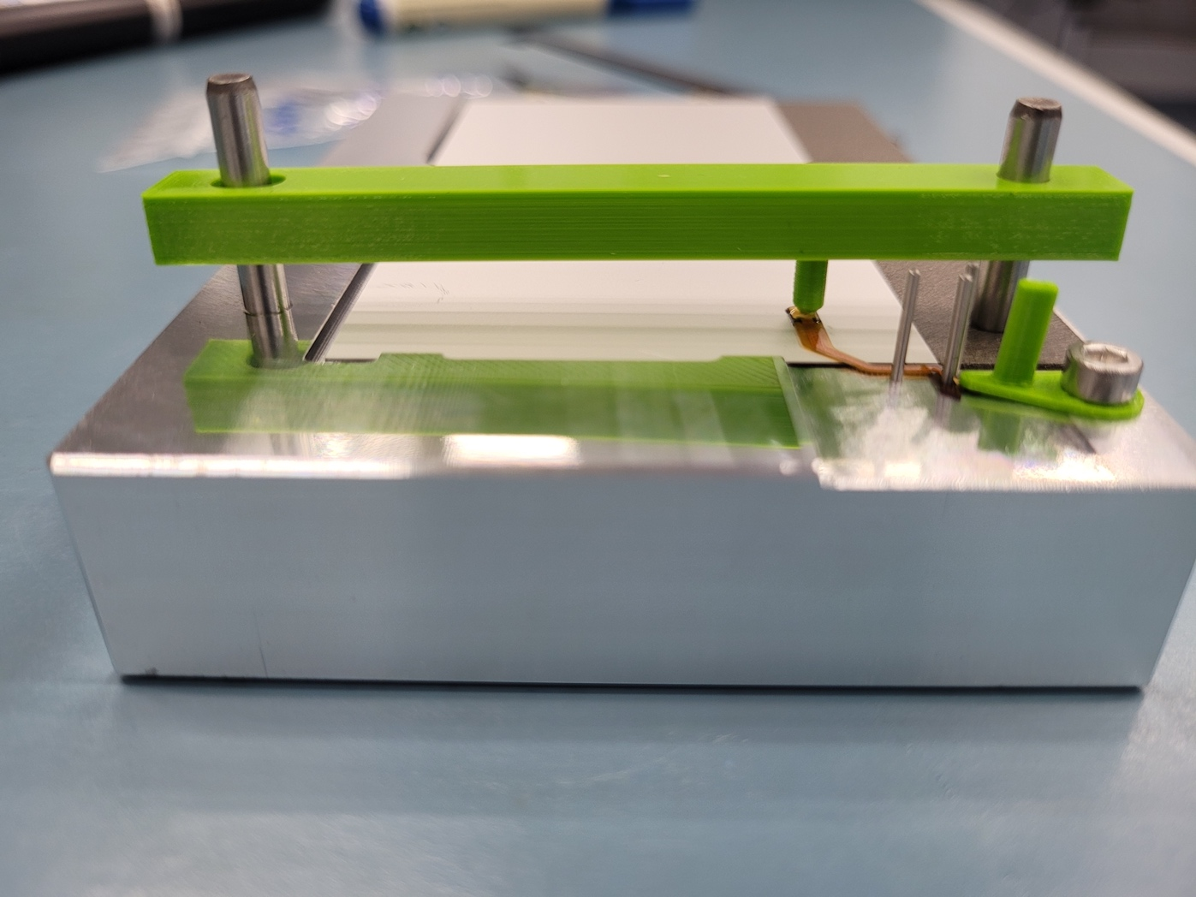

Picture 3