Spatial analysis of greenspace and mental health: consideration of greenspace quantity and quality

Greenspace benefits mental health by offering avenues for physical recreation, social cohesion, restorative experiences, and pollution reduction. Greenspace mental health research has primarily focused on the greenspace-mental health relationship in urban areas, with less attention given to greenspaces in rural areas. In addition, most greenspace research focuses on the quantity of greenspace; inclusion of greenspace quality, however, furthers understanding of the greenspace mental health relationship. This study analyzed the greenspace mental health relationship in Western North Carolina, a predominantly rural, mountainous region. Greenspace was quantified as public greenspaces from the PAD-US and ParkServe datasets, with quality metrics including amenities, trail density, and Normalized Difference Vegetation Index (NDVI). The CDC PLACES dataset from 2020 was used for three mental health outcomes: (1) general mental health, (2) depression diagnoses, and (3) poor sleep. Spatial regression revealed that these metrics do not significantly affect mental health, but greenspace quality did have small protective benefits for sleep. Sociodemographic factors were found to be more predictive of poor mental health outcomes than greenspace metrics. Local Indicators of Spatial Autocorrelation (LISA) analysis found mental health outcomes clustered spatially, while greenspace metrics did not. This analysis furthers understanding of the greenspace mental health relationship in rural regions.

# INTRODUCTION

Proximity to greenspace is a potential determinant on an individual’s mental health (Nutsford, Pearson and Kingham 2013, Ekkel and de Vries 2017, Sarkar, Webster and Gallacher 2018, Collins et al. 2020, Jiang, Stickley and Ueda 2021). As a low-cost mental health intervention, greenspace provides restorative experiences, encourages social cohesion, reduces pollution, and offers opportunities for physical activity (Lachowycz and Jones 2013, Wang et al. 2021). To date, most greenspace research has focused on the greenspace mental health relationship in urban areas, with less attention focused on rural communities (Collins et al. 2020). Within studies that have considered the greenspace mental health relationship in rural areas, evidence is mixed, with some studies finding greenspace benefits mental health similarly in rural areas as compared to urban areas (Verheij, Maas and Groenewegen 2008, Alcock et al. 2015). Other research suggests that the rural greenspace mental health relationship differs from the urban relationship (Jiang, Stickley and Ueda 2021), with private greenspaces — including yards, agricultural fields, and general “countryside greenness” — playing an important role in the rural greenspace mental health relationship (Ekkel and de Vries 2017). As such, further investigation into the rural greenspace mental health relationship is needed, specifically with regards to public greenspace quality, in addition to greenspace quantity — i.e., available area within a greenspace.

Most greenspace studies consider greenspace quantity as the primary metric, with less attention given to greenspace quality (Collins et al. 2020). Past research has found that an increased quantity of greenspace tends to correspond with better mental health outcomes (van Dillen et al. 2012, Wood et al. 2017, Wang et al. 2021). However, more research is needed to determine whether greenspace quality — attributes including nearby amenities, “greenness” metrics like NDVI, or the presence of public hiking or biking trails — are significant predictors of mental health outcomes.

Of the studies that have considered quality, the most common technique is the use of surveys, allowing the researcher to assess self-reported high-quality greenspace and mental health outcomes (Wang et al. 2021). Other studies have qualified greenspace through consideration of the physical characteristics of the greenspace itself, such as land cover, conservation easements, land designations, species diversity and health and presence of birds (Wheeler et al. 2015), as well as water features and heavy tree cover which provides numerous options for shade in hot months (Mears and Brindley 2019). The findings from these studies suggest that the quality of greenspace may be a crucial factor in the greenspace mental health relationship. Thus, consideration of greenspace quality is critical in better understanding the greenspace mental health relationship.

Western North Carolina is a predominantly rural, mountainous region. Mental health care access is limited (MAHEC n.d.), as is the case in many rural regions in the United States, despite similar or higher mental health case counts occurring in rural versus urban areas (McCall-Hosenfeld, Mukherjee and Lehman 2014). As such, investigation into low-cost mental health care interventions is important. This study investigates the greenspace mental health relationship in Western North Carolina to understand better the greenspace mental health relationship in rural, mountainous regions. To address research gaps, this study will consider greenspace quality in a region comprising mostly rural communities. This research adds to the growing body of greenspace mental health literature and adds new knowledge by assessing how greenspace quality influences mental health in rural regions.

# METHODS

## Study Area

Several geographical, environmental, and administrative definitions of Western North Carolina (WNC) are defined across the literature; in this study, Western North Carolina is defined as communities enclosed in the North Carolina Blue Ridge Mountains, encompassing 160 total ZIP codes within 23 counties (Figure ). ZIP codes are used as the defining administrative level due to the availability of publicly-accessible mental health and demographic data, e.g., the PLACES dataset, which had substantial missing data at the census tract scale for this region. WNC is predominantly rural and mountainous, with pockets of urbanization, most notably Asheville, NC. Greenspace varies from public parks to expansive National Forest land (Figure ).

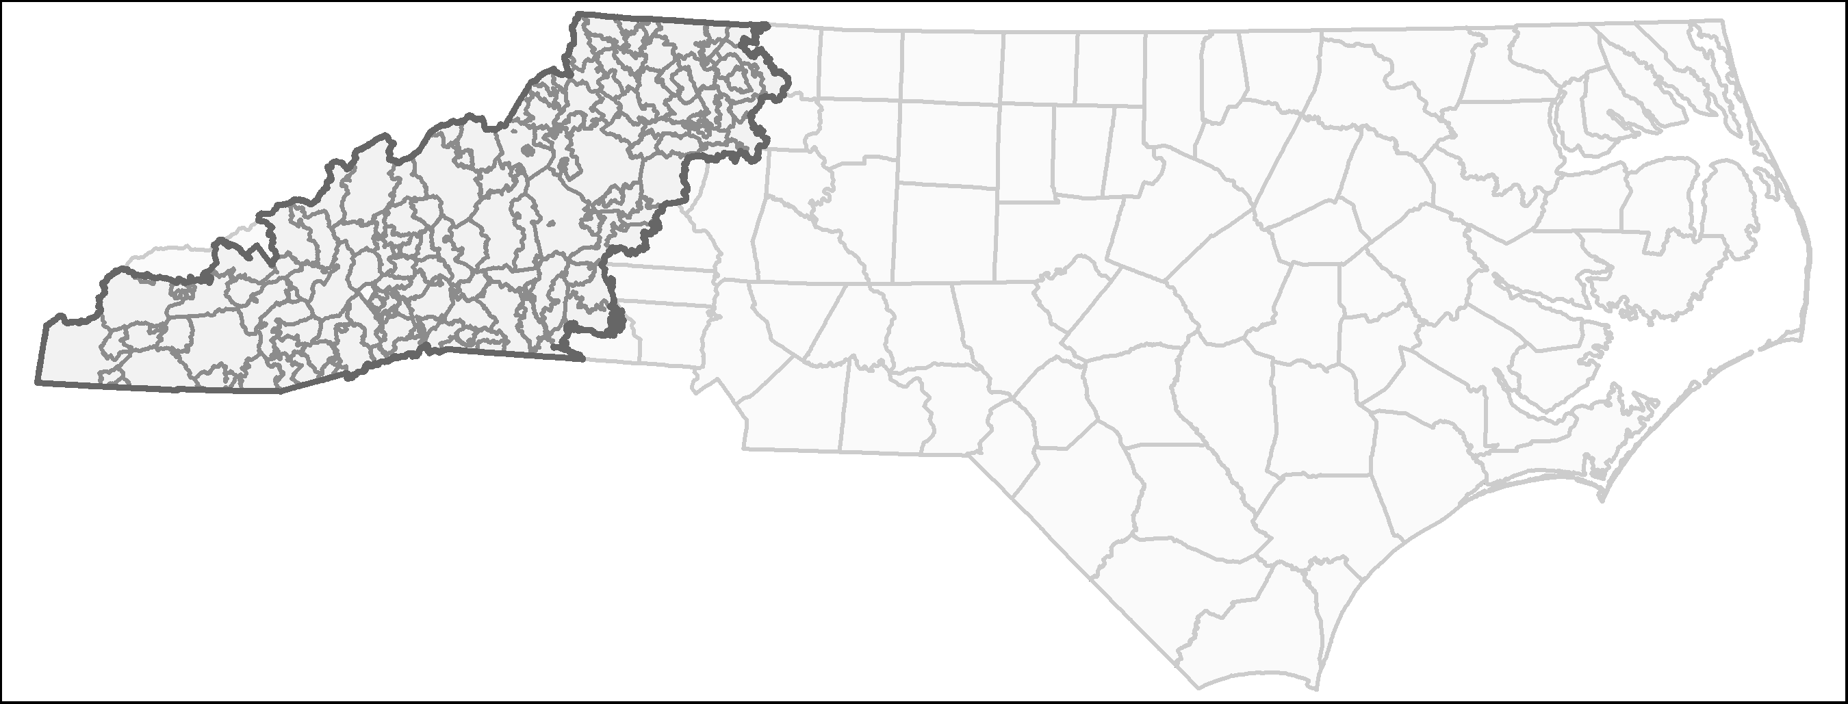

**Figure** : Extent of ZIP codes (dark gray) within Western NC (light gray)

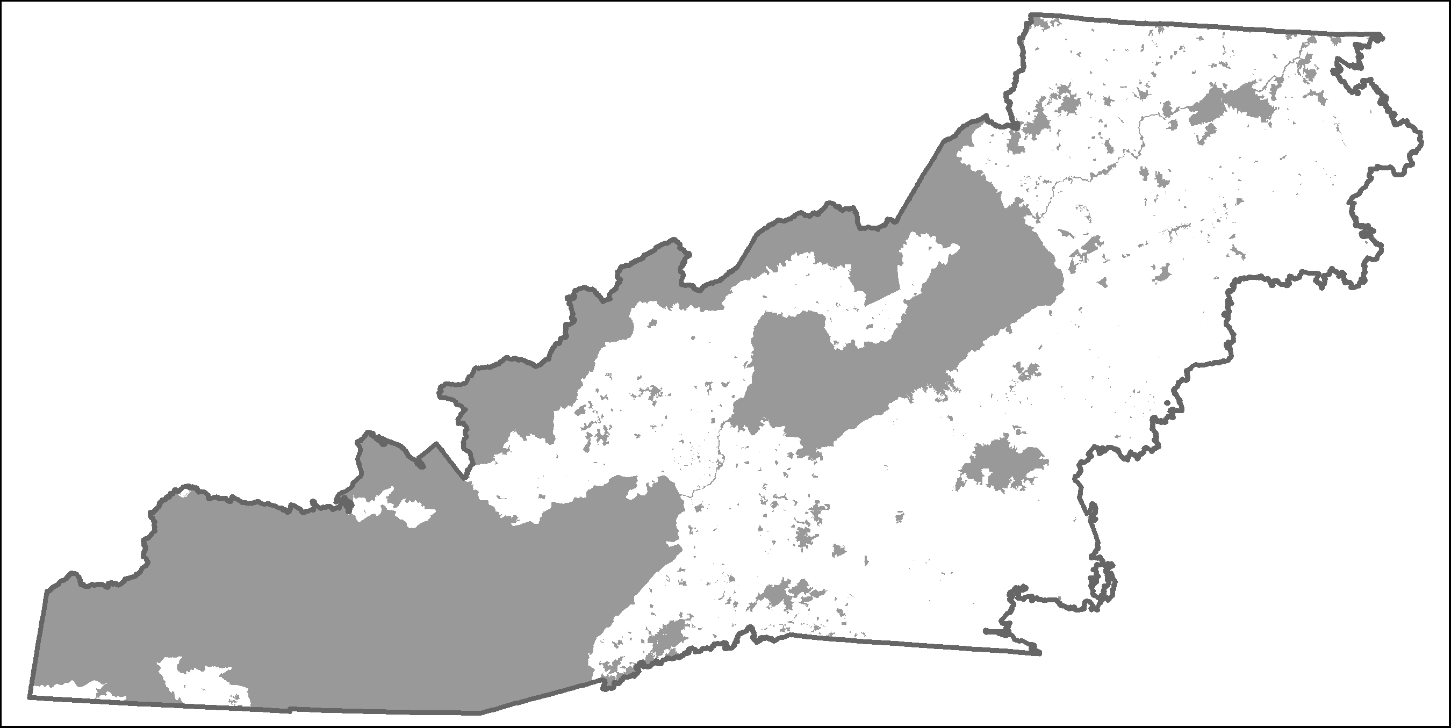

**Figure** : Extent of combined PAD-US and ParkServe greenspace areas (dark gray)

## Mental Health Data

For this analysis, three mental health outcomes were considered: (1) general mental health (Feng & Astell-Burt, 2017; Houlden et al., 2019; Wheeler et al., 2015; Zhang et al., 2017), (2) depression (Beyer et al., 2014; McEachen et al., 2015), and (3) poor sleep (Shin et al., 2020; Johnson et al., 2018; Feng et al., 2020). General mental health is defined as poor mental health for more than 14 days over the last month, depression is based on reported depression diagnoses from a health professional, and poor sleep is defined as regularly getting less than seven hours of sleep during a 24-hour period (CDC, 2022). The CDC PLACES dataset (CDC, 2022) from 2020 was used for mental health indicators. The PLACES dataset offers model-based, population-level community estimates of health outcomes, both physical and mental (CDC, 2022). All data is for adults aged 18 years or older.

## Greenspace Quantity

This study identifies greenspace as areas encompassed by the Trust for Public Land’s ParkServe (ParkServe) dataset and The Protected Area Database of the United States (PAD-US) dataset from 2020 (Runkle et al., 2022; Slawsky et al., 2022; TPL 2020; USGS 2020). ParkServe is a dataset comprising all public parks, including local and city parks and playgrounds (TPL 2020). PAD-US is a spatial dataset of all government-managed greenspaces, such as national forest land, national parks, and historical areas (USGS 2020). All parks and public greenspaces selected from these two datasets were combined to form one public greenspace dataset (Figure ). For consistency with the PLACES mental health datasets at the ZIP Code level, greenspace area was calculated as the percentage of an area within each ZIP code covered by greenspace (defined by the ParkServe and PAD-US datasets); redundant or overlapping greenspaces (i.e., the same greenspace within both datasets) were removed by performing a spatial union of the two datasets, such that overlapping greenspaces do not overestimate greenspace area.

## Greenspace Quality

For this analysis, greenspace quality was determined by looking at vegetation health, trail density, and amenity access as three separate quality metrics. Normalized difference vegetation index (NDVI) data (“Landsat-8 Imagery” 2019), ParkServe (TPL, 2020), and OpenStreetMap amenities data (OpenStreetMap, 2022) were used as metrics of greenspace quality. NDVI assesses vegetation density and health, which has been associated with improved mental health outcomes (Wood et al., 2018; Mears et al., 2019). This study calculated NDVI from Landsat-8 imagery from the months of June to August 2019 and filtered images by those with less than ten percent cloud cover. A spatial buffer of 1 km around the greenspace extent was used in calculating the mean NDVI within each greenspace to remove the effects of small “holes” in the dataset and for small parks whose area was smaller than the resolution of Landsat-8 imagery (30 meters).

Greenspace amenities data from ParkServe, specifically trail accessibility, and OpenStreetMap (OSM) data, provided information on how many greenspace-related amenities (e.g., restrooms, parking) are present in each ZIP Code. OSM data was queried for the study area with the *osmdata* package for R (Padgham 2017) and subsequently spatially filtered to within a 1-km buffer of greenspace extent. This allows for amenities that are “nearby” to greenspaces (e.g., restrooms, restaurants, parking) to factor into greenspace quality. Amenities were summarized as the count of amenities within the 1-km buffer of greenspace extent, and were counted for each ZIP code.

## Covariates

Additional demographic predictor variables include population, race, and household income. Previous research has illustrated that race (Browning & Rigolon, 2018) and income (Hoffiman et al., 2017; deVries et al., 2020) influence the greenspace mental health relationship, as predominantly white, upper-class neighborhoods tend to have the greatest access to greenspaces (Rigolon et al., 2018). Race was accounted for by including the percentage of White residents, and income was accounted for by including the percentage of households with annual income over $125,000/year. Race and Income variables are from 2018 ACS 5-year estimates (U.S. Census Bureau, 2018).

## Regression Analysis

All variables were tested for spatial autocorrelation; Moran’s I was used to assess spatial autocorrelation at a significance level of . *P*-values at or below 0.05 and an Moran’s I-statistic of indicate spatial autocorrelation and spatial dependence, pointing to the need to perform spatial regression (Anselin, 2009; Legendre, 1993). The spatial weights matrix was defined using the queen’s case rule. All variables except population, income and greenspace amenities were found to be spatially autocorrelated (Table ). Variables were tested for multicollinearity, no variables were above the threshold of 5 (Table ) (Craney & Surles, 2002).

**Table** : Calculated statistics for Moran’s I across predictor and response variables

| Variable | Moran's I | Expected | Variance | SD | p value |
| --- | --- | --- | --- | --- | --- |
| Population | 0.0705 | -0.00645 | 0.00262 | 1.5 | 0.133 |
| Mental Health | 0.367 | -0.00645 | 0.00271 | 7.17 | 7.51e-13 |
| Depression | 0.394 | -0.00645 | 0.00272 | 7.67 | 1.69e-14 |
| Sleep | 0.536 | -0.00645 | 0.0027 | 10.4 | 1.71e-25 |
| Percent White | 0.132 | -0.00641 | 0.00249 | 2.78 | 0.00544 |
| Income | 0.0109 | -0.00641 | 0.002 | 0.387 | 0.699 |
| Greenspace Area | 0.739 | -0.00645 | 0.00278 | 14.1 | 2.45e-45 |
| Amenities | 0.000251 | -0.00641 | 3.8e-05 | 1.08 | 0.28 |
| Trails | 0.292 | -0.00629 | 0.00203 | 6.63 | 3.44e-11 |

**Table** : Variance Inflation Factors for variables

| Variable | MHLTH | DEPRESSION | SLEEP |
| --- | --- | --- | --- |
| Mean NDVI | 1.146 | 1.146 | 1.146 |
| Greenspace Area | 1.210 | 1.210 | 1.210 |
| Percent White | 1.065 | 1.065 | 1.065 |
| Income | 1.158 | 1.158 | 1.158 |
| Amenities | 1.379 | 1.379 | 1.379 |
| Trails | 1.046 | 1.046 | 1.046 |

The Lagrange multiplier diagnostics for spatial dependence test was conducted, which illustrates the spatial regression model (spatial error, spatial lag, and robust versions) that performs best for the spatially autocorrelated variables. The spatial regression with the lowest *p*-value and highest statistic was selected. For this analysis, the spatial lag model was the most significant model (Table ).

**Table** : Results from Robust Lagrange Multiplier Test. Spatial lag regression was used in this analysis

| Method | Lagrange Multiplier | p-value |
| --- | --- | --- |
| Spatial Error (SE) | 37.060 | 1.145e-09 |
| Spatial Lag (SL) | 48.450 | 3.388e-12 |
| Robust SE | 3.804 | 5.113e-02 |
| Robust SL | 15.190 | 9.705e-05 |

All regression analysis considered greenspace metrics (quantity, NDVI, trail density, and amenities) in addition to percent of the ZIP Code that is White and percent of households in each ZIP Code that makes over $125,000 per year. All regression analyses were performed in RStudio version 2022.2.3.492 with R version 4.2.0 (2022-04-22 ucrt) (RStudio Team, 2022; R Core Team, 2022).

## Local Indicators of Spatial Autocorrelation (LISA)

Given that the data were spatially autocorrelated, Local Indicators of Spatial Autocorrelation (LISA) were used to identify and visualize spatially explicit clustering of health outcomes, greenspace metrics and demographic and socioeconomic variables (Figure ). LISA clustering was not significant across variables. However, the results highlight trends of spatially explicit clustering. High-high clustering illustrates locations with high rates of the variable of interest that are surrounded by other locations with high rates of the variable, high-low corresponds to high rates surrounded by low rates, low-low illustrates low rates surrounded by low rates and low-high signals low rates surrounded by high rates.

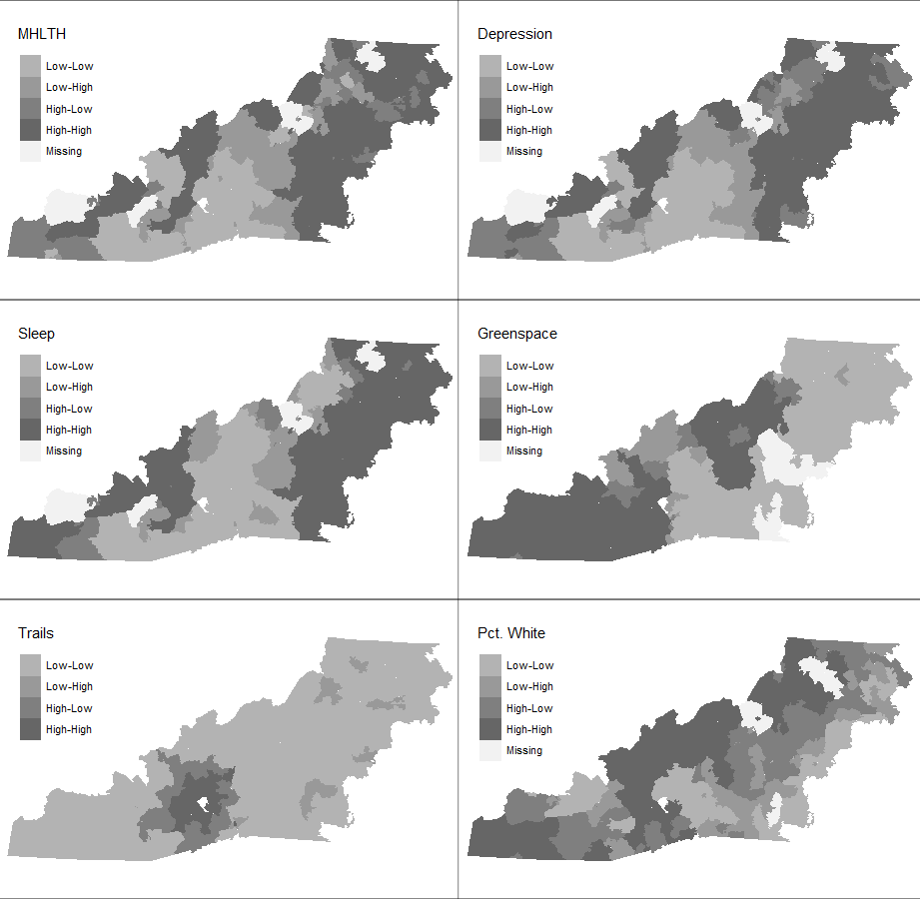

**Figure** : Results from LISA highlighting general trend from hot (high-high) to cold(low-low) clustering of each variable. Note that not all locations have a p-value < 0.05 and that this figure is meant as a visual aid

# RESULTS

## General Mental Health

Spatial regression analysis found that none of the greenspace metrics were associated with reductions in reported poor mental health (Table ). Percent of the ZIP Code that is White () and percent of households in the ZIP Code making over $125,000 () were significantly associated with reductions in mental health outcomes (Table ).

## Warning: The `x` argument of `as_tibble.matrix()` must have unique column names if `.name_repair` is omitted as of tibble 2.0.0.  
## Using compatibility `.name_repair`.  
## This warning is displayed once every 8 hours.  
## Call `lifecycle::last_lifecycle_warnings()` to see where this warning was generated.

**Table** : Spatial lag regression coefficients for each mental health outcome

| c("(Intercept)", "Mean NDVI", "Greenspace Area", "Percent White", | MHLTH | DEPRESSION | SLEEP |
| --- | --- | --- | --- |
| (Intercept) | 10.15 (1.73) *** | 9.58 (2.12) *** | 14.45 (2.19) *** |
| Mean NDVI | 0.87 (2.53) | 1.69 (2.21) | -1.38 (2.60) |
| Greenspace Area | 0.29 (0.32) | 0.21 (0.28) | 0.74 (0.33) * |
| Percent White | -4.48 (1.11) *** | -0.57 (0.97) | -6.98 (1.15) *** |
| Income | -4.64 (1.16) *** | -2.92 (1.01) ** | -5.71 (1.19) *** |
| Amenities | -0.00 (0.01) | -0.00 (0.01) | -0.02 (0.01) * |
| Trails | -0.18 (0.56) | -0.26 (0.49) | -0.28 (0.58) |
| rho | 0.59 (0.08) *** | 0.62 (0.08) *** | 0.78 (0.05) *** |
| Num. obs. | 151 | 151 | 151 |
| Parameters | 9 | 9 | 9 |
| Log Likelihood | -263.91 | -244.48 | -274.50 |
| AIC (Linear model) | 584.95 | 550.63 | 670.83 |
| AIC (Spatial model) | 545.82 | 506.96 | 567.00 |
| LR test: statistic | 41.13 | 45.67 | 105.82 |
| LR test: p-value | 0.00 | 0.00 | 0.00 |

## Depression

Greenspace metrics are not significantly associated with depression (Table ). Percent of the ZIP Code that is White was also not associated with changes in depression diagnoses. Percent of households making over $125,000 per year was significantly associated with reductions in depression diagnoses () (Table ).

## Poor Sleep

Spatial regression found poor sleep to be significantly associated with greenspace metrics (Table ). Greenspace quantity () was significantly associated with an increase in reported poor sleep, while greenspace amenities () were significant;y associated with a decrease in reported poor sleep. Percent White () and percent of households making over $125,000 () were both significantly associated with reductions in reported poor sleep outcomes (Table ).

## Local Indicators of Spatial Autocorrelation (LISA)

LISA analysis identified spatially explicit locations of mental health, greenspace and sociodemographic clustering (Figure ). All mental health outcomes illustrate similar clustering patterns, with high-high clustering found in the northern, eastern, and southwestern parts of the region. Low-low mental health clustering for all outcomes occurred in the central and southern part of the region. Greenspace clustering varied depending on the metric, with high-high trail length clustering in the southern part of the region, while greenspace quantity clustered in the southwest and northern parts of the region. NDVI clustered along the western edge of the region, and amenities, which clustered throughout the region. Race and income metrics (percent White and percent households with annual income over $125,000) have high-high clustering dispersed throughout the region (Figure ).

# DISCUSSION

The greenspace mental health relationship varied with health outcomes in Western North Carolina. Contrary to prior research in more urban areas (e.g., Houlden et al., 2019; Wang et al., 2021), this analysis did not find greenspace quantity to have a significant protective effect on any of the mental health outcomes. Greenspace quality was associated with reduced counts of poor reported sleep. While not statistically significant, LISA cluster analysis illustrated that mental health outcomes clustered together spatially, suggesting additional contextual predictors, such as race and income, may influence mental health outcomes in this region.

Greenspace quality, specifically when measured as greenspace amenities, did have a small protective effect on poor sleep. Poor sleep is a precursor for additional poor mental health outcomes (Freeman et al., 2017; Baglioni et al., 2016). As such, mental health outcomes not included in this analysis may also be related to greenspace quality metrics in Western North Carolina. However, greenspace quantity was significantly associated with increased reports of poor sleep. Research on the greenspace-sleep relationship is still evolving, with most studies finding neighborhood greenspace benefits sleep (Shin et al., 2020; Johnson et al., 2018; Xie et al., 2020). However, other studies have found there is no positive relationship between greenspace and sleep (Feng et al., 2020; Chum et al., 2015). Additionally, the type of greenspace, specifically tree canopy compared to grassland, may influence the greenspace-sleep relationship (Astell-Burt and Feng, 2020), in conjunction with sociodemographic factors (Xie et al., 2020). Additional sociodemographic factors not considered in this analysis (e.g. employment, education) may influence the greenspace-sleep relationship. This analysis suggests the greenspace-sleep relationship is complex and may vary depending on the setting.

Greenspace did not have significant protective effects for depression diagnoses or reported poor mental health. This finding contrasts a growing body of literature linking greenspace to better mental health outcomes (Beyer et al., 2014; Feng & Astell-Burt, 2017; Houlden et al., 2019; Wheeler et al., 2015; Zhang et al., 2017). As with poor sleep, there may be additional contextual factors, including rurality and sociodemographic characteristics, that are moderating this relationship.

Across all health outcomes considered, demographic and socioeconomic factors were found to be better predictors of all mental health outcomes. For both poor mental health and sleep, race (percent White) was significantly associated with reductions in health outcomes. These results suggest that ZIP Codes with higher percentages of White individuals have fewer individuals reporting poor mental health and poor sleep. Income was significantly associated with reductions in poor mental health, poor sleep, and depression diagnoses. This result suggests that ZIP Codes with greater percentages of high-income households have fewer reported poor mental health outcomes, poor sleep, and depression diagnoses. These findings support literature that demographic and socioeconomic variables are driving influences of reported and diagnosed mental health outcomes (Gresenz et al., 2001; Reiss, 2013; Howell and McFeeters, 2008).

## Implications

This analysis illustrates the complexity of the greenspace-mental health relationship in rural, mountainous areas. Findings suggest that sociodemographic variables are more predictive of poor mental health outcomes than public greenspaces. LISA analysis highlights trends of spatially explicit locations with high mental health clustering that may need more targeted mental health interventions. These findings can be applied to public health policy and land management.

## Strengths and Limitations

This article is strengthened by the greenspace metrics considered and the datasets utilized. This analysis considered multiple metrics of greenspace, allowing for deeper analysis into the greenspace mental health relationship. The inclusion of greenspace quality metrics strengthens this analysis as it illustrates the complexity of the greenspace mental health relationship. An additional strength of this analysis is that all data used is publically available, allowing for replicability.

Several limitations to this study exist; this analysis was conducted regionally and therefore the results may not be directly applicable outside of the study area. Additional research is needed at larger scales and across wider geographic regions to better understand the greenspace mental health relationship in rural, mountainous regions. The use of publicly-sourced data (OpenStreetMap) may also lead to observation biases in urban areas — amenities in rural areas are less likely to be reported and present within OSM datasets. In general, this paper highlights the need for a consistent and unified system for categorizing and qualifying public greenspaces in terms of their quality. Additionally, datasets were collected at different time points, therefore temporal mismatch may occur.

# CONCLUSIONS

This study considered the greenspace mental health relationship in Western North Carolina, a predominantly rural, mountainous region. Results suggest that the quantity of public greenspace is not significantly associated with reductions in poor mental health outcomes in this region. However, this analysis did find that greenspace quality, measured as greenspace amenities, benefits sleep. Across all mental health outcomes, sociodemographic factors (race and income) significantly predicted mental health. This analysis suggests that in Western North Carolina, demographic and socioeconomic factors are more predictive of poor mental health outcomes than the quantity or quality of public greenspaces.

# REFERENCES

Alcock, I. et al. 2015. What accounts for ‘England’s green and pleasant land’? A panel data analysis of mental health and land cover types in rural England. *Landscape and Urban Planning* 142: 38–46. <https://doi.org/10.1016/j.landurbplan.2015.05.008>.

Collins, R. et al. 2020. *A systematic map of research exploring the effect of greenspace on mental health*. 11 May 2020. Available at <https://eprints.soton.ac.uk/440876/> [Last accessed 24 September 2021].

Ekkel, E.D., and de Vries, S. 2017. Nearby green space and human health: Evaluating accessibility metrics. *Landscape and Urban Planning* 157: 214–220. <https://doi.org/10.1016/j.landurbplan.2016.06.008>.

Jiang, W., Stickley, A., and Ueda, M. 2021. Green space and suicide mortality in Japan: An ecological study. *Social Science & Medicine* 282: 114137. <https://doi.org/10.1016/j.socscimed.2021.114137>.

Lachowycz, K., and Jones, A. 2013. Towards a better understanding of the relationship between greenspace and health: Development of a theoretical framework. *Landscape and Urban Planning* 118: 62–69. <https://doi.org/10.1016/j.landurbplan.2012.10.012>.

MAHEC n.d. *Rural Health Disparities in Western North Carolina*. Available at <https://mahec.net/innovation-and-research/research/rural-health-initiative/wnc-health-disparities> [Last accessed 10 June 2022].

McCall-Hosenfeld, J.S., Mukherjee, S., and Lehman, E.B. 2014. The Prevalence and Correlates of Lifetime Psychiatric Disorders and Trauma Exposures in Urban and Rural Settings: Results from the National Comorbidity Survey Replication (NCS-R). *PLOS ONE* 9 (11): e112416. <https://doi.org/10.1371/journal.pone.0112416>.

Mears, M., and Brindley, P. 2019. Measuring Urban Greenspace Distribution Equity: The Importance of Appropriate Methodological Approaches. *ISPRS International Journal of Geo-Information* 8 (6, 6): 286. <https://doi.org/10.3390/ijgi8060286>.

Nutsford, D., Pearson, A., and Kingham, S. 2013. An ecological study investigating the association between access to urban green space and mental health. *Public health* 127. <https://doi.org/10.1016/j.puhe.2013.08.016>.

Sarkar, C., Webster, C., and Gallacher, J. 2018. Residential greenness and prevalence of major depressive disorders: A cross-sectional, observational, associational study of 94879 adult UK Biobank participants. *The Lancet. Planetary Health* 2 (4): e162–e173. <https://doi.org/10.1016/S2542-5196(18)30051-2>.

van Dillen, S.M.E., de Vries, S., Groenewegen, P.P., and Spreeuwenberg, P. 2012. Greenspace in urban neighbourhoods and residents’ health: Adding quality to quantity. *Journal of Epidemiology and Community Health* 66 (6): e8. <https://doi.org/10.1136/jech.2009.104695>.

Verheij, R.A., Maas, J., and Groenewegen, P.P. 2008. Urbanrural health differences and the availability of green space. *European Urban and Regional Studies* 15 (4): 307–316. <https://doi.org/10.1177/0969776408095107>.

Wang, R., Feng, Z., Pearce, J., Liu, Y., and Dong, G. 2021. Are greenspace quantity and quality associated with mental health through different mechanisms in Guangzhou, China: A comparison study using street view data. *Environmental Pollution* 290: 117976. <https://doi.org/10.1016/j.envpol.2021.117976>.

Wheeler, B.W. et al. 2015. Beyond greenspace: An ecological study of population general health and indicators of natural environment type and quality. *International Journal of Health Geographics* 14 (1): 17. <https://doi.org/10.1186/s12942-015-0009-5>.

Wood, L., Hooper, P., Foster, S., and Bull, F. 2017. Public green spaces and positive mental health - investigating the relationship between access, quantity and types of parks and mental wellbeing. *Health & Place* 48: 63–71. <https://doi.org/10.1016/j.healthplace.2017.09.002>.