R Module 3 Rubric

# Questions

1. Within your data/ folder, open the file NC_Counties.prj with a program like Notepad or Notepad++.
   * What kind of information does this file contain?
   * Why is it important to include these “auxiliary” files?
   * What would happen if you forgot to include the .prj file?

*This file contains projection metadata for the shapefile, such as datum, GCS, and units.* *These files are important to include as they provide the necessary information to display and project the data.* *Without this file, the system wouldn’t know the projection system, so you wouldn’t be able to do spatial analysis.*

1. For the US_States layer, the fill argument stands on its own, while for NC_Counties, it’s inside the aes() function. Why is this the case – what’s the difference between these two layers?

*In the case of US_States, we want to assign a single “background color”, so we set the fill argument directly. However, with NC_Counties, we wish to “map” the values in population to the fill aesthetic, so we need to include it within the aes() call.*

1. What’s the purpose of the coord_sf() function? Use ?coord_sf() to view documentation and usage, and describe its arguments.

*coord_sf() allows us to set parameters when visualizing sf objects. Some arguments include: xmin and ymin, which are limits on the “bounding box” of our map; expand, which ensures the data and axes don’t overlap; crs, which sets the coordinate reference system, etc. …* *This question is meant to get students to explore the documentation, rather than just rehash what’s included in the module itself.*

1. Using ggplot2, generate a histogram of the distribution of county population. Include axis labels, a title, and your name.

## `stat_bin()` using `bins = 30`. Pick better value with `binwidth`.

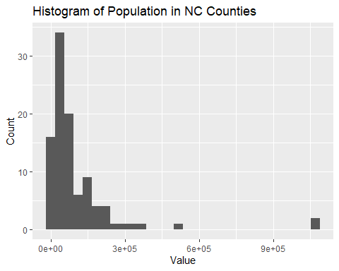

1. What type (continuous or discrete) does this distribution follow? Is the data normally distributed? If not, what kind of transformation can help “normalize” our data?
2. With a shapefile of your own (using ArcGIS, the tigris or tidycensus packages, or other), create a choropleth map using 5 classes, including a title and a legend. Create a map for both *quantile* and *equal-interval* classification, and briefly describe the difference in distribution between your two maps.

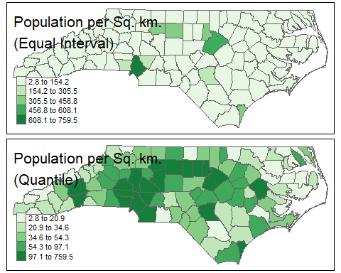

1. Repeat Question 6, using a different choice of classes.

*Same basic maps as above, but with a different number of classes. Students should make 4 maps in total.*