# R Module 1 Rubric

This R module is pretty simple; there aren’t that many difficult questions. Students should mostly just be able to load and run R Studio.

# Load data  
library(MASS)  
  
head(painters)

## Composition Drawing Colour Expression School  
## Da Udine 10 8 16 3 A  
## Da Vinci 15 16 4 14 A  
## Del Piombo 8 13 16 7 A  
## Del Sarto 12 16 9 8 A  
## Fr. Penni 0 15 8 0 A  
## Guilio Romano 15 16 4 14 A

Question 1:

hist(painters$Composition)

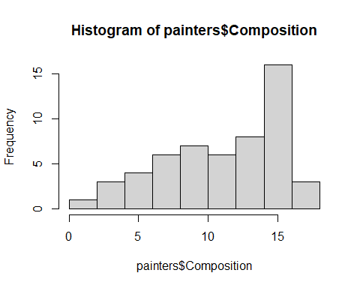

Question 2:

barplot(table(painters$Expression))

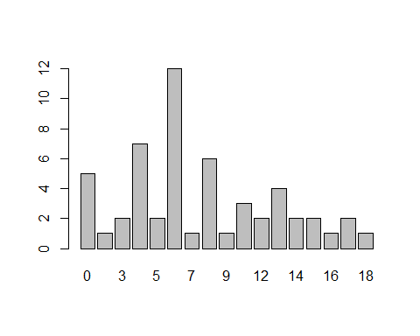

Question 3:

pie(table(painters$School))

