File Management and Mapping Spatial Data

# File Management

When we work with real-life data, it’s important to know how to both read data from our computer and write data from R Studio as a file. File management is an essential part of any workflow, especially as the scope and scale of analyses increases. Sometimes each file can be quite large – often several dozen or hundred megabytes or more – so it’s important to analyze data in a modular fashion (our computers have limited memory, disk space, processing power, and speed, after all). Fortunately, many tools exists within R and R Studio to make these tasks easier. In this R Module, you’ll learn some skills and R Packages that are frequently used to import and export data from your R environment.

Let’s go ahead and initialize a new R Project (File > New Project...) and call it *R Module 3*.

## Importing and Exporting Data

Working in future R Modules, classes, and projects, you’ll need to be able to load, save, and share data. Fortunately, there are tools to load this data for almost any data type, from .CSVs to Shapefiles, raster images, and many more. We’ll go over a couple of the most useful tools and packages used in data management to work with files in R.

In this lab, you’ll use a folder called data, which contains a file called mtcars.csv. When working within R, it’s important to know how to access files and folders. When you create a project, the folder you set it up within is designated as your **working directory**, which is a way of easily accessing files for your project without writing the file’s full path. For example, instead of accessing the file with C:/Users/brownhr/Documents/R Module 3/data/example.file, if you’re in the working directory “R Module 3” (which can be checked with getwd()), you can simply type data/example.file.

**N.B.** within R, it is very important to distinguish between / and \; \ is called an “escape character” and is used in more advanced text entry such as Regex. If you want to enter a file path, use either C:/Example/File/path or C:\\Example\\File\\path; adding two backslashes is necessary in this case.

## **readr**

The readr package provides some excellent functionality reading and writing data from and to files; while many of its functions exist in base R, readr is markedly faster, and provides more functionality for importing different types of data in a “tidy” manner (“tidy” is a programming concept in R that we’ll get to later). For more information about readr, visit <https://readr.tidyverse.org>

readr comes with functions that allow for easy manipulation of primarily table-based data, such as .csv and .tsv files, allowing us to work with data that we make in Excel or Google Sheets. Especially when working with large files, or large numbers of files, readr makes importing and exporting data easy, and is much faster at reading and writing than the base R functions.

# Mapping with sf

Simple Features for R, or sf, is an R package that allows for much easier geospatial analysis than older packages like rgdal. sf works with “simple features” – vector objects in GIS like points, lines, polygons, etc. – and stores their “geometry” – their list of coordinates – as a column in a data frame. This allows for geospatial data to be processed in exactly the same way as non-spatial data; you can run functions and analyses on the attribute table of a shapefile without needing to convert or export to any intermediate formats, for example.

sf can work with Shapefiles and other vector formats made by ArcGIS Pro, QGIS, etc., so if you have a shapefile, you can import it into R with read_sf(), perform your analysis, and export any sort of spatial result with write_sf().

Even better, there’s compatibility with ggplot2! Suppose we have two Shapefiles that we wish to map: NC_Counties and US_States. Combining them is easy in ggplot2:

# Load sf and the tidyverse, which contains packages like ggplot2 and dplyr  
  
library(tidyverse)  
library(sf)  
  
  
# Read in the shapefiles with sf  
  
US_States <- read_sf("data/US_States.shp")  
NC_Counties <- read_sf("data/NC_Counties.shp")  
  
  
# We can create a 'blank' ggplot object and define the data and mappings  
# separately, which is useful if we have more than one input file or want to  
# display more than one dataset.  
  
ggplot() +  
 geom_sf(data = US_States, fill = "white") +  
 geom_sf(data = NC_Counties, aes(fill = Population), color = NA) +  
 coord_sf(xlim = c(-86, -74), ylim = c(32, 38)) +  
 theme_bw() +  
 labs(title = "Population per County for North Carolina")

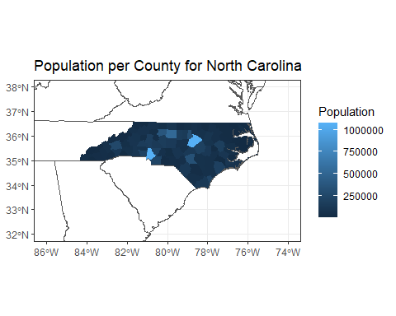

Looks good so far! You’ll make a few maps of your own later in the Module, so feel free to read more about how geom_sf() and the other ggplot2 and sf functions work.

Read more about sf by going to <https://r-spatial.github.io/sf/>

**Create a new R Project, “R Module 3”, to include your code, scripts, etc. Answer the following questions, and include them in your final document:**

1. Within your data/ folder, open the file NC_Counties.prj with a program like Notepad or Notepad++.
   * What kind of information does this file contain?
   * Why is it important to include these “auxiliary” files?
   * What would happen if you forgot to include the .prj file?
2. For the US_States layer, the fill argument stands on its own, while for NC_Counties, it’s inside the aes() function. Why is this the case – what’s the difference between these two layers?
3. What’s the purpose of the coord_sf() function? Use ?coord_sf() to view documentation and usage, and describe its arguments.

## Choropleth Mapping

Choropleth maps are a type of thematic map that is used to display distinct geographic regions, such as states, counties, or countries. The colors used in choropleth mapping are **classified**; rather than a continuous range, the values are grouped into different classes, so that similar values share a color.

The tmap package is very useful for choropleth mapping, and offers a lot of functionality for customizing maps.

library(tidyverse)  
library(sf)  
library(tmap)  
  
# This function reprojects our shapefile into a different coordinate reference  
# system (CRS), and is useful when performing GIS-related tasks. In this case,  
# it's just to make the map look a little nicer.  
data <- US_States %>%  
 st_transform(crs = st_crs("ESRI:102004"))  
  
tm_shape(data) +  
 tm_polygons(  
 # We're setting the color (col) mapping to the column "Population". Notice  
 # that you have to quote the variable name here, which is different than in  
 # ggplot2.  
 col = "Population",  
   
 # You can use RColorBrewer::brewer.pal.info to view many different kinds of  
 # color palettes available in R.  
 palette = "Blues",  
   
 # This argument is used to normalize; i.e. convert from population to  
 # population density. It's better to do this as a separate step in your  
 # data, but can be done here for quick mapping purposes.  
 convert2density = TRUE,  
   
 # This sets the number of classes in our data.  
 n = 6,  
   
 # What method to use to create the classes. Note that some options might  
 # overwrite your choice of n, so pay attention to how many classes your map  
 # actually has!  
 style = "quantile",  
 ) +  
 tm_layout(  
 title = "Population per Sq. km.", title.position = c("center", "top"),  
 legend.title.color = NA  
 )

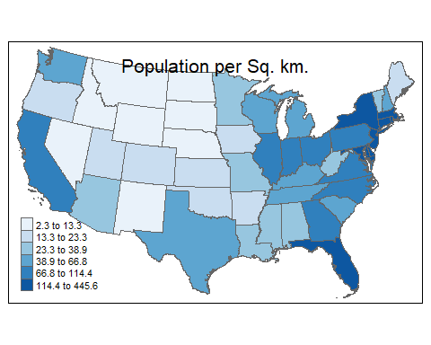

# Probability and Distributions

## Discrete Distributions

Discrete probability distributions count occurrences that have countable or finite outcomes, such as the population of states within the U.S., days of rainfall, or average number of pets in households.

### Uniform

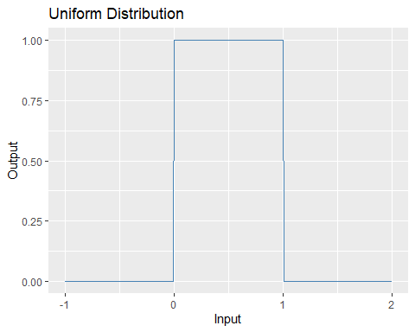

### Binomial

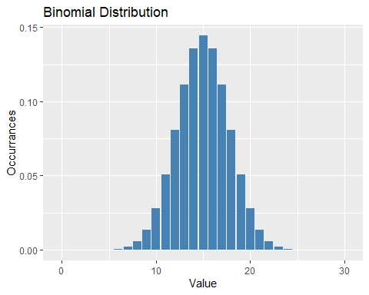

### Poisson Distribution

A Poisson distribution refers to a kind of discrete distribution that shows the probability of a given number of events $k$ occurring, given the parameter lambda, $λ$. $λ$ can be thought of as the “average number of events”; for example, if the average number of goals in a World Cup match is 2.5, then $λ=2.5$. Mathematically, the Poisson distribution is modeled by:

$$p\left(k;λ\right)=\frac{e^{−λ}λ^{k}}{k!},$$

where $k$ is the given number of events that we want to calculate the probability for. For example, if we want to find the probability of 5 goals being scored in a World Cup game, we can calculate the following in R:

p <- dpois(x = 5, lambda = 2.5)  
  
print(p)

## [1] 0.06680094

So, $≈6.68\%$ of the time, 5 goals will be scored. The functions dpois(), ppois(), qpois(), and rpois() are used to calculate the Poisson distribution.

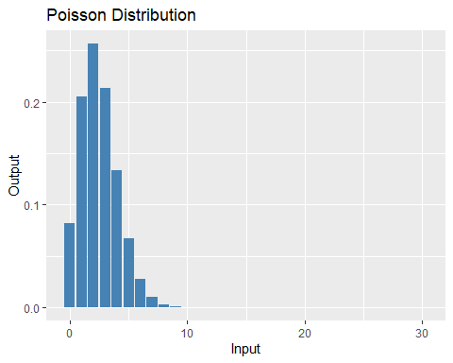

Poisson Distribution with $λ$ = 2.5

## Continuous Distributions

Continuous distributions differ from discrete distributions in that outcomes can lie on a continuous range of values, for example, average daily temperature, atmospheric pressure, or height of buildings.

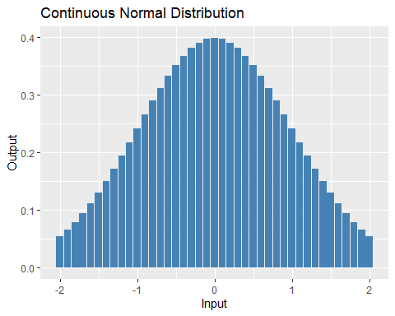

# Assignment

**In addition to questions 1-3 above, answer the following. Write up your responses, and submit your document to Google Classroom:**

1. Using ggplot2, generate a histogram of the distribution of county population. Include axis labels, a title, and your name.
2. What type (continuous or discrete) does this distribution follow? Is the data normally distributed? If not, what kind of transformation can help “normalize” our data?
3. With a shapefile of your own (using ArcGIS, the tigris or tidycensus packages, or other), create a choropleth map using 5 classes, including a title and a legend. Create a map for both *quantile* and *equal-interval* classification, and briefly describe the difference in distribution between your two maps.
4. Repeat Question 6, using a different choice of classes.