## Setup

library(sf)

## Linking to GEOS 3.9.1, GDAL 3.2.1, PROJ 7.2.1; sf_use_s2() is TRUE

library(tidyverse)

## -- Attaching packages --------------------------------------- tidyverse 1.3.1 --

## v ggplot2 3.3.5 v purrr 0.3.4  
## v tibble 3.1.6 v dplyr 1.0.8  
## v tidyr 1.2.0 v stringr 1.4.0  
## v readr 2.1.2 v forcats 0.5.1

## -- Conflicts ------------------------------------------ tidyverse_conflicts() --  
## x dplyr::filter() masks stats::filter()  
## x dplyr::lag() masks stats::lag()

library(spdep)

## Loading required package: sp

## Loading required package: spData

## To access larger datasets in this package, install the spDataLarge  
## package with: `install.packages('spDataLarge',  
## repos='https://nowosad.github.io/drat/', type='source')`

library(tmap)  
library(broom)  
  
library(spatialreg)

## Loading required package: Matrix

##   
## Attaching package: 'Matrix'

## The following objects are masked from 'package:tidyr':  
##   
## expand, pack, unpack

##   
## Attaching package: 'spatialreg'

## The following objects are masked from 'package:spdep':  
##   
## get.ClusterOption, get.coresOption, get.mcOption,  
## get.VerboseOption, get.ZeroPolicyOption, set.ClusterOption,  
## set.coresOption, set.mcOption, set.VerboseOption,  
## set.ZeroPolicyOption

election <- read_sf("export/2004_Election_Counties.shp") %>%   
 st_transform(crs = st_crs("EPSG:2163"))  
  
centroids <- st_centroid(election)$geometry  
  
election_neighbors <- election %>%   
 poly2nb()  
  
election_weighted <- election_neighbors %>%   
 nb2listw(  
 style = "W",  
 zero.policy = TRUE  
 )

## Question 1:

Use lm() to estimate Bush_pct ~ pcincome using ordinary least squares (OLS). Plot the **residuals** on a map (look back to R Module 7) and **test the residuals for spatial autocorrelation**. Provide both an example of your map and the results from your spatial autocorrelation test in your R Markdown report.

lm <- lm(Bush_pct ~ pcincome, data = election,)  
summary(lm)

##   
## Call:  
## lm(formula = Bush_pct ~ pcincome, data = election)  
##   
## Residuals:  
## Min 1Q Median 3Q Max   
## -63.434 -7.927 0.479 8.755 31.904   
##   
## Coefficients:  
## Estimate Std. Error t value Pr(>|t|)   
## (Intercept) 6.343e+01 8.893e-01 71.329 < 2e-16 ***  
## pcincome -1.592e-04 4.832e-05 -3.294 0.000997 ***  
## ---  
## Signif. codes: 0 '***' 0.001 '**' 0.01 '*' 0.05 '.' 0.1 ' ' 1  
##   
## Residual standard error: 12.74 on 3109 degrees of freedom  
## Multiple R-squared: 0.003479, Adjusted R-squared: 0.003158   
## F-statistic: 10.85 on 1 and 3109 DF, p-value: 0.0009974

election$residuals <- lm$residuals  
  
tm_shape(election) +   
 tm_polygons(col = "residuals",  
 border.col = NULL,  
 style = "cont")

## Variable(s) "residuals" contains positive and negative values, so midpoint is set to 0. Set midpoint = NA to show the full spectrum of the color palette.

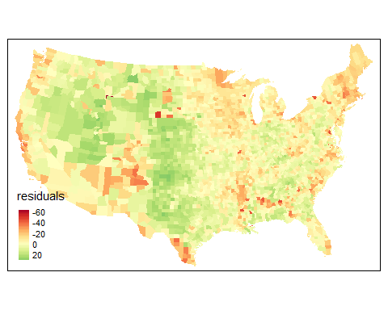

moran_residuals <-   
 moran.test(  
 x = election$residuals,  
 listw = election_weighted,  
 zero.policy = TRUE,  
 alternative = "two.sided"  
 )  
  
moran_residuals

##   
## Moran I test under randomisation  
##   
## data: election$residuals   
## weights: election_weighted n reduced by no-neighbour observations  
##   
##   
## Moran I statistic standard deviate = 51.138, p-value < 2.2e-16  
## alternative hypothesis: two.sided  
## sample estimates:  
## Moran I statistic Expectation Variance   
## 0.5501302998 -0.0003219575 0.0001158637

## Question 2:

Modeling Kerry_pct ~ pcincome, perform the following steps: - Evaluate the relationship between the variables using lm() - Plot the resulting residuals, then test for autocorrelation with moran.test(). Provide your map!

kerry_lm <- lm(Kerry_pct ~ pcincome, data = election)  
  
election$kerry_lm_res <- kerry_lm$residuals  
  
tm_shape(election) +   
 tm_polygons(col = "kerry_lm_res",  
 border.col = NULL,  
 palette = "RdBu",  
 style = "cont",  
 midpoint = 0,  
 title = "Residuals")

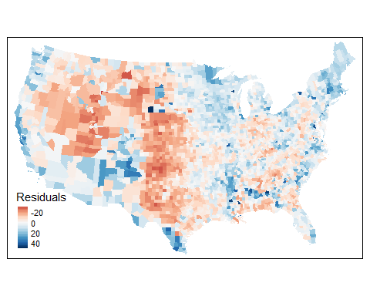

kerry_moran <- moran.test(  
 election$kerry_lm_res,  
 listw = election_weighted,  
 zero.policy = TRUE,  
 alternative = "two.sided"  
)  
kerry_moran

##   
## Moran I test under randomisation  
##   
## data: election$kerry_lm_res   
## weights: election_weighted n reduced by no-neighbour observations  
##   
##   
## Moran I statistic standard deviate = 51.382, p-value < 2.2e-16  
## alternative hypothesis: two.sided  
## sample estimates:  
## Moran I statistic Expectation Variance   
## 0.5527928269 -0.0003219575 0.0001158778

* Estimate the same relationship, using the spatial lag model (spatialreg::lagsarlm())

library(spatialreg)  
kerry_lag <- lagsarlm(  
 Kerry_pct ~ pcincome,  
 data = election,  
 listw = election_weighted,  
 zero.policy = TRUE  
)  
  
tidy(kerry_lag)

* Perform a Moran’s I test on the residuals from the lag model and report your results. Plot the residuals from the spatial lag model, and include in your report.

election$kerry_lag_res <- kerry_lag$residuals  
  
tm_shape(election) +   
 tm_polygons(col = "kerry_lag_res",  
 border.col = NULL,  
 palette = "RdBu",  
 style = "cont",  
 midpoint = 0,  
 title = "Residuals")

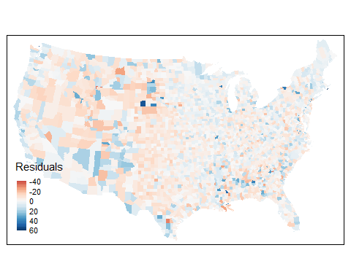

kerry_lag_moran <- moran.test(  
 election$kerry_lag_res,  
 election_weighted,,  
 zero.policy = TRUE,  
 alternative = 'two.sided'  
)  
kerry_lag_moran

##   
## Moran I test under randomisation  
##   
## data: election$kerry_lag_res   
## weights: election_weighted n reduced by no-neighbour observations  
##   
##   
## Moran I statistic standard deviate = -3.3346, p-value = 0.0008542  
## alternative hypothesis: two.sided  
## sample estimates:  
## Moran I statistic Expectation Variance   
## -0.0361970075 -0.0003219575 0.0001157424

* Is there evidence of remaining spatial autocorrelation in the residuals?

*No, as the value of I from the moran.test is close to 0, there is little remaining spatial autocorrelation.*