#R Module 2: Working with R Scripts and Projects

This R Module is intended to introduce summary statistics, measures of central tendency, and measures of dispersion. In terms of R concepts, it will teach students about how to work with files in the working directory, create and use scripts (rather than type all the code in the console!) and organize their R Modules into an R Project (.rproj).

# Load in the data  
library(datasets)  
tree_data <- trees

1. Create your own histogram of the tree_data dataset with ggplot2, showing:
   * Distribution of the Height variable,
   * 20 bins,
   * A color of your choosing,
   * Labels (title and x-axis) that reflect the change in variable

library(ggplot2)  
ggplot(  
 data = tree_data,  
 aes(x = Height)  
) +  
 geom_histogram(bins = 20, fill = "brown3") +  
 labs(  
 x = "Height",  
 y = "Frequency",  
 title = "Histogram of Tree Height"  
 )

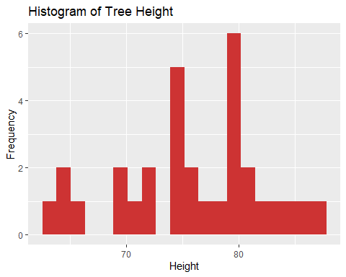

Question 2:

Visualize and Explore the mtcars dataset: 1. Create a new script called mtcars.R 2. Assign mtcars to an object (e.g., “cars”) using the <- operator 3. Choose 3 variables from mtcars and for each: - Record the Mean, Median, and Mode - Create a histogram in ggplot2, with appropriate labels, title, etc.

# The code for this one should include their mtcars.R script as well  
  
cars <- mtcars  
  
# They should have three of the following, for each of the variables they choose:  
mean(mtcars$mpg)

## [1] 20.09062

median(mtcars$mpg)

## [1] 19.2

# Any way they want to find the mode is fine. Oddly, base R doesn't have a function to find the mode.  
find_mode <- function(x) {  
 unique_data <- unique(x)  
 unique_data[which.max(tabulate(match(x, unique_data)))]  
}  
  
find_mode(mtcars$mpg)

## [1] 21

ggplot(mtcars, aes(x = mpg)) +   
 geom_histogram() +   
 labs(  
 x = "Miles per Gallon",  
 y = "Count",  
 title = "Histogram of mpg"  
 )

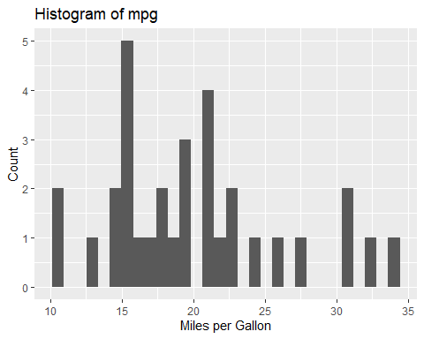

1. Choose two variables from mtcars and create a scatterplot in ggplot2 showing their relation:
   * Include title, labels, etc.
   * *Hint: Use the geom_point() function*
   * Use Google, Stack Exchange, and the built-in Help for examples on how to use these plots!

ggplot(data = mtcars, aes(x = mpg, y = hp)) +   
 geom_point() +   
 labs(x = "Miles per Gallon",  
 y = "Horsepower",  
 title = "mpg. vs. hp.")

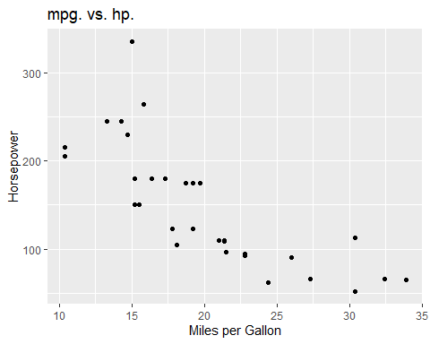

Include a screenshot of your mtcars.R script Submit all questions to Google Classroom; include Name, Question Number, and all figures