R Module 3 Rubric

# Questions

1. Within your data/ folder, open the file NC_Counties.prj with a program like Notepad or Notepad++.
   * What kind of information does this file contain?
   * Why is it important to include these “auxiliary” files?
   * What would happen if you forgot to include the .prj file?

*This file contains projection metadata for the shapefile, such as datum, GCS, and units.* *These files are important to include as they provide the necessary information to display and project the data.* *Without this file, the system wouldn’t know the projection system, so you wouldn’t be able to do spatial analysis.*

1. For the US_States layer, the fill argument stands on its own, while for NC_Counties, it’s inside the aes() function. Why is this the case – what’s the difference between these two layers?

*In the case of US_States, we want to assign a single “background color”, so we set the fill argument directly. However, with NC_Counties, we wish to “map” the values in population to the fill aesthetic, so we need to include it within the aes() call.*

1. What’s the purpose of the coord_sf() function? Use ?coord_sf() to view documentation and usage, and describe its arguments.

*coord_sf() allows us to set parameters when visualizing sf objects. Some arguments include: xmin and ymin, which are limits on the “bounding box” of our map; expand, which ensures the data and axes don’t overlap; crs, which sets the coordinate reference system, etc. …* *This question is meant to get students to explore the documentation, rather than just rehash what’s included in the module itself.*

1. Using ggplot2, generate a histogram of the distribution of county population. Include axis labels, a title, and your name.

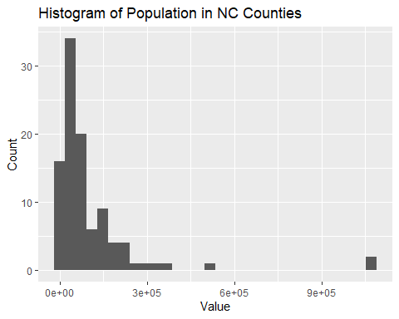

1. What type (continuous or discrete) does this distribution follow? Is the data normally distributed? If not, what kind of transformation can help “normalize” our data?
2. With a shapefile of your own (using ArcGIS, the tigris or tidycensus packages, or other), create a choropleth map using 5 classes, including a title and a legend. Create a map for both *quantile* and *equal-interval* classification, and briefly describe the difference in distribution between your two maps.

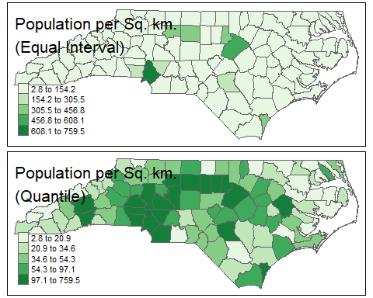

1. Repeat Question 6, using a different choice of classes.

*Same basic maps as above, but with a different number of classes. Students should make 4 maps in total.*