

Game Design Document

for a VR Escape Room

The Greenhouse Escape

31 July 2025

Kaera Barber

Confidential Disclaimer
This Game Design Document has been prepared for review by Kaera Barber. All information is confidential and proprietary and should not be shared without written permission.

Overview of the Game
Genre:
Escape Room, Exploration Puzzle Game

Inspirational References:

Real life greenhouses and botanical gardens (e.g. Lloyd’s Botanical Garden in India, Kew Royal Botanic Gardens in London, Montreal Botanical Garden in Canada)

Narrative:

You wake up inside a locked overgrown greenhouse with no memory on how you got there or how long you’ve been there. Everything around is old and worn out, yet the plants are somehow alive and thriving. With the plants overgrown blocking the clear exit, explore the greenhouse and solve puzzles to escape before you are stuck there forever.

Concept Art/VR Mockup:

VRMockup (also located in the deliverables files)

Front

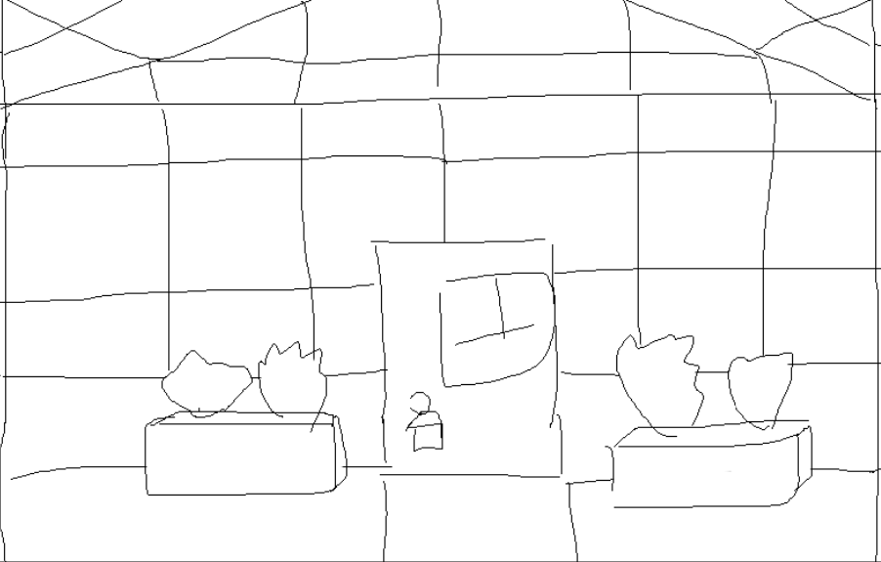

Sides

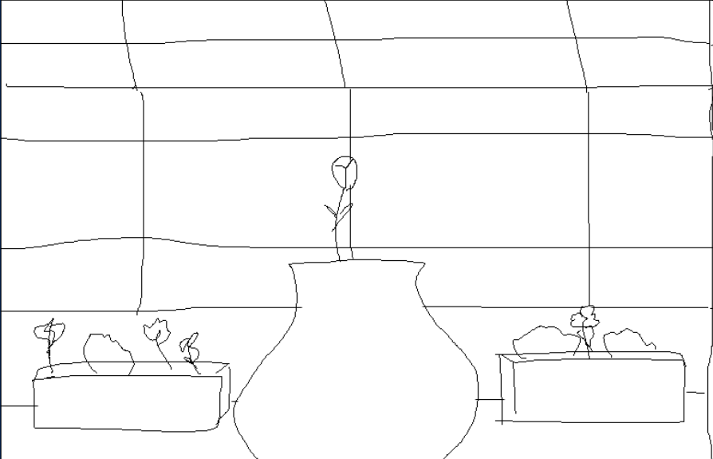

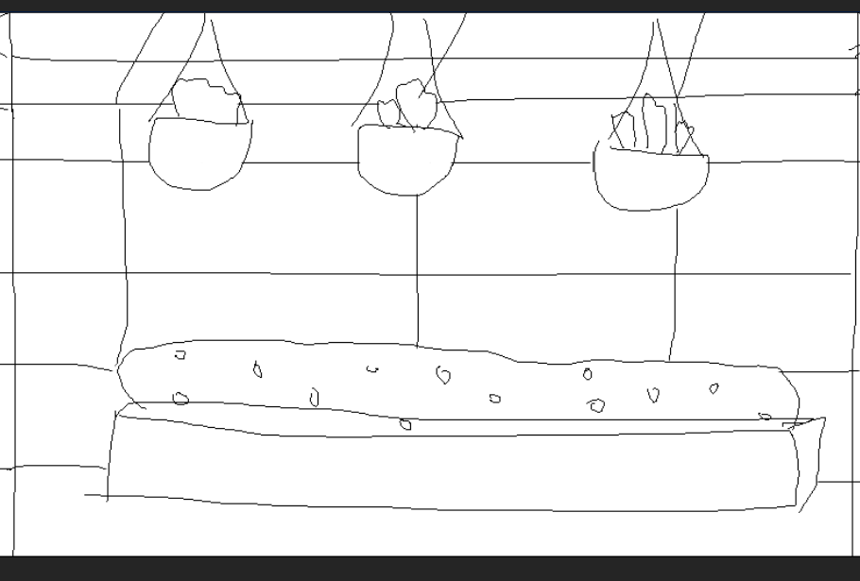

Back

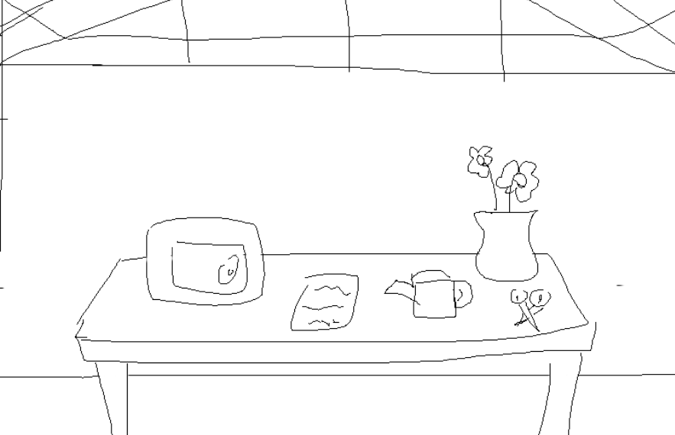
Unique Selling Points
Beginner Friendly Puzzles:

Simple puzzles like interacting with buttons and clicking on items ensuring easier and smoother gameplay for those new to VR and escape rooms.

Skill-Based Puzzles:

The game contains engaging puzzles that help develop and improve basic cognitive skills and soft skills like memory, observation and problem-solving. The player can enjoy the full game experience without extra stress.

Game loop
Steps:

- Player spawns into the greenhouse
- Player explores the greenhouse room, looking for clues
- Use VR controllers to interact with puzzles and objects that help to solve puzzles
- All 5 puzzles are solved, the exit key appears
- Player uses key to escape the room.

Locomotion Style:

Teleportation is the movement type used for the player to move around, for easier implementation and precise movement.

Details of puzzles:

- The first puzzle is to find a watering can around the greenhouse and match it to a pad on the table according to the colour of the pad, as both the pad and the can are grey in colour.

- The second puzzle is to find a pair of gardening clippers around the greenhouse and match it to a pad on the table according to the colour of the pad, as both the pad and the clippers are red in colour.

- The third puzzle is to find a fertiliser spray around the greenhouse and match it to a pad on the table according to the colour of the pad, as both the pad and the spray are blue in colour.

- Once the three puzzles are solved the objects become a clue for the next puzzle, ‘blue, red, grey’

- The fourth puzzle is to find the respective blue button, blue since you are following the colour order clue given by the last puzzles and click it to move on to the next puzzle.

- Once the blue button is clicked, the fifth puzzle is to find a red button, red since you are following the colour order clue given by the last puzzles and click it to move on to the next puzzle.

- When the fifth puzzle is done, a key will spawn on the table in front of where the pads are, this is the final key so now the player can unlock the door and leave the room, therefore finishing the game.

Flowchart:
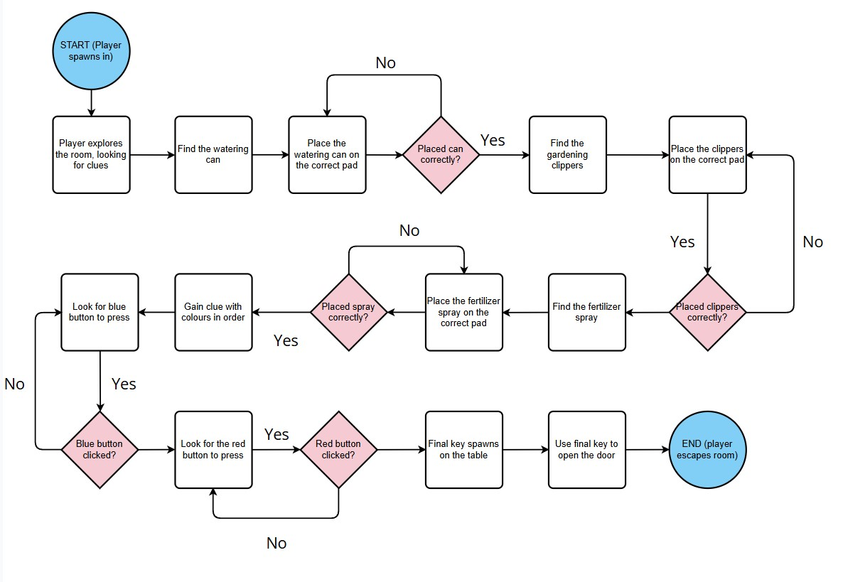

Gameplay Scope
Game Length and average playtime:

Target playtime: 15-20 minutes estimated needed for the game to be solved and completed, factoring in exploring the environment and solving the puzzles.

Environment/Levels:

One singular level with multiple puzzles inside. The level contains a single greenhouse room where the player starts in, without any extra rooms that could confuse the player, the surroundings include objects usually found in a greenhouse (e.g. overgrown plants, bushes, tools, tables or pots) with some being interactable to solve the puzzles.

Objectives:

Solve 5 simple puzzles to clear and unlock the door to complete the game. Once the puzzles are completed, a key appears that allows the player to unlock the exit door and finish the game.
Characters:

Only one character which is the player is present in the game, using VR to grab objects and complete the puzzles, meaning there are no interactable NPCs(Non playable Characters) allowing the game to stay simple and easy to finish. No customisation is needed for a more straight forward, simple and accessible experience.

Art Style
The art style should give an overall slightly eerie feeling, as the narrative of the game is being trapped in an abandoned greenhouse. The whole game will have muted colour tones, such as faded browns, grays and faded greens, to enhance the mysterious environment around the player. The lighting would be dim and subdued to give a more heavy, foggy atmosphere, with the textures of the walls and surfaces being more worn and ‘dirty’(e.g. addition of moss, dirty walls cracked windows) to enhance the abandoned feeling. For the UI, there won’t be any menus for easier playthrough, clues can appear as notes or scribbles to guide the player to solve puzzles.

Inspiration:

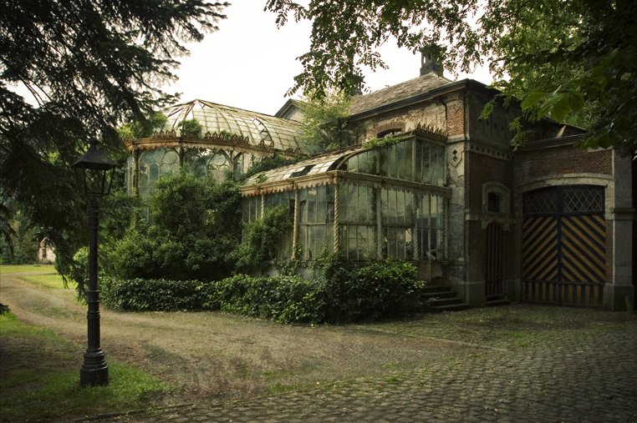
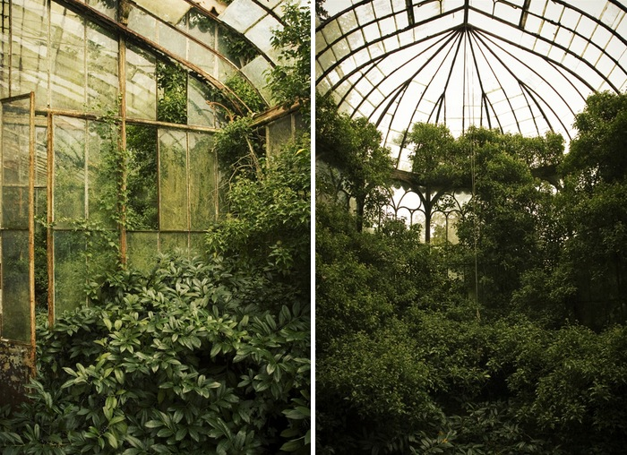
(“Chateau R Greenhouse” Link: Chateau R Greenhouse | After a long time a met up with Bartj… | Flickr)

Player Profiles Stories
Players:
Alex – New to VR and it’s mechanics, wanting to play something easy to complete while learning about VR

John – Likes solving puzzles at his own pace without having the stress of a time limit, he wants a relaxing experience.

How they approach the game:

Alex will most likely take his time to adjust to the VR environment, exploring the mechanics and movement with the headset and controllers. Through the Game Loop Alex is learning how to use the controllers, grabbing, rotating and placing objects, since the puzzles consist of these simple controls. Alex gets to learn comfortably at his own pace without the stress of complicated puzzles and being rewarded at the end with the final key once he completes all the puzzles with his newfound knowledge of VR controls.

John is already equipped with basic knowledge of VR controls, allowing him more time to explore and take in the greenhouse environment. Through the Game Loop John is able to take his time thinking about how to solve the puzzles as there is no specific time limit for completing the game, checking every possible interactive object before moving on to the next puzzle. By the time the game is completed, John has been able to thoroughly and comfortably enjoy the process of the game.
Milestone Schedule

Milestone Number | Milestone Description | Date of Delivery
1 | Completion of Game Design Document | 6 July 2025
2 | Building of scene – Greenhouse building model and teleportation pads | 12 July 2025
3 | Implementation of first 2 puzzles, including testing and bug fixing | 19 July 2025
4 | Implementation of last 2 puzzles and exit door, including testing and bug fixing | 26 July 2025
5 | Polishing the environment with sounds, ambient lighting + testing out the full game | 29 July 2025
6 | Submission of VR Escape Room Game – ‘The Greenhouse Escape’ | 31 July 2025

