SeneGAD Annual Report
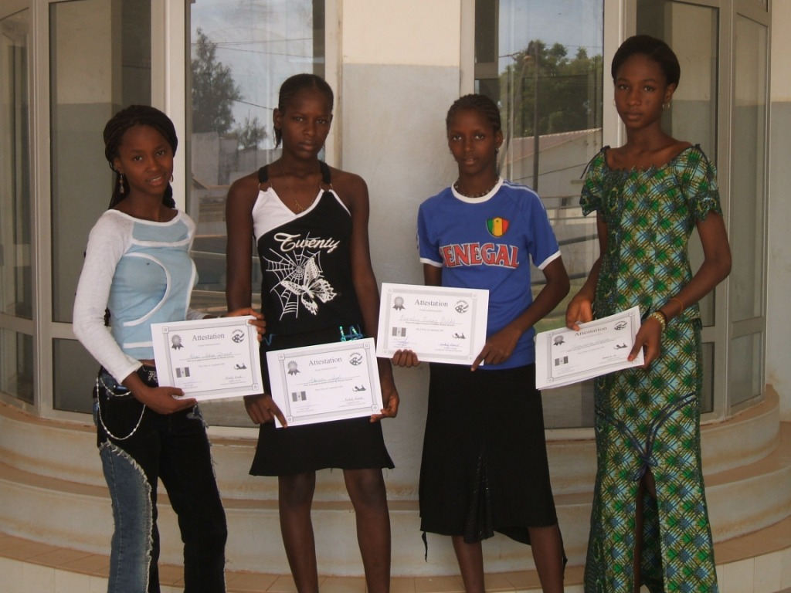
SeneGAD is a gender and development committee within Peace Corps Senegal that seeks to promote gender awareness and implements activities designed to increase women’s and girls’ participation in development progress.

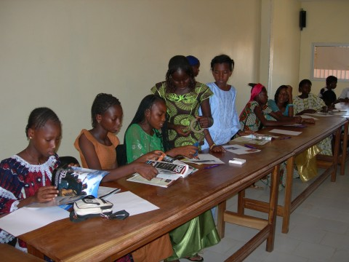
Table of Contents

Letter from SeneGAD
SeneGAD Program & Goals
which includes….
Communications
Youth Clubs
Michelle Sylvester Scholarships
Gender & Development Trainings
Fundraising
List of Board Members

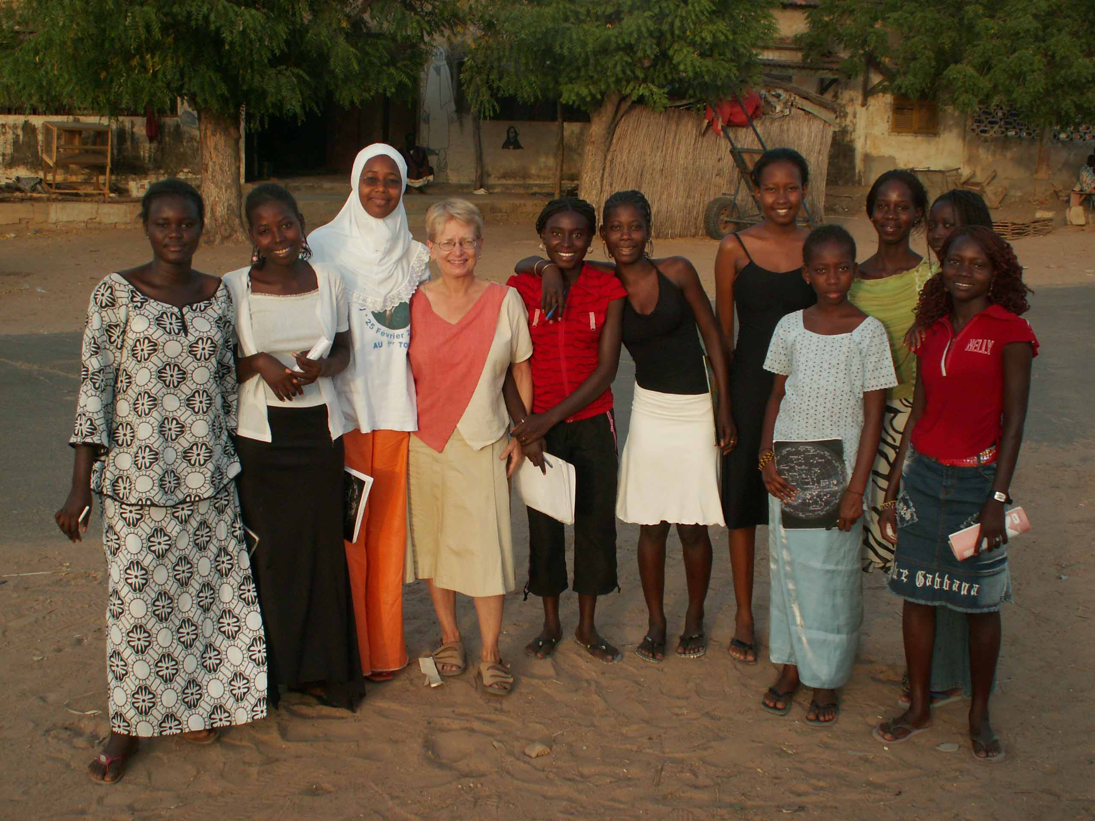
Dear Friends of SeneGAD,
Greetings to all of you!! The SeneGAD committee was started in the early 1990’s, by volunteers to help provide an outlet for volunteers to address gender equity issues that they experienced at site. The National Coordinator of SeneGAD recently reconnected with one of the founders of SeneGAD, Arlette Diop. Arlette was the Health APCD and Staff Advisor for SeneGAD when our committee first started. It was amazing to speak with her about the origins of SeneGAD; the bike tours they once organized to empower young girls, to raise awareness about the importance of girls education, and to sensibilize populations about women’s health. We also discussed the original Michele Sylvester Winners, who volunteers tracked and supported from middle school through high school. These are the types of programs and experiences that current board members always talk about in brainstorming sessions, which we would like to organize again.

Unfortunately SeneGAD has been limited in our activities in the past year due to new official Peace Corps policies. Also there hasn’t been anyone to devote large amounts of time to SeneGAD to help us overcome current constraints. Fortunately, the current National Coordinator, Kim Rusnak, will be staying on for another year, and will be spend the majority of her time trying to find new paths for SeneGAD. Volunteers are very interested in working towards raising awareness in their sites about gender equality, gender roles, empowering Senegalese women to reach their full potential, and increasing the continued enrolment of girls in elementary, middle, high school and beyond. We are excited to see where SeneGAD will grow and change, and we have many committed and motivated Peace Corps Volunteers who are very passionate about Gender and Development. We thank everyone who has supported us and contributed to our endeavours, and we are all excited about SeneGAD moving forward in the future.
The SeneGAD Team

SeneGAD Programs & Goals
The SeneGAD committee organizes two programs, Youth Clubs and Michele Sylvester Scholarship Programs, but we also act as a resource for Peace Corps Senegal Volunteers; training volunteers on gender and development, and providing them with resources and ideas on how to integrate equity and empowerment ideas into their work.
We have been limited in our activities in the past year due to official Peace Corps policies regarding scholarship programs, camps/clubs and fundraising. The new policy limits our abilities to fundraise and distribute funds. The WID/GAD Coordinator in Washington, D.C. has provided Peace Corps Senegal with the new policy which reads:
“Volunteers may participate in fundraising activities as long as they are not the primary organizer of the activity and are not the designated recipient of the funds raised. Instead, all raised funds should go directly to a local NGO or community organization, never passing through the Volunteers hands.” (As per Manual Section 721, 5.3, see http://www.peacecorpsjournals.com/manual/MS721.html)
Needless to say, we are currently in a state of limbo, because we do not, and have not yet been able to secure local partners. During this past year, the national coordinator was working as a health volunteer in the northern region of Senegal, and was not able to spend large amounts of time searching for local partners. SeneGAD is currently seeking a local NGO or community group with which we can develop a working relationship. In the past year we have continued our scholarship and youth club programs, but have not been able to expand or grow.
Because of limitations in fundraising and distribution abilities, we decided to focus on better training for volunteers about the purpose of GAD, and to offer examples of how every volunteer can integrate GAD philosophy into sector work they are already doing. As a result, we created the Training Coordinator position. This position focus’s on better training PCV’s and inspiring them to become more involved in GAD.
We also felt it was necessary to discuss and update our mission and goals, as we continue to search for local partners. The main themes that were discussed and maintained were the ideas of sustainability and encouragement of gender equality. The consensus was that SeneGAD should stress that it works through PCV’s, and also that SeneGAD seeks to facilitate change rather than implement our own gender views. The new mission and goals are as follows:

Our Mission: To empower Senegalese women, men and youth to effectively integrate gender equality into their daily lives, with the support of Peace Corps Volunteers.
Our Goals: 1. To educate and provide resources to volunteers on how to incorporate
gender and development into their work.
- To implement programs that motivate, educate, and inspire Senegalese women and girls to reach their full potential.
- To encourage sustainable change in gender perspectives through collaboration with local communities.

Also this past year, we were trying to improve the amount of resources that are in Regional Houses for volunteers. ICE is the information catalogue which has great resources for volunteers. From this catalogue, we ordered 3 books for every region; “Choose a Future” (for boys), “Choose a Future” (for girls), and “Camp Glow: Girls Leading our World.” These books are great resources that include activities for youth clubs or girl’s empowerment activities.
International Women’s Day
International Women’s Day was March 8, and during the past few years SeneGAD has not initiated anything for volunteers to do for International Women’s Day. We do not have any local partners with which to organize a large event, so instead we created a flyer that was sent out to regional representatives and volunteers with ideas of activities to be done on March 8, or throughout the month of March because it is also Women’s History Month.

Communications
Our Communications Coordinator this past year focused on updating our brochure and other publications. Since we are in the process of trying to find local partners, we felt it was important to translate our brochure into French. He also did minor updates on our website (www.freewebs.com/senegad), but we have also been discussing changing to another browser because we are not able to manipulate or be very creative with the current website. The communications coordinator also created a gmail account for all PCV’s in Senegal, where we are able to post important information pertaining to SeneGAD (meeting minutes, scholarship and youth club applications, etc.). Throughout the past year, the Communications Coordinator wrote two articles for the Sabaar, our in country volunteer newsletter.
At the February 2007 meeting we elected a new Communications Coordinator, Annie Nguyen. She is very interested in working to improve our website, create a logo for SeneGAD, and also hopefully help us to get in better contact with other GAD committees throughout West Africa. We feel that through contacting other GAD committees, it would be a good resource to share and bounce ideas off of each other.
Youth Clubs
In the past year, we’ve made the transition from girls clubs to youth clubs. During training sessions and meetings, we realized that by focusing on only girls clubs, we were limiting what we were encouraging volunteers to do. We felt it was more important to encourage activities that incorporated promoting gender awareness and equality amongst male and female populations. SeneGAD Youth Club funding has made possible numerous activities, including girls’ leadership camps, mixed-gender business courses, and strengthening women’s groups gardening projects. Our goal is to empower girls, boys, young women and men to realize their strengths, and encourage them to have self-confidence and leadership skills. Youth Club activities vary depending on location, participation, leadership and volunteer involvement.
Volunteers submit applications twice a year, in October and May. The Youth Club Coordinator will organize a selection committee who will review the applications and fund on average ten clubs throughout the year. Volunteers can request anywhere from 15000 – 50000 CFA. Below is a table of all the recipients of Youth Club funding since October 2005. In the last fiscal year (Feb ’06 to Jan ’07) we funded ten clubs.

Date Funded | Who | How much $ | Received final report
Oct 2005 | Amy Tomon | 50,000
Oct 2005 | Molly M | 50,000
Oct 2005 | Becky Bartlein | 50,000
Oct 2005 | Whitney | 50,000
Oct 2005 | Erin Wheeler | 50,000 | X
May 2006 | Erica Cummings & BJ Lockhart | 50,000
May 2006 | Megan Kaufman | 50,000 | X
May 2006 | Charles Caldi | 50,000
May 2006 | Amira Sedki | 40,000 | Returned $$
May 2006 | Arian | 50,000 | $$ was stolen

Oct 2006 | Paula Hirschoff | 50,000 | X
Oct 2006 | Erika Jerme & Jane Mitsch | 50,000
Oct 2006 | Annie Nguyen | 50,000
Oct 2006 | Kierstin Homblette & Amparo Garcia | 15,000
Oct 2006 | Kari Browning & Rachel Kercher | 15,000 | X

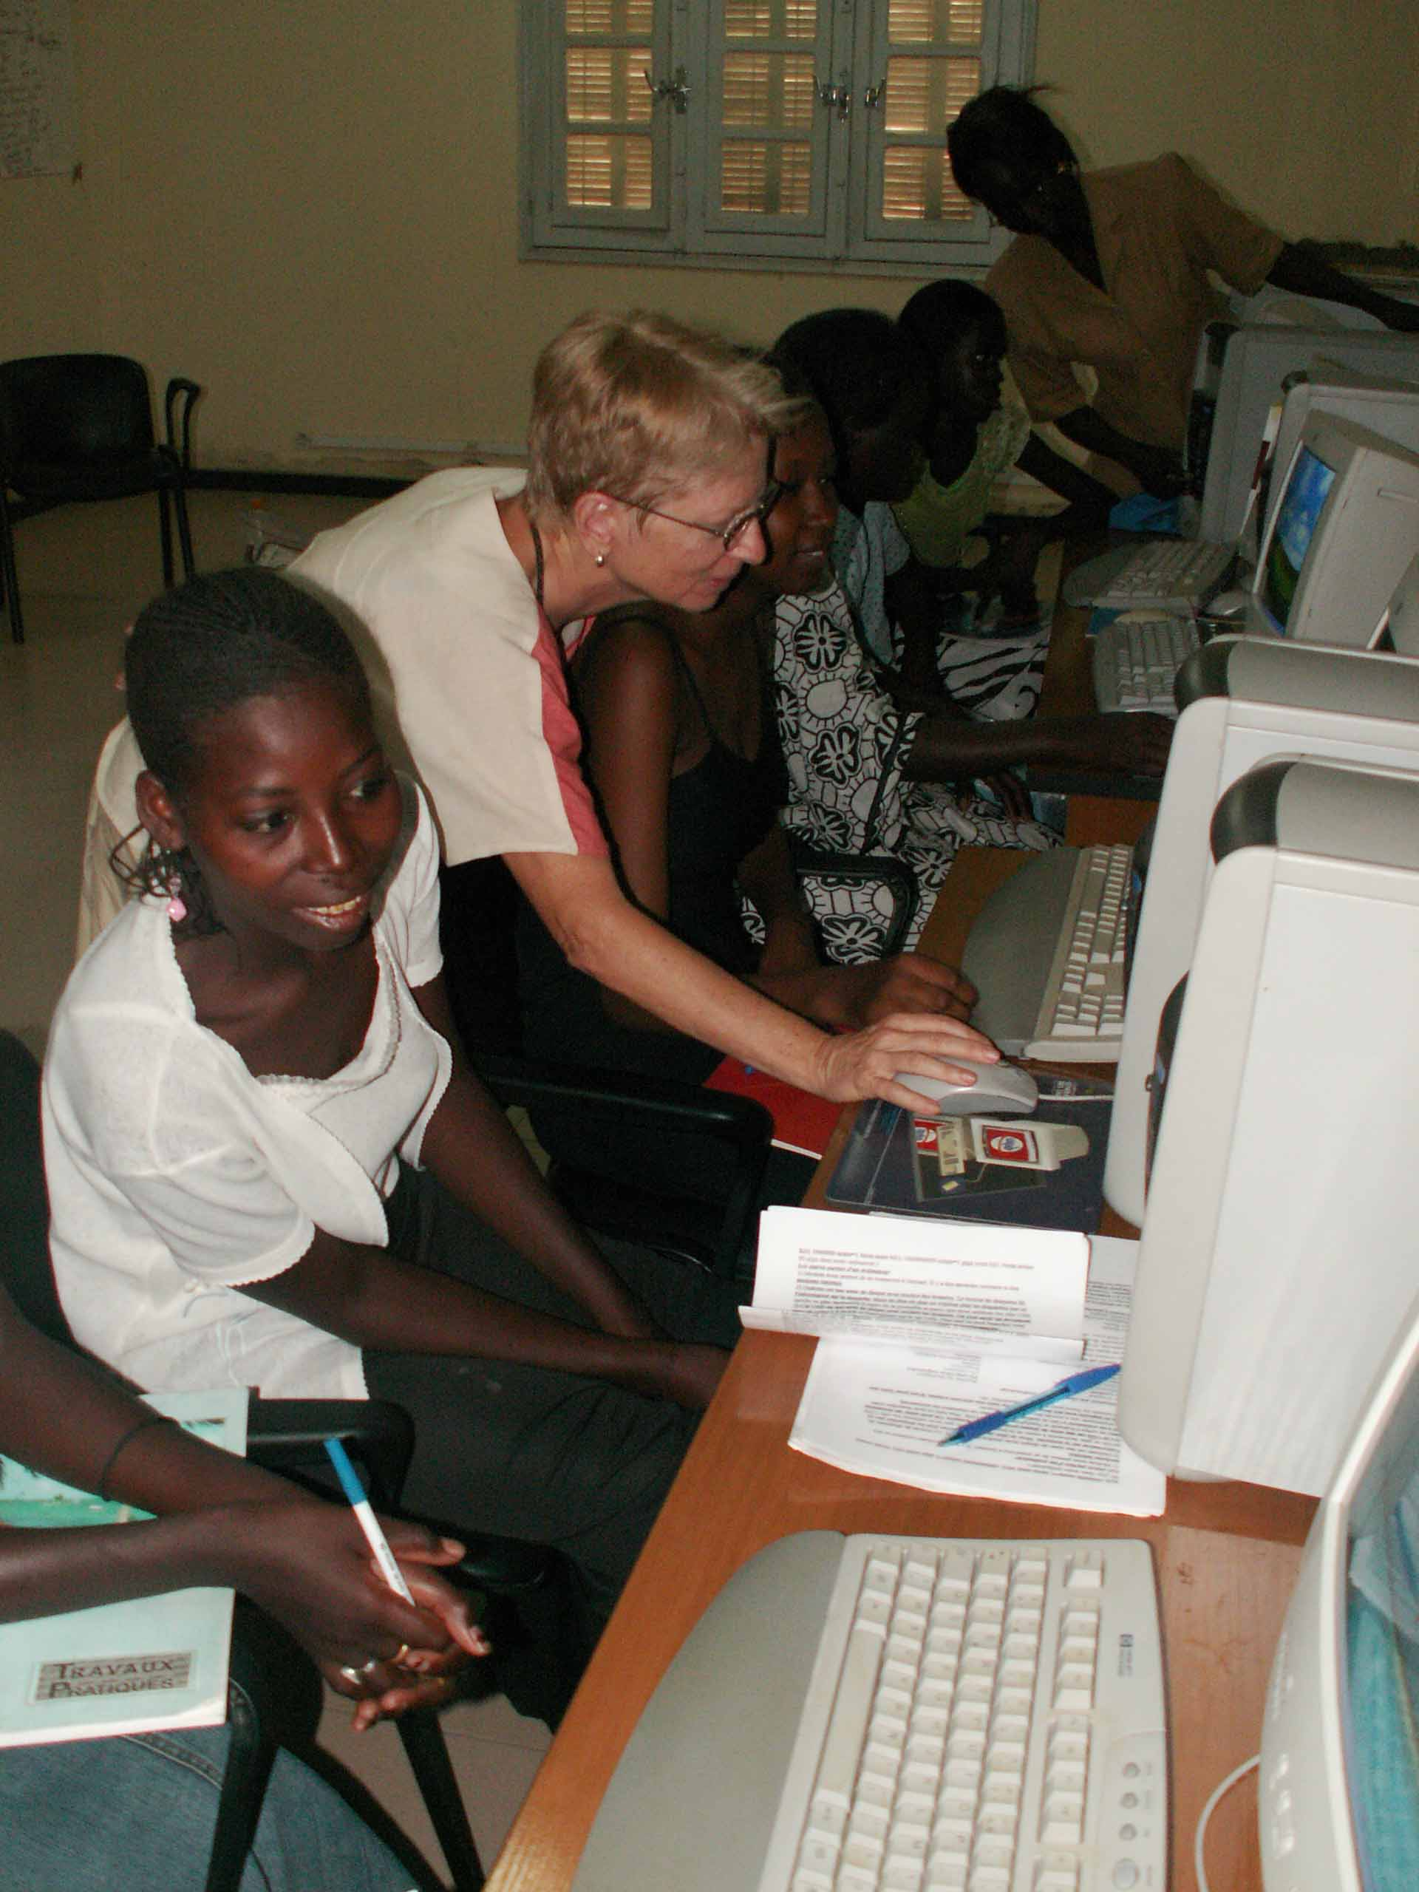
Every club is different, which has lead to some very interesting activities and very interesting feedback from volunteers. Erin Wheeler’s youth club painted a mural in their village promoting girl’s education. They also planned a Sabaar and did skits on HIV/AIDS. Other volunteers, such as Paula Hirschoff have taken the applicants from the Michelle Sylvester Scholarship and organized girls’ clubs to help build their self-confidence and strengthen their leadership capacities.
Right: Paula Hirschoff empowers her young
Girl’s club by teaching them computer skills

Michele Sylvester Scholarship Program
Every volunteer is able to participate in the MS Scholarship Program. Every year the applications are passed out through regional representatives, and then to volunteers who are interested in including their local college (middle school). For the school year 2006-2007 we provided scholarships for 30 winners from 30 different schools throughout Senegal. Every winner received 25,000 CFA (approximately $50) to be used on school fees, supplies and whatever else they might need. The volunteer is then responsible for helping the winner to manage their money, and is also a mentor for them throughout the year. The selection committee was comprised of Peace Corps Senegal Volunteers, and every application was viewed by at least two people. The three main criteria the selection committee was looking for were a dynamic personality, an exceptional personal essay, and financial need (as expressed by the volunteers description of the applicants home life).
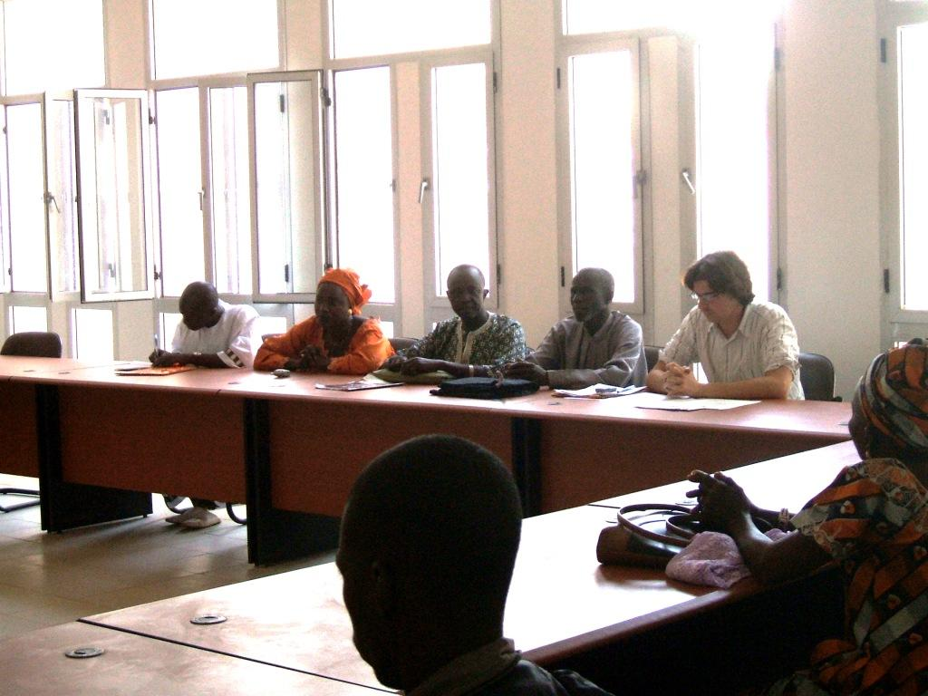
The volunteers in the region of Kolda organized an awards ceremony for the four winners in their region. The attendees included Attendees included The Deputy Mayor of Kolda who opened the ceremony, Mamadou Sarr, who works at Développement Communautaire, Principals and other school representatives, Peace Corps Volunteers, the winners and their families. It is up to the volunteers of each region to decide how they will distribute the scholarships to the winners.
We would like to research other scholarship options in Senegal, so that we could inform volunteers if there are other programs available. We are not able to predict how many scholarships we can distribute every year, it fluctuates depending upon our funds. We also try to have at least one winner from every school that has applied, although we cannot guarantee that every year.

Gender and Development Training
During a SeneGAD meeting this year we discussed at length strengths and weaknesses of SeneGAD. One of the concerns that emerged was our weakness in defining SeneGAD to the larger Volunteer population, and our failure in explaining how every volunteer can and should be involved, and how every volunteer can integrate GAD philosophy into their sector work. As a result of these discussions, we created the Training Coordinator position. Every year two new stages come into country, and each stage has a PST and IST. It is the role of the Training Coordinator to develop session plans and also to work on better publicizing SeneGAD and our goals and missions to volunteers.
Elizabeth Smith was elected to this position in the fall of 2006, and will hold this position through the next year, until September 2007. Elizabeth is very passionionate about Gender and Development, which comes through in her presentation during PST and IST sessions. (Thanks Kim! ☺) Statistics and facts are read at the opening of each session to help create some perspective of how drastically different gender is viewed in Senegal, versus the USA. We are also trying to better integrate male volunteers into SeneGAD work, and the last training sessions we had a male and female representative, which was very well received.
We have also created special interest groups who will research on gender related topics, and then present the information found on our SeneGAD website. The topics chosen were prostitution, child/human trafficking and domestic violence. Many of these topics are things that people have expressed interest about to members of the SeneGAD committee, and volunteers wish that there was more information available about these topics in Senegal. We hope that the website will become a resource for volunteers throughout the following years. Other potential topics include early child marriage and abortion.
Also, in the future we would like to hold weekend workshops for volunteers and/or HCN to address gender related problems in Senegal. A few examples might be, HIV/AIDS and how women and men play different roles in the prevention of HIV/AIDS, Family Planning and the Muslim Faith, or Domestic Violence in Senegal and how volunteers can effect change in their villages. Our goal is to create forums where people can talk about gender and common problems that volunteers might confront during their service.

Fundraising
In the past SeneGAD has had two fundraising coordinators, however we are now trying to de-emphasize fundraising. As a result, Starting in August, 2006, there was only one Fundraising Coordinator. SeneGAD has three major fundraising events a year, (two IST Auctions, WAIST Auction), and open sales throughout the year for Kay Lekk cookbooks and RPCV calendars. The two IST Auctions (where fukijai and other random goods are auctioned off), are the largest fundraisers. Overall in 2006-07 we raised over 1 million CFA (approximately 1,300,000 CFA). During this fiscal year, SeneGAD gave out 420,000 CFA in grants for PCV youth clubs and awarded 28 college aged young women scholarships for one full school year totaling 700,000 CFA. We also have a positive balance of over 600,000 CFA to begin our next fiscal year. We are working towards having a budget and keeping better track of how much we are making every year and how much we are giving out through Youth Clubs and Michelle Sylvester Scholarships.
Overall our fundraisers have been very profitable, but we still believe that there is room for improvement, and there are other avenues we have not yet explored. Peace Corps Volunteer family’s and friends are more than willing to donate money, and we have been in talks with Friends of Senegal and The Gambia who has collected donations for us in the past, however we are currently unable to receive funds from them. Peace Corps Partnership is also an option, although we are no longer allowed to use this for funding scholarships, and for camps/clubs we need to find a local partner to coordinate efforts.

List of Board Members
Here is a list of the Board Members as of March 2006 to March 2007
Staff Advisor: Awa Traore, Thies Training Center Housing Coordinator & Cross-Cultural trainer
National Coordinator: Kimberly Rusnak, Health, Matam Region
Communications Coordinator: Daniel Shier, SED, Dakar Region
Fundraising Coordinators: Lucianna Winters, SED, Matam Region
Becca Schwartz, SED, Kaolack Region
Youth Club Coordinator: Lale Birinioglu , SED, Kaolack Region
Michele Sylvester Scholarship Coordinator: Megan Kaufman, Ag, Kaolack Region
Kari Browning, SED, Dakar Region
Training Coordinator: Elizabeth Smith, Health, Tambacounda Region
Regional Representatives: Lisa Jackson, Urban Ag, Dakar Region
Connor Kamada, SED, Kaolack Region
Dominique Jean-Baptiste, Health, Tambacounda Region
Erin Wheeler, Health, Kedegou Region
Charles Caldi, SED, Kolda Region
Margot McCulloch, Health, Matam Region
Erica Cummings, EE, Podor Region

How to contact SeneGAD
By email: SeneGAD@gmail.com By mail: Corps de la Paix Senegal, B.P. 2534, Dakar,
Senegal, West Africa
Check out our website for updates: www.senegad.org

