Wangari Matthai

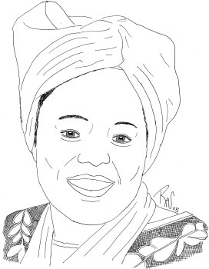

Wangari Matthai faced enormous obstacles in life, not the least of which was that in Kenyan tradition women are seen as the submissive property of men. Nevertheless, she stubbornly pursued an education and eventually became a professor of veterinary medicine. Soon after that, she entered a traditional marriage and had three children. But because of her growing activism, her husband called her "too educated, too strong, too successful, too stubborn, and too hard to control" and divorced her. The President of Kenya labeled her "a mad woman who is a threat to the order and security of the country" and encouraged the Kenyan people "to stamp out trouble-makers." Beaten, threatened with death, and in hiding during much of her long years of activism for human rights, women's rights, and environmentalism, Ms. Matthai has been courageously steadfast. Among her many accomplishments is the founding of the Green Belt Movement, an organization that concentrates on environmental conservation and community development by planting trees to protect the soil. It was through this organization that she became known throughout the world, and in 2004, she became the first African woman to receive the Nobel Peace Prize "for aiding democracy and attempting to save Africa's forests."

Hafsat Abiola

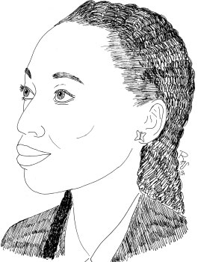
Hafsat Abiola is a human rights and democracy activist from Nigeria, whose activism arose after a series of tragic family events. In 1993, the Nigerian military government decided to hold a democratic election for president. Hafsat's father, Chief Moshood Abiola won the election, but instead of being allowed to take office, he was imprisoned. His wife, Kudirat Abiola was assassinated for leading a campaign to try to free her husband. In honor of her mother, Abiola founded KIND, (Kudirat Institute for Nigerian Democracy) which works to empower women and youth and advance democracy and development in Africa. She travels around the world to share her story and her passion for justice and democracy, inspiring many other women and youth to work for a better world.

Marian Wright Edelman
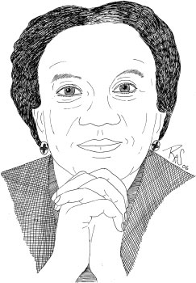
Marian Wright Edelman is an American author, activist and one of the nation's leading advocates for the rights of children. She is founder and president of the Children's Defense Fund, whose mission is to ensure that every child has a healthy and fair start in life. Marian Wright Edelman's worldview was greatly influenced by her father, Arthur Wright, a Baptist preacher who expected his children to work hard at getting a good education and to serve others. She has dedicated her life to serving those who cannot always advocate for themselves. After becoming the first woman to get her law degree and be admitted to the Bar in Mississippi, she worked for the NAACP Legal Defense Fund and then moved to Washington DC in 1968 to serve as legal counsel for the Poor People's March organized by Martin Luther King, Jr. She worked on a number of other civil rights and public service causes before founding the Children's Defense Fund (CDF) in 1973.
As the nation's most powerful lobby for children, CDF has helped convince the government to adopt many policies to protect and empower children, such as the 1990 Act for Better Child Care which overhauled and improved childcare, as well as other legislation to protect children who are abused, adopted, handicapped, homeless, neglected or poor. CDF continues to advocate for the 14 million American children living in poverty by advocating for health care, support for homeless children, expanding Head Start programs, youth pregnancy-prevention, reducing violence in the media, and other programs. Marian Wright Edelman has been honored with many awards for her dedication to a better world including the Albert Schweitzer Prize for Humanitarianism, the Robert F. Kennedy Lifetime Achievement Award and the Presidential Medal of Freedom.

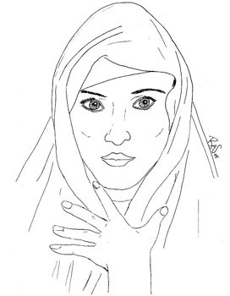

Waris Dirie

Dirie was born into a nomadic tribe in Somalia. Her home was a portable hut woven from grass. According to her autobiography, at age five, her mother held her down while a local woman cut away her genitals. Afterwards, she was stitched up tightly, leaving a hole the diameter of a matchstick and making it nearly impossible to walk. "I felt not complete with myself as a woman. Some days I felt so powerless," she said. "When I think back about that, it still disturbs me. But coming back over that is still the hardest thing for me because you have to learn about yourself, you have to feel comfortable with yourself." Although Dirie survived the procedure, her sister and two cousins did not. Waris ran away from her home because of an arranged marriage.
Dirie fled Somalia at the age of thirteen because her father gave her in marriage to a 61-year-old man in exchange for five camels. She escaped the marriage by traveling to her uncle's home, and hid her passport when he was going to return her. She ended up staying in Britain illegally and surviving by scrubbing floors at McDonald's.
By chance, she was discovered by photographer Terence Donovan, who put her face on the cover of the 1987 Pirelli calendar. From there, her career took off, being placed in ads for designers such as Chanel. "It's very sad that I had to make the choice to leave my country and at the same time I did not want to leave," she said. "Africa is different. I was young. I had nothing to worry about. I had my family, I had my animals, I had my simple life. It was beautiful." Dirie now lives in Vienna, Austria but still feels the contrasts between the West and her war-torn home. "Here it seems like it is chaos forever and I'm trying to sit down for a moment and there's no time for that," she laughed. "In Somalia we don't have clocks so we don't care what time it is. But in the West, everything is money-money, power, sucking, sucking away. It is never enough."In 1987, Waris played a role in the Bond movie The Living Daylights. In 2005 she became an Austrian citizenWaris is a cousin of fellow Somali supermodel Iman.^{[1]}
In 1997, Waris Dirie quit modelling to focus on her work against female genital mutilation. That year UN Secretary-General Kofi Annan appointed her Special Ambassador for the Elimination of Female Genital Mutilation ^{[2]}.
Her autobiographical novel Desert Flower, which tells the story of her own childhood and genital mutilation, has been printed in numerous languages and topped best-seller lists in Europe. ^{[3]},^{[4]}
In 2007 she received the Chevalier de la Légion d'honneur for her humanitarian work

Liya Kebede
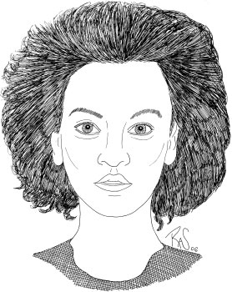

Liya Kebede
(1980-)
Ethiopian Supermodel,
World Health Organization Goodwill Ambassador
QUOTES
Every day we hear about the dangers of cancer, heart disease and AIDS. But how many of us realize that, in much of the world, the act of giving life to a child is still the biggest killer of women of child-bearing age?
The message of our campaign is "Make every mother and child count". This campaign is not just about health. It is also a powerful call for radical progress in women's rights and the rights of their children. Too often, the health of mothers and children does not count. In too many parts of the world, they are forgotten.

Ambassador
Gertrude Ibengwe Mongella

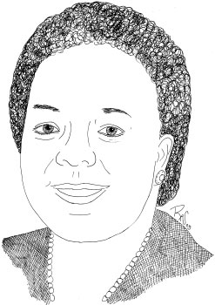
QUOTES
"Women have always struggled with their men-folk for the abolition of slavery, the liberation of countries from colonialism, the dismantling of apartheid and the attainment of peace. It is now the turn of men to join women in their struggle for equality."

Malika Sanders
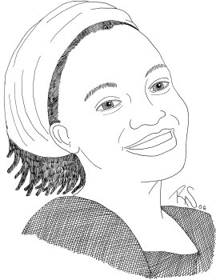

When she was 12, Sanders decided to dedicate her life to fighting injustice and inequality. She later described the decision as a spiritual one, but it didn't take her long to put her ideas into practice. As a 15-year-old high school student in Selma, she realized that African-American students were routinely being tracked into lower-level classes rather than college-preparatory programs, regardless of their grades or test scores. The result was a new form of segregation. Sanders led a student walkout that began with just a few participants but grew into a series of marches and protest meetings that drew more than 100 students. The students formed an organization dubbed SMART--the Student Movement Against Racial Tracking.
The group staged a five-day sit-in, facing down FBI and National Guard forces called in by Selma mayor Joe Smitherman. The Ku Klux Klan erected a sign atop the school building where the students were ensconced. Sanders herself was arrested for the questionable crime of passing out leaflets. But in the end the students were victorious; impartial testing programs were implemented, and the Selma school board's white majority, which had terminated a black superintendent who had tried to take the students' side, was soon eliminated.

