Feature Detection, Spatial Selection, and Descriptor Matching
Jordan Brown
ME 566 — Mechanical Engineering
AI Use Disclosure—AI assistance was used to draft and format this report and to write the supplemental evaluation script. The camera images, original implementation, and notebook were supplied in the Homework 2 project.
Abstract—Four feature detectors and three descriptors were compared on camera-captured rotation, scale, and translation sequences. FAST was the quickest detector (0.16–0.44 ms per frame), while a single-scale Difference of Gaussians (DoG) produced the most detections but collapsed under the largest scale change. A four-way spatial partition retained 249 of 372 FAST candidates without improving occupied image cells. Shared FAST keypoints were described with SIFT, BRIEF, and ORB. Supplemental geometric proxy labels provide confusion matrices; an ORB ratio-test ROC had AUC 0.661 and a balanced threshold of 0.812. The results show the speed, coverage, and matching tradeoffs and their limits.
Index Terms—feature detection, repeatability, FAST, DoG, Harris, Shi–Tomasi, BRIEF, ORB, ROC.

I. INTRODUCTION
Homework 2 asks how keypoint detection, spatial selection, and descriptor matching respond to physical changes in camera viewpoint [1]. The three image sequences were captured with a camera: rotation, scale, and translation. No frame was digitally rotated or scaled. The original experiments and figures are in report.ipynb; detector and matcher classes are in src/; supplemental repeatability and confusion-matrix calculations are in report_metrics.py. All paths in this report are relative to Homework/two/.

II. METHODS

A. Data and Evaluation Protocol
A fixed Python random seed (566) selected three frames from each capture sequence: rotation 145/175/185, scale 110/120/165, and translation 130/160/170. Question 1 used all nine frames. The first and last frame of each sequence were used for geometric repeatability; descriptor matching used translation frames 130 and 170. Images were read as BGR, converted to grayscale for detection/description, and otherwise left at their captured resolution. The notebook measured one detector invocation per image with perf_counter, so its timings are comparative single-run measurements, not stable benchmarks.
Algorithm 1. Detector and repeatability workflow
1. Load the named camera frames and detect keypoints with each method at its stated defaults.
2. Register each sequence’s first and last frame by SIFT correspondences, a 0.7 ratio filter, and a RANSAC homography with a 5 px threshold.
3. Project every first-frame keypoint into the last frame; retain projections inside its bounds.
4. Mark a keypoint repeated when a last-frame detection is within 3 px of its projection.
5. Report repeatability = repeated / visible first-frame points.
The homography is an approximate reference for a mostly planar scene. It can mislabel parallax, occlusion, and registration errors. The repeatability measure tests position only and does not require descriptor agreement or one-to-one assignment.

B. Detector Equations and OpenCV Settings
For normalized grayscale intensity I, the implemented DoG response is D(x,y)=Gσ₁∗I−Gσ₂∗I with σ₁=1 and σ₂=2. The code keeps 3×3 local maxima of |D| above 0.03. GaussianBlur uses (0,0) so OpenCV derives the kernel from σ; dilate finds local maxima. This is a single pair of scales, not a full SIFT scale-space pyramid.
Harris uses the second-moment matrix M=Σw[Ix² IxIy; IxIy Iy²] and response R=det(M)−k·tr(M)². After GaussianBlur(5×5, σ=1.4), cornerHarris uses blockSize=2, ksize=3, k=0.04. Nonmaximal responses above 0.01·max(R) are kept. Shi–Tomasi uses min(λ₁,λ₂) of M; goodFeaturesToTrack is called with maxCorners=100, qualityLevel=0.01, minDistance=10 after the same blur. Thus its count is explicitly capped at 100.
FAST tests a contiguous arc around a candidate pixel against its center intensity. FastFeatureDetector_create(threshold=30) uses OpenCV defaults for nonmaximum suppression and the 9–16 pattern. The threshold sets the required intensity contrast; increasing it normally yields fewer, stronger corners [2].

C. Spatial Feature Selection
The project’s “Octree” class is a two-dimensional, four-child spatial partition. It starts from FAST(threshold=30), repeatedly splits the populated leaf with the most candidates when the split stays within max_features=500, then retains the largest-response keypoint in each final leaf. Four-way partitioning and one feature per cell spread detections across textured regions. This implementation is inspired by spatial feature distribution in ORB-based SLAM; it is not the adaptive nonmaximum suppression method of Brown et al. [3], and it cannot populate cells with no FAST candidates [4].
Algorithm 2. Spatial selection: initialize one full-image cell; while a populated cell can split within the 500-leaf budget, split the most populated cell at its horizontal and vertical midpoints; retain argmax(response) from each leaf. A 4×4 and 8×8 occupancy grid counts cells containing at least one selected feature.

D. Descriptors, Matching, and Ground Truth Proxy
All descriptor comparisons begin with the same FAST(threshold=30) keypoints on translation frames 130 and 170. OpenCV descriptor compute may discard keypoints whose support window crosses an image edge. SIFT_create defaults produce floating-point descriptors. FLANN uses KD-tree algorithm=1, trees=5, checks=50, k=2; Lowe’s test accepts d₁<0.7d₂, where d₁ and d₂ are first and second nearest descriptor distances [5]. BRIEF uses xfeatures2d.BriefDescriptorExtractor_create defaults and ORB uses ORB_create(nfeatures=500). Both use BFMatcher(NORM_HAMMING, crossCheck=True) for the notebook’s reported match lists. Hamming distance counts differing binary bits: dH(a,b)=Σi[aᵢ≠bᵢ]. The notebook displays at most 50 binary matches; reported counts include all cross-checked matches [2].
For confusion matrices, report_metrics.py considers one nearest descriptor match per surviving query keypoint. Prediction is positive if SIFT passes its 0.7 ratio test, or if a BRIEF/ORB pair is mutual nearest. A reference homography is estimated independently from SIFT detected keypoints and RANSAC; a candidate is labeled geometrically positive if its reprojection error is at most 5 px. Matrix layout is [[TN, FP], [FN, TP]]. This is geometric proxy ground truth, not manual correspondence labeling, and the SIFT-derived reference may favor SIFT-like correspondences. Precision=TP/(TP+FP), recall=TP/(TP+FN).
Algorithm 3. Descriptor evaluation: compute each descriptor on shared FAST keypoints; find nearest candidates; apply each matcher’s acceptance rule; project candidates with the reference homography; count TN, FP, FN, and TP against the 5 px geometric criterion.

E. ROC Construction
The notebook’s ROC calculation uses ORB_create(nfeatures=1000) on FAST keypoints, BFMatcher(NORM_HAMMING).knnMatch(k=2), and a nearest/second-nearest distance ratio r=d₁/max(d₂,1). Its geometric labels come from findHomography(..., RANSAC, 5 px) on nearest candidates. For every unique threshold τ, predicted positive means r≤τ; TPR=TP/(TP+FN) and FPR=FP/(FP+TN). Trapezoidal integration yields AUC, and Youden’s J=TPR−FPR selects the reported balanced threshold. Because this reference is estimated from the candidate pool itself, the ROC measures agreement with that geometric model rather than independently verified physical truth.

III. RESULTS AND DISCUSSION

A. Detection Speed and Feature Count
TABLE I. DETECTOR RESULTS ACROSS THREE FRAMES PER CAPTURE
Capture | Detector | Mean ms | Mean count | Count range
Rotation | DoG | 12.75 | 3127 | 2540–3454
Rotation | Harris | 18.34 | 187 | 140–212
Rotation | Shi-Tomasi | 16.41 | 100 | 100–100
Rotation | FAST | 0.39 | 257 | 229–307
Scale | DoG | 11.67 | 3070 | 36–5029
Scale | Harris | 15.39 | 337 | 261–390
Scale | Shi-Tomasi | 18.28 | 100 | 100–100
Scale | FAST | 0.31 | 273 | 0–512
Translation | DoG | 12.57 | 4496 | 4156–5104
Translation | Harris | 15.63 | 197 | 150–243
Translation | Shi-Tomasi | 18.09 | 100 | 100–100
Translation | FAST | 0.35 | 471 | 372–528

FAST was roughly 30–50 times faster than the other implementations on these frames. DoG returned thousands of points in most images, often dense along textured edges; this does not imply equal numbers of stable or independent landmarks. Shi–Tomasi returned 100 points in every frame because maxCorners=100. On scale frame 165, FAST returned no points and DoG only 36, suggesting the fixed thresholds and single-scale implementations were poorly suited to this capture. The images also changed apparent feature size and visibility, so these results do not isolate scale invariance alone.

B. Geometric Repeatability
TABLE II. FIRST-TO-LAST FRAME REPEATABILITY AT 3 PX
Capture | Detector | Repeated | Visible | Rate
Rotation | DoG | 1196 | 3151 | 38.0%
Rotation | Harris | 86 | 207 | 41.5%
Rotation | Shi-Tomasi | 53 | 94 | 56.4%
Rotation | FAST | 102 | 218 | 46.8%
Scale | DoG | 3 | 1077 | 0.3%
Scale | Harris | 50 | 182 | 27.5%
Scale | Shi-Tomasi | 11 | 52 | 21.1%
Scale | FAST | 0 | 165 | 0.0%
Translation | DoG | 1133 | 3718 | 30.5%
Translation | Harris | 23 | 126 | 18.2%
Translation | Shi-Tomasi | 6 | 82 | 7.3%
Translation | FAST | 104 | 457 | 22.8%

Shi–Tomasi had the highest measured rotation repeatability (56.4%), while DoG and FAST performed better than Shi–Tomasi under the translation test. The large scale change was especially difficult: DoG repeated 0.3% of visible points, and FAST had no last-frame detections. These rates should be compared with the different detector counts and the homography limitation. Figures 1–3 provide the original visual overlays for all three frames in each capture.
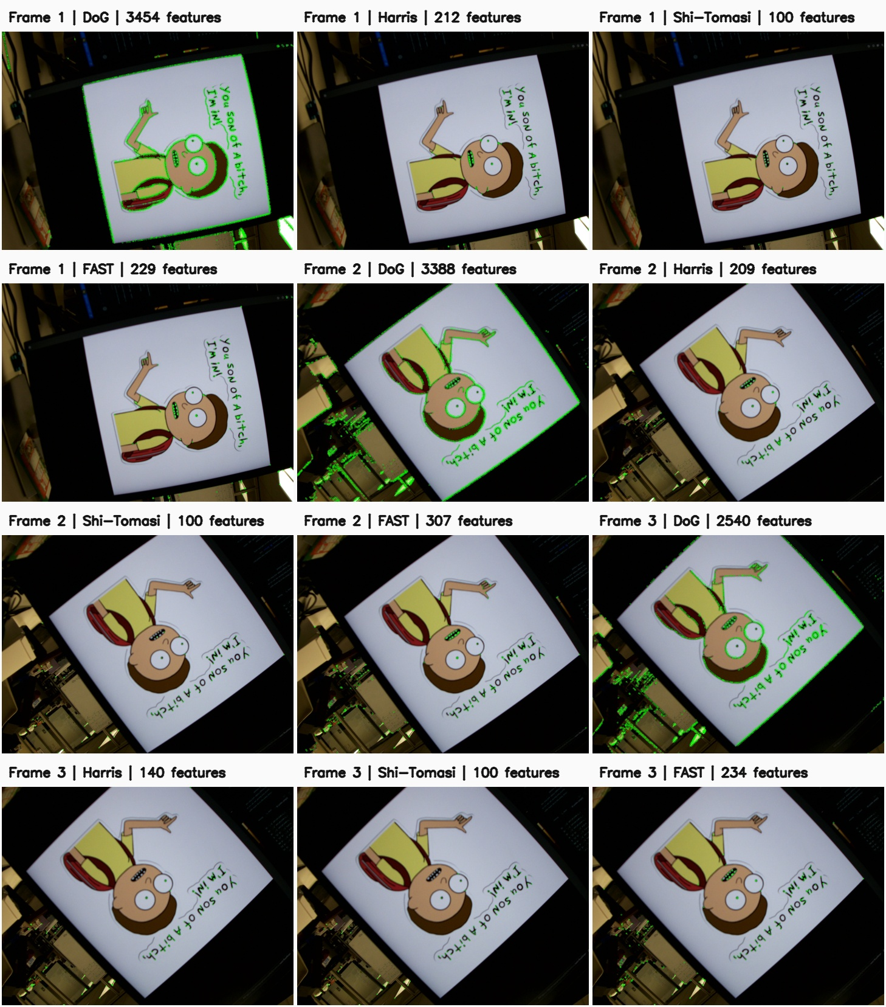
Fig. 1. Captured rotation sequence; columns are frames 145, 175, and 185, with four detector rows.
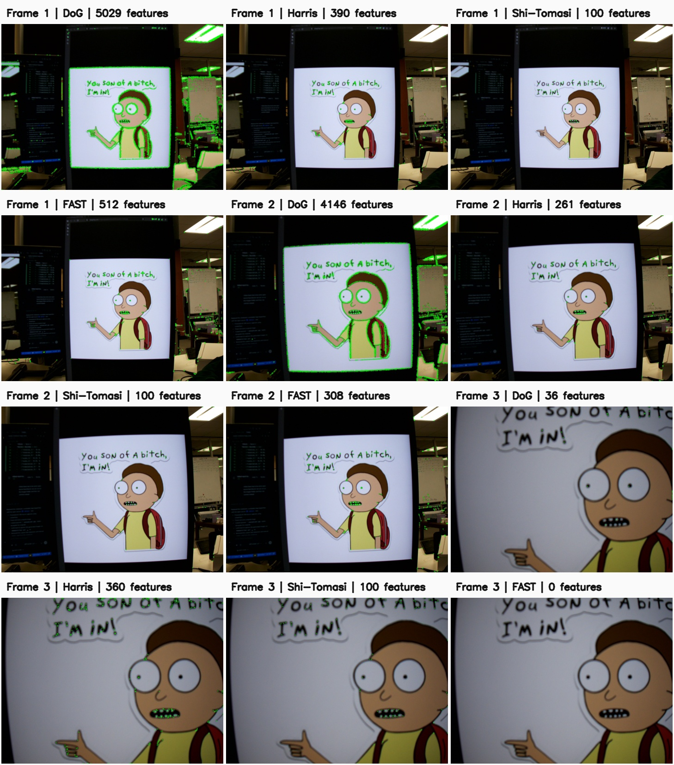
Fig. 2. Captured scale sequence; columns are frames 110, 120, and 165.
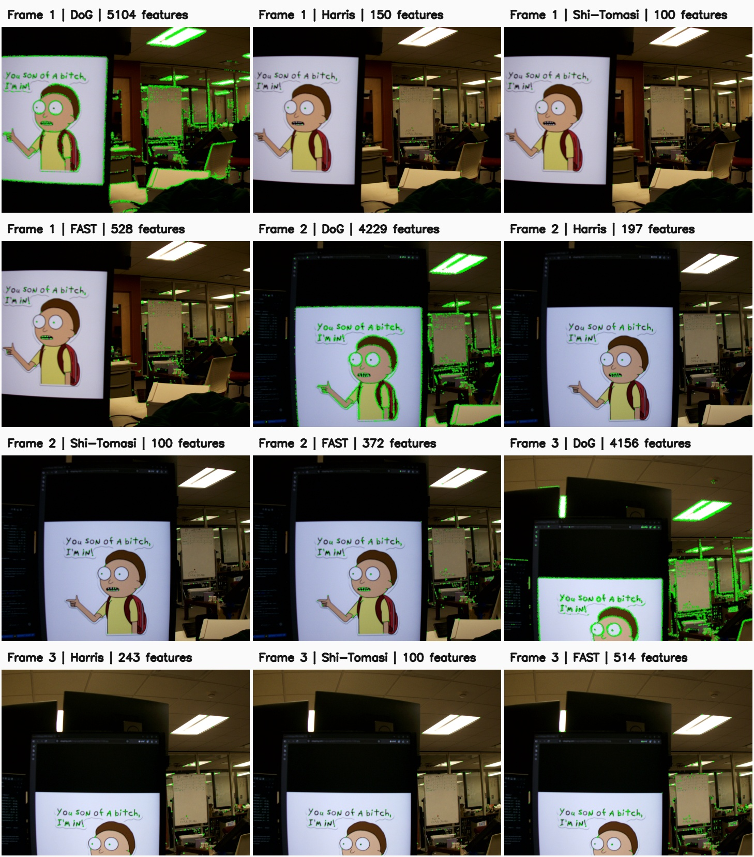
Fig. 3. Captured translation sequence; columns are frames 130, 160, and 170.

C. Spatial Coverage
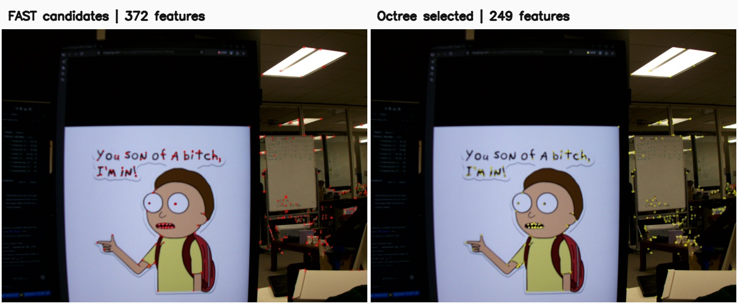
Fig. 4. FAST candidates (left) and four-way spatial selection (right) on translation frame 160.
The selector kept 249 of 372 candidates (66.9%). A 4×4 grid had 11/16 occupied cells before and after selection; an 8×8 grid had 36/64 occupied cells before and 35/64 after. Thus the method reduced concentration while largely preserving the original spatial footprint, but did not improve this simple coverage measure. The max_features=500 setting is a ceiling, not a target: the partition stopped at 249 leaves because eligible splits would exceed the remaining leaf budget or produced no useful subdivision.

D. Descriptor Speed, Matches, and Confusion Matrices
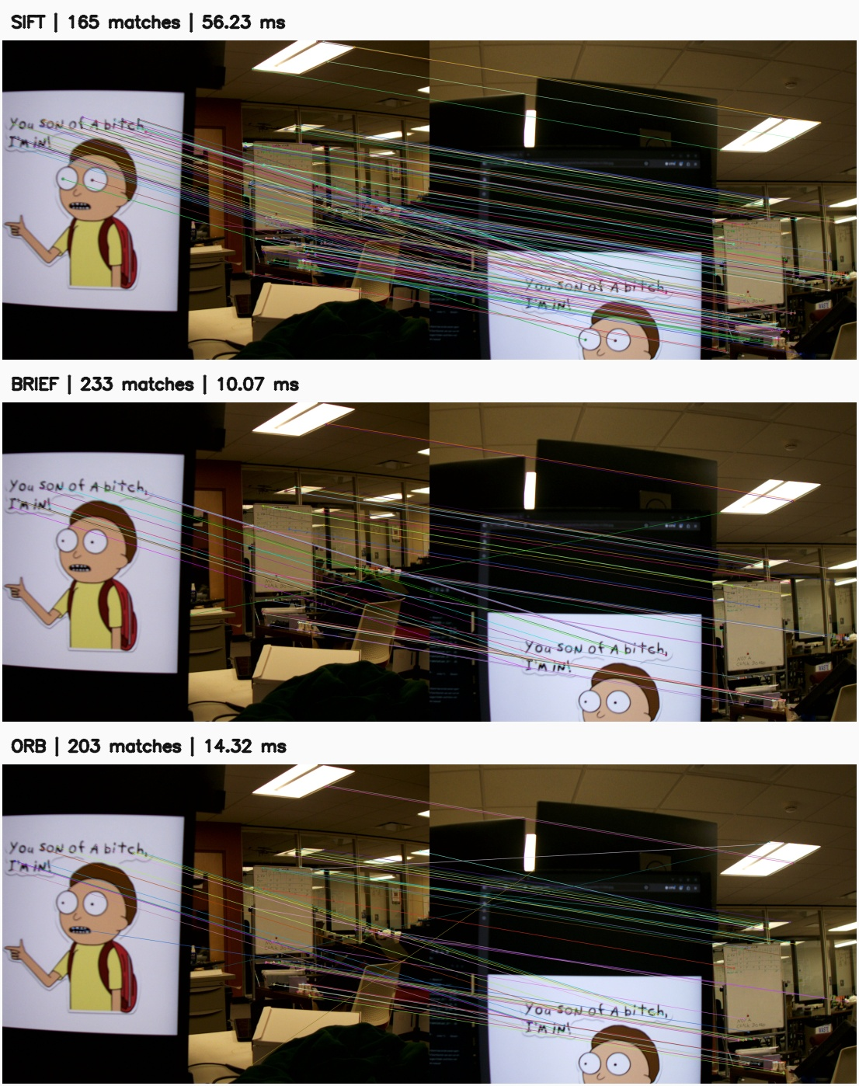
Fig. 5. Shared FAST detections matched with SIFT, BRIEF, and ORB on translation frames 130 and 170. The binary overlays show at most 50 matches.
TABLE III. MATCHING RESULTS; CANDIDATES AND MATRICES FROM SUPPLEMENTAL GEOMETRIC EVALUATION
Descriptor | Time (ms) | Matches | Cand. | TN | FP | FN | TP | Precision | Recall
SIFT | 56.23 | 165 | 528 | 307 | 102 | 60 | 59 | 36.7% | 49.6%
BRIEF | 10.07 | 233 | 517 | 260 | 150 | 24 | 83 | 35.6% | 77.6%
ORB | 14.32 | 203 | 512 | 282 | 142 | 27 | 61 | 30.0% | 69.3%

The notebook’s match counts and timings come from the original FLANN or cross-check implementation; candidate totals and matrix entries come from the supplemental nearest-neighbor evaluation. They are deliberately reported separately because the acceptance pipelines differ. BRIEF was quickest and returned the most matches in the notebook, while SIFT was slowest. Under the geometric proxy, BRIEF had the highest recall but also 150 false positives; SIFT had the highest precision of the three, though still only 36.7%. Repeated scene texture, perspective effects, and proxy-label errors are plausible contributors. A match count alone is therefore not a quality measure.

E. ORB ROC and Parameter Choice
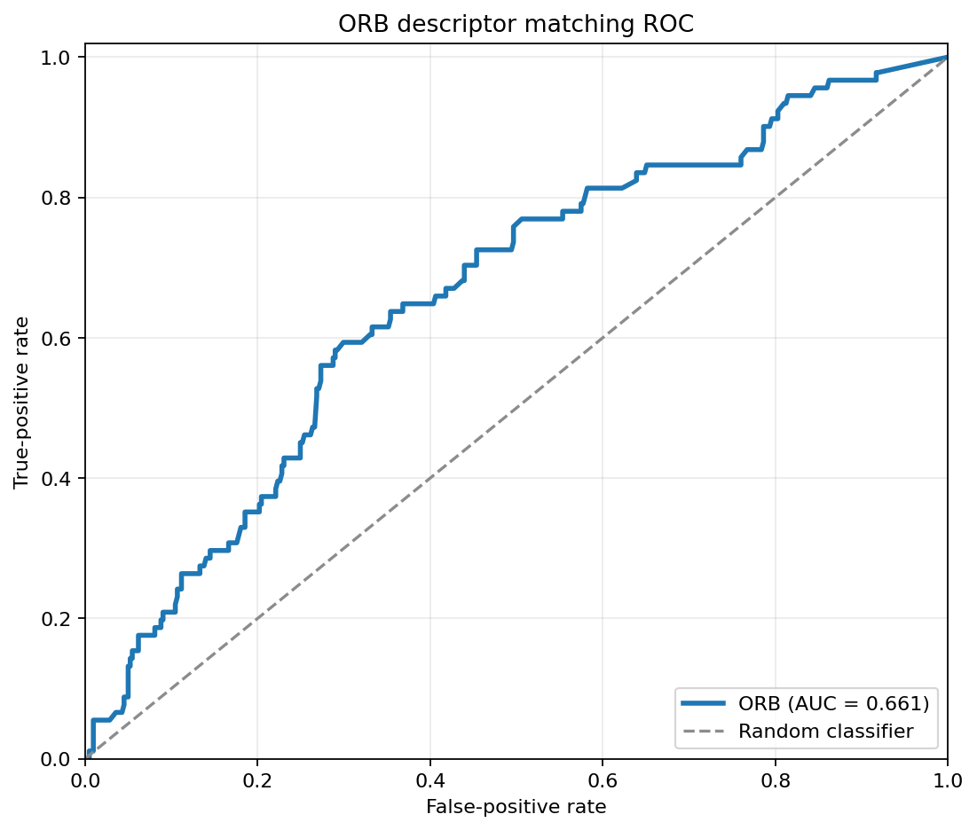
Fig. 6. ORB nearest/second-nearest Hamming-distance ratio ROC on translation frames 130 and 170.
The ROC contains 91 RANSAC inliers and 421 outliers and has AUC=0.661. Youden’s J is largest at a ratio threshold of 0.812 for this capture. Smaller ratios demand a more distinctive best match, reducing false positives at the cost of recall; larger ratios accept more ambiguous matches. FAST threshold 30 controls candidate quantity and stability. ORB nfeatures=1000 prevents descriptor configuration from unnecessarily restricting these FAST candidates. The 5 px RANSAC tolerance defines the geometric reference labels; it is not the matching threshold. A stricter geometry threshold would count fewer candidates as true, and a looser one could admit poor correspondences. The selected ratio should be retuned for another camera, scene, or false-match cost.

IV. CONCLUSION
On these captured images, FAST minimized detection time, while fixed-parameter DoG generated many points but was fragile under the large scale change. Spatial selection reduced crowded FAST responses while preserving almost the same occupied image cells. BRIEF offered the shortest measured matching time and highest geometric-proxy recall; SIFT was slowest and had the highest proxy precision. ORB offered a middle speed with an ROC AUC of 0.661. These conclusions are specific to the sampled frames, one-run timings, shared FAST detections, and homography-based labels.

REFERENCES
[1] ME 566, “Homework 2: Feature Detection and Matching,” course assignment, Homework 2.pdf.
[2] OpenCV, “Feature Detection and Description” and “Feature Matching,” OpenCV 4.x documentation. https://docs.opencv.org/4.x/db/d27/tutorial_py_table_of_contents_feature2d.html
[3] M. Brown, R. Szeliski, and S. Winder, “Multi-Image Matching Using Multi-Scale Oriented Patches,” CVPR, 2005. https://www.microsoft.com/en-us/research/wp-content/uploads/2005/06/cvpr05.pdf
[4] R. Mur-Artal and J. D. Tardós, “ORB-SLAM2: An Open-Source SLAM System for Monocular, Stereo, and RGB-D Cameras,” IEEE Trans. Robotics, 2017. https://arxiv.org/abs/1610.06475
[5] D. G. Lowe, “Distinctive Image Features from Scale-Invariant Keypoints,” Int. J. Computer Vision, 2004. https://www.cs.ubc.ca/~lowe/papers/ijcv04.pdf
[6] E. Rublee et al., “ORB: An Efficient Alternative to SIFT or SURF,” ICCV, 2011. https://doi.org/10.1109/ICCV.2011.6126544

APPENDIX: REPRODUCTION AND CODE
From Homework/two/, use a Python environment with numpy, scipy, matplotlib, opencv-contrib-python, and Jupyter. Open report.ipynb and choose Run All to regenerate the original output figures and notebook tables. Run “python report_metrics.py” to regenerate outputs/report_metrics.json, Tables II–III, and the 4×4/8×8 coverage check described above. The implementation code is supplied alongside this report in src/detectors/{dog,harris,shi_tomasi,fast,octree}.py, src/matchers/{sift,brief,orb}.py, src/utils.py, and report_metrics.py. The exact captured frame names and numerical parameters are specified in Section II and in those files.

