Camera Calibration, Image Filtering, Thresholding, and Morphological Segmentation
Jordan Brown
ME 566 — Mechanical Engineering
AI Use Disclosure—AI assistance was used for code cleanup, document formatting, and help with wording. The analysis, implementation decisions, and final submission were reviewed by the student.
Abstract—This report evaluates a camera-calibration workflow and fundamental image-processing methods. A 10×7 chessboard with 23.5 mm squares was used to calibrate a camera from subsets of two to all available images. Gaussian, median, and rank filters were compared on four noisy images. Global and adaptive thresholding were then applied to coin and screw images, followed by morphological processing. Calibration quality depends on viewpoint diversity as well as image count; median filtering is best suited to impulse noise; adaptive thresholding is preferable under nonuniform illumination; and opening followed by closing produces useful binary masks.
Index Terms—camera calibration, Gaussian filtering, median filtering, thresholding, morphology.

I. INTRODUCTION
This assignment implements camera calibration, noise suppression, threshold segmentation, and morphological refinement. All visual comparisons were generated in report.ipynb and saved in output_images/. The supporting implementation uses the CameraCalibrator, ImageFiltering, Thresholder, and MorphologicalFilter classes [4].

II. METHODS
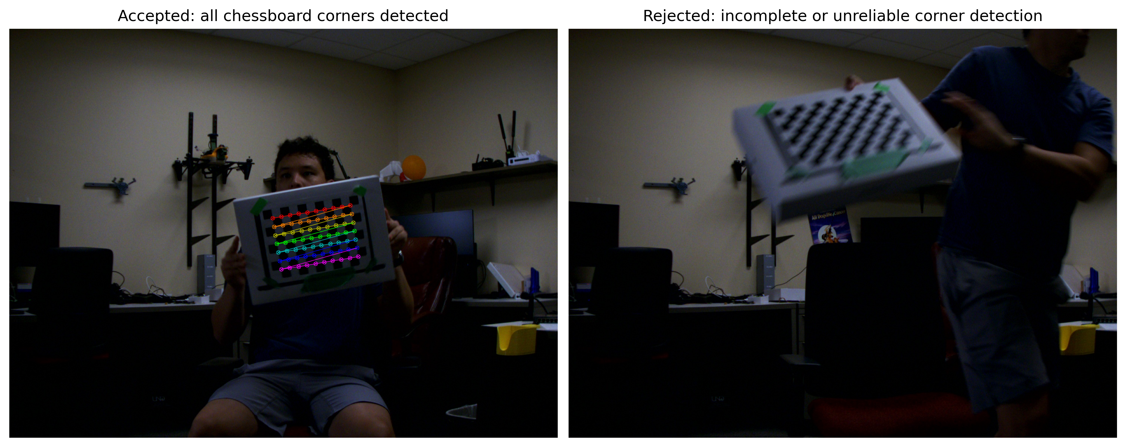
Fig. 1. Complete corner detection (left) versus a blurred, tilted chessboard rejected by the detector (right).
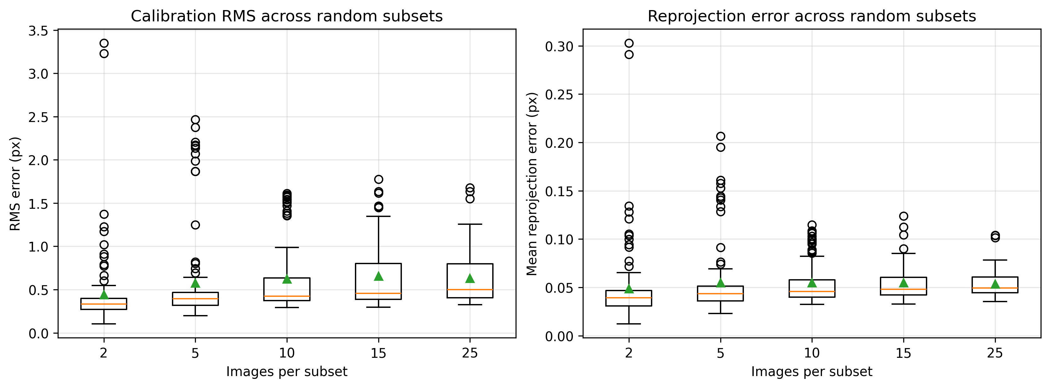
Fig. 2. Box-and-whisker distributions for 100 successful random subsets at each non-full set size. Boxes show the interquartile range, orange lines show medians, green triangles show means, and circles show outliers.

A. Camera Calibration
Algorithm 1. Camera Calibration Workflow
Input: calibration images I and square size s
1. Load images and validate chessboard dimensions and resolution.
2. Create planar object points from the grid dimensions and s.
3. Detect and refine corners for each calibration image.
4. Keep object/image points only for successful detections.
5. Estimate K, distortion, poses, and RMS with calibrateCamera.
6. Reproject points, compute mean pixel error, and save JSON.
Output: camera parameters and reprojection error
Images were read from images/calibration_set_me566_2; only images with a fully detected chessboard were retained. Object coordinates were generated for a 10×7 grid with 23.5 mm spacing, and OpenCV calibrateCamera estimated the intrinsic matrix, distortion coefficients, and per-image poses [1]. Results were saved as JSON with matrices and vectors represented as nested lists. Mean reprojection error was obtained by projecting object points into each image and averaging the Euclidean corner error.

B. Noise Filtering
Algorithm 2. Filter Selection
Input: image I, filter type f, kernel (kx, ky), sigma, and rank
1. If f is Gaussian, apply GaussianBlur.
2. If f is median, apply medianBlur.
3. If f is rank, apply rank_filter with size (ky, kx, 1).
4. Otherwise, raise ValueError.
Output: filtered image
The Camera Man, salt-and-pepper, Gaussian, and uniform-noise images were processed with Gaussian blur, median blur, and rank filtering. Gaussian and median filters used 3×3 and 5×5 windows. Rank filtering used ranks 0, 4, and 8 for the 3×3 window and ranks 0, 12, and 24 for the 5×5 window; the midpoint ranks are median ranks.

C. Thresholding and Morphology
Algorithm 3. Binary Segmentation and Morphology
Input: image I, threshold type, operation, and odd kernel size
1. Convert I to grayscale when it has three channels.
2. Apply fixed or adaptive Gaussian thresholding to obtain B.
3. Validate the operation and create a square kernel.
4. Apply erosion/dilation or morphologyEx, as appropriate.
Output: refined binary mask
Each coin and screw image was converted to grayscale. A global threshold of 127 and adaptive Gaussian thresholding with an 11×11 neighborhood and C = 2 were applied [2]. The binary results were processed with a 3×3 square structuring element using erosion, dilation, opening, closing, gradient, top-hat, and black-hat operations [3].

III. RESULTS AND DISCUSSION

A. Calibration
Table I reports the mean ± sample standard deviation across 100 successful random subsets for each non-full size. The box-and-whisker plots in Fig. 2 show the full distributions: the two-image subsets have the lowest mean RMS but a large spread and high outliers, making them unreliable. The 5-, 10-, 15-, and 25-image distributions overlap substantially, so more images do not automatically lower the in-sample residual. Each random subset has different pose coverage, blur, illumination, and corner-localization quality; adding diverse but noisier views can increase residual while improving representativeness. A stronger next evaluation would measure held-out reprojection error and the stability of the recovered intrinsic parameters.
TABLE I. CALIBRATION RESULTS
Images | Trials | RMS mean ± SD (px) | Reprojection mean ± SD (px)
2 | 100 | 0.4424 ± 0.4629 | 0.0489 ± 0.0423
5 | 100 | 0.5759 ± 0.5427 | 0.0550 ± 0.0365
10 | 100 | 0.6223 ± 0.4178 | 0.0548 ± 0.0220
15 | 100 | 0.6579 ± 0.4036 | 0.0550 ± 0.0183
25 | 100 | 0.6305 ± 0.3038 | 0.0535 ± 0.0132
All | 1 (fixed) | 0.6966 | 0.0535

B. Filtering
Gaussian filtering is the best general-purpose choice for additive Gaussian and uniform noise. The 5×5 kernel removes more variation than 3×3, but it also softens edges and texture. Median filtering is preferable for salt-and-pepper noise because it rejects isolated bright and dark impulses while retaining edge locations; 3×3 is preferred when possible to preserve detail. Midpoint rank filters behave as median filters. Minimum and maximum ranks are specialized choices for predominantly bright or dark impulses and are not general denoisers.
No clean reference image was supplied, so quality was judged by residual noise, edge preservation, and loss of fine detail. With a reference image, MSE, PSNR, and SSIM would provide objective quality measures.
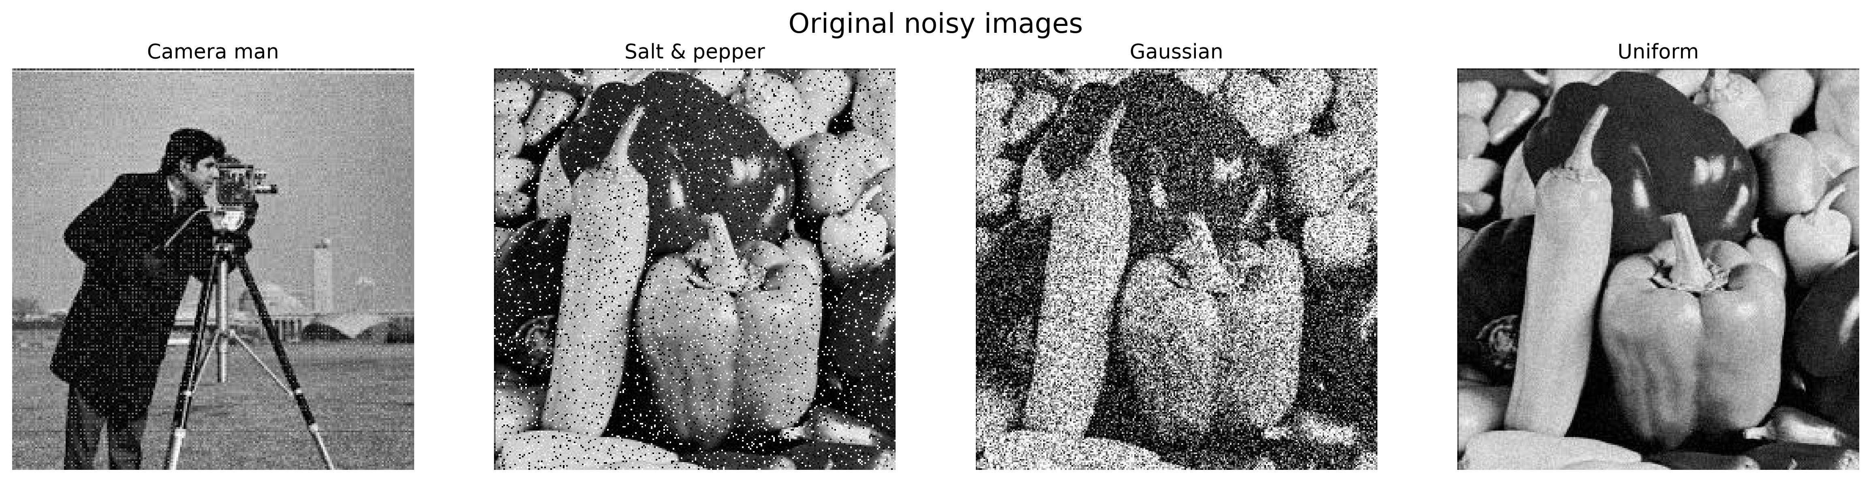
Fig. 3. Original noisy images.
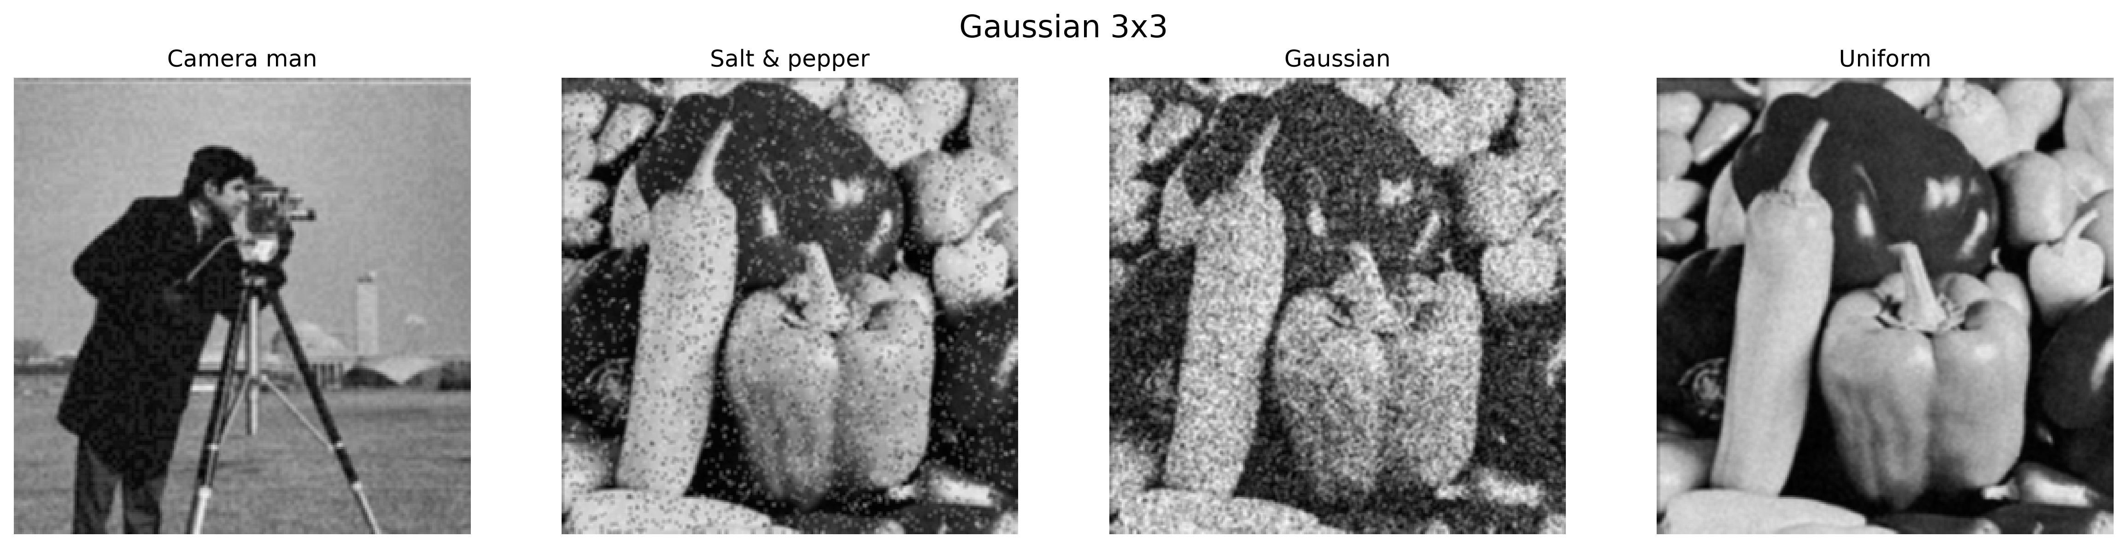  (a) Gaussian 3×3 | 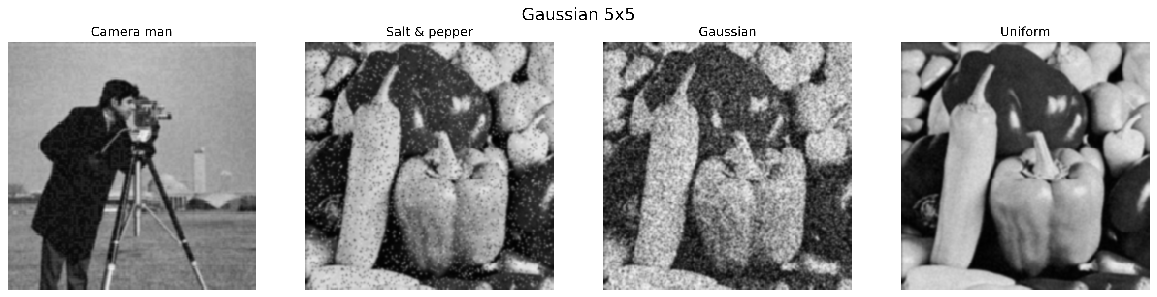  (b) Gaussian 5×5
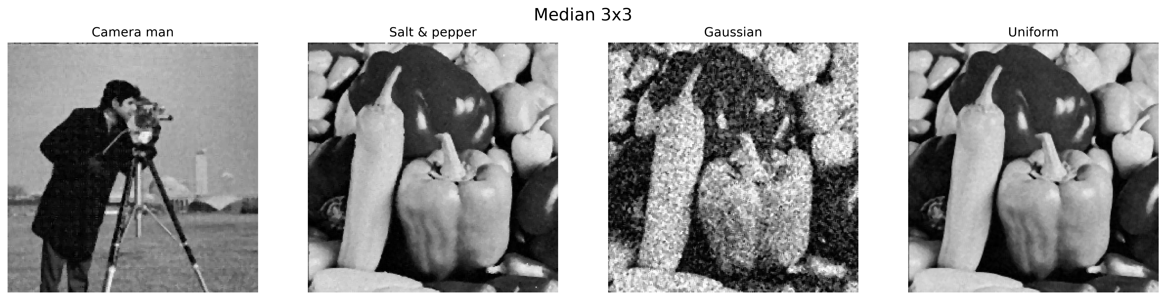  (c) Median 3×3 | 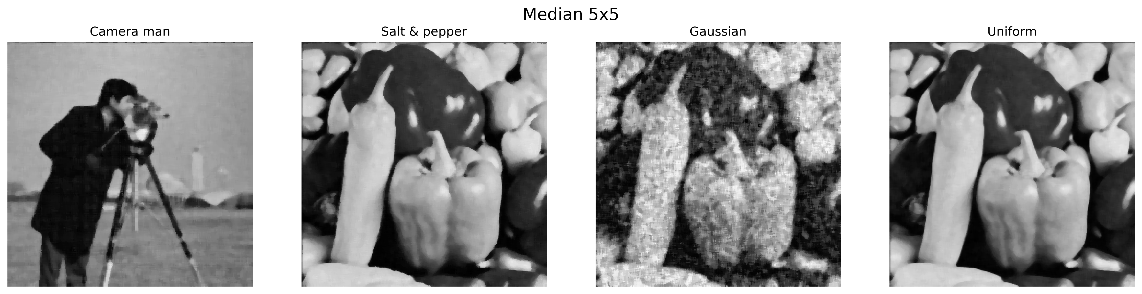  (d) Median 5×5
Fig. 4. Gaussian and median filter comparisons for all noisy inputs.
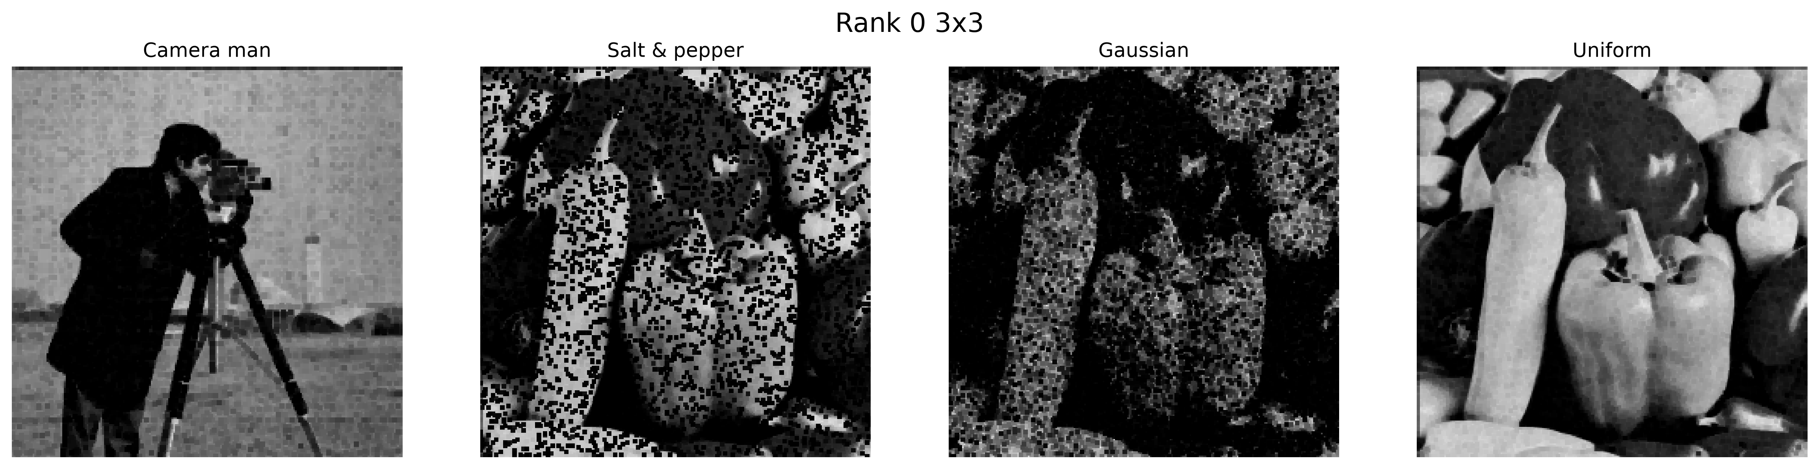  (a) Rank 0, 3×3 | 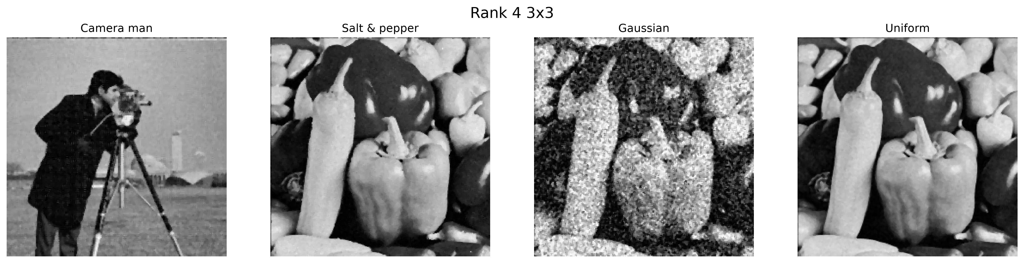  (b) Rank 4, 3×3 | 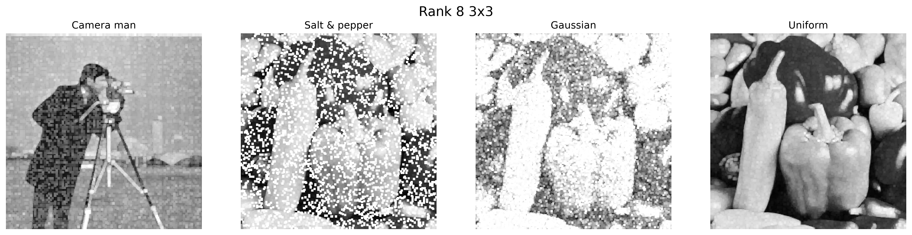  (c) Rank 8, 3×3
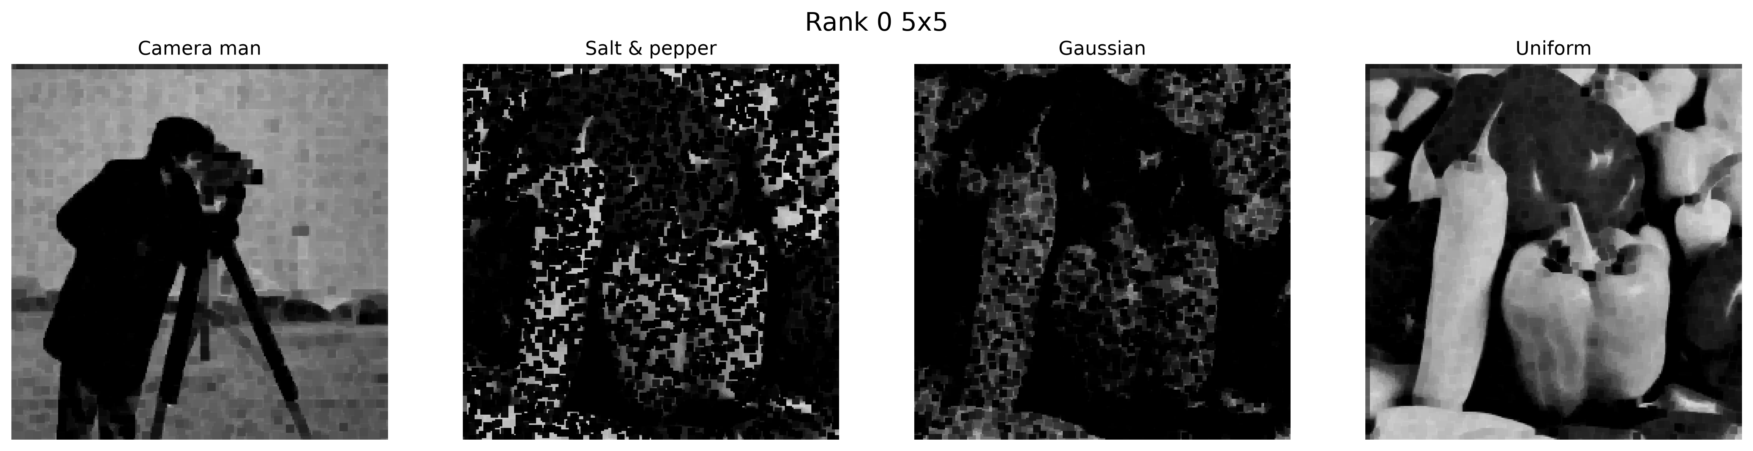  (d) Rank 0, 5×5 | 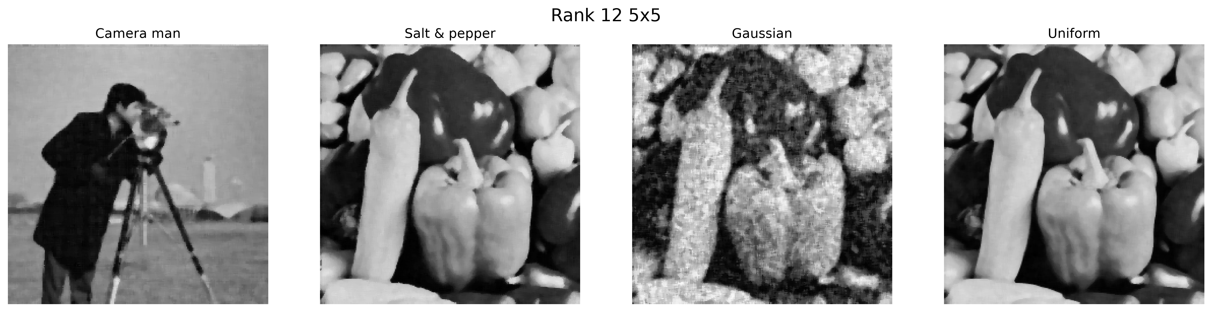  (e) Rank 12, 5×5 | 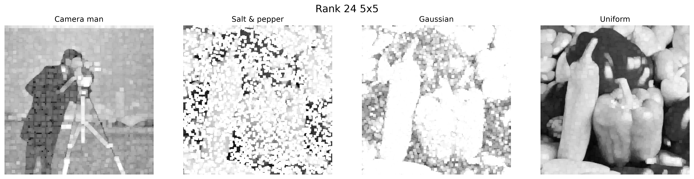  (f) Rank 24, 5×5
Fig. 5. Rank-filter comparisons for all noisy inputs.

C. Thresholding
Global thresholding uses a single intensity cutoff and is cleanest when illumination and contrast are uniform. Adaptive thresholding uses local neighborhoods and better preserves objects when illumination varies across reflective coins and screws. Its tradeoff is sensitivity to texture and noise, which can create extra foreground regions. Adaptive thresholding is therefore the better starting point under nonuniform lighting; global thresholding is preferred for controlled scenes.
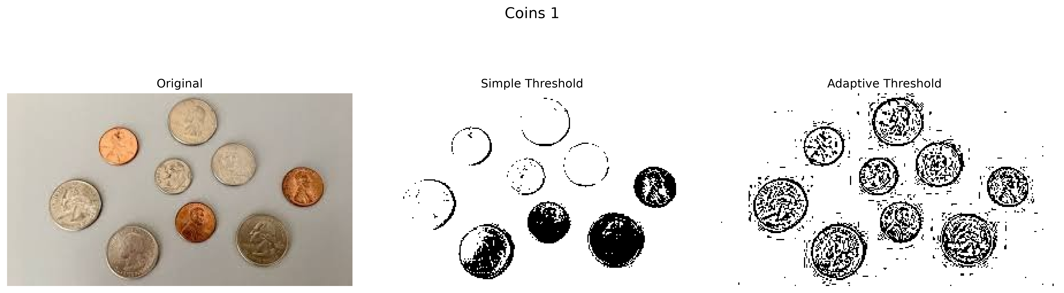  (a) Coins 1 | 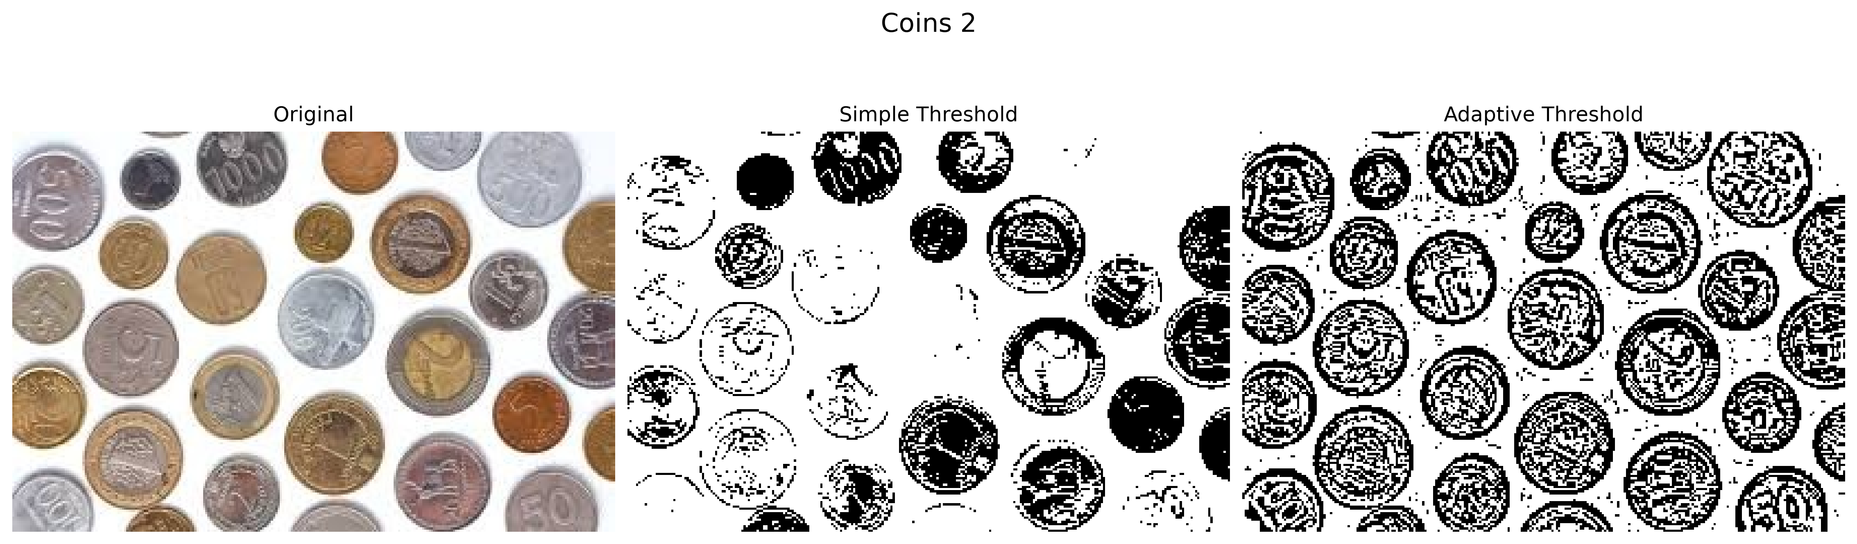  (b) Coins 2 | 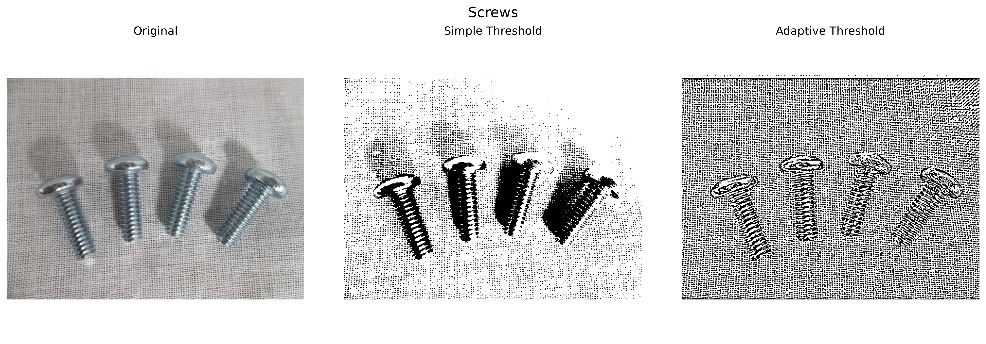  (c) Screws
Fig. 6. Original, global-threshold, and adaptive-threshold results.

D. Morphological Segmentation
Opening removes small isolated foreground pixels and is the most useful first operation for suppressing segmentation speckle. Closing fills small holes and reconnects narrow breaks. The recommended final-mask sequence is opening followed by closing. Erosion and dilation provide controlled shrinking and expansion, while gradient, top-hat, and black-hat are most useful as diagnostic edge and small-feature visualizations.
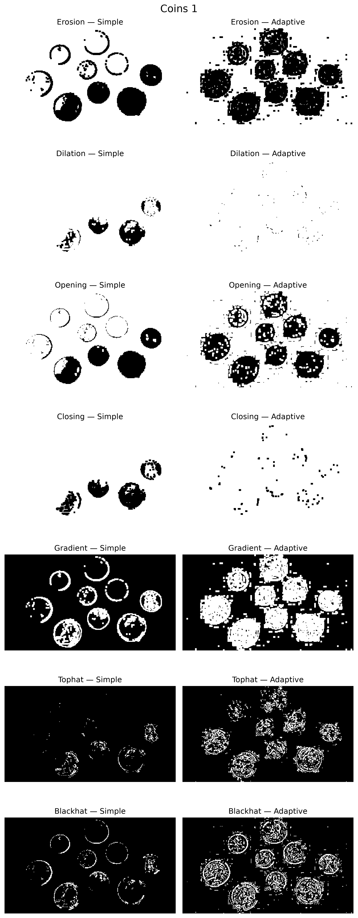  (a) Coins 1 | 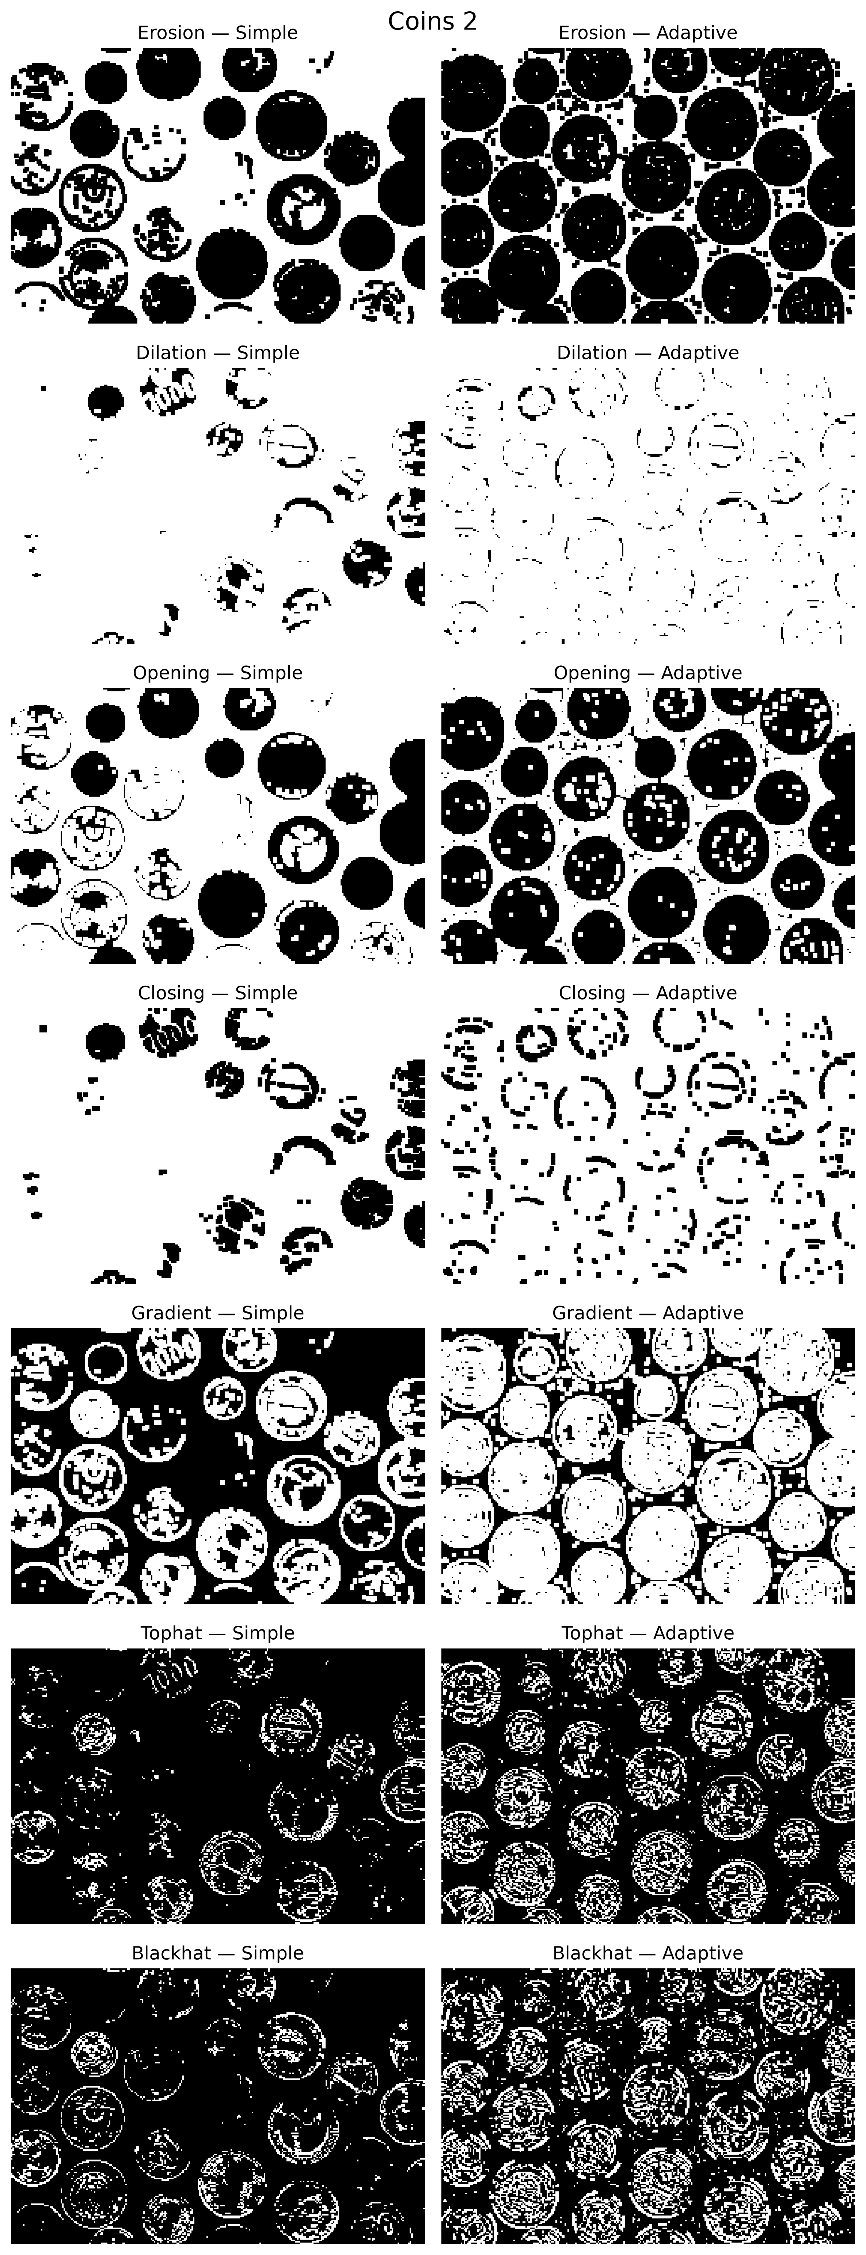  (b) Coins 2 | 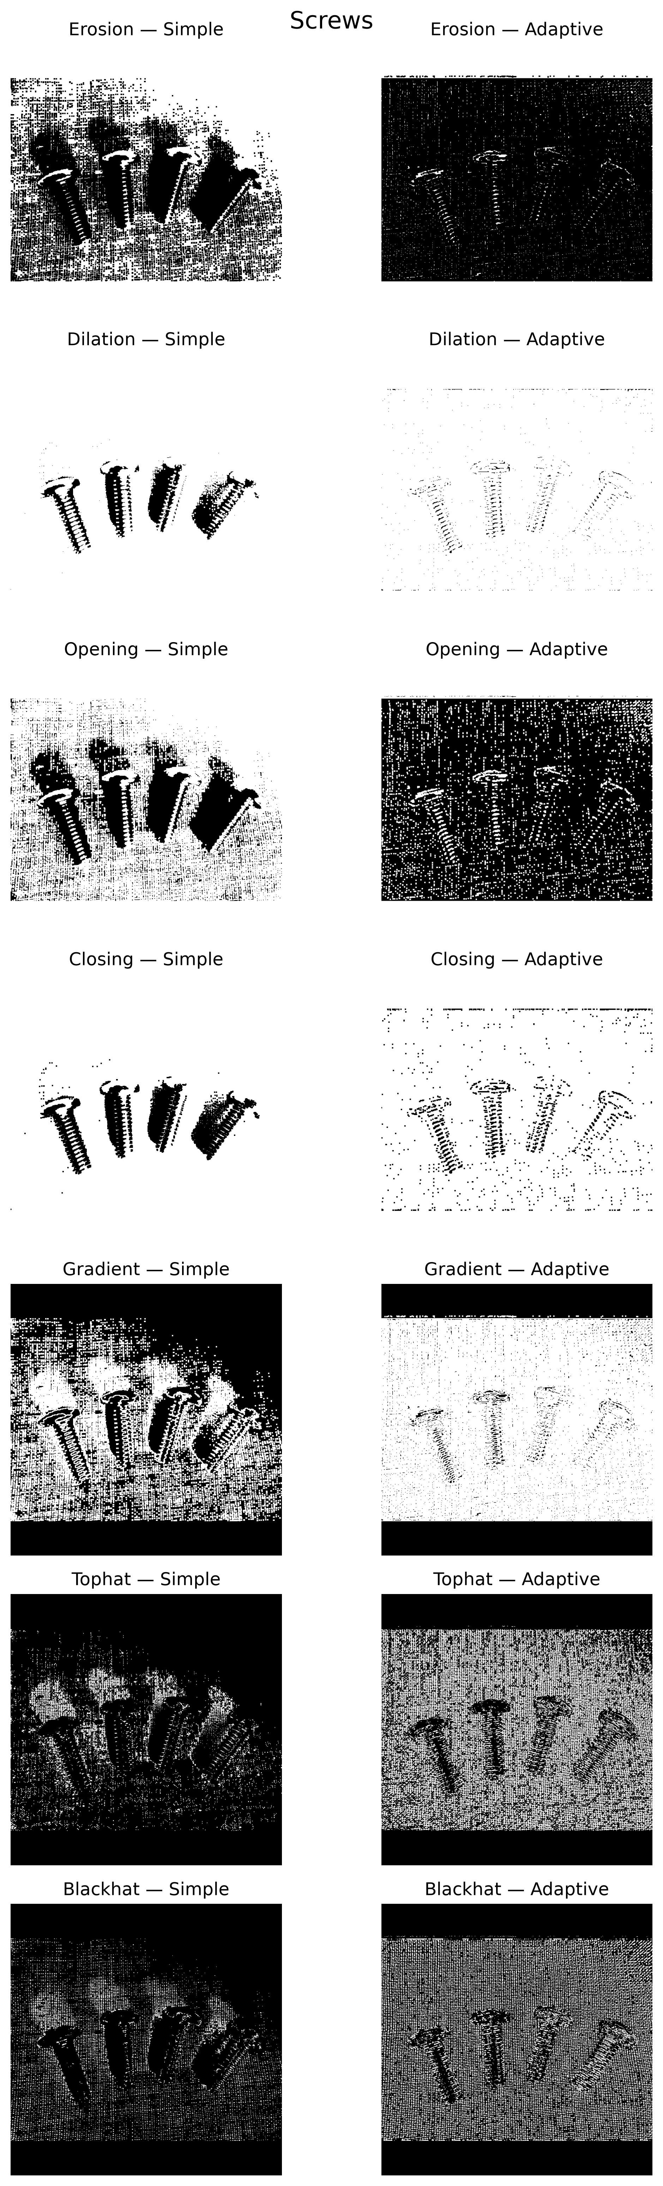  (c) Screws
Fig. 7. Morphological-operation comparisons for simple and adaptive binary inputs.

IV. CONCLUSION
A small favorable image set can yield deceptively low calibration residuals; robust calibration requires well-distributed views and reliable corner detections. Gaussian blur is appropriate for additive noise, whereas median filtering is strongest for salt-and-pepper noise. Adaptive thresholding better handles uneven illumination, and a 3×3 opening-closing sequence is recommended to refine the resulting binary masks.

REFERENCES
- OpenCV, “Camera Calibration and 3D Reconstruction,” OpenCV Documentation, 2026. [Online]. Available: https://docs.opencv.org/4.x/d9/d0c/group__calib3d.html
- OpenCV, “Image Thresholding,” OpenCV Documentation, 2026. [Online]. Available: https://docs.opencv.org/4.x/d7/d4d/tutorial_py_thresholding.html
- OpenCV, “Morphological Transformations,” OpenCV Documentation, 2026. [Online]. Available: https://docs.opencv.org/4.x/d9/d61/tutorial_py_morphological_ops.html
- Project source code, src/calibration/calibrate_camera.py and src/processing/, ME 566 Homework 1, 2026.

