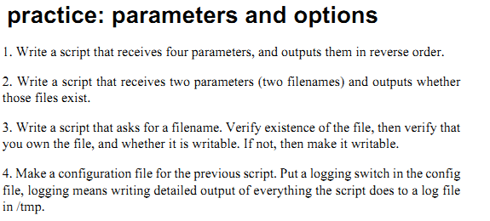

**Support: ;]**

**A bash shell script can have parameters. The numbering you see in the script below**

**continues if you have more parameters. You also have special parameters containing**

**the number of parameters, a string of all of them, and also the process id, and the last**

**return code. The man page of bash has a full list.**

#!/bin/bash

echo The first argument is $1

echo The second argument is $2

echo The third argument is $3

echo $$ PID of the script

echo $# count arguments

echo $? last return code

echo $* all the arguments

**'shift' example**

kahlan@solexp11$ cat shift.ksh

#!/bin/ksh

if [ "$#" == "0" ]

then

echo You have to give at least one parameter.

exit 1

fi

while (( $# ))

do

echo You gave me $1

shift

done

Below is some sample output of the script above.

kahlan@solexp11$ ./shift.ksh one

You gave me one