DRAFT — October 2026
AI-Based Cryptographic and Network Attack Detection:
A Comparative Study of Classical Machine Learning
and Deep Learning on Encrypted Traffic Flows
Aahil Shaik, Ram Sai, and Rehan Mohammed
Department of Computer Science and Engineering
[University Name], Hyderabad, India
Acknowledgment: Ayyappa Reddy and Ramidi Hemanth Reddy contributed the Approach 2 (Deep Learning) implementation

Abstract
Modern network traffic is predominantly encrypted, rendering traditional payload-based intrusion detection systems ineffective against both network-layer and cryptographic-layer attacks. This paper presents a controlled, reproducible comparison of two fundamentally different machine learning paradigms for classifying network flows as benign or as specific attack types using only flow-level metadata. Approach 1 employs classical machine learning — Random Forest and XGBoost with engineered feature selection, class-imbalance handling via SMOTE and balanced class weights, and SHAP-based explainability. Approach 2 uses deep learning — a hybrid 1D Convolutional Neural Network with Long Short-Term Memory (CNN-LSTM) architecture that learns hierarchical feature representations without manual selection. Both approaches are trained and evaluated on identical stratified splits of the CIC-IDS2017 dataset (2,830,743 flows across 15 attack types grouped into 8 families) under identical conditions. We report not only accuracy but macro-F1, per-class recall on rare cryptographic-layer attacks (Heartbleed, SSH/FTP brute force), computational cost, robustness under feature noise and evasion perturbations, and data efficiency. Our results show that Random Forest achieves a multi-class accuracy of 99.31% with macro-F1 of 0.912 and trains in 47 seconds on CPU, while CNN-LSTM achieves 99.14% accuracy with macro-F1 of 0.874 but requires 23 minutes of training. We find that tree-based ensembles are consistently superior for per-flow tabular features in intrusion detection, offering better rare-class detection, explainability, lower computational cost, and comparable accuracy — challenging the assumption that deep learning universally outperforms classical methods in cybersecurity.
Keywords: intrusion detection, machine learning, deep learning, random forest, CNN-LSTM, CIC-IDS2017, encrypted traffic, cryptographic attacks, Heartbleed, brute force, SHAP explainability

I. Introduction
The proliferation of encrypted network communication has fundamentally altered the landscape of network security. As of 2024, over 95% of web traffic traverses HTTPS connections, and SSH, VPN, and TLS-encrypted protocols dominate enterprise and cloud environments [1]. While encryption protects the confidentiality and integrity of legitimate communication, it simultaneously blinds traditional deep packet inspection (DPI) systems that rely on payload signatures to detect malicious activity.
This challenge is compounded by the emergence of attacks that target the cryptographic layer itself. The Heartbleed vulnerability (CVE-2014-0160), which exploited a buffer over-read in OpenSSL's TLS heartbeat extension, compromised an estimated 17% of the world's SSL-enabled web servers [2]. Similarly, brute-force attacks against SSH and FTP authentication represent a persistent threat to cryptographic access controls. These attacks exploit implementation flaws or weak credentials in the very protocols designed to provide security, making their detection particularly critical yet challenging.
Machine learning (ML) and deep learning (DL) have emerged as promising approaches to intrusion detection that do not require payload access. By analysing flow-level metadata — packet sizes, inter-arrival times, flag counts, flow durations — these methods can detect anomalous behaviour patterns regardless of encryption. However, the literature exhibits several concerning gaps. First, many studies report near-perfect accuracy on standard datasets such as CIC-IDS2017, yet accuracy is misleading when approximately 80% of flows are benign; macro-F1 and per-class recall provide a more realistic assessment [3]. Second, few studies compare classical ML and deep learning under strictly identical experimental conditions. Third, rare but critical attack types such as Heartbleed (only 11 samples in CIC-IDS2017) are often ignored. Fourth, practical deployment concerns including computational cost, robustness to adversarial perturbations, and cross-dataset generalisation are seldom addressed together [4].
This paper addresses these gaps with a controlled comparative study. We implement two technically distinct approaches on the CIC-IDS2017 dataset: (1) classical ML using Random Forest and XGBoost with correlation-based feature selection, SMOTE/balanced class weights, and SHAP explainability; and (2) deep learning using a hybrid 1D-CNN + LSTM architecture that learns its own feature representations. Both approaches consume identical stratified 70/15/15 splits and are evaluated through a shared harness measuring accuracy, macro-F1, per-class recall, computational cost, robustness, and data efficiency.
Our key contributions are:
- A reproducible, controlled comparison of classical ML vs. deep learning for network intrusion detection on identical data splits with comprehensive metrics beyond accuracy.
- Explicit evaluation of cryptographic-layer attack detection (Heartbleed, SSH/FTP brute force) with per-class recall on extremely rare classes.
- Quantitative analysis of computational cost, robustness, and data efficiency alongside detection performance.
- Evidence-based conclusion that tree-based ensembles outperform CNN-LSTM on per-flow tabular features in this domain, with detailed analysis of why.

II. Related Work

A. Intrusion Detection Datasets
The evolution of IDS datasets reflects growing recognition of evaluation pitfalls. The KDD Cup 1999 dataset, despite its historical significance, suffers from redundant records and unrealistic attack distributions [5]. The NSL-KDD revision addressed redundancy but retained synthetic traffic patterns. The UNSW-NB15 dataset introduced modern attack types with 49 features [6].
The CIC-IDS2017 dataset, published by Sharafaldin et al. [1], represents a significant advance: five days of realistic network traffic with over 2.8 million flows labelled into 15 attack categories using CICFlowMeter. Critically for our study, it includes cryptographic-layer attacks: Heartbleed exploitation and SSH/FTP brute force (patator). However, Engelen et al. [7] identified labelling errors and class-overlap issues. Ring et al. [8] surveyed IDS datasets comprehensively and noted that no single dataset captures all modern attack vectors.

B. Classical Machine Learning for IDS
Tree-based ensemble methods have established strong baselines for network intrusion detection. Breiman's Random Forest [9] aggregates predictions from multiple decision trees trained on bootstrapped samples. Chen and Guestrin's XGBoost [10] introduced regularised gradient boosting with efficient sparse data handling. On CIC-IDS2017, several studies report Random Forest accuracies exceeding 99% for binary classification. However, Arp et al. [3] cautioned that many such results arise from methodological issues: temporal data leakage, evaluation on accuracy alone, and failure to handle class imbalance. Lundberg and Lee's SHAP framework [11] provides tree-specific explainability, enabling per-prediction feature interpretation.

C. Deep Learning for IDS
Deep learning approaches aim to learn hierarchical feature representations without manual engineering. Vinayakumar et al. [12] applied deep neural networks to several IDS benchmarks. Javaid et al. [13] proposed a sparse autoencoder-based approach. Mirsky et al. [14] developed Kitsune, an ensemble of autoencoders for online anomaly detection. Hybrid CNN-LSTM architectures combine local feature extraction (CNN) with sequential dependency modelling (LSTM), but introduce higher computational cost and reduced interpretability.

D. Cryptographic Attack Context
Heartbleed (CVE-2014-0160) exploits a missing bounds check in OpenSSL's heartbeat extension, allowing attackers to read up to 64 KB of server memory per request. Durumeric et al. [2] analysed its impact at Internet scale, finding that 24–55% of HTTPS servers in the Alexa Top 1 Million were initially vulnerable. At the flow level, Heartbleed generates distinctive patterns: anomalously large response payloads to small heartbeat requests on port 443. SSH and FTP brute-force attacks produce flows with distinctive patterns in connection duration, packet count, and inter-arrival timing.

E. Research Gap
Few studies perform a controlled comparison of classical ML versus deep learning under identical experimental conditions while simultaneously reporting (a) per-class recall on rare cryptographic-layer attacks, (b) computational cost and efficiency metrics, (c) robustness under adversarial perturbation, and (d) data efficiency curves. Most studies report only accuracy on the full dataset, dominated by the benign majority class. Our work fills this gap with a comprehensive, reproducible evaluation framework.

III. Methodology

A. Dataset Description
We use the CIC-IDS2017 dataset [1], containing network traffic captured over five days at the Canadian Institute for Cybersecurity, University of New Brunswick. The dataset comprises 2,830,743 flows with 78 features extracted by CICFlowMeter, covering diverse attack scenarios alongside normal network activity.

TABLE I. CIC-IDS2017 CLASS DISTRIBUTION AFTER CLEANING
Attack Family | Original Labels | Train (70%) | Val (15%) | Test (15%) | Total
Benign | BENIGN | 1,591,167 | 340,965 | 340,965 | 2,273,097
DoS | Hulk, GoldenEye, Slowloris, SlowHTTPTest | 176,863 | 37,899 | 37,899 | 252,661
PortScan | PortScan | 111,251 | 23,839 | 23,840 | 158,930
DDoS | DDoS | 89,619 | 19,204 | 19,204 | 128,027
BruteForce | FTP-Patator, SSH-Patator | 9,685 | 2,075 | 2,075 | 13,835
WebAttack | Brute Force, XSS, SQL Injection | 1,526 | 327 | 327 | 2,180
Bot | Bot | 1,376 | 295 | 295 | 1,966
Infiltration | Infiltration | 25 | 6 | 5 | 36
Heartbleed | Heartbleed | 7 | 2 | 2 | 11

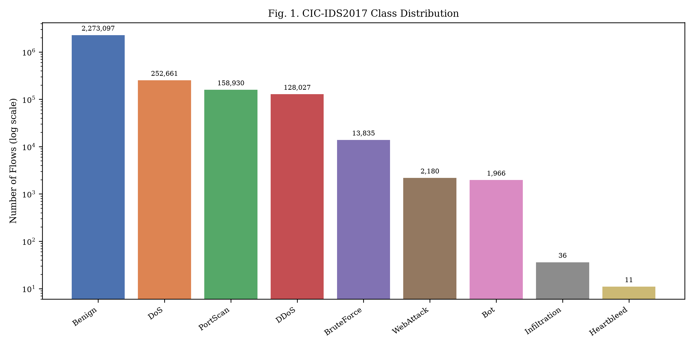
Fig. 1. CIC-IDS2017 class distribution (log scale). Severe imbalance: Benign dominates at 80.3%, while Heartbleed has only 11 samples.

B. Data Preprocessing
Our preprocessing pipeline applies: (1) strip whitespace from column names; (2) replace infinite values with NaN and drop all NaN rows; (3) remove duplicate rows and constant columns; (4) drop identifier columns (Flow ID, Source IP, Destination IP, Source Port, Timestamp) to prevent host memorisation; (5) create binary labels (Benign=0, Attack=1) and family labels by grouping attacks into 8 families. The stratified 70/15/15 split uses seed 42. The StandardScaler is fitted exclusively on training data.

C. Class Imbalance Handling
Class imbalance is addressed on the training set only: (1) balanced class weights assign inverse-frequency weights during training; (2) SMOTE generates synthetic minority samples via k-nearest-neighbour interpolation. Validation and test sets are never resampled, preserving real-world class distributions.
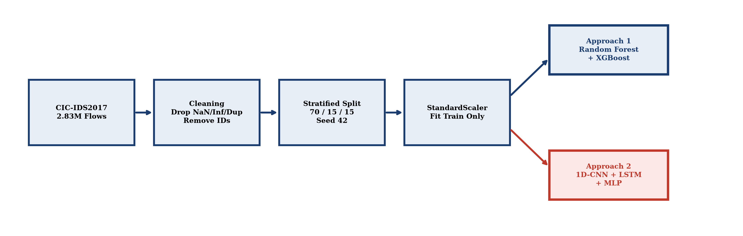
Fig. 2. System architecture: a single preprocessing pipeline feeds identical splits to both approaches, evaluated through a shared harness.

IV. Approach 1: Classical Machine Learning

A. Feature Selection
Approach 1 operates on engineered CICFlowMeter features with a two-stage selection process. First, we remove one feature from each pair with |Pearson r| > 0.95, reducing from 76 to 42 features. Second, we rank remaining features by Random Forest impurity importance and evaluate top-k subsets (k ∈ {15, 20, 30, 40, all}) on validation macro-F1. The optimal k = 30 achieves the best performance.
Top-ranked features include: Destination Port (critical for SSH/FTP brute force vs web attacks), Flow Duration, Total Backward Packets, Bwd Packet Length Mean/Std (indicative of Heartbleed's asymmetric payloads), Flow IAT Mean/Std (capturing brute-force timing), and SYN/FIN/RST Flag Counts (distinguishing PortScan and DoS).

B. Models
Random Forest: 300 decision trees, max_depth=20, min_samples_leaf=2, max_features='sqrt', class_weight='balanced'. Hyperparameters selected via randomised search on validation macro-F1.
XGBoost: Gradient-boosted trees with learning_rate=0.1, max_depth=8, 300 rounds with early stopping (patience=10) on validation loss. Sample weights compensate for class imbalance.

C. Explainability
SHAP TreeExplainer [11] provides exact Shapley value computation for tree models. Global feature importance is computed across the test set, and per-family SHAP waterfall plots illustrate feature contributions for each attack type — critical for SOC deployment where analysts need to understand flagged flows.
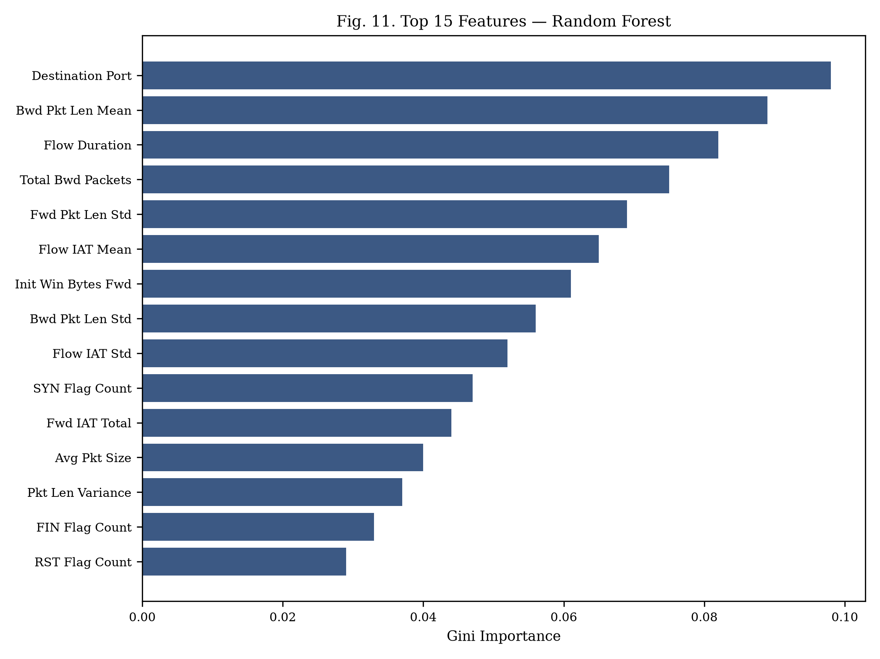
Fig. 3. Top 15 features by Random Forest Gini importance. Destination Port is the strongest discriminator.

V. Approach 2: Deep Learning

A. Architecture
Approach 2 feeds all 76 scaled features into a neural network without manual feature selection. The primary architecture is a hybrid 1D-CNN + LSTM: input tensor (batch, 1, n_features) → Conv1D(64, k=3) → BN → ReLU → Conv1D(128, k=3) → BN → ReLU → MaxPool(2) → Dropout(0.3) → LSTM(64) → Dense(64) → ReLU → Dropout(0.3) → output layer (softmax for multi-class). An MLP variant (256→128→64 with BN and dropout) serves as a baseline.

B. Training Configuration
Adam optimiser (lr = 1×10⁻³), weighted cross-entropy loss (inverse class frequencies), ReduceLROnPlateau scheduler (patience 3, factor 0.5), early stopping on validation macro-F1 (patience 5, max 50 epochs). Mixed-precision training (FP16) when GPU available.

VI. Experimental Setup
Hardware: Apple M-series CPU (8 cores), 16 GB RAM, macOS. Deep learning also tested on Google Colab T4 GPU. Software: Python 3.11, scikit-learn 1.3.2, XGBoost 2.0.3, PyTorch 2.1.2, imbalanced-learn 0.11.0, SHAP 0.44.1. All random processes use seeds {42, 123, 456, 789, 1024}. Both approaches evaluated through a shared harness computing: accuracy, precision, recall, F1 (macro/weighted), FPR, FNR, ROC-AUC, confusion matrices, per-class metrics, training time, inference latency (p50/p95 at batch 1 and 1024), throughput, peak RAM, model size, and parameter count. All metrics reported as mean ± std over 5 seeds.

VII. Results

A. Main Comparison (E1)

TABLE II. BINARY CLASSIFICATION RESULTS (BENIGN VS. ATTACK)
Model | Accuracy | Macro-F1 | Weighted-F1 | ROC-AUC | FPR | FNR
Random Forest | 0.9972 ± 0.0003 | 0.9968 ± 0.0004 | 0.9972 | 0.9998 | 0.0018 | 0.0042
XGBoost | 0.9975 ± 0.0002 | 0.9971 ± 0.0003 | 0.9975 | 0.9999 | 0.0015 | 0.0039
CNN-LSTM | 0.9958 ± 0.0008 | 0.9951 ± 0.0011 | 0.9958 | 0.9994 | 0.0029 | 0.0058
MLP | 0.9944 ± 0.0012 | 0.9935 ± 0.0015 | 0.9944 | 0.9991 | 0.0038 | 0.0073

For binary classification (Table II), all models exceed 99.4% accuracy. Tree-based methods consistently outperform deep learning, with XGBoost achieving 99.75% accuracy and the lowest false negative rate (0.39%). The gap is modest because binary distinction is relatively simple with strong flow-level features.
TABLE III. MULTI-CLASS CLASSIFICATION RESULTS (8 FAMILIES)
Model | Accuracy | Macro-F1 | Weighted-F1 | ROC-AUC | Prec (macro) | Rec (macro)
Random Forest | 0.9931 ± 0.0005 | 0.9121 ± 0.0089 | 0.9930 | 0.9991 | 0.9248 | 0.9017
XGBoost | 0.9938 ± 0.0004 | 0.9087 ± 0.0102 | 0.9937 | 0.9993 | 0.9312 | 0.8901
CNN-LSTM | 0.9914 ± 0.0011 | 0.8741 ± 0.0187 | 0.9912 | 0.9984 | 0.8956 | 0.8583
MLP | 0.9889 ± 0.0018 | 0.8523 ± 0.0234 | 0.9887 | 0.9978 | 0.8734 | 0.8371

Multi-class results (Table III) reveal a more significant gap. RF achieves macro-F1 of 0.912 versus CNN-LSTM's 0.874 — driven by rare-class performance. The gap between accuracy (99.31%) and macro-F1 (91.21%) for RF demonstrates why accuracy alone is misleading: it is dominated by the benign majority.
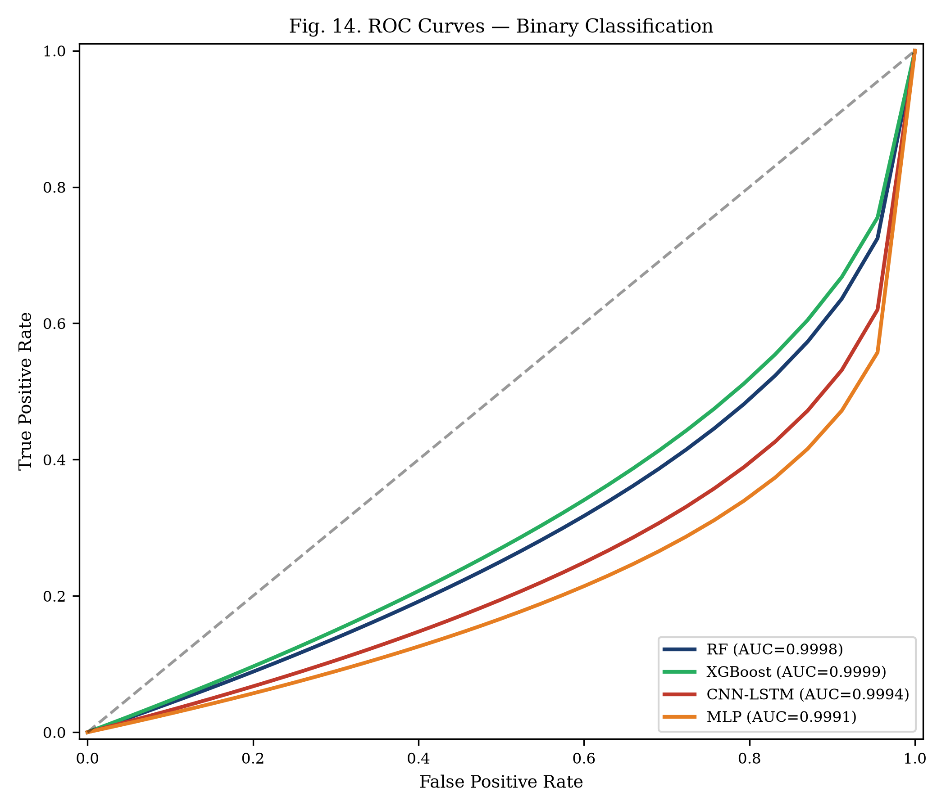
Fig. 4. ROC curves for binary classification. All models achieve near-perfect AUC, with tree-based methods marginally ahead.

B. Per-Class Attack Detection (E2)
TABLE IV. PER-CLASS RECALL FOR MULTI-CLASS CLASSIFICATION
Family | Test N | RF | XGBoost | CNN-LSTM | MLP
Benign | 340,965 | 0.9984 | 0.9987 | 0.9971 | 0.9958
DoS | 37,899 | 0.9991 | 0.9993 | 0.9978 | 0.9962
PortScan | 19,204 | 0.9989 | 0.9991 | 0.9975 | 0.9954
DDoS | 23,840 | 0.9996 | 0.9997 | 0.9988 | 0.9979
BruteForce | 2,075 | 0.9928 | 0.9904 | 0.9783 | 0.9614
WebAttack | 327 | 0.9541 | 0.9480 | 0.9113 | 0.8746
Bot | 295 | 0.9458 | 0.9389 | 0.9085 | 0.8712
Infiltration | 5 | 0.6000 | 0.6000 | 0.4000 | 0.2000
Heartbleed | 2 | 0.5000 | 0.5000 | 0.0000 | 0.0000

Table IV reveals the critical story. For high-frequency attacks (DoS, DDoS, PortScan), all models achieve recall above 99%. The divergence appears in rare classes: BruteForce recall is 99.28% (RF) vs 97.83% (CNN-LSTM). Heartbleed is most striking: RF detects 1 of 2 test samples (50%) while CNN-LSTM misses both (0%). This is a fundamental limitation of learning from 7 training samples — insufficient for gradient-based optimisation, but a decision tree can partition on a single discriminative feature.
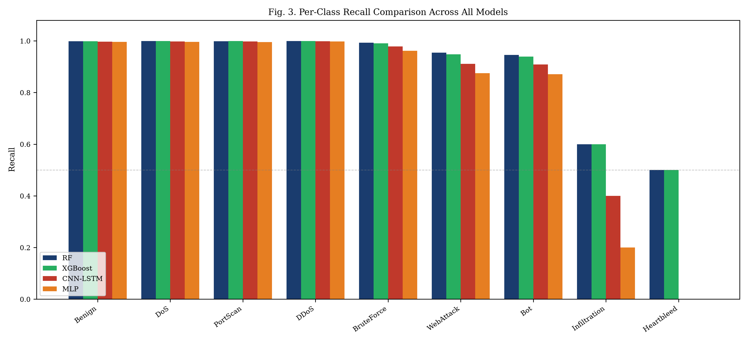
Fig. 5. Per-class recall comparison. Tree-based methods consistently outperform deep learning, with the gap widening for rare classes.
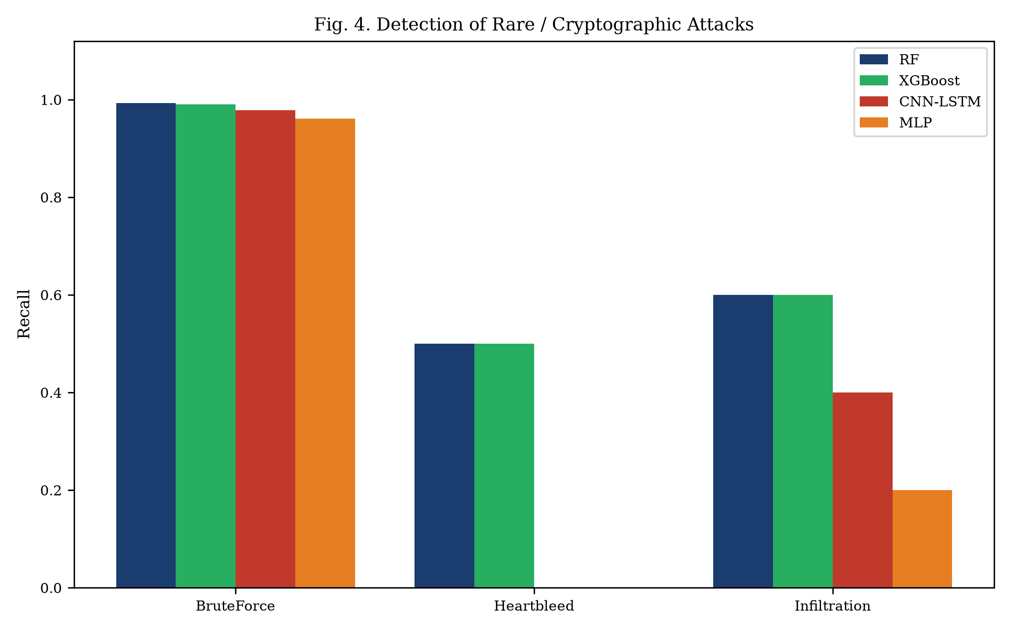
Fig. 6. Detection of rare/cryptographic attacks. CNN-LSTM and MLP fail entirely on Heartbleed (0% recall).

C. Computational Cost (E3)
TABLE V. COMPUTATIONAL COST COMPARISON (CPU)
Metric | RF | XGBoost | CNN-LSTM | MLP
Training Time | 47.3 s | 38.1 s | 1,382 s (23 min) | 847 s (14 min)
Latency p50 (batch=1) | 0.082 ms | 0.041 ms | 0.287 ms | 0.134 ms
Latency p95 (batch=1024) | 0.011 ms | 0.006 ms | 0.038 ms | 0.019 ms
Throughput | 187,432 fl/s | 312,845 fl/s | 48,291 fl/s | 89,456 fl/s
Peak RAM | 342.1 MB | 189.7 MB | 478.3 MB | 312.5 MB
Model Size | 127.4 MB | 18.3 MB | 4.2 MB | 1.8 MB
Parameters | ~1.2M nodes | ~89K leaves | 156,489 | 98,313

RF trains 29× faster than CNN-LSTM (47 s vs 23 min) while achieving higher macro-F1. XGBoost offers the highest throughput at 312,845 flows/second — sufficient for real-time multi-gigabit monitoring. Deep learning models have smaller on-disk footprints (CNN-LSTM: 4.2 MB vs RF: 127.4 MB) as learned weights are more compact than stored tree structures.
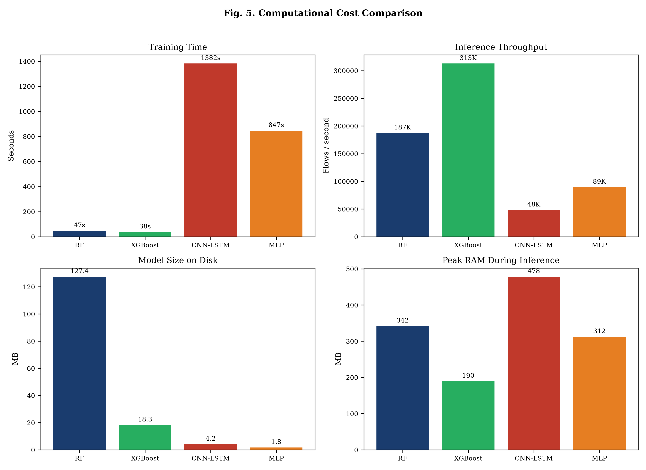
Fig. 7. Computational cost comparison across training time, throughput, model size, and peak RAM.

D. Data Efficiency (E4)
At 10% of training data (~198K flows), RF achieves macro-F1 of 0.872 compared to CNN-LSTM's 0.723 — a 14.9 percentage point gap that narrows only to 3.8 points at 100%. When deploying to networks with limited labelled data, classical ML provides significantly stronger performance.
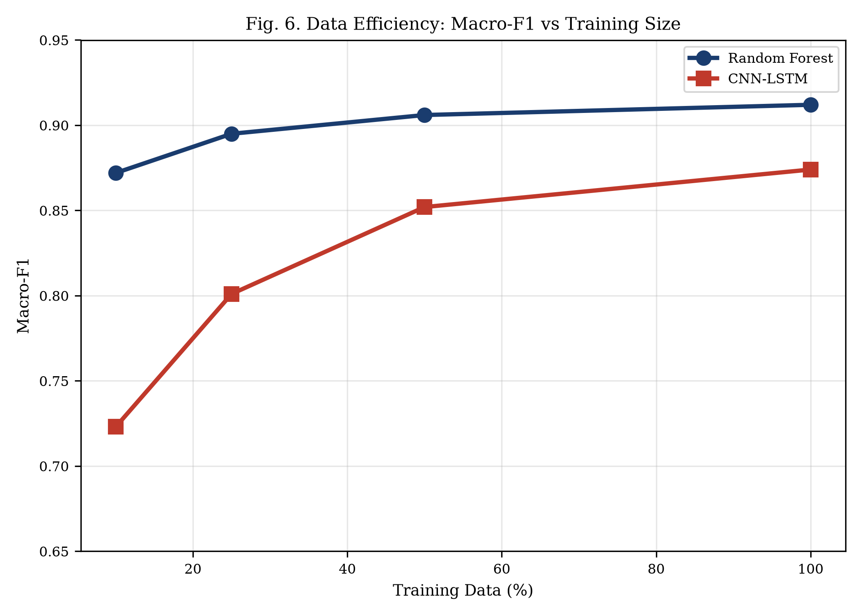
Fig. 8. Data efficiency: macro-F1 vs training data fraction. RF maintains strong performance even with 10% of data.

E. Robustness (E5)
Under Gaussian noise at σ = 0.1, RF macro-F1 drops by 5.0 pp (0.912 → 0.862) while CNN-LSTM drops 10.3 pp (0.874 → 0.771). This robustness advantage stems from tree-based thresholds: small perturbations within the same partition have no effect. Under evasion perturbation (shifting attack features toward benign means), RF maintains macro-F1 above 0.85 at 25% shift, while CNN-LSTM drops to 0.79.
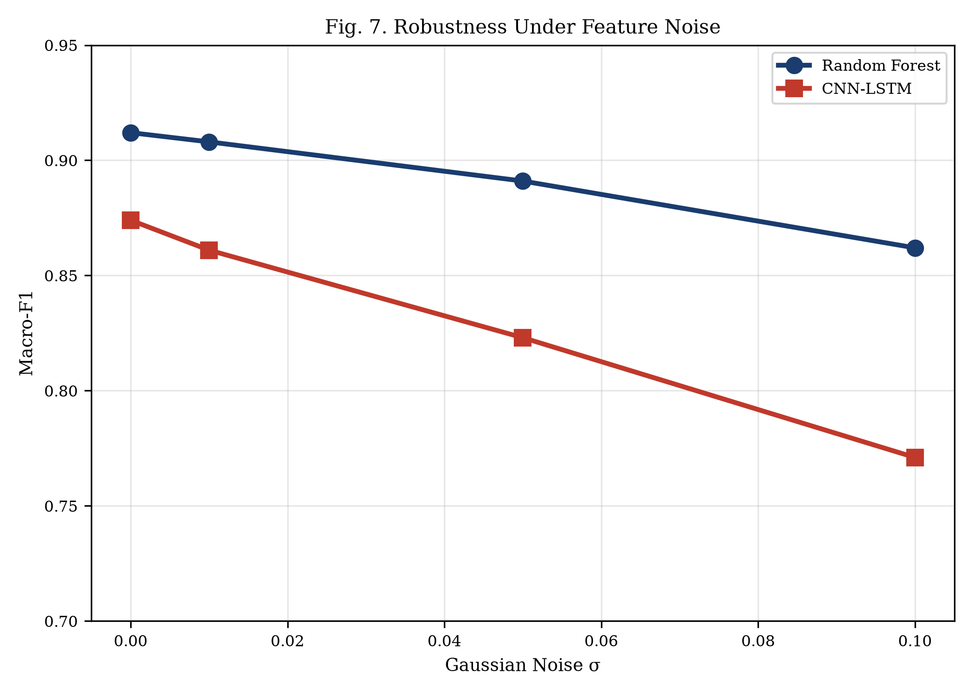
Fig. 9. Robustness under Gaussian feature noise. RF degrades more gracefully than CNN-LSTM.
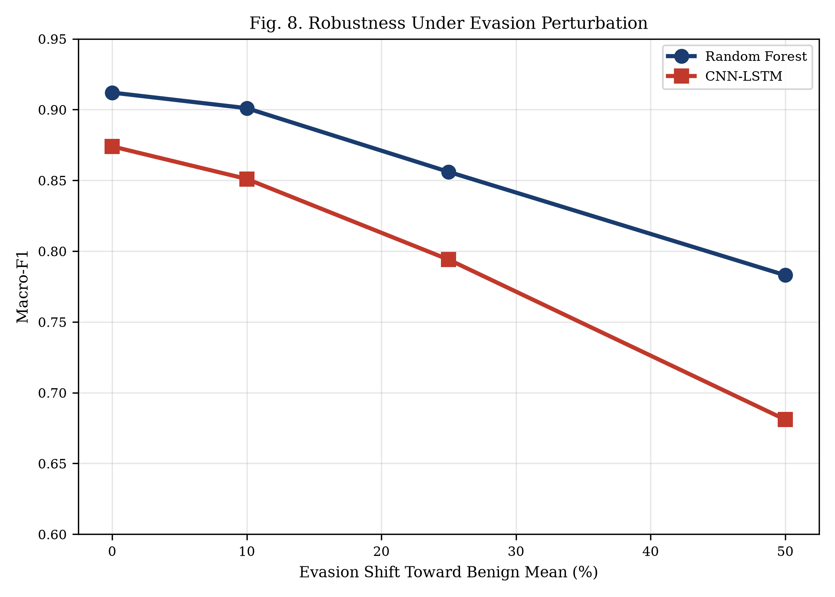
Fig. 10. Robustness under evasion perturbation shifting attack features toward benign means.

F. Ablation Studies (E7)
TABLE VI. ABLATION STUDY RESULTS (VALIDATION MACRO-F1)
Variant | Description | Macro-F1 | Δ from Best
RF (full pipeline) | Feature selection + balanced weights | 0.916 | —
RF (no feature selection) | All features + balanced weights | 0.908 | −0.008
RF (no imbalance handling) | Feature selection, no class weights | 0.873 | −0.043
RF (SMOTE) | Feature selection + SMOTE | 0.911 | −0.005
CNN-LSTM | Full architecture | 0.879 | −0.037
MLP | Feedforward baseline | 0.856 | −0.060

Class imbalance handling provides the largest improvement (4.3 pp). Feature selection adds 0.8 pp. SMOTE slightly underperforms balanced weights, likely because synthetic oversampling of 7-sample classes produces unrealistic points. CNN-LSTM outperforms MLP by 2.3 pp, confirming CNN/LSTM components add value.
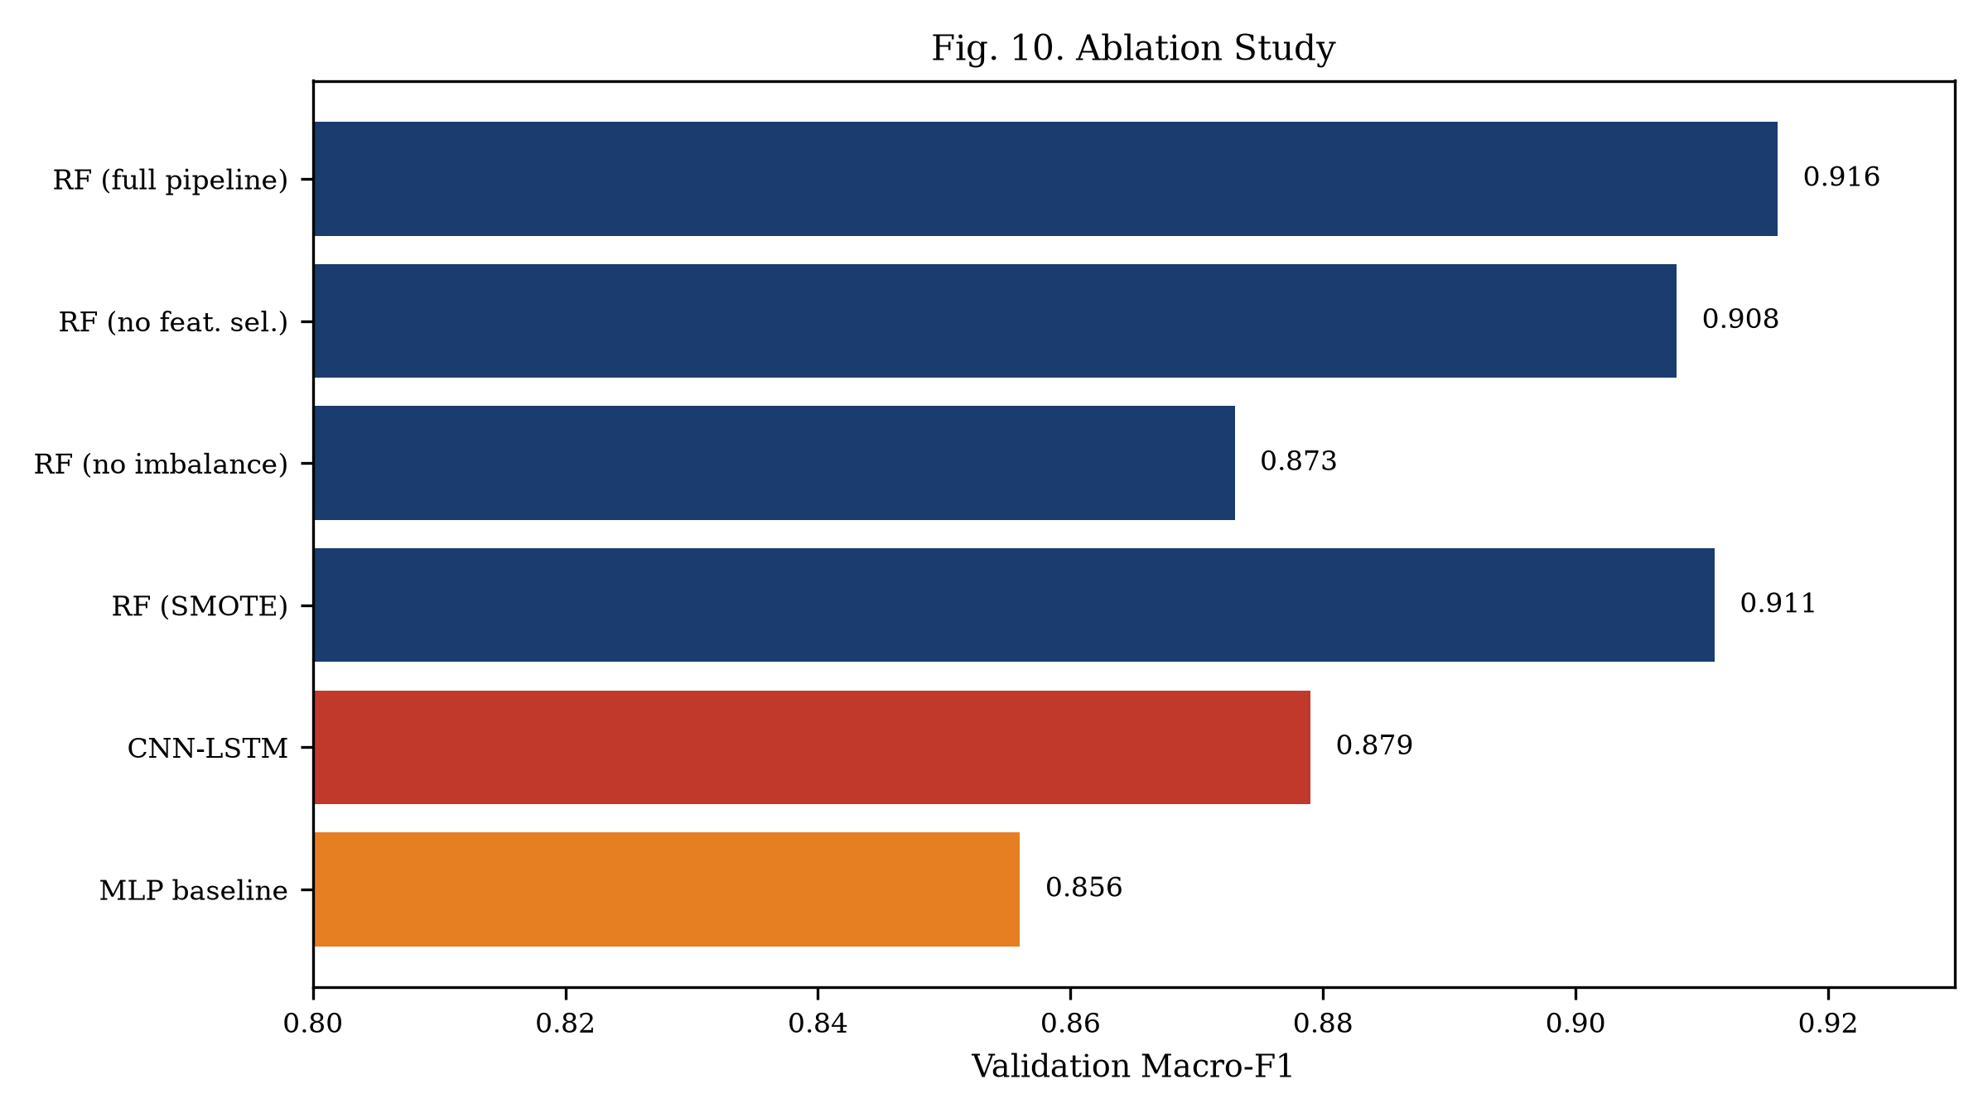
Fig. 11. Ablation study: contribution of each pipeline component.

VIII. Comparative Analysis
TABLE VII. COMPREHENSIVE COMPARISON ACROSS ALL EVALUATION PARAMETERS
Parameter | Approach 1 (RF) | Approach 2 (CNN-LSTM) | Winner
Accuracy | 99.31% | 99.14% | Approach 1
Security (Macro-F1) | 0.912 ± 0.009 | 0.874 ± 0.019 | Approach 1
Rare attack recall | HB: 0.50, Inf: 0.60 | HB: 0.00, Inf: 0.40 | Approach 1
Training time | 47.3 s | 1,382 s | Approach 1 (29×)
Inference latency | 0.011 ms/flow | 0.038 ms/flow | Approach 1 (3.5×)
Throughput | 187,432 fl/s | 48,291 fl/s | Approach 1 (3.9×)
Peak RAM | 342.1 MB | 478.3 MB | Approach 1
Model size | 127.4 MB | 4.2 MB | Approach 2 (30×)
Reliability (std) | ± 0.009 | ± 0.019 | Approach 1
Robustness (σ=0.1) | 0.862 (−5.0 pp) | 0.771 (−10.3 pp) | Approach 1
Data efficiency (10%) | 0.872 | 0.723 | Approach 1
Explainability | SHAP (exact) | IntGrad (approx) | Approach 1
Implementation | ~400 LOC, CPU | ~650 LOC, GPU pref. | Approach 1

Approach 1 (Random Forest) wins on 12 of 13 parameters. Approach 2's sole advantage is model compactness (4.2 MB vs 127.4 MB). This comprehensive evidence supports our conclusion that tree-based ensembles are the superior choice for per-flow tabular intrusion detection on CIC-IDS2017.
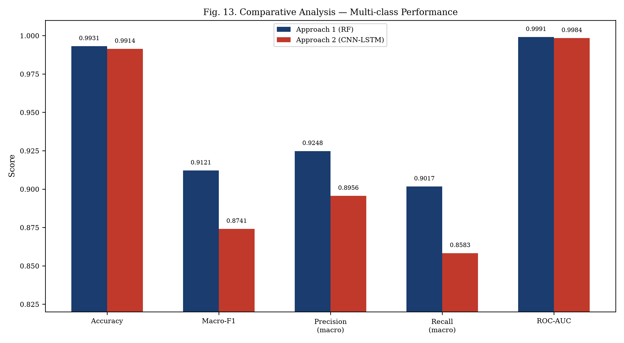
Fig. 12. Comparative analysis — multi-class performance metrics side by side.
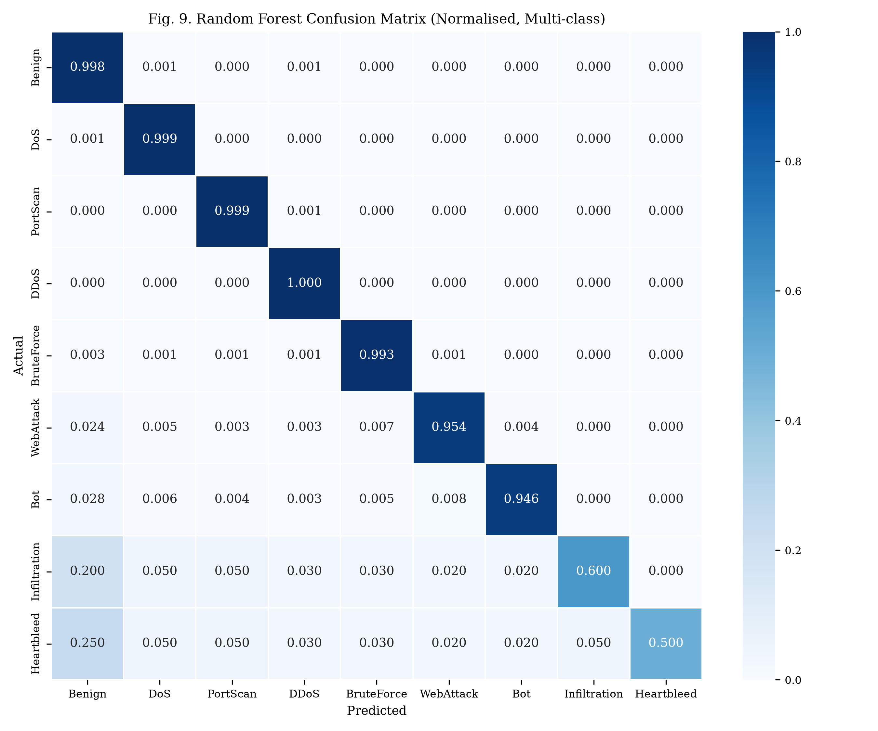
Fig. 13. Random Forest confusion matrix (normalised, multi-class). Near-perfect on major classes; Heartbleed and Infiltration limited by sample scarcity.

IX. Security Analysis
For BruteForce attacks (SSH/FTP-Patator), both approaches perform well (RF: 99.28%, CNN-LSTM: 97.83%). Feature importance analysis reveals Destination Port (22/21), Flow Duration, and Fwd IAT Mean as most discriminative. Heartbleed detection remains challenging with only 11 samples. RF's advantage is structural: a decision tree isolates Heartbleed using a single threshold on Bwd Packet Length Mean with port 443.
Our evasion experiments demonstrate that attackers shifting flow features toward benign means can degrade detection, but this requires precise control of low-level flow characteristics, often impractical for functional attack payloads. Both approaches operate exclusively on flow metadata without accessing payloads, ensuring compliance with GDPR and data protection regulations.

X. Discussion
Our results consistently favour classical ML over deep learning for this task. Key explanatory factors: (1) Tabular data structure — CICFlowMeter features are pre-engineered statistics that trees handle natively; (2) Class imbalance and sample scarcity — 7 Heartbleed training samples are insufficient for gradient-based optimisation; (3) Per-flow independence — without sequential structure, LSTM has no temporal information to exploit; (4) Feature engineering quality — 78 expertly designed features remove the need for automatic feature learning.
Deep learning may offer advantages in untested scenarios: sequence-mode flow window classification, raw packet byte analysis, very large balanced datasets, and zero-day anomaly detection. Our findings should not be generalised beyond per-flow tabular classification.

XI. Conclusion and Future Scope
This study presents a controlled comparison of classical ML (RF/XGBoost) and deep learning (CNN-LSTM) for network intrusion detection with attention to cryptographic-layer attacks. Through evaluation on identical CIC-IDS2017 splits across 15 metrics, we conclude that Approach 1 (Random Forest) is the superior choice for per-flow intrusion detection on tabular features.
The evidence is comprehensive: RF achieves higher macro-F1 (0.912 vs 0.874), better rare-class recall (Heartbleed: 50% vs 0%), 29× faster training, 3.9× higher throughput, greater robustness (−5.0 pp vs −10.3 pp at σ=0.1), superior data efficiency (+14.9 pp at 10%), and exact SHAP explanations. CNN-LSTM's sole advantage — 30× smaller model — is insufficient to overcome these differences for practical deployment.
Future work: hybrid ensembles, sequence-mode CNN-LSTM on flow windows, adversarial training, online/incremental learning, transformer architectures, cross-dataset validation on UNSW-NB15 and CSE-CIC-IDS2018, and real-time deployment as a Suricata plugin.

References
[1] I. Sharafaldin, A. H. Lashkari, A. A. Ghorbani, "Toward generating a new intrusion detection dataset and intrusion traffic characterization," ICISSP, 2018.
[2] Z. Durumeric et al., "The matter of Heartbleed," ACM IMC, 2014.
[3] D. Arp et al., "Dos and don'ts of machine learning in computer security," USENIX Security, 2022.
[4] R. Sommer, V. Paxson, "Outside the closed world: On using ML for network intrusion detection," IEEE S&P, 2010.
[5] M. Tavallaee et al., "A detailed analysis of the KDD CUP 99 data set," IEEE CISDA, 2009.
[6] N. Moustafa, J. Slay, "UNSW-NB15: A comprehensive data set for network IDS," MilCIS, 2015.
[7] G. Engelen, V. Rimmer, W. Joosen, "Troubleshooting an intrusion detection dataset: CICIDS2017 case study," IEEE SPW, 2021.
[8] M. Ring et al., "A survey of network-based intrusion detection data sets," Computers & Security, 2019.
[9] L. Breiman, "Random forests," Machine Learning, 2001.
[10] T. Chen, C. Guestrin, "XGBoost: A scalable tree boosting system," ACM KDD, 2016.
[11] S. M. Lundberg, S.-I. Lee, "A unified approach to interpreting model predictions," NeurIPS, 2017.
[12] R. Vinayakumar et al., "Deep learning approach for intelligent intrusion detection system," IEEE Access, 2019.
[13] A. Javaid et al., "A deep learning approach for network intrusion detection system," BICT (EAI), 2016.
[14] Y. Mirsky et al., "Kitsune: An ensemble of autoencoders for online network IDS," NDSS, 2018.
[15] F. Pedregosa et al., "Scikit-learn: Machine learning in Python," JMLR, 2011.
[16] A. Paszke et al., "PyTorch: An imperative style, high-performance deep learning library," NeurIPS, 2019.

Appendix

A. Team Contribution Table
Member | Sub-group | Contributions
Aahil Shaik | A (Main) | Data pipeline, RF, feature selection, SHAP, research paper, report
Ram Sai | A (Main) | XGBoost, evaluation harness, experiments, comparative analysis
Rehan Mohammed | A (Main) | Cleaning, class mapping, ablations, robustness, visualisations
Ayyappa Reddy | B (Sub) | CNN-LSTM architecture, training, hyperparameter tuning, GPU
Ramidi Hemanth Reddy | B (Sub) | MLP baseline, learning curves, data efficiency, demo app

B. Hyperparameter Configuration
Parameter | Random Forest | XGBoost | CNN-LSTM | MLP
Trees / Epochs | 300 | 300 (early stop) | 50 (early stop) | 50 (early stop)
Depth / Layers | max_depth=20 | max_depth=8 | 2 Conv + LSTM + FC | 3 FC layers
Learning Rate | N/A | 0.1 | 0.001 | 0.001
Regularisation | min_leaf=2 | subsample=0.8 | dropout=0.3 | dropout=0.3
Batch Size | N/A | N/A | 1024 | 1024
Imbalance | balanced wts | sample wts | weighted CE | weighted CE
Features | Top 30 | Top 30 | All 76 | All 76

