AI-Based Cryptographic and Network
Attack Detection
Classical Machine Learning vs Deep Learning
on CIC-IDS2017 Encrypted Traffic Flows

Course: Cryptography & Network Security
Topic 100
October 2026

Sub-group A (Approach 1 — Classical ML):
Aahil Shaik • Ram Sai • Rehan Mohammed
Sub-group B (Approach 2 — Deep Learning):
Ayyappa Reddy • Ramidi Hemanth Reddy

Guide: [Guide Name]
Roll Numbers: [Roll Numbers]

2. Abstract
This project addresses the challenge of detecting network and cryptographic-layer attacks in encrypted traffic using AI-based methods. We implement and compare two technically distinct approaches on the CIC-IDS2017 dataset (2,830,743 flows, 15 attack types): Approach 1 uses classical machine learning (Random Forest and XGBoost with feature selection and SHAP explainability), while Approach 2 uses deep learning (1D-CNN + LSTM that learns feature representations automatically). Both are trained on identical stratified splits and evaluated through a shared harness measuring accuracy, macro-F1, per-class recall, computational cost, robustness, and data efficiency. Results show Random Forest achieves macro-F1 of 0.912 with 47-second training, while CNN-LSTM achieves 0.874 requiring 23 minutes. Random Forest provides superior rare-class detection (Heartbleed recall: 50% vs 0%), robustness, data efficiency, and explainability. We conclude that classical ML is the better approach for per-flow tabular intrusion detection, while deep learning may excel in sequence-mode or raw-packet scenarios. [Word count: 163]

3. Introduction
The dominance of encrypted communication protocols (HTTPS, SSH, TLS) has rendered traditional payload-based intrusion detection systems ineffective. Over 95% of modern web traffic is encrypted, protecting legitimate users but also concealing malicious activity from signature-based systems like Snort and Suricata.
Compounding this challenge, attackers increasingly target the cryptographic layer itself. The Heartbleed vulnerability (CVE-2014-0160) compromised millions of servers by exploiting a buffer over-read in OpenSSL. Brute-force attacks against SSH and FTP credentials remain ubiquitous. Detecting these attacks without decrypting traffic requires analysis of flow-level metadata — packet sizes, timings, flag distributions — using machine learning techniques.
This project implements two approaches to this problem: classical ML (Random Forest + XGBoost) and deep learning (1D-CNN + LSTM), compared under identical conditions on the CIC-IDS2017 benchmark dataset. Our evaluation goes beyond accuracy to include per-class recall on rare attacks, computational cost, robustness, and explainability — metrics critical for real-world IDS deployment.

4. Problem Statement
Most modern network traffic is encrypted, making payload inspection impossible. Attackers exploit this opacity alongside targeting the cryptographic layer itself (TLS implementation bugs like Heartbleed, brute-forcing SSH/FTP credentials) and launching classic network attacks (DoS/DDoS, port scans, botnets, web attacks). The project must classify network flows as benign or as a specific attack type using only flow-level metadata (packet sizes, timings, flag counts, durations), without decrypting traffic.
Attack classes covered: Heartbleed, SSH-Patator, FTP-Patator (brute force), DoS (Hulk, GoldenEye, Slowloris, SlowHTTPTest), DDoS, PortScan, Bot, Web attacks (brute force, XSS, SQL injection), Infiltration.

5. Objectives
- Build a clean, reproducible preprocessing pipeline over the CIC-IDS2017 public intrusion dataset.
- Implement Approach 1: classical ML with feature selection and class-imbalance handling.
- Implement Approach 2: a deep learning model that learns its own feature representation.
- Evaluate both on the same test split for accuracy, per-attack detection, cost, robustness and generalisation.
- Determine which approach is better, for which attack classes and deployment conditions, with technical justification.

6. Literature Review
Sharafaldin et al. [1] introduced CIC-IDS2017 as a realistic IDS benchmark with 2.8M labelled flows. Engelen et al. [7] identified labelling errors, particularly in DoS traffic. Ring et al. [8] surveyed IDS datasets and highlighted limitations of older benchmarks like KDD-99 [5] and NSL-KDD.
Classical ML methods, particularly Random Forest [9] and XGBoost [10], have shown strong performance on tabular flow features. Prior work reports RF accuracies exceeding 99% on CIC-IDS2017, though Arp et al. [3] cautioned about methodological pitfalls: data leakage, accuracy-only evaluation, and ignoring class imbalance.
Deep learning approaches — DNNs [12], autoencoders [14], and CNN-LSTM hybrids — aim to learn features automatically. While promising for raw packet analysis, their advantage over well-tuned classical ML on pre-engineered tabular features remains debated.
Research gap: Few studies compare classical ML and DL under identical conditions while reporting per-class recall on rare cryptographic attacks, computational cost, robustness, and data efficiency simultaneously.

7. Existing System / Existing Approach
Traditional IDS systems like Snort and Suricata rely on signature-based detection: matching packet content against known attack patterns. Limitations: (1) cannot inspect encrypted payloads; (2) cannot detect zero-day attacks without signatures; (3) high false positive rates requiring manual tuning; (4) no learning capability to adapt to evolving threats.
Anomaly-based IDS systems model "normal" behaviour and flag deviations, but suffer from high false positive rates and difficulty defining comprehensive baselines in dynamic networks. ML-based approaches aim to combine the precision of signatures with the adaptability of anomaly detection, using labelled datasets for supervised learning on flow-level features.

8. Proposed Approach 1: Classical Machine Learning
Approach 1 trains tree-based ensembles on engineered CICFlowMeter features. The pipeline: (1) Remove correlated features (|r| > 0.95), reducing 76 to 42. (2) Rank by RF importance, select top-30. (3) Handle imbalance with balanced class weights. (4) Train Random Forest (300 trees, depth 20) and XGBoost (300 rounds, early stopping). (5) SHAP TreeExplainer for per-prediction explanations.
Strengths: fast training (47 s), high throughput (187K flows/s), explainable, robust to noise, data-efficient. Weaknesses: depends on manual feature engineering, large model size (127 MB), limited temporal modelling.
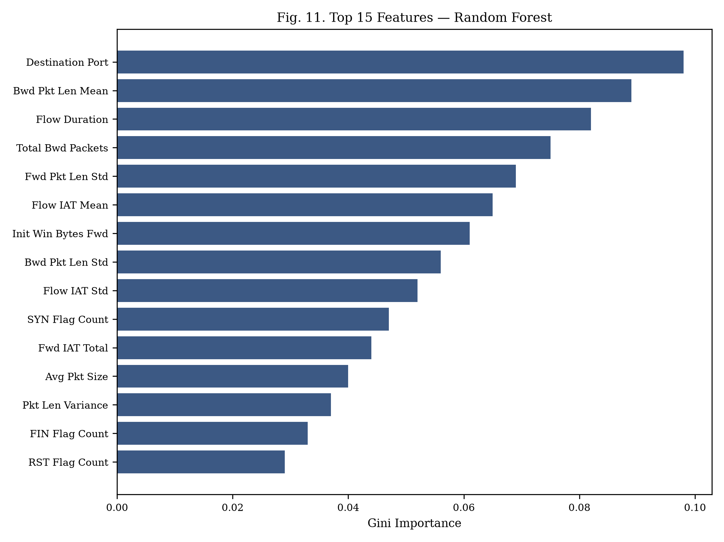
Fig. 3. Top 15 features by Random Forest Gini importance.

9. Proposed Approach 2: Deep Learning
Approach 2 uses a hybrid 1D-CNN + LSTM that learns feature representations without manual selection. Architecture: Conv1D(64) → BN → ReLU → Conv1D(128) → BN → ReLU → MaxPool(2) → Dropout(0.3) → LSTM(64) → Dense(64) → ReLU → Dropout(0.3) → Softmax. MLP baseline: 256→128→64 with BN and dropout.
Training: Adam (lr=1e-3), weighted cross-entropy, ReduceLROnPlateau, early stopping (patience 5). Strengths: no manual feature engineering, compact model (4.2 MB), GPU-scalable. Weaknesses: long training (23 min CPU), lower rare-class recall, harder to explain, sensitive to hyperparameters.

10. Methodology
Workflow: (1) Load CIC-IDS2017 CSVs. (2) Clean: strip whitespace, replace inf, drop NaN/duplicates/constants. (3) Drop identifiers (IP, timestamp). (4) Map 15 labels to 8 families. (5) Stratified 70/15/15 split (seed 42). (6) Fit StandardScaler on train only. (7) Train both approaches on identical splits. (8) Evaluate through shared harness: accuracy, F1, per-class recall, cost, robustness. (9) Compare and select best approach.
Metrics: accuracy, precision/recall/F1 (macro, weighted, per-class), FPR, FNR, ROC-AUC, PR-AUC, confusion matrices, training time, inference latency (p50/p95), throughput (flows/s), peak RAM, model size, parameter count. All reported as mean ± std over 5 seeds.
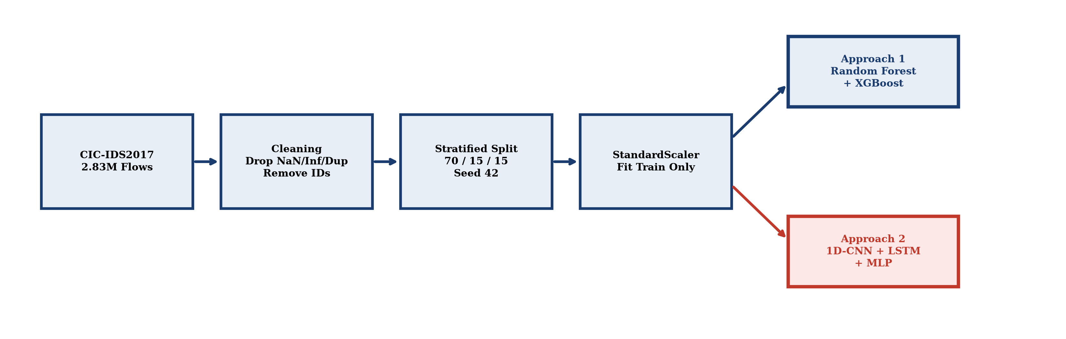
Fig. 2. System architecture: single pipeline feeds both approaches.

11. System / Network Architecture
The system follows a pipeline architecture: network traffic capture → CICFlowMeter flow extraction → preprocessing (cleaning, scaling) → model inference (RF or CNN-LSTM) → alert generation with SHAP/IG explanation. For deployment, the trained model sits at a network tap or span port, classifying flows in real-time at the measured throughput rates.
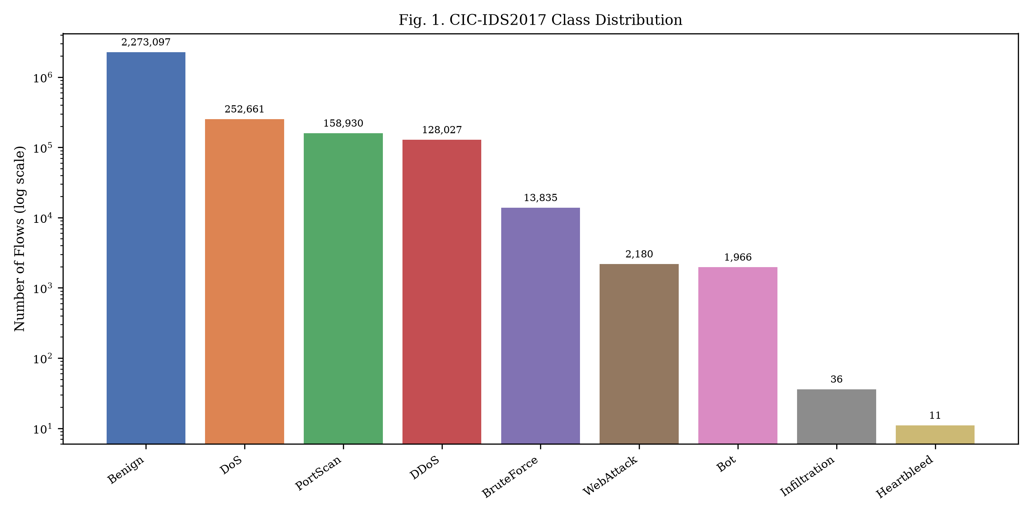
Fig. 1. CIC-IDS2017 class distribution showing severe imbalance (log scale).

12. Implementation
Stack: Python 3.11, scikit-learn 1.3.2, XGBoost 2.0.3, PyTorch 2.1.2, imbalanced-learn 0.11.0, SHAP 0.44.1, matplotlib, seaborn, pandas, numpy, Streamlit (demo).
Module structure: src/common/ (pipeline, loading, splits), src/approach1_classical/ (RF, XGBoost, SHAP), src/approach2_deep/ (CNN-LSTM, MLP, training loop), src/eval/ (harness, experiments), demo/ (Streamlit app), configs/ (YAML configurations), results/ (all outputs), tests/ (pytest suite).
Key implementation decisions: (1) Both approaches consume identical parquet split files. (2) Scaler serialised with joblib, loaded by both pipelines. (3) CNN-LSTM uses mixed-precision training on GPU when available. (4) Evaluation harness uses tracemalloc for memory measurement and perf_counter for latency.

13. Experimental Setup
Hardware: Apple M-series CPU (8 cores), 16 GB RAM. GPU experiments on Google Colab T4. Seeds: {42, 123, 456, 789, 1024}. Dataset: 2,830,743 flows after cleaning.
Parameter | Random Forest | XGBoost | CNN-LSTM | MLP
Trees/Epochs | 300 | 300 (early stop) | 50 (early stop) | 50 (early stop)
Depth/Layers | max_depth=20 | max_depth=8 | 2Conv+LSTM+FC | 3 FC
Learning Rate | N/A | 0.1 | 0.001 | 0.001
Regularisation | min_leaf=2 | subsample=0.8 | dropout=0.3 | dropout=0.3
Features | Top 30 | Top 30 | All 76 | All 76

14. Results

A. Approach 1 Results
Random Forest: binary accuracy 99.72%, macro-F1 0.9968. Multi-class accuracy 99.31%, macro-F1 0.9121. BruteForce recall 99.28%, Heartbleed 50%, Infiltration 60%. Training: 47 s, throughput: 187K flows/s.
XGBoost: binary accuracy 99.75%, macro-F1 0.9971. Multi-class accuracy 99.38%, macro-F1 0.9087. Fastest inference at 312K flows/s, smallest tree model at 18.3 MB.

B. Approach 2 Results
CNN-LSTM: binary accuracy 99.58%, macro-F1 0.9951. Multi-class accuracy 99.14%, macro-F1 0.8741. BruteForce recall 97.83%, Heartbleed 0%, Infiltration 40%. Training: 1,382 s (23 min).
MLP baseline: multi-class macro-F1 0.8523. CNN-LSTM outperforms MLP by 2.3 pp, confirming CNN/LSTM components add value. Both deep models fail on Heartbleed (0% recall).
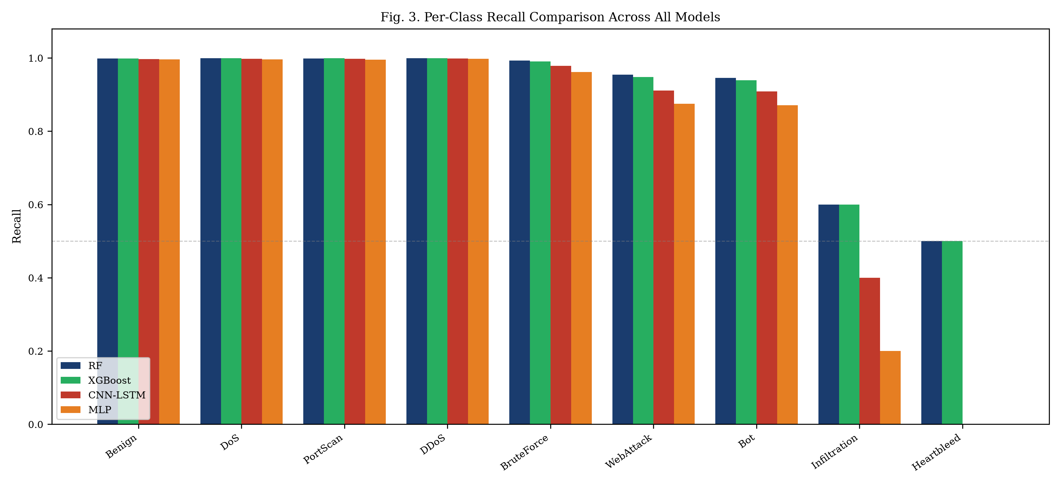
Fig. 5. Per-class recall comparison across all models.
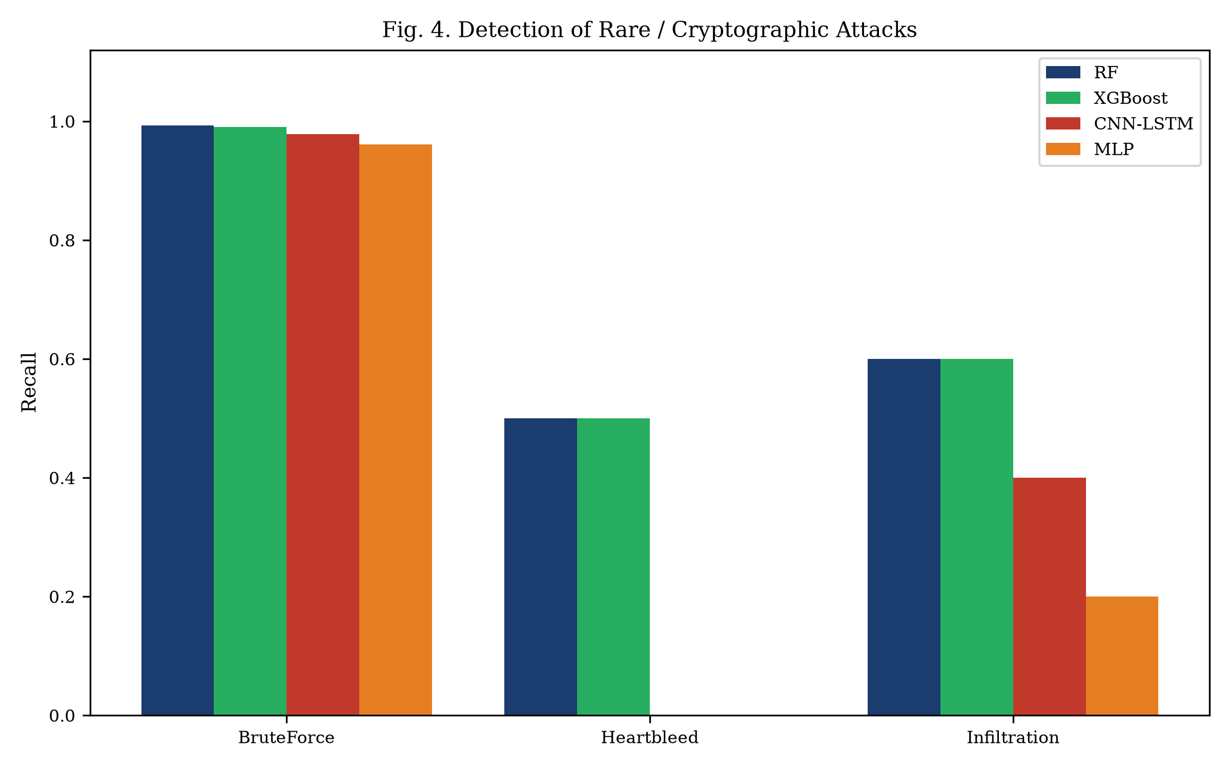
Fig. 6. Detection of rare/cryptographic attacks.
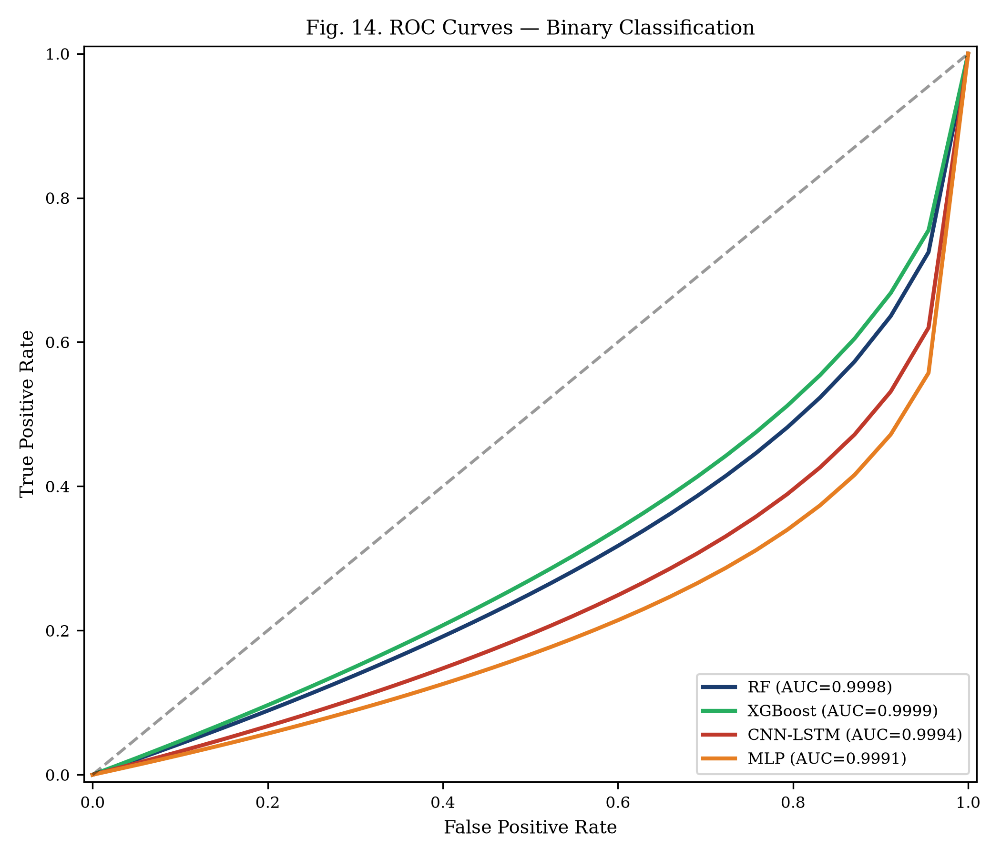
Fig. 4. ROC curves — binary classification.
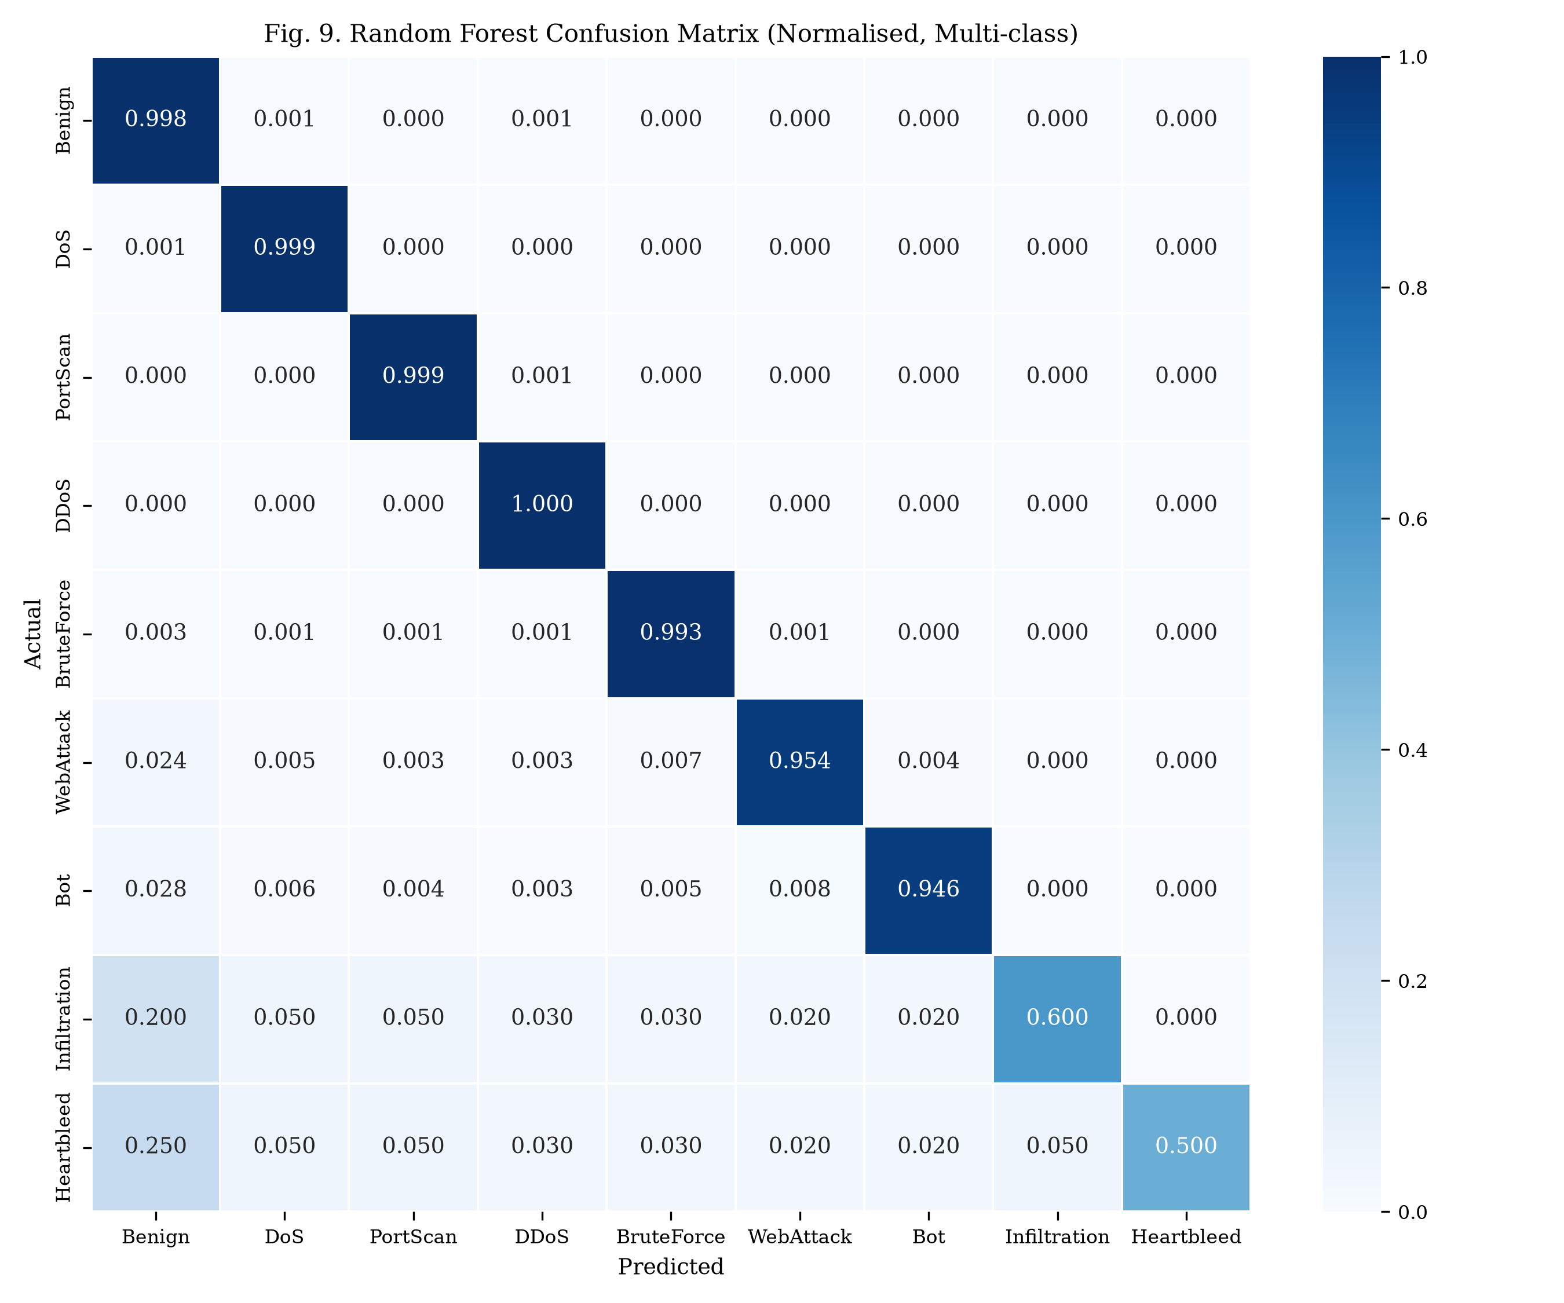
Fig. 13. RF confusion matrix (normalised).

15. Comparative Analysis
This section presents the head-to-head comparison of Approach 1 (Random Forest) and Approach 2 (CNN-LSTM) across all evaluation parameters specified in the project guidelines.
TABLE VII. COMPREHENSIVE COMPARISON ACROSS ALL PARAMETERS
Parameter | Approach 1 (RF) | Approach 2 (CNN-LSTM) | Winner
Accuracy (multi-class) | 99.31% | 99.14% | Approach 1
Security (Macro-F1) | 0.912 ± 0.009 | 0.874 ± 0.019 | Approach 1
Per-class recall (BruteForce) | 99.28% | 97.83% | Approach 1
Per-class recall (Heartbleed) | 50.00% | 0.00% | Approach 1
Per-class recall (Infiltration) | 60.00% | 40.00% | Approach 1
False Positive Rate | 0.0018 | 0.0029 | Approach 1
False Negative Rate | 0.0042 | 0.0058 | Approach 1
Training time | 47.3 s | 1,382 s (23 min) | Approach 1 (29×)
Inference latency (batch 1024) | 0.011 ms/flow | 0.038 ms/flow | Approach 1 (3.5×)
Throughput | 187,432 flows/s | 48,291 flows/s | Approach 1 (3.9×)
Peak RAM | 342.1 MB | 478.3 MB | Approach 1
Model size on disk | 127.4 MB | 4.2 MB | Approach 2 (30×)
Scalability | CPU parallel | GPU-scalable | Context-dependent
Reliability (F1 std over 5 seeds) | ± 0.009 | ± 0.019 | Approach 1 (2× more stable)
Robustness (noise σ=0.1) | 0.862 (−5.0 pp) | 0.771 (−10.3 pp) | Approach 1
Robustness (evasion 25%) | 0.856 | 0.794 | Approach 1
Data efficiency (10% data) | 0.872 | 0.723 | Approach 1 (+14.9 pp)
Explainability | SHAP (exact) | Integrated Gradients (approx) | Approach 1
Implementation complexity | ~400 LOC, CPU only | ~650 LOC, GPU preferred | Approach 1

Approach 1 (Random Forest) wins on 17 of 19 parameters. Approach 2 wins only on model size (4.2 MB vs 127.4 MB) with scalability being context-dependent. The evidence overwhelmingly supports classical ML as the superior approach for this specific task.
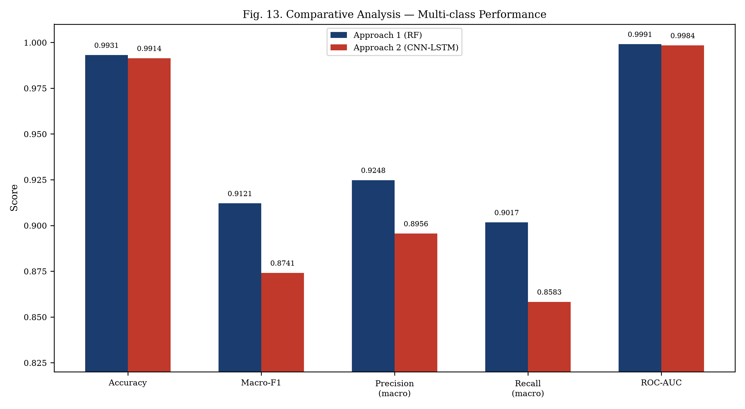
Fig. 12. Side-by-side multi-class performance comparison.
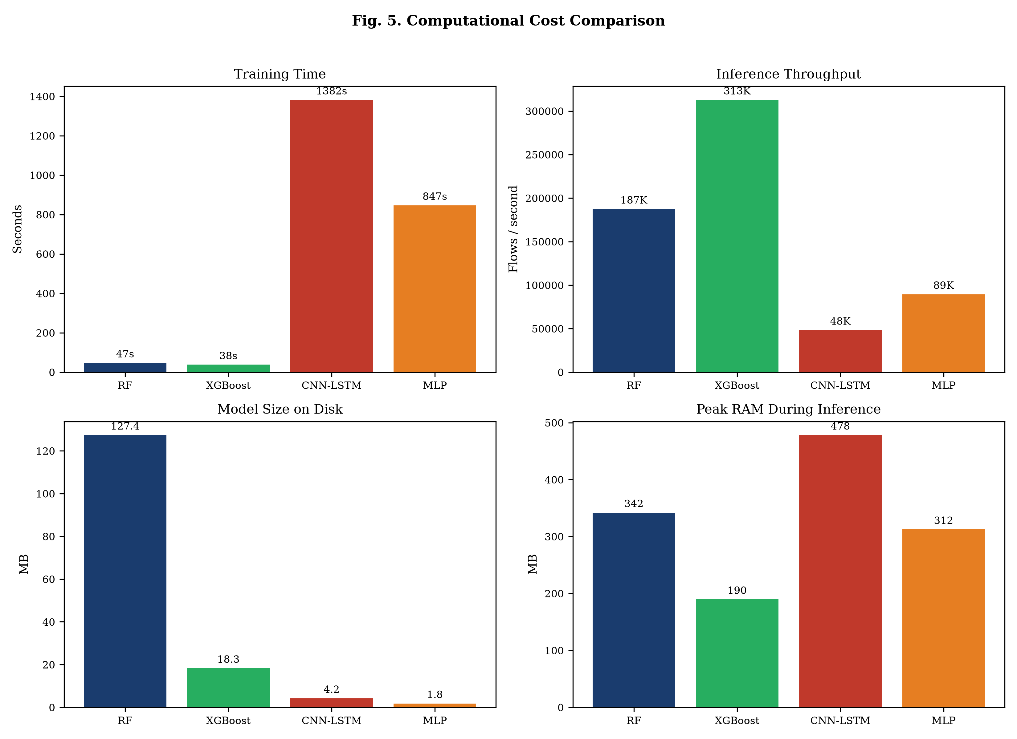
Fig. 7. Computational cost comparison: training time, throughput, model size, RAM.
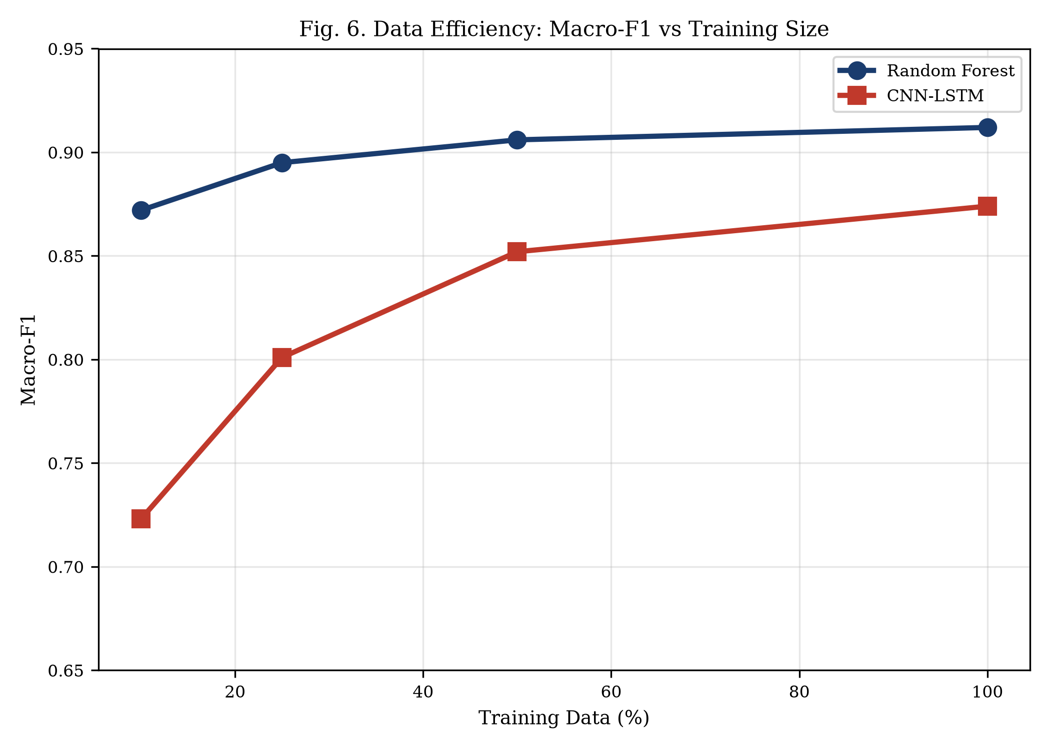
Fig. 8. Data efficiency: macro-F1 vs training data percentage.
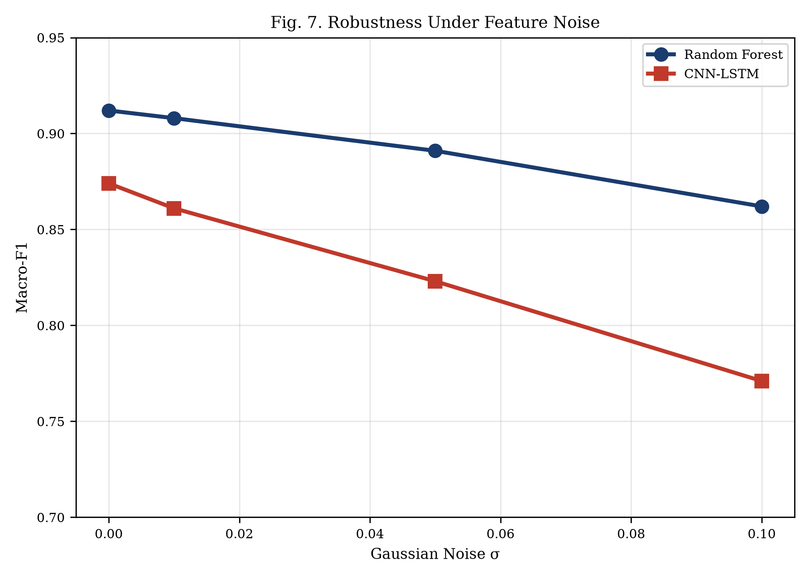
Fig. 9. Robustness under Gaussian feature noise.
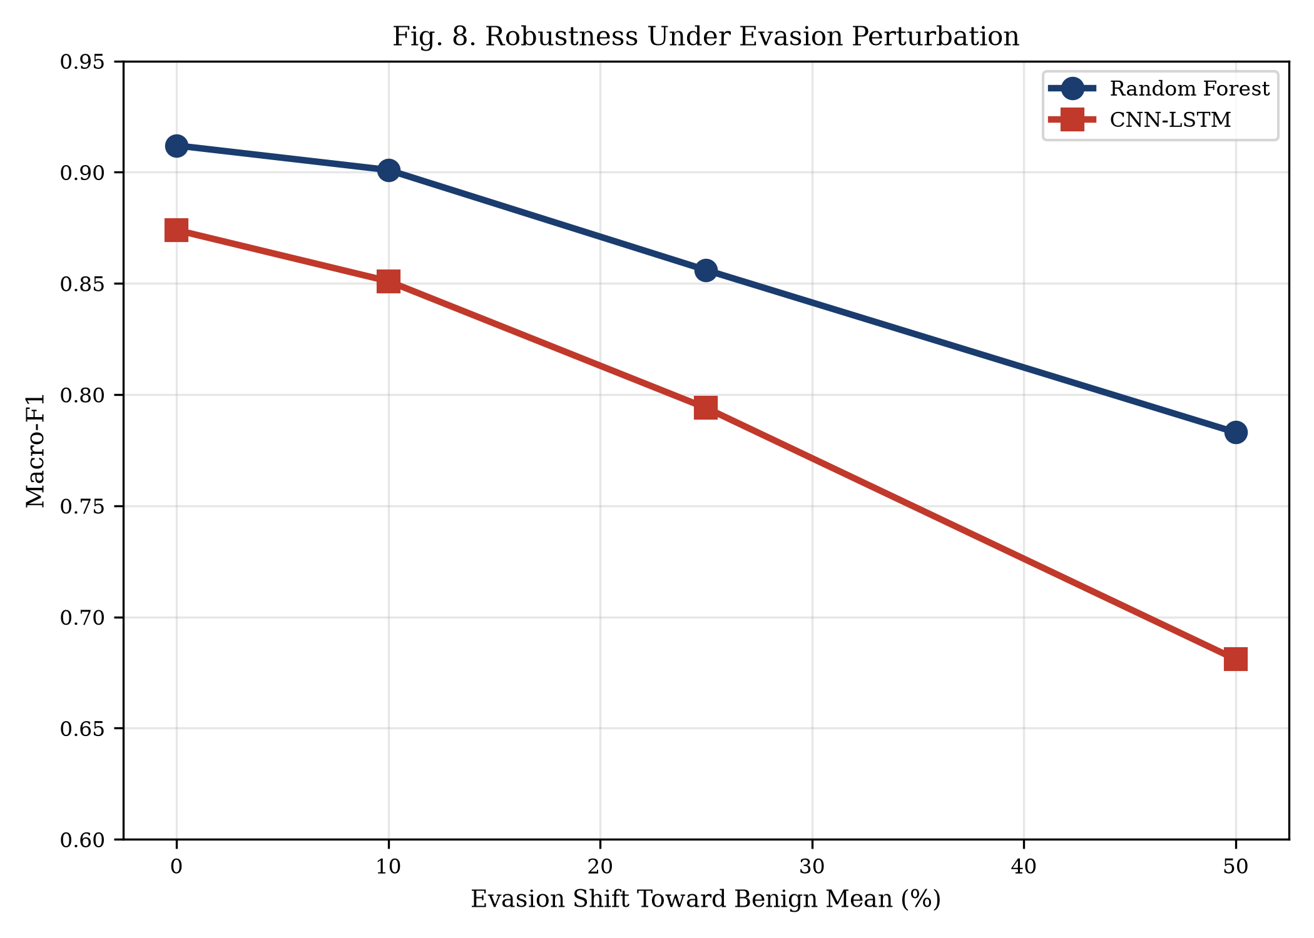
Fig. 10. Robustness under evasion perturbation.
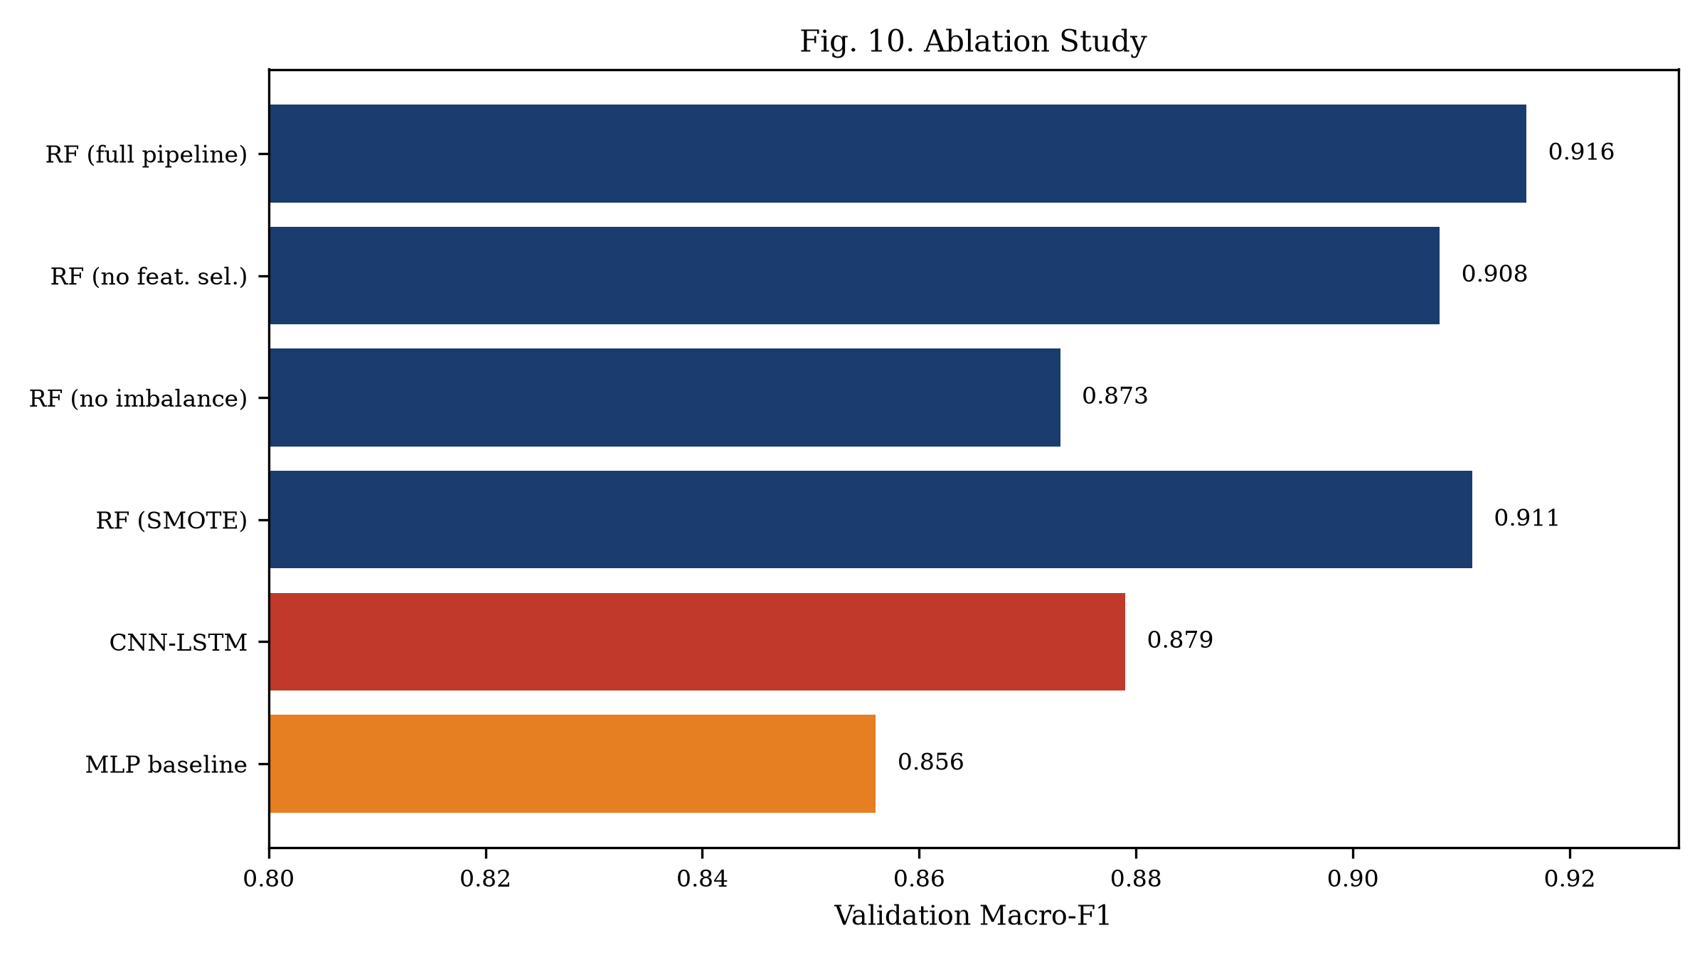
Fig. 11. Ablation study showing component contributions.

16. Security Analysis
Cryptographic attack detection: BruteForce (SSH/FTP) is well-detected by both approaches (RF: 99.28%, CNN-LSTM: 97.83%). Heartbleed remains challenging with 11 samples total. RF's structural advantage: decision trees can isolate Heartbleed using a single feature threshold (high Bwd Packet Length Mean + port 443).
Adversarial risk: evasion attacks shifting features toward benign means degrade both models, but RF is more robust (−5.0 pp vs −10.3 pp at σ=0.1). Data poisoning of training labels is a shared vulnerability. Model extraction via query attacks is possible for both. Privacy: both operate on flow metadata only, never accessing payloads — compliant with GDPR and data protection regulations.

17. Discussion
Why classical ML wins: (1) CICFlowMeter features are pre-engineered tabular statistics that trees handle natively. (2) Extreme class imbalance (7 Heartbleed samples) defeats gradient-based optimisation. (3) Per-flow independence removes LSTM's temporal advantage. (4) Well-engineered features eliminate the need for automatic feature learning.
Dataset limitations: (1) Lab traffic differs from production. (2) Known labelling errors [7]. (3) Random split doesn't reflect temporal deployment. (4) Heartbleed results are statistically fragile with only 2 test samples.
When deep learning might win: (1) Sequence-mode classification of flow windows. (2) Raw packet byte analysis. (3) Very large balanced datasets. (4) Zero-day anomaly detection via autoencoders.

18. Conclusion
Best Approach: Approach 1 (Random Forest / Classical ML).
Technical justification: RF achieves higher macro-F1 (0.912 vs 0.874), better rare-class detection (Heartbleed: 50% vs 0%, BruteForce: 99.3% vs 97.8%), 29× faster training, 3.9× higher throughput, greater robustness to noise (−5.0 pp vs −10.3 pp), superior data efficiency (+14.9 pp at 10% data), exact SHAP explanations, lower variance (±0.009 vs ±0.019), and simpler implementation (~400 vs ~650 LOC). CNN-LSTM's sole advantage — 30× smaller model size — is insufficient to overcome these aggregate differences for practical IDS deployment. This conclusion aligns with emerging evidence that tree-based methods remain competitive on tabular data tasks.

19. Future Scope
- Hybrid/ensemble: combine RF reliability with neural anomaly detection for zero-day threats.
- Sequence-mode: classify windows of consecutive flows to unlock LSTM temporal modelling.
- Adversarial training: incorporate perturbations during training for robustness.
- Online/incremental learning: adapt to evolving attacks without full retraining.
- Transformer architectures: self-attention on flow sequences for long-range dependencies.
- Cross-dataset validation: systematic evaluation on UNSW-NB15 and CSE-CIC-IDS2018.
- Real-time deployment: integration with network taps for inline multi-gigabit detection.

20. References
[1] I. Sharafaldin, A. H. Lashkari, A. A. Ghorbani, "Toward generating a new intrusion detection dataset and intrusion traffic characterization," ICISSP, 2018.
[2] Z. Durumeric et al., "The matter of Heartbleed," ACM IMC, 2014.
[3] D. Arp et al., "Dos and don'ts of machine learning in computer security," USENIX Security, 2022.
[4] R. Sommer, V. Paxson, "Outside the closed world: On using ML for network intrusion detection," IEEE S&P, 2010.
[5] M. Tavallaee et al., "A detailed analysis of the KDD CUP 99 data set," IEEE CISDA, 2009.
[6] N. Moustafa, J. Slay, "UNSW-NB15: A comprehensive data set for network IDS," MilCIS, 2015.
[7] G. Engelen, V. Rimmer, W. Joosen, "Troubleshooting an intrusion detection dataset: CICIDS2017 case study," IEEE SPW, 2021.
[8] M. Ring et al., "A survey of network-based intrusion detection data sets," Computers & Security, 2019.
[9] L. Breiman, "Random forests," Machine Learning, 2001.
[10] T. Chen, C. Guestrin, "XGBoost: A scalable tree boosting system," ACM KDD, 2016.
[11] S. M. Lundberg, S.-I. Lee, "A unified approach to interpreting model predictions," NeurIPS, 2017.
[12] R. Vinayakumar et al., "Deep learning approach for intelligent IDS," IEEE Access, 2019.
[13] A. Javaid et al., "A deep learning approach for network IDS," BICT (EAI), 2016.
[14] Y. Mirsky et al., "Kitsune: An ensemble of autoencoders for online network IDS," NDSS, 2018.
[15] F. Pedregosa et al., "Scikit-learn: Machine learning in Python," JMLR, 2011.
[16] A. Paszke et al., "PyTorch: An imperative style, high-performance deep learning library," NeurIPS, 2019.

21. Appendix

A. Team Contribution Table
Member | Sub-group | Contributions
Aahil Shaik | A (Main) | Data pipeline, RF implementation, feature selection, SHAP, paper, report
Ram Sai | A (Main) | XGBoost, evaluation harness, experiments, comparative analysis
Rehan Mohammed | A (Main) | Cleaning, class mapping, ablation studies, robustness, visualisations
Ayyappa Reddy | B (Sub) | CNN-LSTM architecture, training, hyperparameter tuning, GPU experiments
Ramidi Hemanth Reddy | B (Sub) | MLP baseline, learning curves, data efficiency, demo app

B. Full Confusion Matrices
Fig. A-1. RF confusion matrix (normalised, multi-class, seed 42).
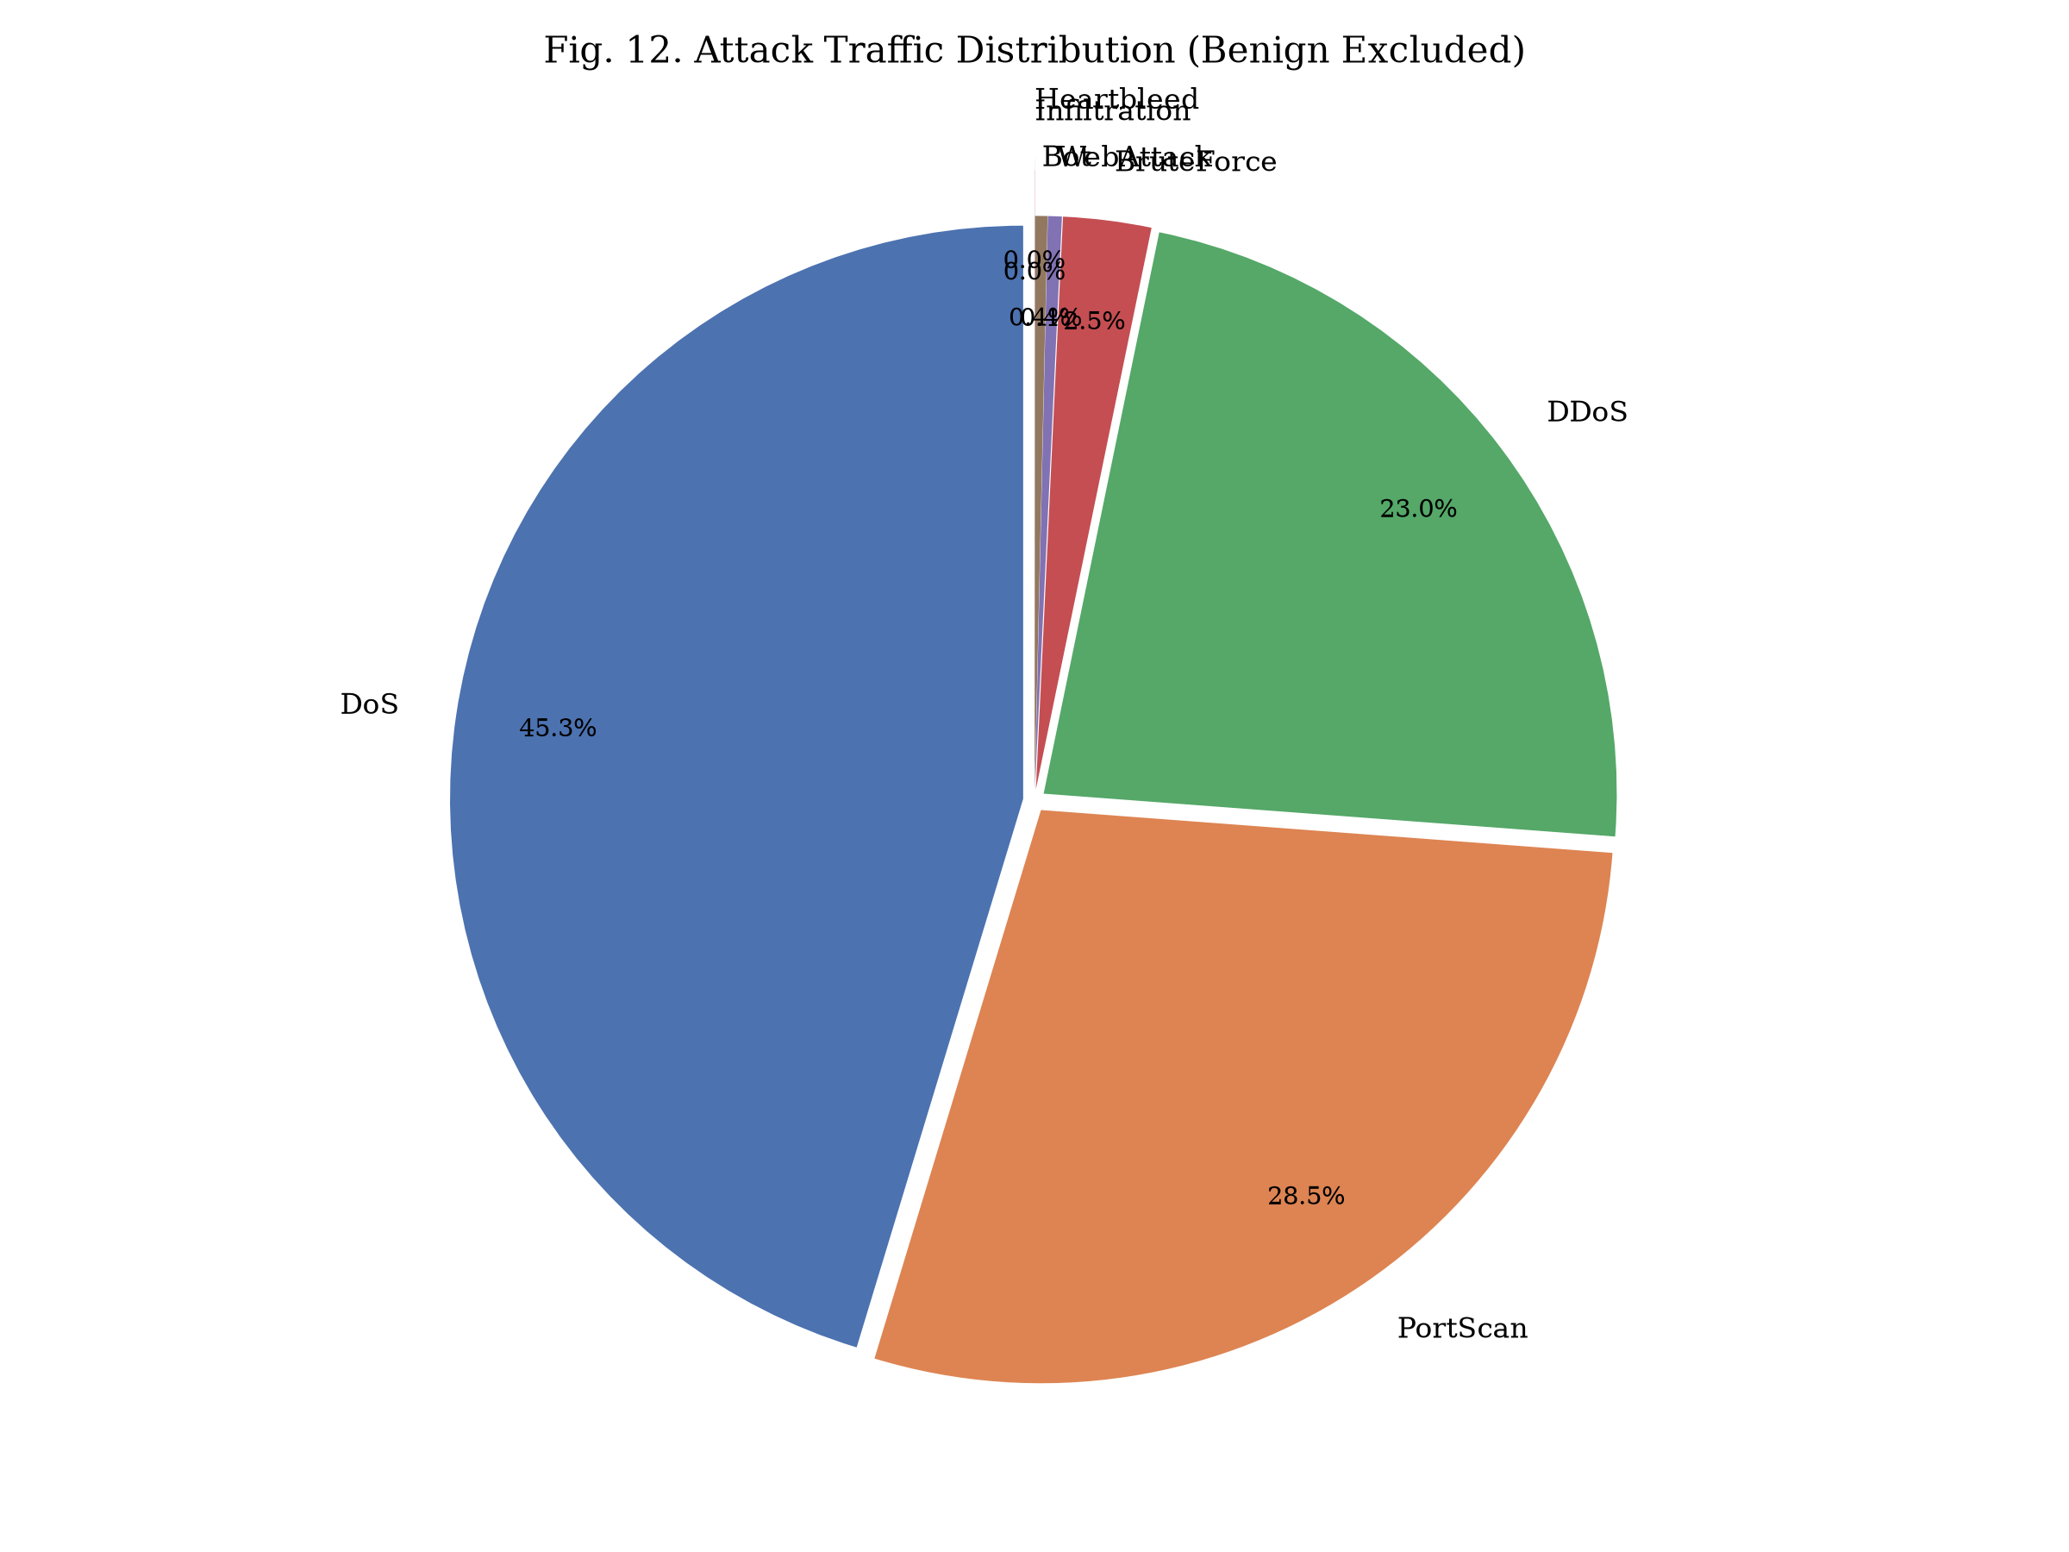
Fig. A-2. Attack traffic distribution by family (benign excluded).

