CRM EXTENDED

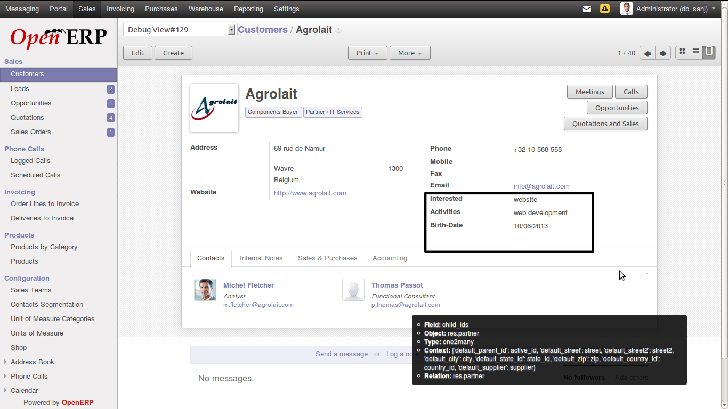
- In Customer form you can fill Personal information like Interested, Activities, Birth-Date

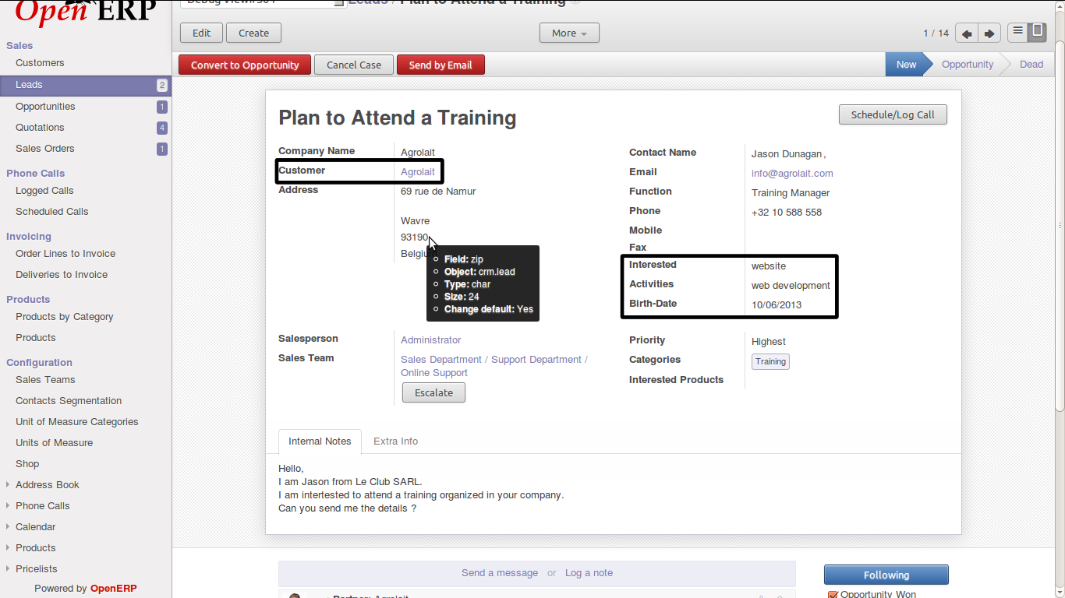
- In lead form if you select Agrolait then related fields will automatically fill which we have mentioned above.

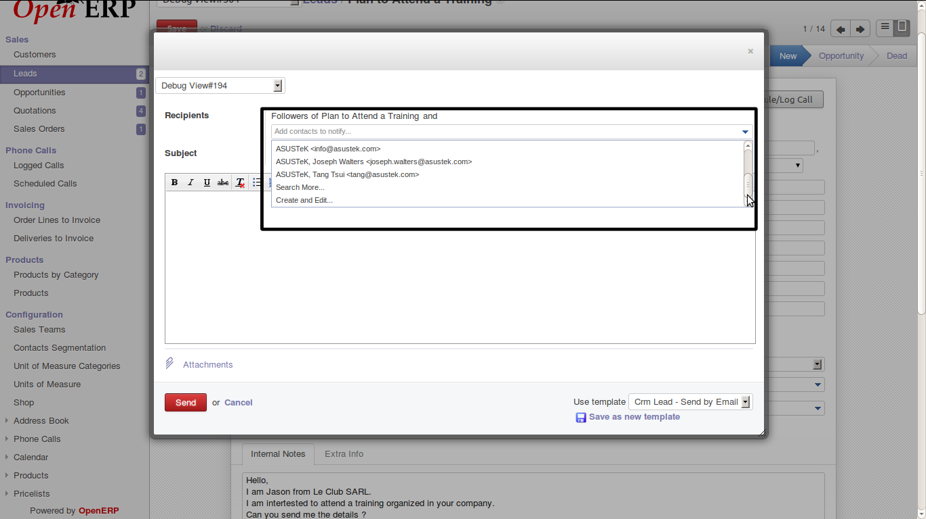
- In send by email option you can add recipients from the drop down list.

