**CPSC449**

**Project 3**

**__________________________________________________________________________**

**Team Members:**

**Bony Roy ( Ops)**

**Suramya Singh (Dev 2)**

**Brandon Tomich (Dev1)**

**__________________________________________________________________________**

**Brandon Tomich (Dev1)**

I was able to successfully port the data base to Cassandra. After testing I’m able to confirm that each service is running successfully though Cassandra. For instructions to get the project running as well as screen shots showing each service running on Cassandra please see ops role.

**__________________________________________________________________________**

**Suramya Singh (Dev2)**

Before running the cachedxspy.py service please run the following commands to install pymemcache and memcached

$ pip3 install –user pymemcache

sudo apt-get install memcached

sudo service memcached start

Please go through the instructions provided in the ops role to test the caching

**__________________________________________________________________________**

**Bony Roy: (Ops)**

#### To start with we need to do all the steps from project 2 for setting up Kong and Minio server.

**The command to start Kong is ulimit -n 4096 && sudo kong start**

#### Once Kong has started please run the Curl commands created from project 2 and saved in file “CurlCommands.txt”.

#### Now once they have started. Install Memcached and Scylla DB. Start them in Separate tab in command prompt.

#### Memcached & Scylla:

#### Run Scylla with- docker start Scylla

#### Run Memcached with:  memcstat --servers=localhost

#### Install libraries like:

#### Pymemcache (pip3 install --user pymemcache)

#### Running Cassandra with python: (sudo apt install --yes python3-cassandra)

#### flask_cassandra(pip3 install --user flask_cassandra)

#### Note: Cassandra is running on '172.17.0.2' and it is mentioned in all the python files(Tracks.py, desc.py, user.py, Playlist.py) ,in case there is an issue regarding that please run command “docker exec -it scylla nodetool status” to check the address and if you face error change those parameter in code according to the address your Cassandra/Scylla is running.

#### 

#### Commands to run the python files(separate window):

#### export FLASK_APP=Tracks.py

#### flask init

#### export FLASK_APP=user.py

#### flask init

foreman start -m users=3,desc=3,Tracks=3,Playlist=3

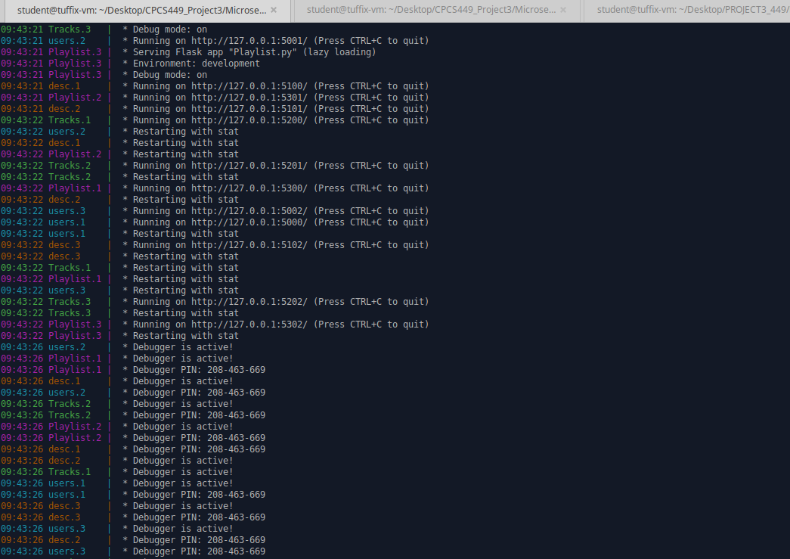

Then clear Memcached server with command “**memcflush --servers=localhost”**

#### And run Memcached with:  memcstat --servers=localhost

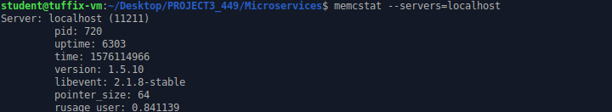

**Run below command in separate window to run xspf:**

Run the command “export FLASK_APP=cachedxspy”

Then run the command “flask run -p 6001”

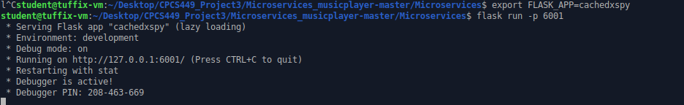

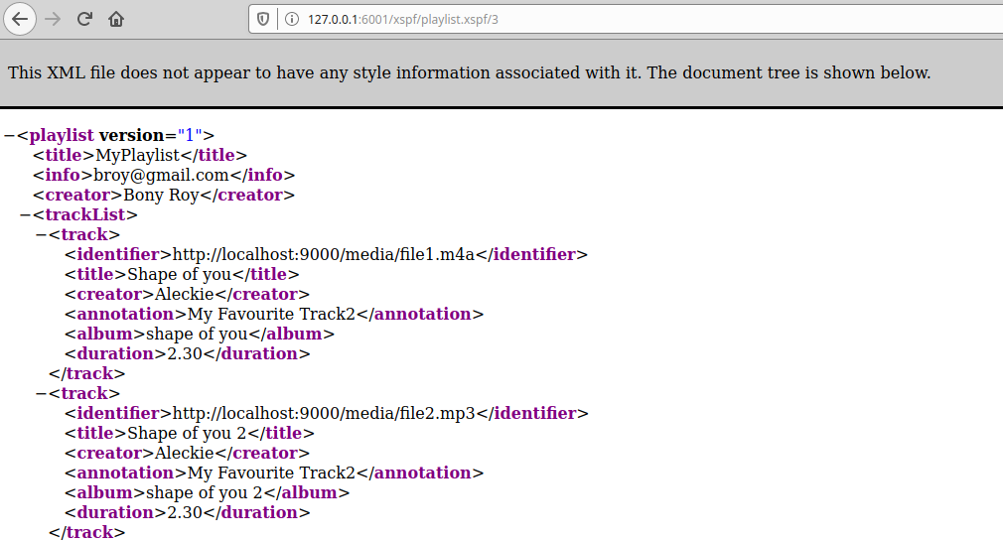

Before validating **cachedxspy** output and checking output is cached or not we will check Memcached output(get parameters), below is the screenshot of the same.

#### 

#### 

#### Now do get on XSPF playlist id 3:

#### The network timing currently is 692 ms.

#### 

#### Memcached: stat:

#### Get miss count increased to 119:

#### 

#### Do get again on XSPF playlist id 3: (Cache Timing set to 100 ms in code. So, do in between that time)

#### The network timing currently is 8 ms. Much less than previous 692 ms.

#### 

#### Memcache stat: GET hits count increased to 33.

#### 

#### 

#### Testing other services:

#### User microservice:

#### 

#### Playlist Microservice:

#### 

#### Tracks microservice:

#### 

#### Tracks description microservice:

#### 

#### ********************End of Ops*******************************