Spend no more than a couple hours putting together a system that keeps track of employee leave/vacation requests. This is not meant to be a completely functional application, but should demonstrate the process, patterns and methods you’d use to construct the functional application. Please submit a partial skeleton project demonstrating one or two areas of focus in addition to a short document describing your initial approach, and potential paths forward, were you to be asked to finish the project.

Requirements:
- This system should handle all the vacation requests for a given employee and the approvals by the corresponding manager.
- An Employee would login/access the system and checks their available vacation days or sick days.
- He also views his previous vacation approvals/denials for the current fiscal year.
- A Manager logs in into the system and retrieves the recent pending leave requests.
- For a given employee or his team the manager either approves or denies the vacation request.
Use Cases:
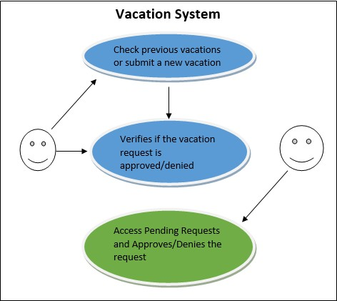
Employee
Manager

Employee Algorithm:
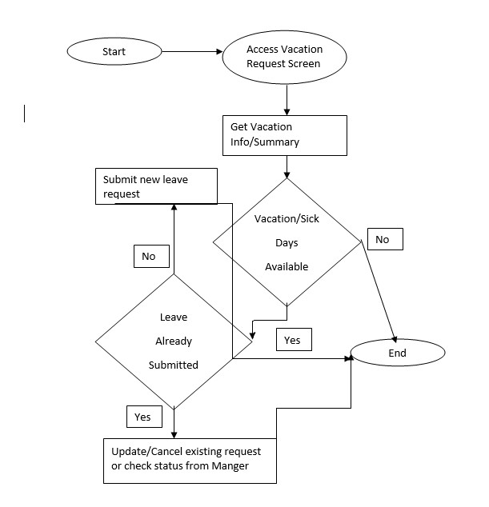

Manager Algorithm:
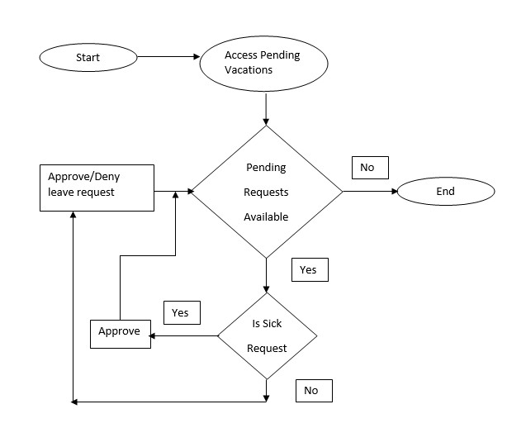

Design Flow:
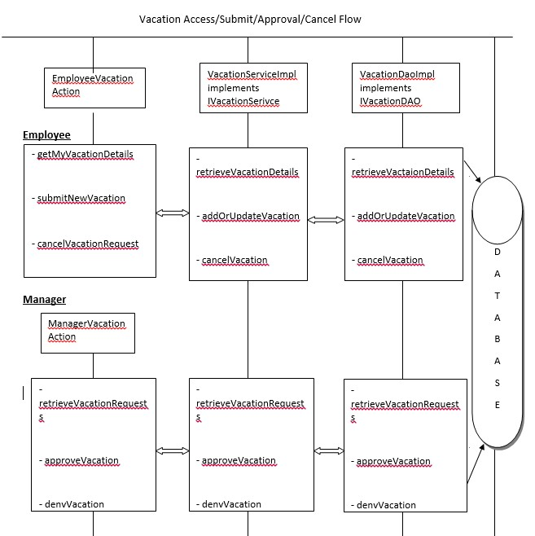

DB Design:
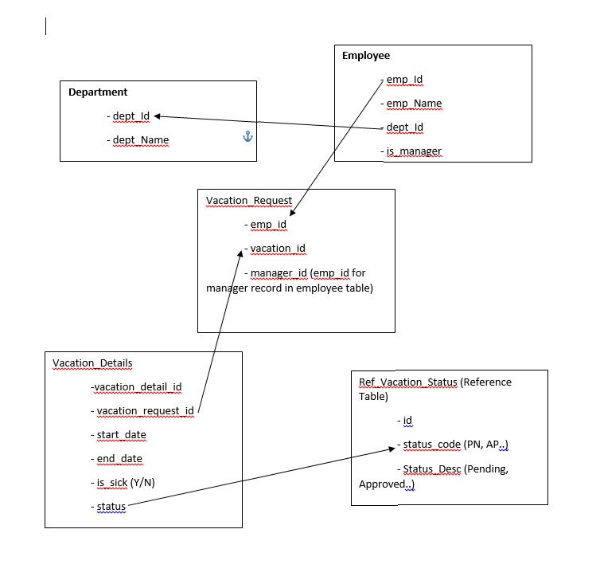

Sample Screen For Employee:
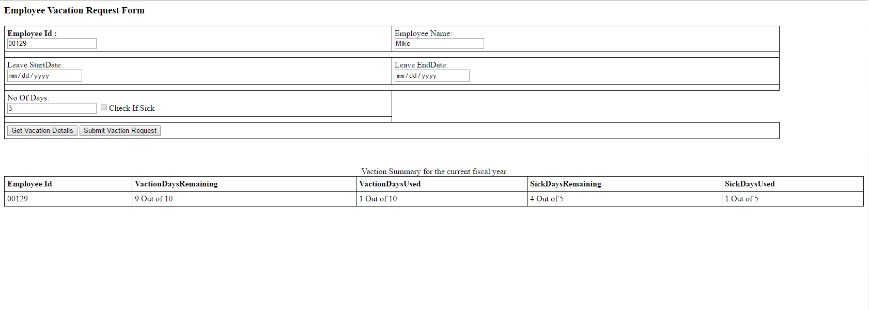

Sample Screen for Manager:
