Project 1: Hybrid Images

Part 1: Hybrid Images

Hybrid Images are those images is as two different images depending the distance from which we are looking at. Typically we generate hybrid images by combining two images, where one image goes to a high pass filter and the other a low pass filter

1. Lion + Dea
Lion + FFT + Dea + FFT

Hybrid + FFT

2. Brahmi
Lion + FFT + Dea + FFT

Hybrid + FFT

3. Fruits
Lion + FFT + Dea + FFT

Hybrid + FFT

Part 2:
Contrast Enhancement
Contrast Enhancement achieved by using Contrast Limited Adaptive Histogram Equalization method. Below are the enhanced images. I have used a clipLimit of 1 on CLAHE and applied in on L of the LAB color space.

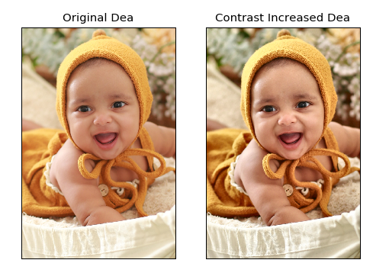
Color Enhancement
Color Enhancement achieved by converting the image to HSV color scope and reduced the brightness of the image. By changing the “s” value from the code, we can increase the saturation of the image.

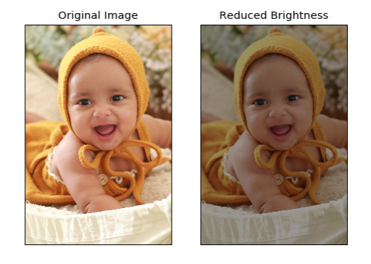

Bells & Whistles:

Gaussian and Laplacian Pyramids are using a sigma of 4 with utils.guassian_kernel() api

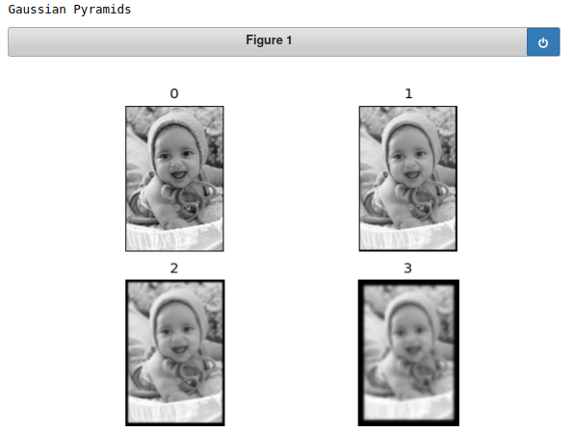

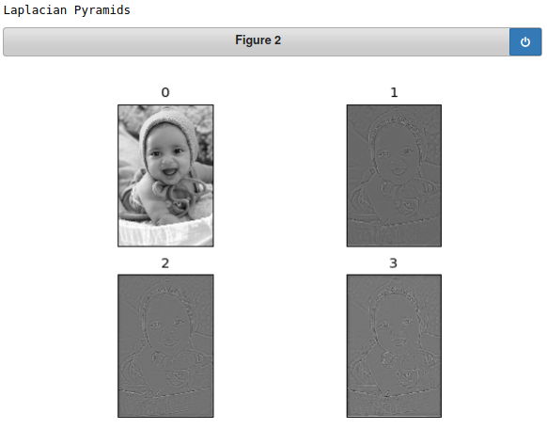

Color Shift
I have used a different approach in coding in comparison with other two tasks. Here I work on Lab color space and increase redness and decrease yellow by 0.15 % and 0.17 % respectively.

