Project 2 : Image Quilting

Image Quilting is the process of generating a visual appearance in which a new image is synthesized by stitching together small patches of existing images.

1. Randomly Sampled Texture
In this procedure we patch parts of the image of size “patch_size” and build a new image.
Below is the original and patched image.

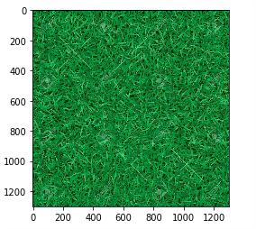
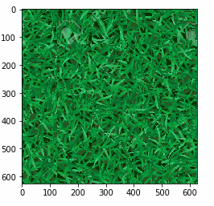

Original Random Cut

2. Overlapping Patches
In this procedure we patch parts of the image of size “patch_size” but add overlapping blocks into the new image. Below is the original and patched image.

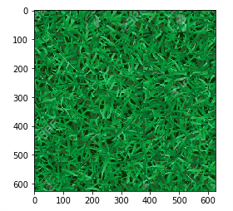

Original Overlapping Patches

3. Seam Finding

