[1. 20 Points Narrative Description]

File A
This file has Inventory Information in this case a car. Data on inventory owned by a personal seems to be uniquely identified by an id. This ID is known as VID as referenced in File B.
It seems to contain information as follows - Year of Purchase of the car, Name of the Manufacturer, Model of the Car, All Wheel Driver or a 4 Wheel Drive, Color of the Car, Number of Car doors, Type of Engine and Price of the Car. Price of the Car is quoted as US Dollars and look consistently formatted in the data set.
Data seems to be complete but not arranged in any specific format or Order.
In the context of Completeness, there don’t seem to be any missing values or errors
As for the readability, data can be cleaned and arranged in a much better format.
By looking at the data, it is difficult to identify the personal who owns a specific inventory as there is no information related to the personal.

File B
This file has information related to information on the personal who owns a particular inventory and details on the inventory.
It seems to contain information columned as follows.
LastName,
FirstName
MI
Address
City
State
Country
SaleDate
Model
Year
Color
Engine
VIN
MSRP
Discount
TradeIn
TradeInValue
PurchasePrice
RepeatCustomer

File C – Personal Information
This file seems to contain Personal Information of the Personal who owns a particular inventory. Personal Information includes Name with address and pincode.

[2. 10 Points Narrative to design a database schema]

Tables, Attributes, Data Types, Primary and Foreign Keys

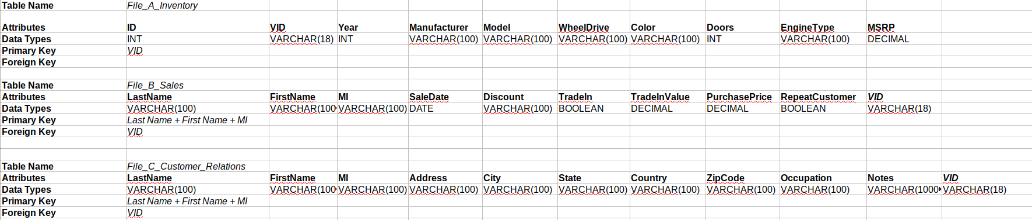

[3. 15 Points Example of each table]
File A - Inventory

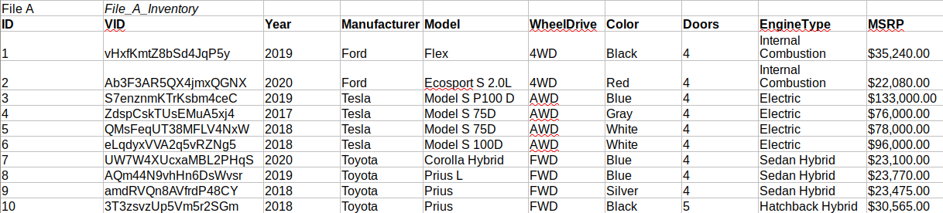

File B – Sales

File C – Customer Relationship

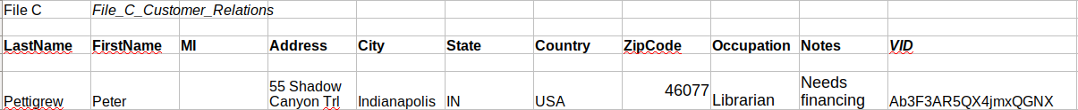

[4. 30 Points Process for creating the database schema and tables. Describe decisions]

Relationship between data files
Upon careful observation on the data provided File A, File B, File C, we come down to the following conclusion on the relationship between these 3 data files.
File B has all the data related to a person’s information, Inventory (car) he possess and his purchase information o the inventory. A VID column in File B is an Unique ID that can be used to identify the owner in File A. The First and Last Name in File B can used to get the address of the owner from File C.

