Instructions
- [10 points] Create an ER diagram for Pre-owned dealer database, as described in the attached file.
- [10 points] Create a separate ER diagram that reflects the schema you designed for Assignment 1. You may update the schema based on feedback you received from instructors after submitting Assignment 1.
- Create 1 to 3 intermediate ER diagrams that showcase your integration process [15 points]. These diagrams should be accompanied by narrative prose (either in a separate document or as annotations directly to the diagram) that describe each of the integration steps taken on the diagram [20 points]. See the integration process described in the data integration slides for examples of what this might look like, and follow the example shown in the “Schema integration: an example” lecture. There is no one right way to do this, but your decisions should be justifiable, and should minimize the potential for information loss. Be sure to justify your design decisions in your narrative prose! Discussion of both various curatorial objectives and the pros and cons of various integration steps is necessary.
- Finally, create one integrated ER diagram represented the merged schemas of the two dealerships (i.e., the final product of the integration process) [10 points]. Be sure to describe any final integration steps taken at this point (as described in step 3 above) [10 points]. Be sure to justify your design decisions in your narrative prose! Discussion of both various curatorial objectives and the pros and cons of the final design is necessary. Consider how you could have done things differently and in which areas the design can still be improved.
- Submit your documents to Assignment 3 Peer Review for peer grading. Each student will be required to grade the submissions of 5 of their peers. Submissions will be graded based on the following criteria. Write a constructive and professional review and post to the course forum replying to the individual’s submission.
- Is everything represented?
- Is it clearly written? Are the ER diagrams and integration process presented?
- What are the pros and cons of the representation in the integrated ER diagram?
- What are the pros and cons of this integration process?
- How could it be done differently? How could it be improved?
6. Using your peer reviews, revise and submit all documents to Assignment 3 Submission for instructor grading.
If you have questions about the assignment, use the course Forum. This is a great place to ask questions and also help your fellow classmates.

Assignment 3: Ontologies / ER Diagram Design Exercise

1. ER diagram for Pre-owned dealer database (MDS_Exercise3_FileA.xlsx)
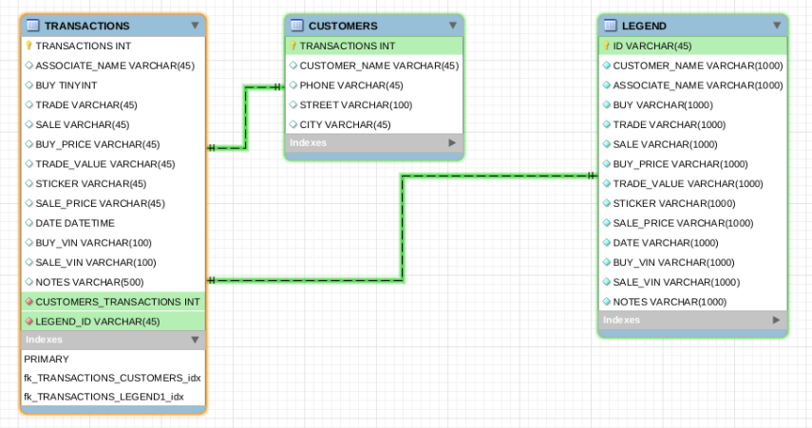
Write a Narrative on MDS_Ex3_FileA contents and tables;

2. ER diagram for Assignment1 (FileA, FileB, FileC)

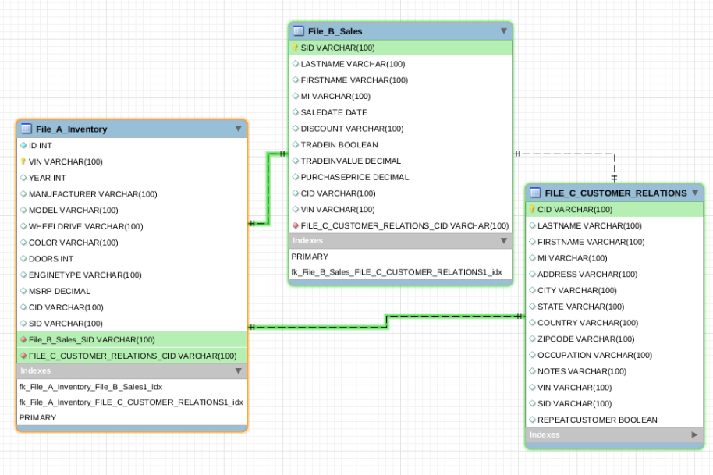
Write a Narrative on File A, File B and File C

3. Merging ER1 and ER2

Write a Narrative on merging process and take intermediate snapshots.
Also explain about the clean up

- Integrate CUSTOMER_RELATIONS table from Assignment1 and CUSTOMERS table from MDS_Exercise3_FileA.

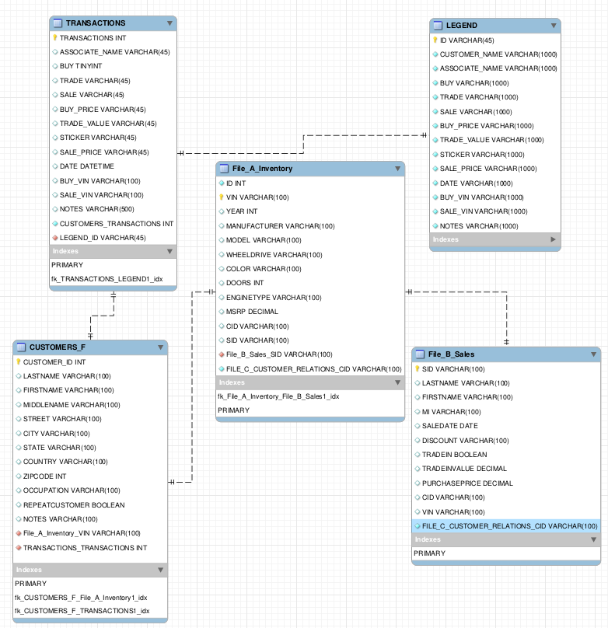

- Integrate SALES table from Assignment with TRANSACTIONS table from MDS_Exercise3_FileA.

- TRADE_VALUE in Transactions table from MDS_Exercise3_FileA and TRADE_IN_VALUE from Sales table from Assignment1 are duplicated. We can discard one.
- TRADE_VALUE in Transactions table from MDS_Exercise3_FileA and PURCHASE_PRICE from Sales table from Assignment1 are duplicated. We can discard one.
- LASTNAME, FIRSTNAME,MI from Sales table from Assignment1 can be replaced with CUSTOMER_ID from customers table.
- TRADE in Transactions table from MDS_Excerise3_FileA and TRADE_IN from Sales table from Assignment1 are duplicated. We can discard one.

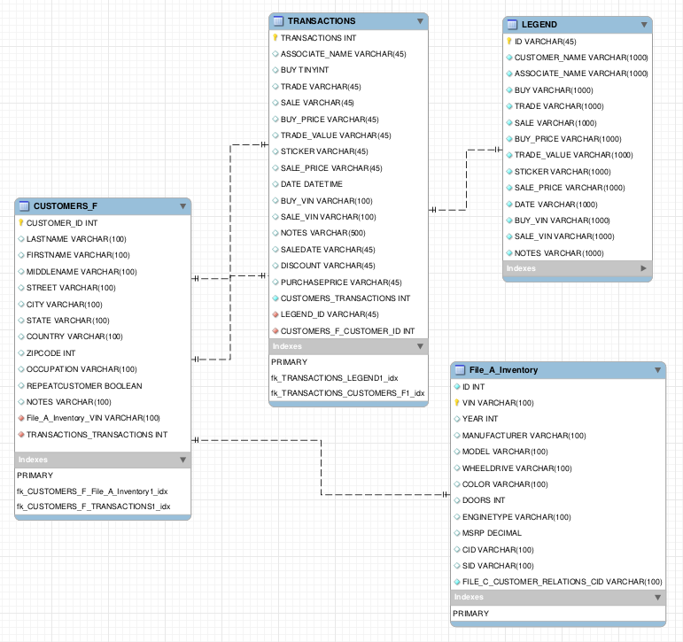
- Integrate Inventory and Legend table with every other table, in other words Final Integrated ER diagram before clean up.

- Inventory table should be accessible only from Transaction table based on the SALE_VIN or BUY_VIN attribute.
- Disconnect connection between CUSTOMERS_F table and Inventory table.
- Inventory Table doesn’t need Customer ID entry. Transaction ID is a better way to arrive at Inventory Information.
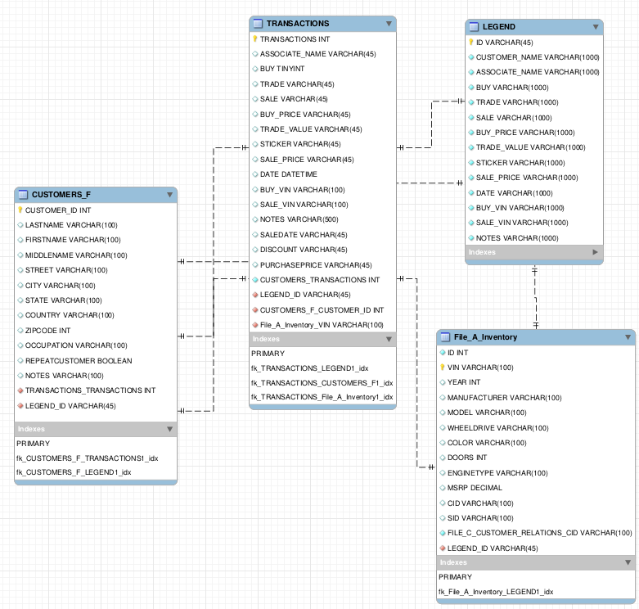
4. Integrated ER Diagram after Clean up

Write-up on Clean up activities.

- Customer ID from Customers Table is the primary entry point from Customer, Sales representative point of view.
- Customer Tables is linked with Transactions table via TRANSACTION_ID and to Legend Table via LEGEND_ID.
- Transactions table will have information on the kind of sale i.e BUY, SALE or TRADE based on the respective attributes from Transactions table. We have a corresponding SALE_VIN and BUY_VIN unique entries for BUY and SALE transactions.
- SALE_VIN and BUY_VIN are the entry points to the INVENTORY Table.
- LEGEND_ID is linked to INVENTORY Table via LEGEND_ID for information reference.
- We removed redundant NOTES from Transactions table.
- During the Clean up process, we have taken extra to maintain no-duplicity and data abstraction.

5. Justify design decisions, various curatorial objectives and the pros and cons for final design

- Below are the design decision considered during the integration process.

- No multiple paths to retrieve a particular attribute
- No data redundancy
- Data abstraction
- Clearly defined attributes
- Notes and Legend
- DataTypes and Size of VARCHAR

- Pros, Cons and Improvement areas
- Pros
- Cons
- Improvement Areas

