Robotic Printer Development - Challenges
  - Achieving the specified measuremement accuacy of the laser at different distances in different environmental conditions(M1).
  - Manual involvement in marking of 1st and 2nd corners of the layout. Inaccuracy in marking these will cause inaccuracy in total layout squaring. (M2)
  - Rectangular Gantry Assembly and it's weight management. How far it's flexible to customize for fixing wheels, printing head, laser radar and other control electronics (M3)

  - Axi Draw gantry is required to mark corner points and print layout where main print head may not reach like edges.
    - Fixing this might require experimenting several times with different fixture mechanisms (M3)
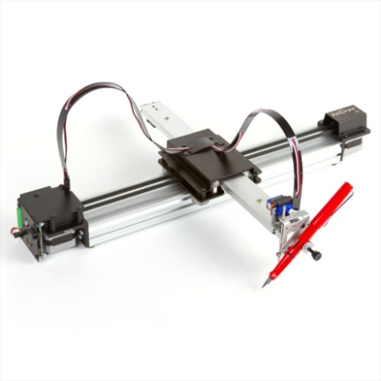
  - Identifying, proper print head is still underway.
    - We have to customize, printing head and associated circuitry and ink supply system. There are no such small printing systems available.
    - Need to investigate and experiment a lot in this regard(M3).
  - XY gantry mechanical assembly and drive interface programming. Fixing the drive at a proper position to be experimented. There will be external dependency in getting the mechanical fabrication services(M3).
  - Axi draw gantry mechanical assembly and drive and positioning Programming(M3).
Mechanical Fixtures fabrication takes experimentation of trial and errors. Getting fabrication services for lesser quatities of 1 or 2 pieces will be a bigger challenge. This might affect project schedule severely(M3).
  - Navigation of the mobile platform to the respective location without alignment errors.
    - Many options to be investigated to overcome these alignment errors. Slight misalignment will lead to mismatch in the print. (M4)

  - Stability of the platform while printing head movement (How rapidly we move head).
    - Stability issues will arise when we try to reduce weight. More waight will cause more load on the battery. All these need to be optimized in several trials (M4).
  - Print head/Platform positioning accuracy depends on measurement of laser accuracy. Accuracy of the chosen laser to be experimented (doing it in the M1)(M4).
  - Floor plan transformation to printing format and related data translation to the stepper motors/servomotors and print head of the gantry for printing.
    - Extensive learning has to be taken up here to understand and transform the floor plan to printer friendly format(M4).
  - Alignment of different printed segments. This poses another major challenge.
    - The printed segments have to be aligned perfectly.
    - Even a small misalignment of 1mm will cause the printed segments not matching with one another(M4).
  - Mechanical assembly of obstacle detection lasers.
    - One idea is to add rotor lasers at four corners of the gantry closer to the floor. This is a complex mechanical assembly to be experimented.
    - The accuracy of abstacle detection depends on the laser measurement accuracy(M4).
  - Choosing proper batteries with optimum weight and AH rating. Need to experiment with test prints, measure power consumption and redesign the battery subsystem if required(M4).
  - Overall weight management of the system for optimum stability.
    - Stability of the system to be stidued with performance measurement. If there is any stability issues, these are to be analyzed and decided whether due weight or any misalignment of the mechanical parts (M4)
  - Complexity in understanding the .DWG format, related tools for programmatically adjusting the floor plan based on the layout squaring & abstacle detection(M4,M5).
  - Wireless communication between all the devices, synchronization and battery power optimization(M5).

