LASER Devices for Aligning & Measuring Distance
Proof of Concept (PoC)

Develop LASER device that aligns automatically with another device of same kind and estimate the distance between itself and the device it is aligned with.

The device consists of a
- LASER beam generator
- LASER beam sensor/detector

The device generates a LASER beam and points towards another LASER device such that the beam generated by one device falls on the sensor of the other device.

When the device detects a LASER beam falling on its sensor communicates with the device sending the beam. Both the devices generates and detects the beam from other device and estimates the distance between the two of them.

After the device aligns itself with other device, estimates distance and send the estimated distance value to a mobile application over a bluetooth communication link.

Requirements:
- PoC should produce minimum of two devices and demonstrate the processes of
  - Automatic alignment with other device
  - Distance estimation
  - Sending the measured distance to a mobile application over bluetooth.
  - Devices shall be capable estimating the distance accurate to 1/16th of an inch (1/16'')
- Basic mobile application will be provided
- The devices need not have display on them to show the measured distance.
- The device shall have the mechanical arrangement to move the LASER source & detector left-right, forward-backward and up-down

Note:
- Drawing 1 below is a Sample scheme of demonstration of the LASER PoC device(s).

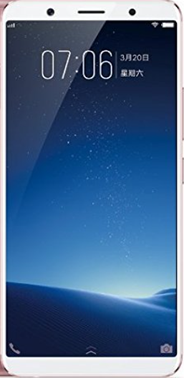

Drawing 1: Sample Scheme of LASER Device Demonstration
D1-D2: 98'2''
D2-D1: 98'3''
D1
D2
LASER Beams

