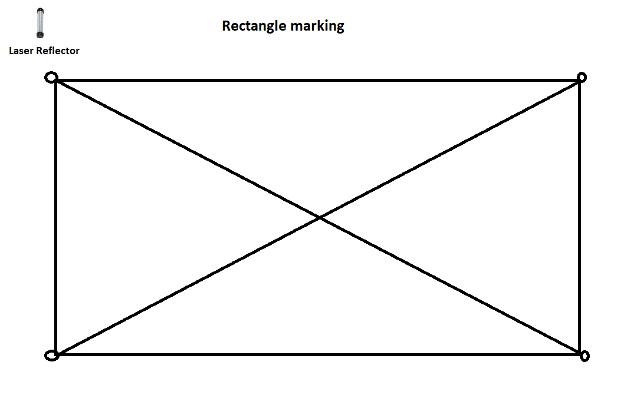
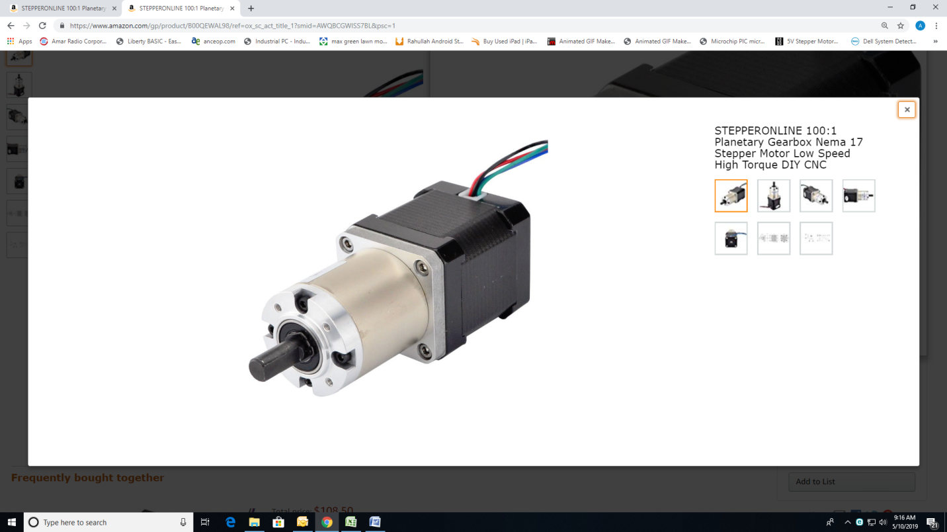
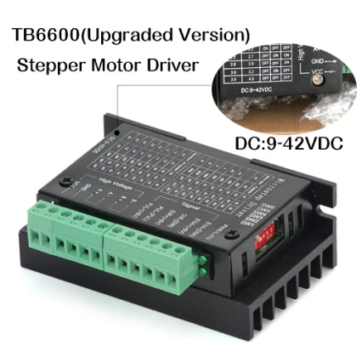
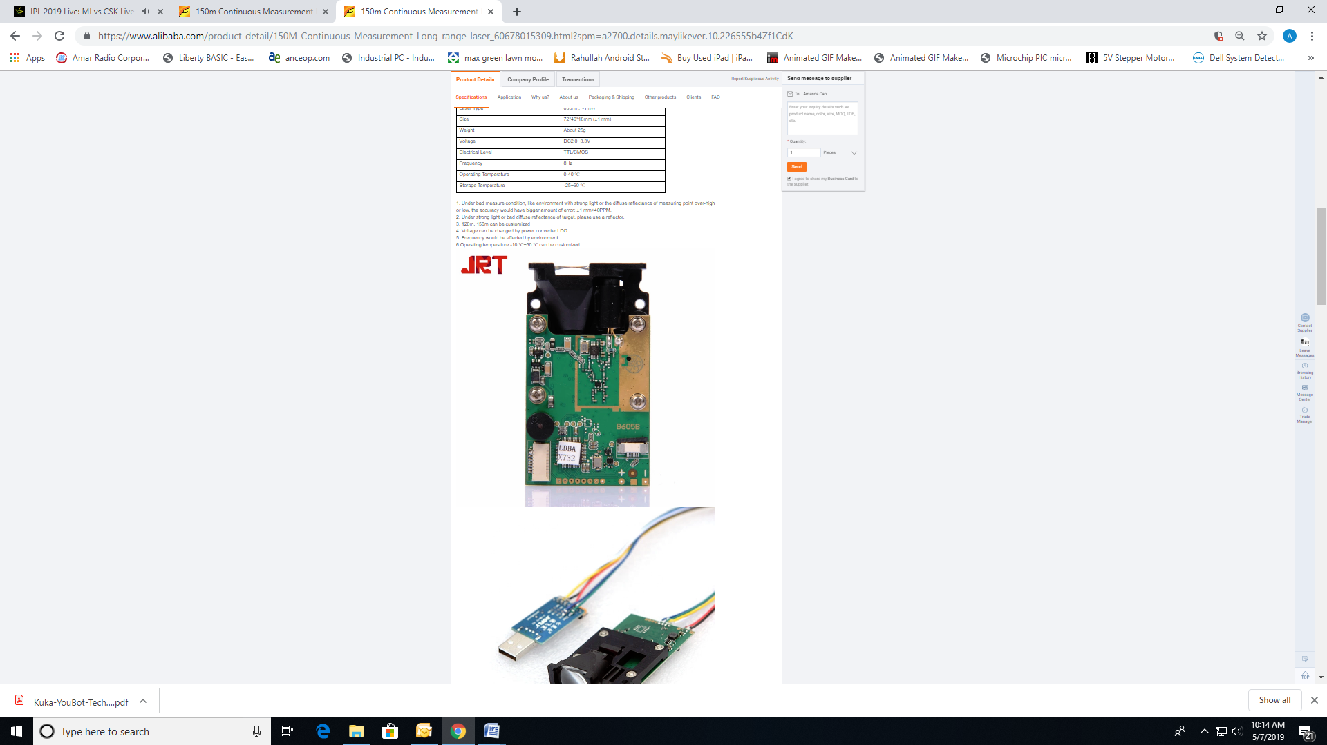
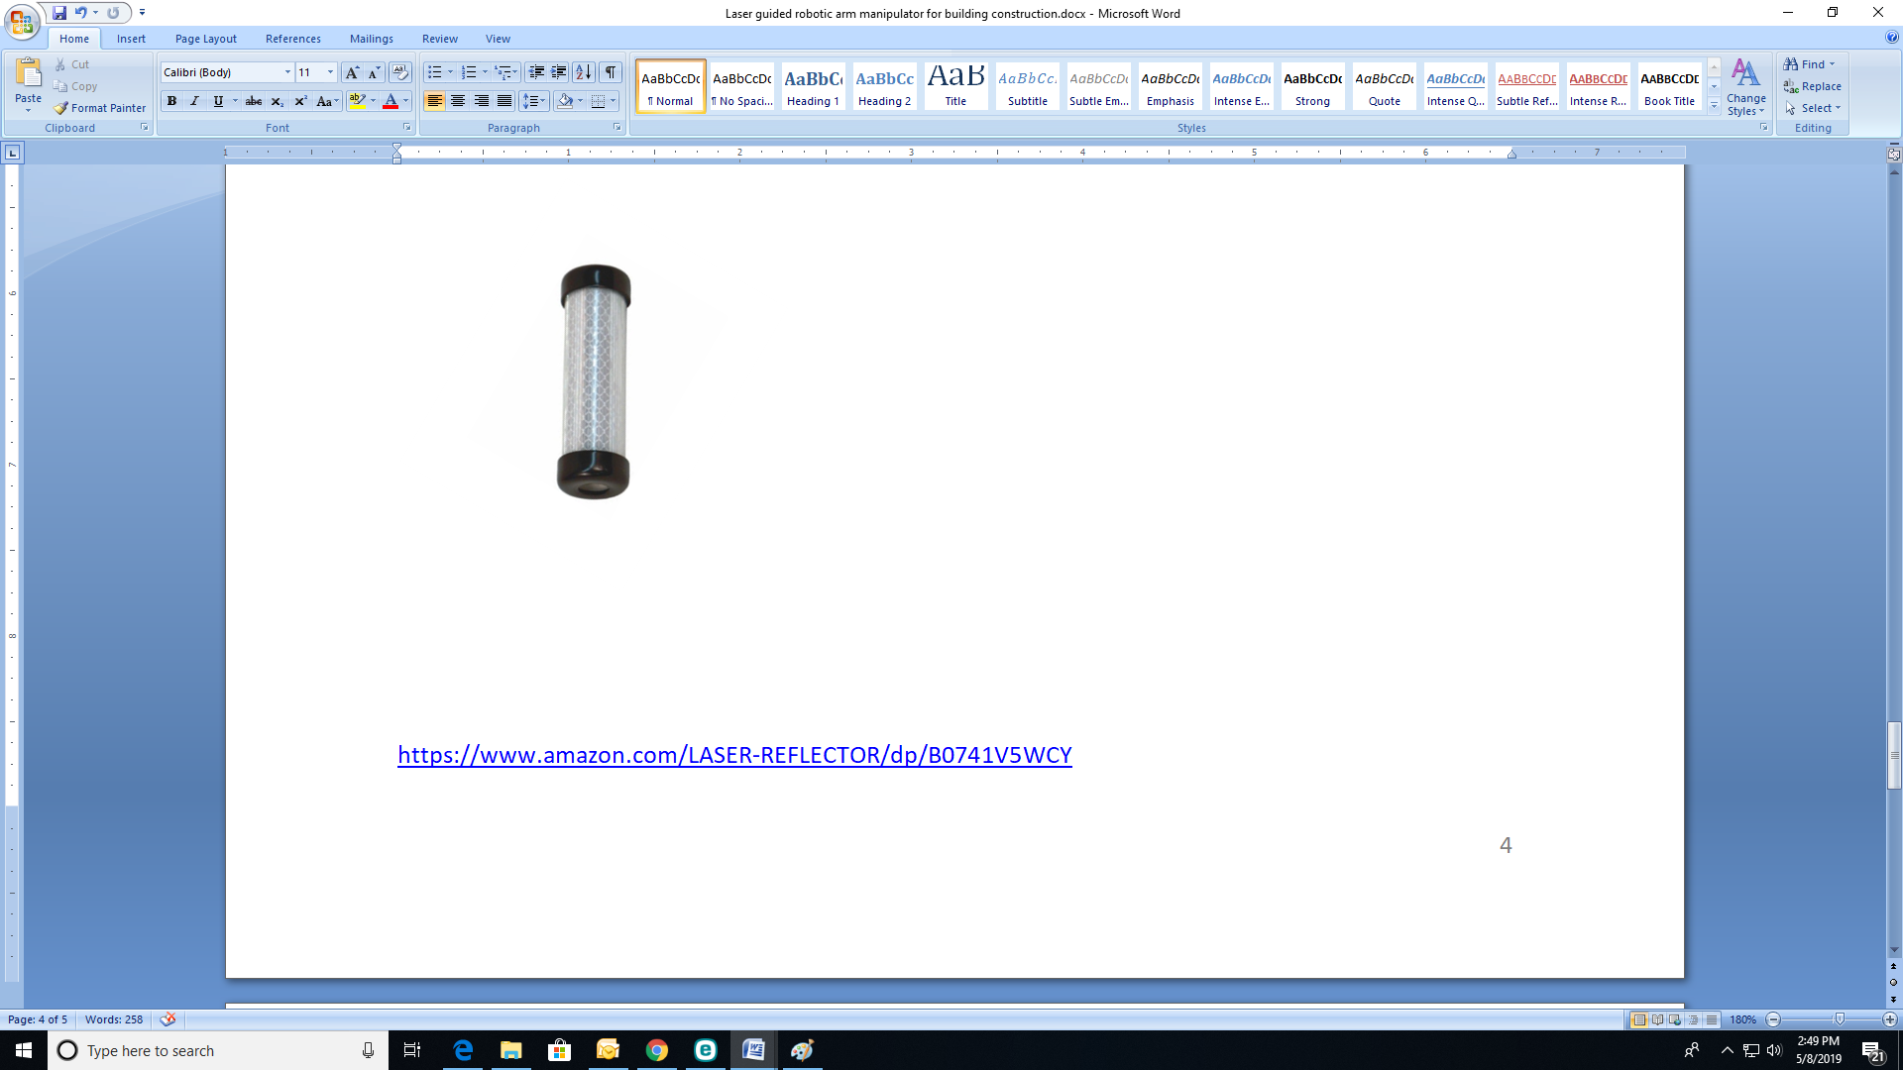
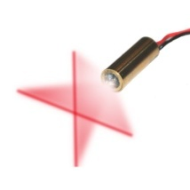
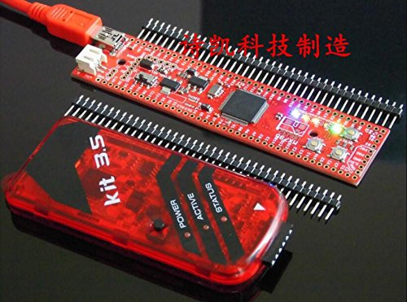
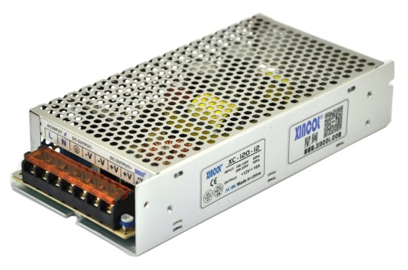
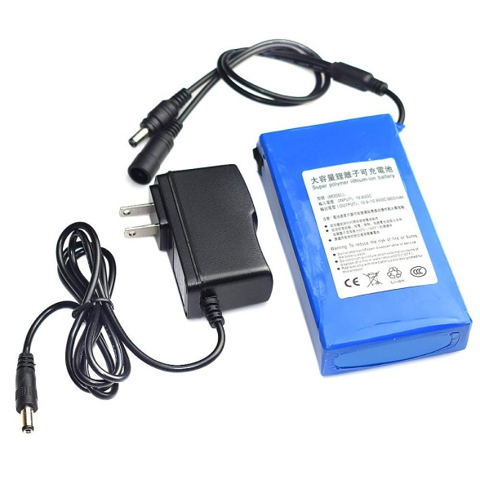
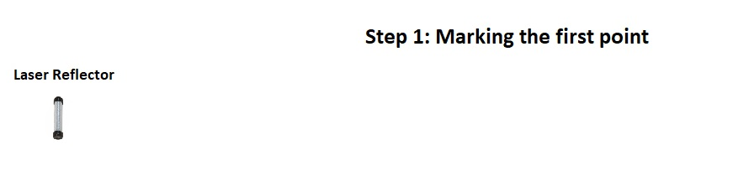
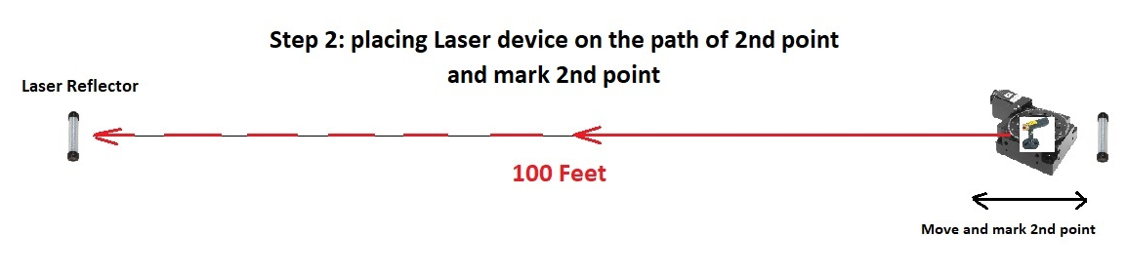
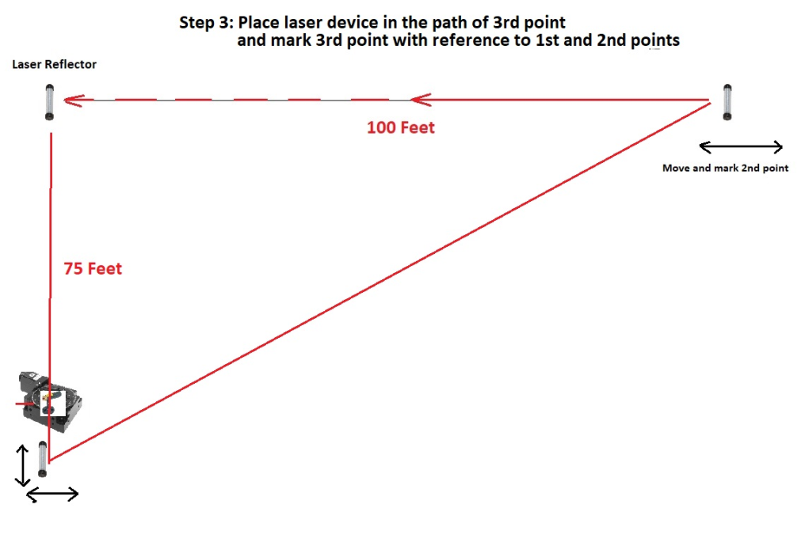
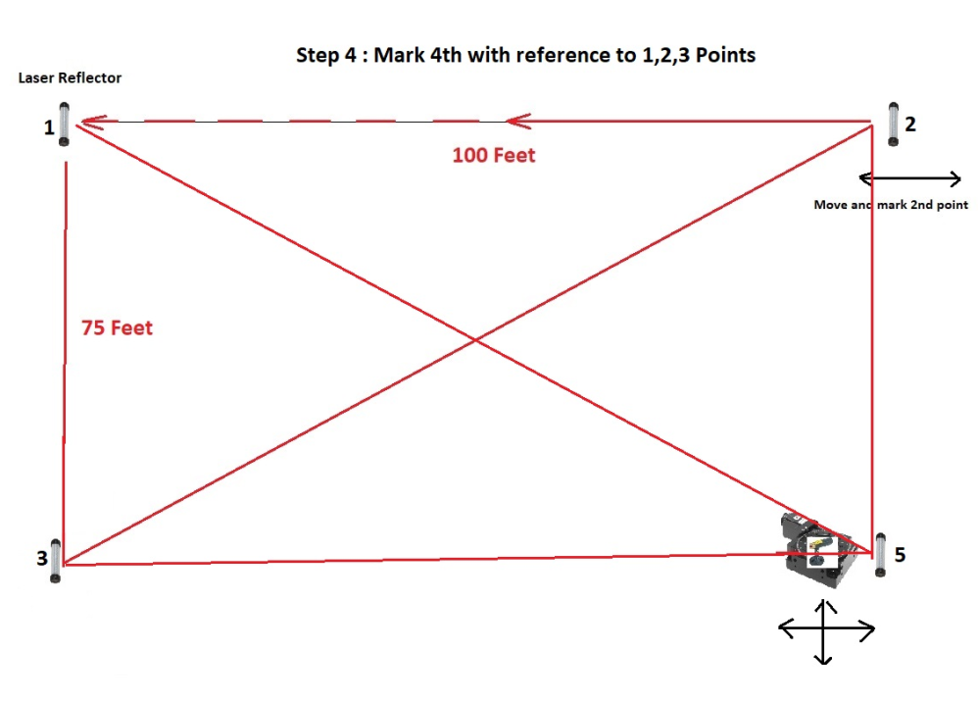
Laser marking POC
Rev 1.1
Date : 14th May 2019, Prepared by
Azam Khan and Bhasker Reddy
Objective :
To check the range of Laser rotating Object and mark the 4 coordinates of a rectangle in the field.
To prove the concept of marking four coordinates of a rectangle, a Laser measuring device is mounted on a geared stepper motor rotating disk is required.

Fig 1: Perfect Rectangle

Equipment required:

- Geared Stepper Motor with controller
- Laser measuring device
- Laser pole reflectors
- Cross hair laser
- Controller UBW32
- SMPS Power Supply
- Portable Battery

- Motorized laser device

https://www.amazon.com/gp/product/B00QEWAL98/ref=ox_sc_act_title_1?smid=AWQBCGWISS7BL&psc=1

https://www.amazon.com/Twotrees-Stepper-Driver-TB6600-Controller/dp/B07PQ5KNKR/ref=sr_1_1_sspa?keywords=stepper+motor+controller&qid=1557840339&s=gateway&sr=8-1-spons&psc=1

- Laser Measuring Module :

https://www.alibaba.com/product-detail/150M-Continuous-Measurement-Long-range-laser_60678015309.html?spm=a2700.details.maylikever.10.226555b4Zf1CdK
Specs : Distance : 500Ft, Accuracy : 1mm, Weight : 25Grs, Excluding Batteries, Price : $60
//-----------------------------------------------------------------------------------------------------------------

- Laser Reflectors :
Price : $8.5
https://www.amazon.com/LASER-REFLECTOR/dp/B0741V5WCY
- Cross hair Laser pointer:
https://www.amazon.com/VLM-650-29-LPT-Line-width-optimize-distance/dp/B00BP42YMW/ref=sr_1_16?crid=2SLNGFFA7404D&keywords=crosshair+laser+module&qid=1557442531&s=gateway&sprefix=cross+hair+laser+%2Caps%2C158&sr=8-16
- Controller UBW32
https://www.amazon.com/USBkit3-download-Whacker-PIC32MX795-Development/dp/B073PWKCQ1/ref=sr_1_1?keywords=ubw32&qid=1557839987&s=gateway&sr=8-1

- SMPS Power Supply
https://www.amazon.com/XINCOL-Switched-Switching-Transformer-Adapter/dp/B01LWUQH3E/ref=sr_1_11_sspa?keywords=12v+amps&qid=1557840581&s=gateway&sr=8-11-spons&psc=1
- Portable battery

https://www.amazon.com/Fheaven-TM-Li-ion-Battery-6800-18000mAh/dp/B07G8585YZ/ref=sr_1_9?keywords=12v%2Blithium%2Bion%2Bbattery&qid=1557840831&s=gateway&sr=8-9&th=1

Development Schedule
Components/Modules :
- Laser Measuring Device – 1No
- Geared Stepper Motor with Controller – 1 No
- Laser Reflectors – 4 No
- Cross Hair laser for marking – 1 No
- PIC32 based Controller modules – 1No
- SMPS Power Supply – 1 No
- Portable Battery Supplies – 1No

S.No. | Task | In-Charge | Effort  (Person hrs)
1 | Assembly of the System | Azam Khan
2 | Coding on UBW32  (For LASER device & Motor control) | Azam Khan
3 | Coding on Mobile Device | Betabulls
4 | Testing | Azam Khan
Total Effort (Person Hours)
Duration (Calendar Weeks)
Note: Duration starts from the reception of all the components/modules listed above
Task 1 : Assembly of the System
- Assembly of All components
Task 2 : Coding on the PIC32 based Controller
- Coding for additional commands for Laser, stepper motor and Blue tooth Interface, in ‘C’
- Coding in Visual C# or Matlab for PC/Laptop to communicate with PIC32 Controllers via Blue tooth (If needed)
Task 3: Coding on Mobile Device
- Coding in Android for mobile device to communicate with UBW32 via Blue tooth
- Display the distances received from each LASER device
Task 4: Testing
- Testing of the system indoor, outdoor and demonstration.
Perfect Rectangle Marking Procedure
The following Steps describes the marking of perfect rectangle using laser device mounted on a rotating table.
Step 1: Go to the open land and place the laser reflector at the known 1st point of the rectangle.

Fig 1: marking 1st point of the rectangle

Step 2: Move the laser rotating device on the path of 2nd point, while measuring the distance between the points, identify 2nd point and place a second reflector, which indicates 2nd point of rectangle.

Fig 2: marking 2nd point of the rectangle

Step 3: Move the laser in the path of 3rd point and Identify 3rd point of the rectangle.
Fig 3: marking 3rd point of rectangle

Step 4: marking 4th point of a rectangle
Fig 4: marking 4th point of a rectangle

