Mobile Printer POC
Rev 1.0
Date : 16th May 2019, Prepared by Azam Khan
Objective :
To design a mobile printer prototype, with the following features:
- High Speed XY-Gantry.
- Bubble jet printing mechanism
- 4 Mecanum wheel platform, guided by Laser tracking device.
- Battery power supply,
- Controller board for navigation
- Controller for data receiving and Plotting.

Design:

After identifying the working area, the printer moves to the starting location of the printing. Once it positioned itself, it starts printing the building plan received from the host system wirelessly.

- The navigation of the printer is managed by the Laser tracking system.
- The Mecanum wheels together with servo drives need to be customized to fix on the frame of XY-Gantry.
- The jet printing head and associated controller, Ink tanks need to be customized to lesser weight.
- Li-Ion Flat battery modules need to be customized with charging circuitry.
- Laser guided system has to be fixed on top of the unit.
- Entire unit need to be detachable following modules
- Mobile platform,
- Printer,
- Electronics together with Batteries,
- Laser tracking system
- All modules must be rigid and strong and properly protected with dust, rain,

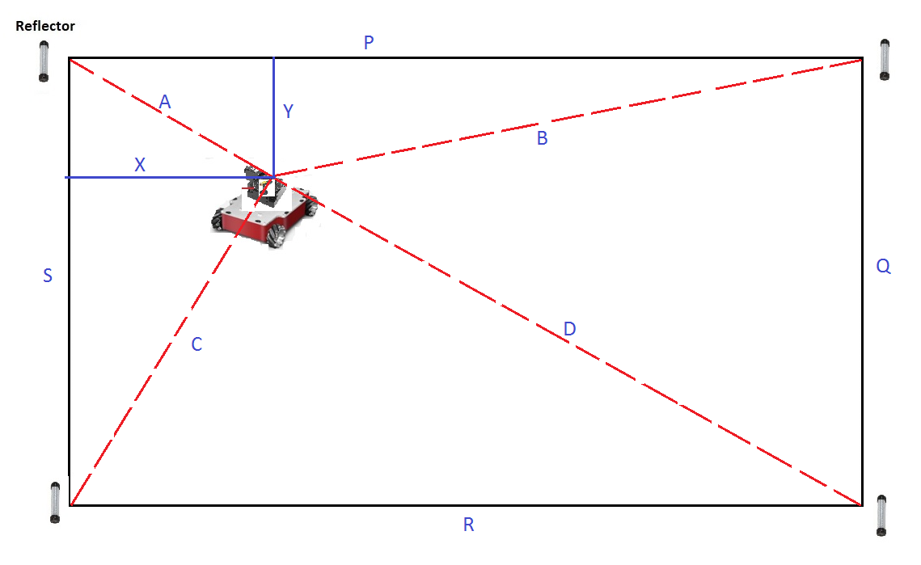

Equipment :
- High Speed XY Table:
https://www.macrondynamics.com/
https://www.youtube.com/watch?time_continue=26&v=OAVGXHH91uI
- Ink Jet print head and controllers
www.Rea-jet.com
https://www.youtube.com/watch?time_continue=12&v=lW1R0k0Isio

- Mobile Platoform

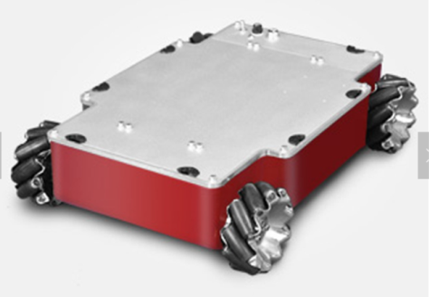

https://www.alibaba.com/product-detail/20kg-payload-Compass-Q2-industry-AUTO_60753270152.html?spm=a2700.details.maylikever.6.154f5a0d1CmZGP

or Customized wheels and drivers for the XY-Table gantry from the below sites.
Macnum Wheel rovers
https://www.robotnik.eu/
https://www.youtube.com/watch?v=_tmiu1wpp_E
www.Makeblock.com
https://www.youtube.com/watch?v=FpP2oDS91r8
- Laser Guiding System : It is from the POC for Laser marking system.

