Mobile Robotic Layout Printer Design
13th May 2019, Ver 1.2
Betabulls

Objective:

To design and develop a working prototype of autonomous mobile layout printer, which shall be on wheels and accessible remotely. Layout printing performance to be on par with manual layout printing.

Tasks of the Mobile Robotic Printer System:

- Marking of working area (perimeter) and squaring the corners using the mobile platform and robotic arm combination.
- Printing the building layout plan on the surface of the proposed building floors (concrete, wooden)
- Application for controlling and accessing using a tablet PC.

Note:
- Image processing based obstacle (drain pipes, water pipes etc.) detection is complex as it needs to implement ML/AI based object detection. Takes longer duration. Instead, trying to do obstacle detection using the same single laser and reflectors mechanism. Still working on the concept.
- Over all weight optimization will be considered after the printing job is achieved satisfactorily.

Approach:

- Marking of working area:

Marking of the working area is accomplished by using a laser distance measuring device mounted on a robotic arm & mobile platform combination.

Major components of the layout (perimeter) marking subsystem:
Mobile Platform  with Robotic Arm | Laser Distance Measuring Device | UBW32  Controller Board | Laser Reflectors
 | 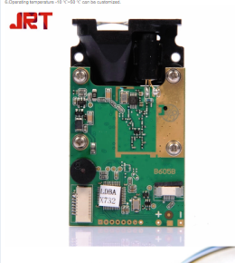 |  | 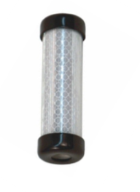

Tasks for Layout Perimeter Marking Subsystem:
- Integratingassembling laser measuring devices with robotic arm.
- Writing software for the UBW32 controller to navigate the platform with remote access for positioning the laser measurement device at a desired location and direction.

Challenges/works:
- Check the performance of Laser measuring device against its specifications given by the manufacturer and define the achievable measuring accuracy.
- Mechanical mounting of laser device on the robotic arm.
- Design and fabrication of base stands/plates for laser reflectors.
- Programming of the UBW32 Controller to perform the tasks of measurements for the marking of working area.

The following Steps describes the marking of perfect rectangle using laser device mounted on a mobile platform.

Step 1:
Place one laser reflector at the known 1st point of the rectangle on the open floor.

Fig 1: Marking 1st corner of the rectangle

Step 2:
Move the laser rotating device on the path of 2nd point, while measuring the distance between the points, identify 2nd point and place a second reflector, which indicates 2nd point/corner of the rectangle.

Fig 2: Marking 2nd corner of the rectangle

Step 3:
Move the laser in the path of 3rd point and locate 3rd corner of the rectangle.

Fig 3: Marking 3rd corner of the rectangle

Step 4:
Mark the 4th corner of the rectangle by moving the laser to the appropriate location.

Fig 4: Marking 4th corner of the rectangle

Layout squaring completed. Robot ready for printing the layout.

- Printing of building plan in the marked area:

The printing of the building plan is accomplished by a mobile jet printer. The building plan is loaded into the printer from a host device. The entire building floor plan is divided into number of sections. Each section is printed by the printer one by one. At first the printer prints first section. To print next section, the printer moves to the starting location of second section. This navigation is accomplished by mobile platform mechanism which moves the printer setup on wheels.

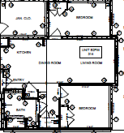

Robotic Printer
Subsystem
Layout
Image File
Input image conversion
to printer friendly format

Major components of the layout printing robot subsystem:
Mobile Platform with Robotic Arm | Flow ink Pens for low complexity printing | Jet print cartridge for high complexity printing | Printer Controller Board/Module
 | 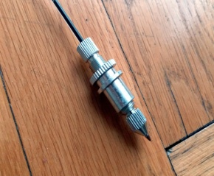

Challenges/works:
- Ink pens/ jet print cartridge mounting on the arm.
- How fast we can move the arm.
- Control and maintain the proper distance of pens/cartridges with printing surface.
- Hardware board assembly/mounting on the mobile platform.
- Software implementation for mobile platform navigation, robotic Arm and printing processing.
- Obstacle detection by laser scanning method. Acomplishing obstacle detection by image processing is risky in Phase-I time frame.

The following Steps describes the marking of perfect rectangle using laser device mounted on a mobile platform.

Step 1:
The Mobile Printer moves to the first section of printing area.
Step 2:
Scans its position, with reference to the laser marks and computes its position by means of triangulation shown below.

The position(X,Y) of the robotic device can be calculated from the values of A,B,C,P,S using Heron’s formula.
Fig.5: Printing Head Navigation
https://www.youtube.com/watch?v=mZt2Yqlz8UE
https://www.youtube.com/watch?v=5492ZjivAQ0

Step 3:
Print the section of the layout corresponding to the current printer location
Fig.6: Printing selected section of the layout
Step 4:
Move the mobile positioning platform to the next location in the designated area, estimate the position by the above triangulation and print the layout corresponding to that location.

Bill of Materials:

S.No. | Device | Source | Qty. | Unit Price | Extended Price(USD)
1 | Mobile Platform with Robotic Arm | http://www.youbot-store.com/wiki/index.php/YouBot_Detailed_Specifications | 1 | $30000-35000 | $30000-35000
4 | Laser measuring device  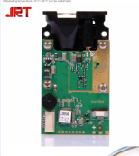 | https://www.alibaba.com/product-detail/150M-Continuous-Measurement-Long-range-laser_60678015309.html?spm=a2700.details.maylikever.10.226555b4Zf1CdK | 1 | $60 | $60
6 | Laser Markers  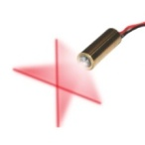 | https://www.amazon.com/VLM-650-29-LPT-Line-width-optimize-distance/dp/B00BP42YMW/ref=sr_1_16?crid=2SLNGFFA7404D&keywords=crosshair+laser+module&qid=1557442531&s=gateway&sprefix=cross+hair+laser+%2Caps%2C158&sr=8-16 | 4 | $20 | $80
7 | UBW32 Board  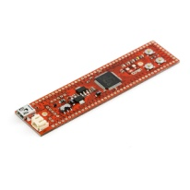 | https://www.sparkfun.com/products/9713 | 4 | $50 | $200
8 | Print Cartridge Mechanisms | https://www.rea-jet.com/en-un/coding-and-marking-systems/large-character-inkjet-printer/rea-jet-dod-inkjet-print-head.html | 1
9 | Printer Pen Mechanisms | To Be Decided | 1
10 | Plotting Pens | To Be Decided | 4

