.

**LA GRANDEE INTERNATIONAL COLLEGE**

**Simalchaur, Pokhara Nepal**

A Project Proposal

On

**“Contact Management System”**

**Submitted to:**

Bachelor of Computer Application (BCA) Program

In partial fulfilment of the requirements for the degree of BCA under

Pokhara University

**Submitted by:**

|  |  |  |  |
| --- | --- | --- | --- |
| **Name:** | **Course** | **Semester** | **P.U. Registration Number** |
| Manisha Sharma | BCA | 2nd | 2021-01-53-0354 |
| Prabin Shrestha | BCA | 2nd | 2021-01-53-0358 |
| Pawan Paudel | BCA | 2nd | 2021-01-53-0357 |
|  |  |  |  |
|  | Date:11/24/2022 |  |  |

# ABSTRACT

A contact management is a software program that enables users to easily store and find contact information, such as names, addresses, and email. Contact Management System is a system which is used by every individual for their personal and business needs. The purpose of contact management software is to record contact information in a central location to be easily accessed and updated. This information may include names, addresses, phone numbers, email addresses etc.

**TABLE OF CONTENTS**

ABSTRACT ii

List of Figures iv

1. Introduction 1

2. Problem Statement 2

3. Objectives 3

4. Requirement Analysis 4

4.1 Functional Requirements 5

4.2 Non-Functional Requirements 5

5. Methodology 6

5.1 Problem Identification 7

5.2 Requirement analysis 7

5.3 System Design 7

5.4 Implementation 7

5.5 Testing 7

5.6 Deployment 7

5.7 Maintenance 7

6. Data Flow Diagram 8

7. Project Gantt Chart/ Timeline Chart 9

8. Deliverables 10

9. Conclusion 11

10. References 12

## List of Figures

# Introduction

Contact is one of the important needs of people whether it is in business, organization or in their regular lives. It helps to maintain a close relationship between peoples. Also it leads to increase in business contacts and profit.

Thus to manage the contacts and increase the usability of contacts and SMS, we are developing a new project on Contact Management System. A Contact Management System is a program that enables user to store, view and find contact information such as name, address, phone number, E-mail address etc. It also helps user to add, update and delete contacts. This system can be used by every individual, organizations, college, universities as well as bank to store their contacts, send messages to their clients/staffs and many other purposes. It works on the same way that cell phones do with contacts. In this project, we can add, view, edit, search and delete contacts. In this project file handling was used to record all information. This system makes easy to keep records of each person..

The usability of Contact Management System is very high as it can be used by any number of peoples by modifying them as needed.

For CMS, Akshat Kumar has developed a project with similar objectives. In this project, c language is used for coding and file handling is used for storing contact information. This project is a simple form of contact management system which is focused on simple activities such as adding, updating, viewing and deleting of contact information of people. Contact information includes the information like name, phone number address, email address and gender (Kumar, 2017) [1].

Vendor contact management system is also a contact management system. It was developed by Rank Expert. In this project electronic database is used for customer as well as business people to store their contacts. It has also added the features of tracking contacts and information of its users (Expert, 2013) [2].

# Problem Statement

Our aim is to develop an application for the user’s in which a user can add, edit, delete and save the number. Before making a system we had took an individual interview with some people and we encountered that are existing in today’s scenario.

* In many offices and businesses, the contact information, address, personal information of their customer or staffs is recorded manually.
* Data inconsistency.
* Once the data is destroyed it’s hard to recover.
* Time to access the information increases.
* Duplication of data.

To improve the existing system and reduce the manual system of recording information, we are proposing a new project called Contact Management System. This system will be a solution to these problems.

# Objectives

* To reduce the manual form of managing contacts, information, address and phone number.
* To store all the contacts, addresses, phone numbers and other information safely and in an effective way so that it can be accessed in any time.

# Requirement Analysis

It is the process of defining the expectations of user’s that is to be build or modify. Without proper analysis before the software is built the developer may end up developing incomplete software that does not solve the problem it intended to.

During analysis of this project, we used different methods to collect information about contact management and the trend of using this system in the market. While collecting data we interviewed some people near the market and asked some questions regarding this system. The questions asked are given below:

1. Which type of contact management do you prefer?

2. Which is easier and beneficial between manual storage of contacts or digital system?

3. For sending message which system do you choose between SMS and e-mail or other networking sites?

4. Do you prefer to create group of particular people from your contact list?

After interviewing some people, we found that many people prefer contact management system which can store as many contacts as possible and create groups for sending group message or multiple messages. People who are illiterate also prefer SMS system for sending message than E-mail because they feel easier to understand and use SMS system. Some people prefer E-mail because it is more secure than SMS.Some people viewed their ideas about offline and online topic. In SMS system, no internet connection is required to send message but in contrast, Email or any other networking sites require internet connection to do any work. We also studied some existing project on Contact Management System. From the analysis of those projects we analysed some problems. After studying Vendor Contact Management System (Expert, 2013) [1], we found that While storing contacts and information in a cloud database, many people may be affected by the internet connection. Also while studying a contact management system in c language we found while logging in, some user may have same email- id or password which can cause problem in login. Another common problem faced in other existing system is poor security. It may be in storing password or login process. Moreover, there is one more problem analysed that is the group forming features. In the former projects, feature of creating group is not added effectively. This may cause problem in team work or in people gathering. Our project will try to solve all this problem faced in existing Contact Management system and improve the performance of contact management.

## 4.1 Functional Requirements

Functional requirements is the description of the services that the system should provide to the user. Some functional requirements are:

* Users Login: - For log in people must have verified account.
* Add contact: The user can enter new contact information in the add new contact section.
* Edit contact: The user can edit/update their own contact information in the edit contact.
* Delete contact: The user can delete their contact information using the delete contact option.
* Admin Login: -Admin can enter the user name and password to get access of the application.

## 4.2 Non-Functional Requirements

Non-Functional requirements are set of specifications that describe the system’s operation capabilities and constraints and attempt to improve its functionality. Some non-functional requirements are:

* Usability: - The system should provide easy access to the users without any barriers and should be able to support multiple languages.
* Portability: - The system should be able use on different platforms without change in its behaviour or performance.
* Security: - The system should be secured and it should not show customer’s name, password and their other date to any other users.

# Methodology

For the development of the project we use waterfall model. In this sequential type of model we go linearly through each steps of software development lifecycle.

First we go linearly through problem identification and then requirements are analysed. After the analysis program design is done and coding is started after its completion. And program is tested and debugged and finally delivered.

The process of waterfall model is shown below:

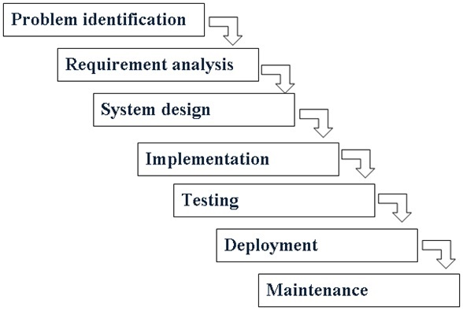

Figure 5.1 Waterfall Model

The sequential phases of waterfall model are:

## Problem Identification

The first step in program development is problem identification. This step clearly identify the root cause of problem.

## 5.2 Requirement analysis

All possible requirements of the system to develop contact management system are captured in this phase and documented in a requirement specification document.

## 5.3 System Design

The requirement specifications are studied in this phase and the system design is prepared. The system design helps in specifying hardware and system requirements and helps in defining the overall system architecture.

## 5.4 Implementation

With inputs from the system design, the system is first developed in small programs called units, which are integrated in the next phase. Each unit is developed and tested for its functionality, which is referred to as unit testing.

## 5.5 Testing

All the units developed in the implementation phase are integrated into a system after testing of each unit. Post integration the entire system is tested for any faults and failures.

## 5.6 Deployment

Once the functional and non-functional testing is done; the product is deployed in the customer environment or released into the market.

## 5.7 Maintenance

There are some issues which come up with the client environment. To fix those issues, patches are released. Also to enhance the product some better versions are released. Maintenance is done to deliver these changes in the customer environment.

# Data Flow Diagram

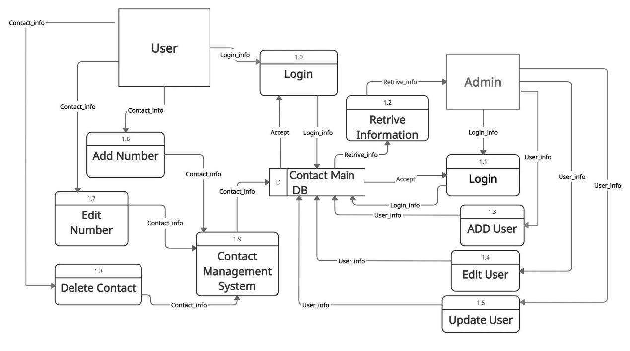

Figure 6.1 Level-1 DFD

# Project Gantt Chart/ Timeline Chart

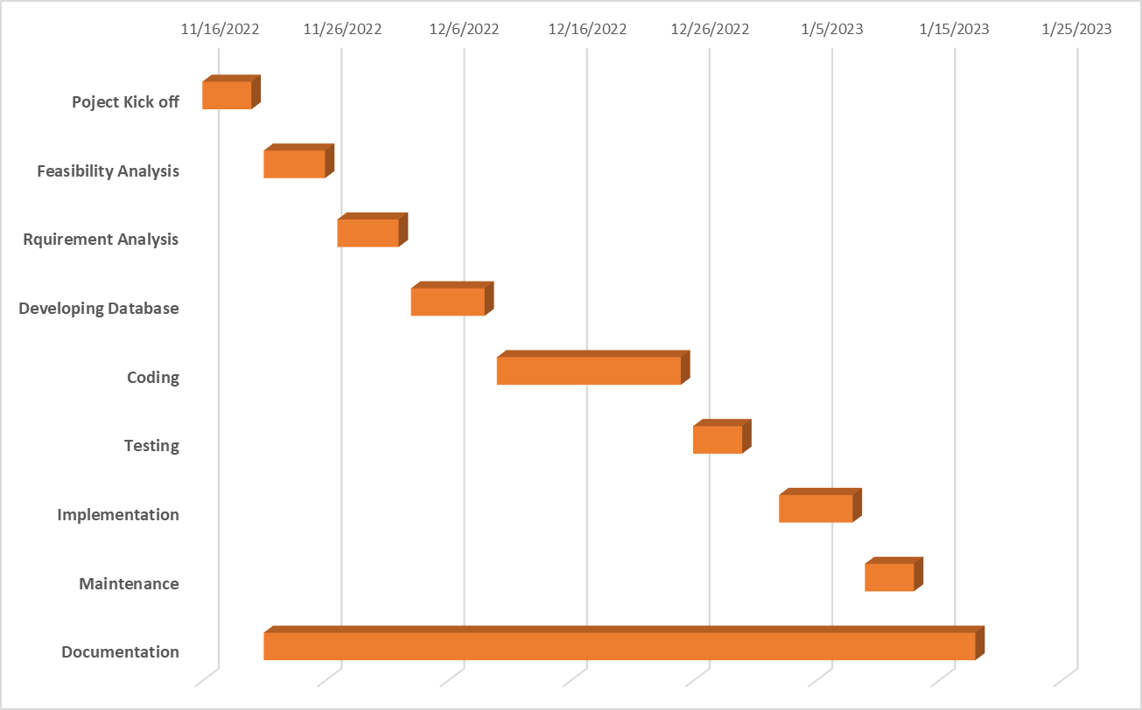

Figure 7.1 Gantt chart

# Deliverables

When we develop a software application we face many problems by maintaining the features of it properly but the system can't be perfect there may be some problems but after developing the software we always expect a better output. Similarly, by making this contact management system we expect the output equal as the hard work put in it.

With the completion of the project, we will obtain a system where we can add, delete, edit, store and update our contact information.

Documentation and manuals:

A detailed information from the starting of the making system to the end of the system will be created as a document. Similarly, a guide manual will also be created and provided to users so if they encounter any problems they can search about that on their own.

System Design:

Data flow diagrams are also created which help us to know how exactly the system is designed and how it will function. It will also shows how the system is designed.

Codes:

Similarly, we will create codes using C programming that will run the system.

# Conclusion

We have conclude that our project will be completed the following objectives and satisfy the user needs:

* Our project will be able to reduce manual system of saving contacts.
* It will provide user privacy of creating their own account and managing it.
* It will manage all the information of email, contacts, people, as well as group.

Contact Management System is a simple desktop-based application suitable for small organization. The system gives solution for most of the problems that we have identified in the Contact currently. The tasks that now are carried out manually will be able to do with the system in more easy way. The data that are now kept in large physical files will be stored in centralized database of the system which will reduced the damaged that can be happened to the data unexpectedly.

We believe that this system will help to enhance the functions of Contact in a smoother and easier way.

# References

1].Expert, R. (2013, 2 15). home. Retrieved from Slideshare:

<https://www.slideshare.net/gopalbhat/contact-management-system-16541357>

[2].Kumar, A. (2017). Contact Management System