Ownership and Memory 1

Ownership Rules 3

Variable Binding Scope 3

The String Type 4

Memory and Allocation 5

Ways Bindings and Data Interact: Move 7

Ways Bindings and Data Interact: Clone 10

Stack-only Data: Copy 10

Ownership and Functions 11

Return Values and Scope 12

References and Borrowing 14

Mutable References 16

Dangling References 19

The Rules of References 20

Slices 21

String Slices 23

String Literals are Slices 26

String Slices as Arguments 27

Other Slices 27

Summary 28

Chapter 4

Understanding Ownership

Ownership is Rust’s most unique feature, and enables Rust to make memory safety guarantees without needing a garbage collector. It’s therefore important to understand how ownership works in Rust. In this chapter we’ll talk about ownership as well as several related features: borrowing, slices, and how Rust lays things out in memory.

Ownership and Memory

Rust’s central feature is ownership. It is a feature that is straightforward to explain, but has deep implications for the rest of the language.

All programs have to manage the way they use a computer’s memory while running. Some languages have garbage collection that’s constantly looking for no longer used memory as the program runs, while in others the programmer has to explicitly allocate and free the memory. Rust takes a third approach: memory is managed through a system of ownership with a set of rules that the compiler checks at compile-time. You do not pay any run-time cost for any of these features.

Since ownership is a new concept for many programmers, it does take some time to get used to. There is good news, though: the more experienced you become with Rust and the rules of the ownership system, the more you’ll be able to naturally develop code that is both safe and efficient. Keep at it!

Once you understand ownership, you have a good foundation for understanding the features that make Rust unique. In this chapter, we’ll learn ownership by going through some examples, focusing on a very common data structure: strings.

PROD: START BOX

The Stack and the Heap

In many programming languages, we don’t have to think about the stack and the heap very often. But in a systems programming language like Rust, whether a value is on the stack or the heap has more of an effect on how the language behaves and why we have to make certain decisions. We’re going to be describing parts of ownership in relation to the stack and the heap, so here is a brief explanation.

Both the stack and the heap are parts of memory that is available to your code to use at runtime, but they are structured in different ways. The stack stores values in the order it gets them and removes the values in the opposite order. This is referred to as last in, first out. Think of a stack of plates: when you add more plates, you put them on top of the pile, and when you need a plate, you take one off the top. Adding or removing plates from the middle or bottom wouldn’t work as well! Adding data is called pushing onto the stackand removing data is called popping off the stack.

The stack is fast because of the way it accesses the data: it never has to look around for a place to put new data or a place to get data from; that place is always the top. Another property that makes the stack fast is that all data on the stack must take up a known, fixed size.

For data with a size unknown to us at compile time, or a size that might change, we can store data on the heap instead. The heap is less organized: when we put data on the heap, we ask for some amount of space. The operating system finds an empty spot somewhere in the heap that is big enough, marks it as being in use, and returns to us a pointer to that location. This process is called allocating on the heap, and sometimes we just say, “allocating” for short. Pushing values onto the stack is not considered allocating. Since the pointer is a known, fixed size, we can store the pointer on the stack, but when we want the actual data, we have to follow the pointer.

Think of being seated at a restaurant. When you enter, you say how many people are in your group, and the staff finds an empty table that would fit everyone and leads you there. If someone in your group comes late, they can ask where you have been seated to find you.

Accessing data in the heap is slower because we have to follow a pointer to get there. Modern processors are faster if they jump around less in memory, not unlike a waiter taking all orders at each table instead of going to all tables and taking one order from each, as both accessing memory at random and moving to another table take time and effort. Allocating a large amount of space can also take time.

When our code calls a function, the values passed into the function (including, potentially, pointers to data on the heap) and the function’s local variables get pushed onto the stack. When the function is over, those values get popped off the stack.

Keeping track of what parts of code are using what data on the heap, minimizing the amount of duplicate data on the heap, and cleaning up unused data on the heap so that we don’t run out of space - these are all problems that ownership addresses. Once you understand ownership, you won’t need to think about the stack and the heap very often, but knowing that managing heap data is why ownership exists can help explain why it works the way it does.

PROD: END BOX

Ownership Rules

First, let’s take a look at the rules. Keep these in mind as we go through the examples that will illustrate the rules:

Each value in Rust has a variable binding that’s called its *owner*.

There can only be one owner at a time.

When the owner goes out of scope, the value will be dropped.

Variable Binding Scope

We’ve walked through an example of a Rust program already in the tutorial chapter. Now that we’re past basic syntax, we won’t include all of the fn main() { stuff in examples, so if you’re following along, you will have to put the following examples inside of a main function yourself. This lets our examples be a bit more concise, letting us focus on the actual details rather than boilerplate.

As a first example of ownership, we’ll look at the *scope* of some variable bindings. A scope is the range within a program for which an item is valid. Let’s say we have a variable binding that looks like this:

let s = "hello";

The variable binding s refers to a string literal, where the value of the string is hard coded into the text of our program. The binding is valid from the point at which it’s declared until the end of the current *scope*. That is:

{ // s is not valid here, it’s not yet declared

let s = "hello"; // s is valid from this point forward

// do stuff with s

} // this scope is now over, and s is no longer valid

In other words, there are two important points in time here:

When s comes into scope, it is valid.

It remains so until it goes out of scope.

At this point, things are similar to other programming languages. Now let’s build on top of this understanding by introducing the String type.

The String Type

In order to illustrate the rules of ownership, we need a data type that is more complex than the ones we covered in Chapter 3. All of the data types we’ve looked at previously are stored on the stack and popped off the stack when their scope is over, but we want to look at data that is stored on the heap and explore how Rust knows when to clean that data up.

We’re going to use String as the example here and concentrate on the parts of String that relate to ownership. These aspects also apply to other complex data types provided by the standard library and that you create. We’ll go into more depth about String specifically in Chapter XX.

We’ve already seen string literals, where a string value is hard-coded into our program. String literals are convenient, but they aren’t always suitable for every situation you want to use text. For one thing, they’re immutable. For another, not every string value can be known when we write our code: what if we want to take user input and store it?

For things like this, Rust has a second string type, String. This type is allocated on the heap, and as such, is able to store an amount of text that is unknown to us at compile time. You can create a String from a string literal using the from function, like so:

let s = String::from("hello");

The double colon (::) is an operator that allows us to namespace this particular from function under the String type itself, rather than using some sort of name like string_from. We’ll discuss this syntax more in the “Method Syntax” and “Modules” chapters.

This kind of string can be mutated:

let mut s = String::from("hello");

s.push_str(", world!"); // push_str() appends a literal to a String

println!("{}", s); // This will print `hello, world!`

So, what’s the difference here? Why can String be mutated, but literals cannot? The difference comes down to how these two types deal with memory.

Memory and Allocation

In the case of a string literal, because we know the contents at compile time, the text is hard-coded directly into the final executable. This makes string literals quite fast and efficient. But these properties only come from its immutability. Unfortunately, we can’t put a blob of memory into the binary for each piece of text whose size is unknown at compile time and whose size might change over the course of running the program.

With the String type, in order to support a mutable, growable piece of text, we need to allocate an amount of memory on the heap, unknown at compile time, to hold the contents. This means two things:

The memory must be requested from the operating system at runtime.

We need a way of giving this memory back to the operating system when we’re done with our String.

That first part is done by us: when we call String::from, its implementation requests the memory it needs. This is pretty much universal in programming languages.

The second case, however, is different. In languages with a garbage collector(GC), the GC will keep track and clean up memory that isn’t being used anymore, and we, as the programmer, don’t need to think about it. Without GC, it’s the programmer’s responsibility to identify when memory is no longer being used and call code to explicitly return it, just as we did to request it. Doing this correctly has historically been a difficult problem in programming. If we forget, we will waste memory. If we do it too early, we will have an invalid variable. If we do it twice, that’s a bug too. We need to pair exactly one allocate with exactly one free.

Rust takes a different path: the memory is automatically returned once the binding to it goes out of scope. Here’s a version of our scope example from earlier using String:

{

let s = String::from("hello"); // s is valid from this point forward

// do stuff with s

} // this scope is now over, and s is no longer valid

There is a natural point at which we can return the memory our String needs back to the operating system: when s goes out of scope. When a variable binding goes out of scope, Rust calls a special function for us. This function is called drop, and it is where the author of String can put the code to return the memory. Rust calls drop automatically at the closing }.

Note: This pattern is sometimes called Resource Acquisition Is Initialization in C++, or RAII for short. While they are very similar, Rust’s take on this concept has a number of differences, so we don’t tend to use the same term. If you’re familiar with this idea, keep in mind that it is roughly similar in Rust, but not identical.

This pattern has a profound impact on the way that Rust code is written. It may seem simple right now, but things can get tricky in more advanced situations when we want to have multiple variable bindings use the data that we have allocated on the heap. Let’s go over some of those situations now.

Ways Bindings and Data Interact: Move

There are different ways that multiple bindings can interact with the same data in Rust. Let’s take an example using an integer:

let x = 5;

let y = x;

We can probably guess what this is doing based on our experience with other languages: “Bind the value 5 to x, then make a copy of the value in x and bind it to y.” We now have two bindings, x and y, and both equal 5. This is indeed what is happening since integers are simple values with a known, fixed size, and these two 5 values are pushed onto the stack.

Now let’s look at the String version:

let s1 = String::from("hello");

let s2 = s1;

This looks very similar to the previous code, so we might assume that the way it works would be the same: that the second line would make a copy of the value in s1 and bind it to s2. This isn’t quite what happens.

To explain this more thoroughly, let’s take a look at what String looks like under the covers in Figure 4-1. A String is made up of three parts, shown on the left: a pointer to the memory that holds the contents of the string, a length, and a capacity. This group of data is stored on the stack. On the right is the memory that holds the contents, and this is on the heap.

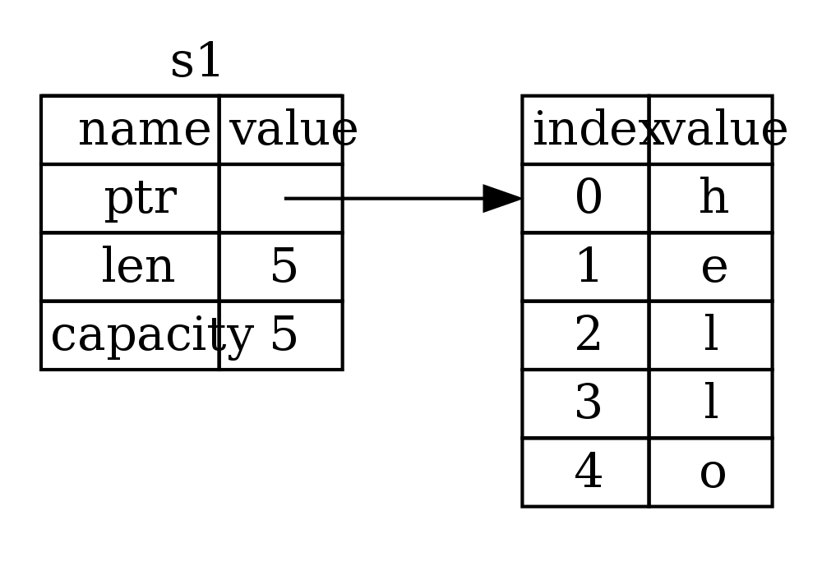Figure 4-1: Representation in memory of a String holding the value “hello” bound to s1

The length is how much memory, in bytes, the contents of the String is currently using. The capacity is the total amount of memory, in bytes, that the String has gotten from the operating system. The difference between length and capacity matters but not in this context, so for now, it’s fine to ignore the capacity.

When we assign s1 to s2, the String data itself is copied, meaning we copy the pointer, the length, and the capacity that are on the stack. We do not copy the data on the heap that the String’s pointer refers to. In other words, it looks like figure 4-2.

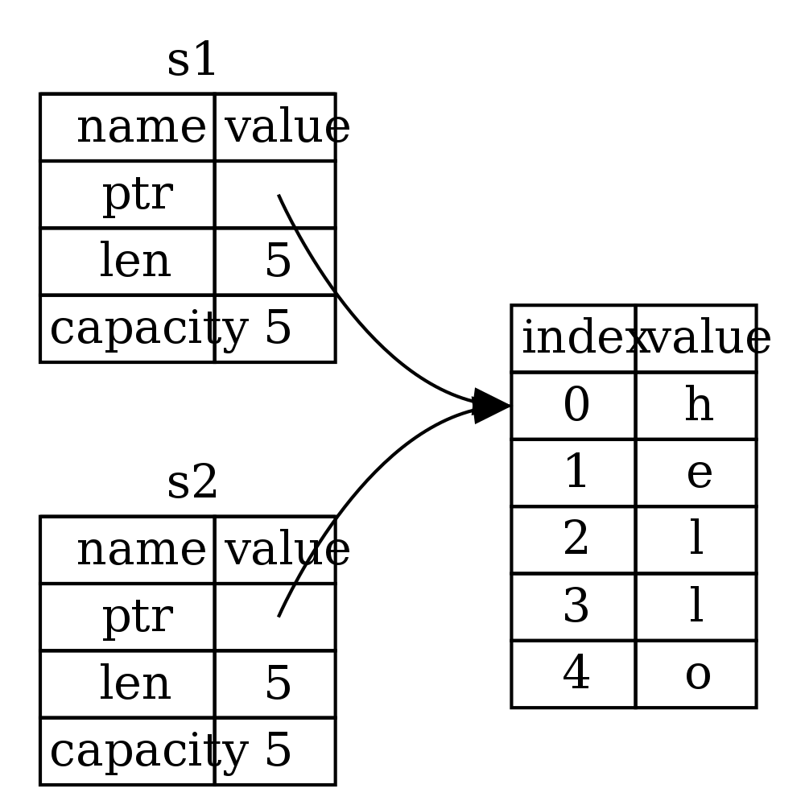Figure 4-2: Representation in memory of the binding s2 that has a copy of s1‘s pointer, length and capacity

And not Figure 4-3, which is what memory would look like if Rust instead copied the heap data as well. If Rust did this, the operation s2 = s1 could potentially be very expensive if the data on the heap was large.

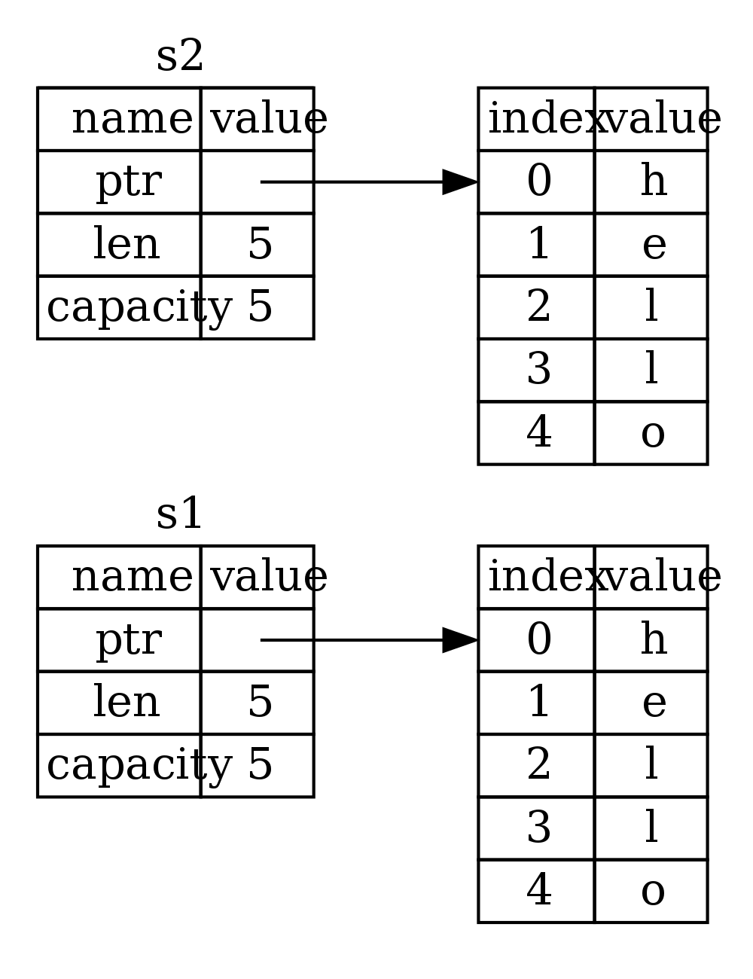Figure 4-3: Another possibility for what s2 = s1 might do, if Rust chose to copy heap data as well.

Earlier, we said that when a binding goes out of scope, Rust will automatically call the drop function and clean up the heap memory for that binding. But in figure 4-2, we see both data pointers pointing to the same location. This is a problem: when s2 and s1 go out of scope, they will both try to free the same memory. This is known as a double free error and is one of the memory safety bugs we mentioned before. Freeing memory twice can lead to memory corruption, which can potentially lead to security vulnerabilities.

In order to ensure memory safety, there’s one more detail to what happens in this situation in Rust. Instead of trying to copy the allocated memory, Rust says that s1 is no longer valid and, therefore, doesn’t need to free anything when it goes out of scope. Check out what happens when you try to use s1 after s2 is created:

let s1 = String::from("hello");

let s2 = s1;

println!("{}", s1);

You’ll get an error like this:

5:22 error: use of moved value: `s1` [E0382]

println!("{}", s1);

^~

5:24 note: in this expansion of println! (defined in <std macros>)

3:11 note: `s1` moved here because it has type `collections::string::String`, which is moved by default

let s2 = s1;

^~

If you have heard the terms “shallow copy” and “deep copy” while working with other languages, the concept of copying the pointer, length, and capacity without copying the data probably sounds like a shallow copy. But because Rust also invalidates the first binding, instead of calling this a shallow copy, it’s known as a move. Here we would read this by saying that s1 was *moved* into s2. So what actually happens looks like Figure 4-4.

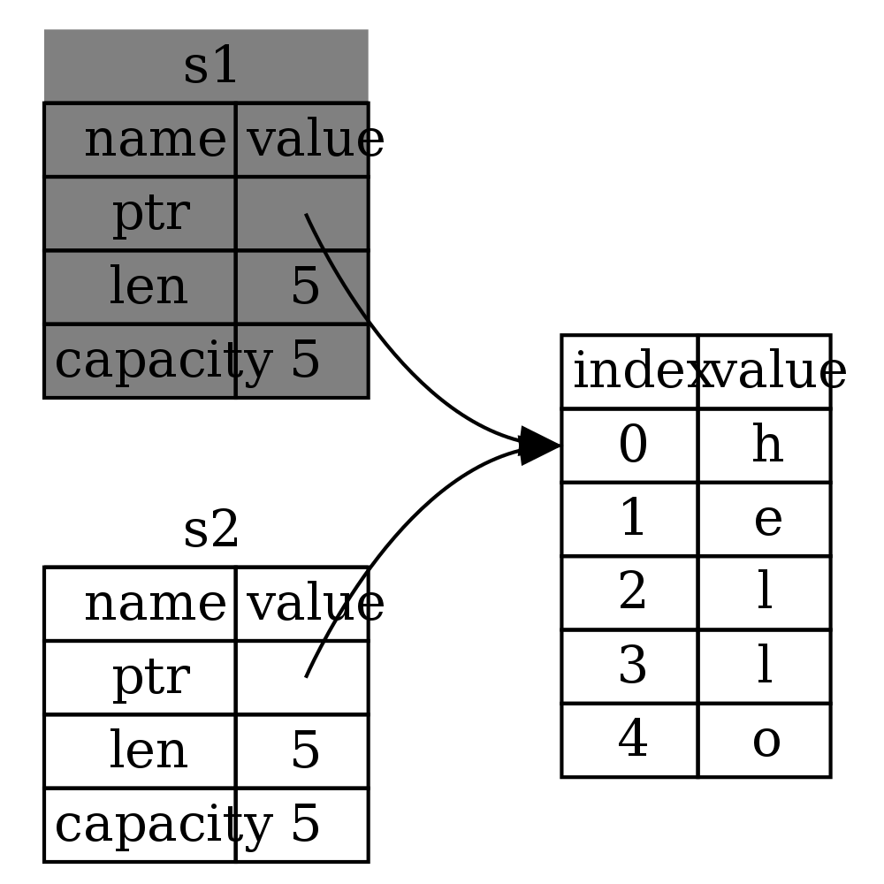

Figure 4-4: Representation in memory after s1 has been invalidated

That solves our problem! With only s2 valid, when it goes out of scope, it alone will free the memory, and we’re done.

Furthermore, there’s a design choice that’s implied by this: Rust will never automatically create “deep” copies of your data. Therefore, any automaticcopying can be assumed to be inexpensive.

Ways Bindings and Data Interact: Clone

If we do want to deeply copy the String’s data and not just the String itself, there’s a common method for that: clone. We will discuss methods in the section on structs in Chapter XX, but they’re a common enough feature in many programming languages that you have probably seen them before.

Here’s an example of the clone method in action:

let s1 = String::from("hello");

let s2 = s1.clone();

println!("s1 = {}, s2 = {}", s1, s2);

This will work just fine, and this is how you can explicitly get the behavior we showed in Figure 4-3, where the heap data does get copied.

When you see a call to clone, you know that some arbitrary code is being executed, and that code may be expensive. It’s a visual indicator that something different is going on here.

Stack-only Data: Copy

There’s another wrinkle we haven’t talked about yet. This code, that we showed earlier, works and is valid:

let x = 5;

let y = x;

println!("x = {}, y = {}", x, y);

This seems to contradict what we just learned: we don’t have a call to clone, but x is still valid, and wasn’t moved into y.

This is because types like integers that have a known size at compile time are stored entirely on the stack, so copies of the actual values are quick to make. That means there’s no reason we would want to prevent x from being valid after we create the binding y. In other words, there’s no difference between deep and shallow copying here, so calling clone wouldn’t do anything differently from the usual shallow copying and we can leave it out.

Rust has a special annotation called the Copy trait that we can place on types like these (we’ll talk more about traits in Chapter XX). If a type has the Copy trait, an older binding is still usable after assignment. Rust will not let us annotate a type with the Copy trait if the type, or any of its parts, has implemented drop. If the type needs something special to happen when the value goes out of scope and we add the Copy annotation to that type, we will get a compile-time error.

So what types are Copy? You can check the documentation for the given type to be sure, but as a rule of thumb, any group of simple scalar values can be Copy, and nothing that requires allocation or is some form of resource is Copy. Here’s some of the types that are Copy:

All of the integer types, like u32.

The boolean type, bool, with values true and false.

All of the floating point types, like f64.

Tuples, but only if they contain types which are also Copy. (i32, i32) is Copy, but (i32, String) is not.

Ownership and Functions

The semantics for passing a value to a function are similar to assigning a value to a binding. Passing a binding to a function will move or copy, just like assignment. Here’s an example, with some annotations showing where bindings go into and out of scope:

Filename: src/main.rs

fn main() {

let s = String::from("hello"); // s comes into scope.

takes_ownership(s); // s's value moves into the function...

// ... and so is no longer valid here.

let x = 5; // x comes into scope.

makes_copy(x); // x would move into the function,

// but i32 is Copy, so it’s okay to still

// use x afterward.

} // Here, x goes out of scope, then s. But since s's value was moved, nothing

// special happens.

fn takes_ownership(some_string: String) { // some_string comes into scope.

println!("{}", some_string);

} // Here, some_string goes out of scope and `drop` is called. The backing

// memory is freed.

fn makes_copy(some_integer: i32) { // some_integer comes into scope.

println!("{}", some_integer);

} // Here, some_integer goes out of scope. Nothing special happens.

If we tried to use s after the call to takes_ownership, Rust would throw a compile-time error. These static checks protect us from mistakes. Try adding code to main that uses s and x to see where you can use them and where the ownership rules prevent you from doing so.

Return Values and Scope

Returning values can also transfer ownership. Here’s an example with similar annotations:

Filename: src/main.rs

fn main() {

let s1 = gives_ownership(); // gives_ownership moves its return

// value into s1.

let s2 = String::from("hello"); // s2 comes into scope

let s3 = takes_and_gives_back(s2); // s2 is moved into

// takes_and_gives_back, which also

// moves its return value into s3.

} // Here, s3 goes out of scope, and is dropped. s2 goes out of scope, but was

// moved, so nothing happens. s1 goes out of scope, and is dropped.

fn gives_ownership() -> String { // gives_ownership will move its

// return value into the function

// that calls it.

let some_string = String::from("hello"); // some_string comes into scope.

some_string // some_string is returned, and

// moves out to the calling

// function.

}

// takes_and_gives_back will both take a String and return one

fn takes_and_gives_back(a_string: String) -> String { // a_string comes into scope

a_string // a_string is returned, and moves out to the calling function

}

It’s the same pattern, every time: assigning a value to another binding moves it, and when heap data values’ bindings go out of scope, if the data hasn’t been moved to be owned by another binding, the value will be cleaned up by drop.

Taking ownership then returning ownership with every function is a bit tedious. What if we want to let a function use a value but not take ownership? It’s quite annoying that anything we pass in also needs to be passed back if we want to use it again, in addition to any data resulting from the body of the function that we might want to return as well.

It is possible to return multiple values using a tuple, like this:

Filename: src/main.rs

fn main() {

let s1 = String::from("hello");

let (s2, len) = calculate_length(s1);

println!("The length of '{}' is {}.", s2, len);

}

fn calculate_length(s: String) -> (String, usize) {

let length = s.len(); // len() returns the length of a String.

(s, length)

}

But this is too much ceremony and a lot of work for a concept that should be common. Luckily for us, Rust has a feature for this concept: references.

References and Borrowing

The issue with the tuple code at the end of the last section is that we have to return the String back to the calling function so that we can still use the String after the call to calculate_length, since the String was moved into calculate_length.

Here is how you would use a function without taking ownership of it using references*:*

Filename: src/main.rs

fn main() {

let s1 = String::from("hello");

let len = calculate_length(&s1);

println!("The length of '{}' is {}.", s1, len);

}

fn calculate_length(s: &String) -> usize {

let length = s.len();

length

}

First, you’ll notice all of the tuple stuff in the binding declaration and the function return value is gone. Next, note that we pass &s1 into calculate_length, and in its definition, we take &String rather than String.

These &s are references, and they allow you to refer to some value without taking ownership of it. Figure 4-5 shows a diagram of this.

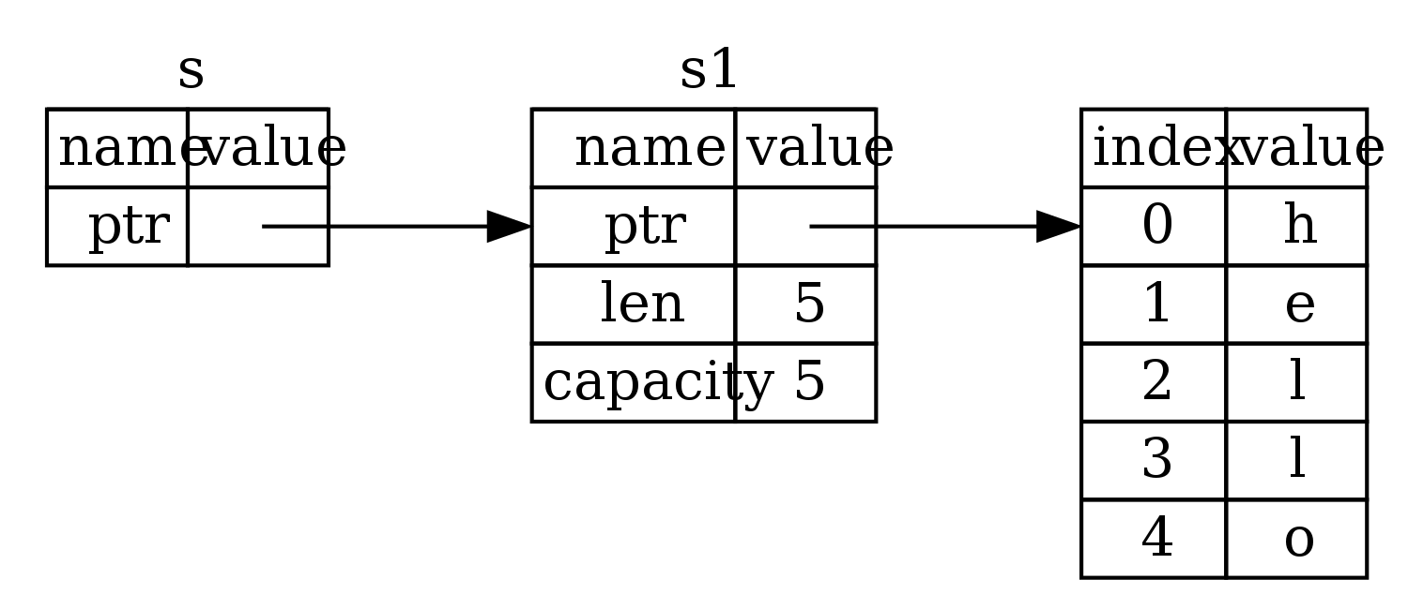

Figure 4-5: &String s pointing at String s1

Let’s take a closer look at the function call here:

let s1 = String::from("hello");

let len = calculate_length(&s1);

The &s1 syntax lets us create a reference which refers to the value of s1 but does not own it. Because it does not own it, the value it points to will not be dropped when the reference goes out of scope.

Likewise, the signature of the function uses & to indicate that it takes a reference as an argument. Let’s add some explanatory annotations:

fn calculate_length(s: &String) -> usize { // s is a reference to a String

let length = s.len();

length

} // Here, s goes out of scope. But since it does not have ownership of what

// it refers to, nothing happens.

It’s the same process as before, but we don’t drop what the reference points to when it goes out of scope because we don’t have ownership. This lets us write functions which take references as arguments instead of the values themselves, so that we won’t need to return them to give back ownership.

We call this process borrowing. Just like with real life, if a person owns something, you can borrow it from them, and when you’re done, you have to give it back.

So what happens if we try to modify something we’re borrowing? Try this code out. Spoiler alert: it doesn’t work!

Filename: src/main.rs

fn main() {

let s = String::from("hello");

change(&s);

}

fn change(some_string: &String) {

some_string.push_str(", world");

}

Here’s the error:

error: cannot borrow immutable borrowed content `*some_string` as mutable

--> error.rs:8:5

|

8 | some_string.push_str(", world");

| ^^^^^^^^^^^

Just as bindings are immutable by default, so are references. We’re not allowed to modify something we have a reference to.

Mutable References

We can fix this error with just a small tweak:

Filename: src/main.rs

fn main() {

let mut s = String::from("hello");

change(&mut s);

}

fn change(some_string: &mut String) {

some_string.push_str(", world");

}

First, we had to change s to be mut. Then we had to create a mutable reference with &mut s and accept a mutable reference with some_string: &mut String.

Mutable references have one big restriction, though: you can only have one mutable reference to a particular piece of data in a particular scope. This code will fail:

Filename: src/main.rs

let mut s = String::from("hello");

let r1 = &mut s;

let r2 = &mut s;

Here’s the error:

error[E0499]: cannot borrow `s` as mutable more than once at a time

--> borrow_twice.rs:5:19

|

4 | let r1 = &mut s;

| - first mutable borrow occurs here

5 | let r2 = &mut s;

| ^ second mutable borrow occurs here

6 | }

| - first borrow ends here

This restriction allows for mutation but in a very controlled fashion. It is something that new Rustaceans struggle with, because most languages let you mutate whenever you’d like. The benefit of having this restriction is that Rust can prevent data races at compile time. A data race is a particular type of race condition where two or more pointers access the same data at the same time, at least one of the pointers is being used to write to the data, and there’s no mechanism being used to synchronize access to the data. Data races cause undefined behavior and can be difficult to diagnose and fix when trying to track them down at runtime; Rust prevents this problem from happening since it won’t even compile code with data races!

As always, we can use {}s to create a new scope, allowing for multiple mutable references, just not simultaneous ones:

let mut s = String::from("hello");

{

let r1 = &mut s;

} // r1 goes out of scope here, so we can make a new reference with no problems.

let r2 = &mut s;

There is a similar rule for combining mutable and immutable references. This code errors:

let mut s = String::from("hello");

let r1 = &s; // no problem

let r2 = &s; // no problem

let r3 = &mut s; // BIG PROBLEM

Here’s the error:

error[E0502]: cannot borrow `s` as mutable because it is also borrowed as immutable

--> borrow_thrice.rs:6:19

|

4 | let r1 = &s; // no problem

| - immutable borrow occurs here

5 | let r2 = &s; // no problem

6 | let r3 = &mut s; // BIG PROBLEM

| ^ mutable borrow occurs here

7 | }

| - immutable borrow ends here

Whew! We also cannot have a mutable reference while we have an immutable one. Users of an immutable reference don’t expect the values to suddenly change out from under them! Multiple immutable references are okay, however, since no one who is just reading the data has the ability to affect anyone else’s reading of the data.

Even though these errors may be frustrating at times, remember that it’s the Rust compiler pointing out a potential bug earlier (at compile time rather than at runtime) and showing you exactly where the problem is instead of you having to track down why sometimes your data isn’t what you thought it should be.

Dangling References

In languages with pointers, it’s easy to make the error of creating a dangling pointer, a pointer referencing a location in memory that may have been given to someone else, by freeing some memory while keeping around a pointer to that memory. In Rust, by contrast, the compiler guarantees that references will never be dangling: if we have a reference to some data, the compiler will ensure that the data will not go out of scope before the reference to the data does.

Let’s try to create a dangling reference:

Filename: src/main.rs

fn main() {

let reference_to_nothing = dangle();

}

fn dangle() -> &String {

let s = String::from("hello");

&s

}

Here’s the error:

error[E0106]: missing lifetime specifier

--> dangle.rs:5:16

|

5 | fn dangle() -> &String {

| ^^^^^^^

|

= help: this function's return type contains a borrowed value, but there is no

value for it to be borrowed from

= help: consider giving it a 'static lifetime

error: aborting due to previous error

This error message refers to a feature we haven’t learned about yet: lifetimes. We’ll discuss lifetimes in detail in Chapter XX, but, disregarding the parts about lifetimes, the message does contain the key to why this code is a problem:

this function’s return type contains a borrowed value, but there is no value for it to be borrowed from.

Let’s have a closer look at exactly what’s happening at each stage of our dangle code:

fn dangle() -> &String { // dangle returns a reference to a String

let s = String::from("hello"); // s is a new String

&s // we return a reference to the String, s

} // Here, s goes out of scope, and is dropped. Its memory goes away.

// Danger!

Because s is created inside of dangle, when the code of dangle is finished, it will be deallocated. But we tried to return a reference to it. That means this reference would be pointing to an invalid String! That’s no good. Rust won’t let us do this.

The correct code here is to return the String directly:

fn no_dangle() -> String {

let s = String::from("hello");

s

}

This works, no problem. Ownership is moved out, nothing is deallocated.

The Rules of References

Here’s a recap of what we’ve talked about:

At any given time, you may have *either*, but not both of:

One mutable reference.

Any number of immutable references.

References must always be valid.

Next, let’s look at a different kind of reference: slices.

Slices

There is another data type which does not have ownership: slices. Slices let you reference a contiguous sequence of elements in a collection rather than the whole collection itself.

Here’s a small programming problem: write a function which takes a string and returns the first word it finds in that string. If it doesn’t find a space in the string, it means the whole string is one word, so the whole thing should be returned.

Let’s think about the signature of this function:

fn first_word(s: &String) -> ?

This function, first_word, takes a &String as an argument. We don’t want ownership, so this is fine. But what should we return? We don’t really have a way to talk about part of a string. We could return the index of the end of the word, though. Let’s try that:

Filename: src/main.rs

fn first_word(s: &String) -> usize {

let bytes = s.as_bytes();

for (i, &item) in bytes.iter().enumerate() {

if item == b' ' {

return i;

}

}

s.len()

}

Let’s break that down a bit:

let bytes = s.as_bytes();

Since we need to go through the String element by element and check if a value is a space, we will convert our String to an array of bytes using the as_bytes method.

for (i, &item) in bytes.iter().enumerate() {

We will be discussing iterators in more detail in Chapter XX, but for now, know that iter is a method that returns each element in a collection, and enumerate wraps the result of iter and returns each element as part of a tuple instead, where the first element of the tuple is the index, and the second element is a reference to the element itself. This is a bit nicer than calculating the index ourselves.

Since it’s a tuple, we can use patterns, just like elsewhere in Rust. So we match against the tuple with i for the index and &item for a single byte. Since we get a reference from .iter().enumerate(), we use & in the pattern.

if item == b' ' {

return i;

}

}

s.len()

We search for the byte that represents the space, using the byte literal syntax. If we find a space, we return the position. Otherwise, we return the length of the string, using s.len().

We now have a way to find out the index of the end of the first word in the string, but there’s a problem. We’re returning a usize on its own, but it’s only a meaningful number in the context of the &String. In other words, because it’s a separate value from the String, there’s no guarantee that it will still be valid in the future. Consider this program that uses this first_word function:

Filename: src/main.rs

fn main() {

let mut s = String::from("hello world");

let word = first_word(&s); // word will get the value 5.

s.clear(); // This empties the String, making it equal to "".

// word still has the value 5 here, but there's no more string that

// we could meaningfully use the value 5 with. word is now totally invalid!

}

This program compiles without any errors, and also would if we used word after calling s.clear(). word isn’t connected to the state of s at all, so word still contains the value 5. We could use that 5 with 5 to try to extract the first word out, but this would be a bug since the contents of s have changed since we saved 5 in word.

This is bad! It’s even worse if we wanted to write a second_word function. Its signature would have to look like this:

fn second_word(s: &String) -> (usize, usize) {

Now we’re tracking both a start and an ending index, and we have even more values that were calculated from data in a particular state but aren’t tied to that state at all. We now have three unrelated variable bindings floating around which need to be kept in sync.

Luckily, Rust has a solution to this problem: string slices.

String Slices

A string slice is a reference to part of a String, and looks like this:

let s = String::from("hello world");

let hello = &s[0..5];

let world = &s[6..11];

This is similar to taking a reference to the whole String, but with the extra [0..5] bit. Rather than a reference to the entire String, it’s a reference to an internal position in the string and the number of elements that it refers to.

We create slices with a range of [starting_index..ending_index], but the slice data structure actually stores the starting position and the length of the slice. So in the case of let world = &s[6..11];, world would be a slice that contains a pointer to the 6th byte of s and a length value of 5.

Figure 4-6 shows this in a diagram:

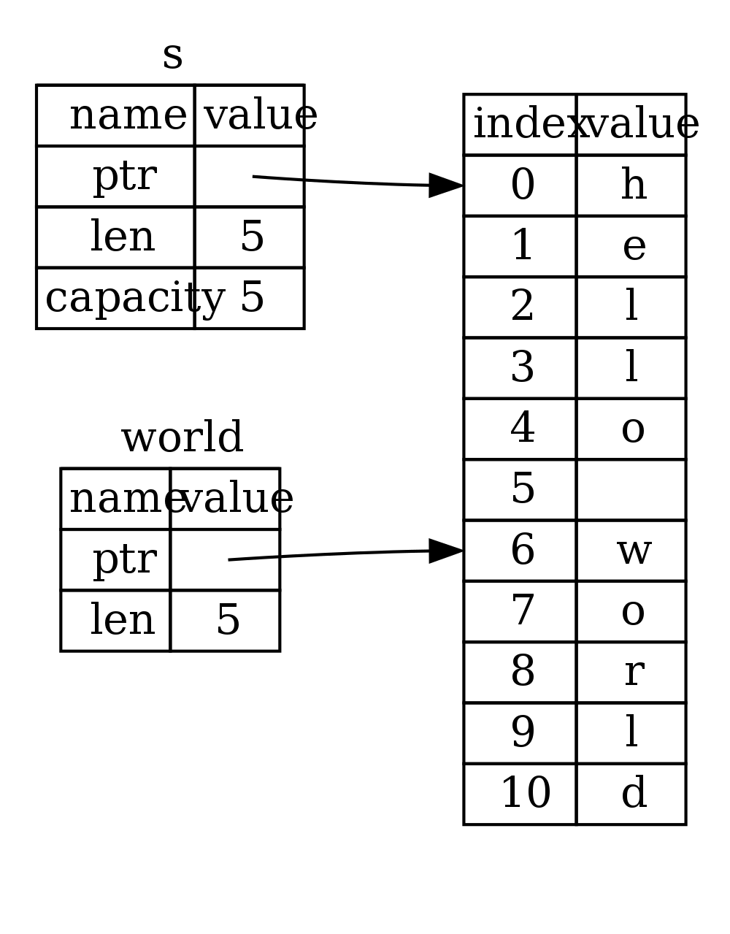

Figure 4-6: Two string slices referring to parts of a String

With Rust’s .. range syntax, if you want to start at the first index (zero), you can drop the value before the ... In other words, these are equal:

let s = String::from("hello");

let slice = &s[0..2];

let slice = &s[..2];

By the same token, if your slice should include the last byte of the String, you can drop the trailing number. That means these are equal:

let s = String::from("hello");

let len = s.len();

let slice = &s[3..len];

let slice = &s[3..];

You can also drop both values to take a slice of the entire string. So these are equal:

let s = String::from("hello");

let len = s.len();

let slice = &s[0..len];

let slice = &s[..];

With this in mind, let’s re-write first_word to return a slice. The type that signifies “string slice” is written as &str:

Filename: src/main.rs

fn first_word(s: &String) -> &str {

let bytes = s.as_bytes();

for (i, &item) in bytes.iter().enumerate() {

if item == b' ' {

return &s[0..i];

}

}

&s[..]

}

We get the index for the end of the word in the same way as before, by looking for the first occurrence of a space. When we find a space, we return a string slice using the start of the string and the index of the space as the starting and ending indices.

Now when we call first_word, we get back a single value that is tied to the underlying data. The value is made up of a reference to the starting point of the slice and the number of elements in the slice.

Returning a slice would also work for a second_word function:

fn second_word(s: &String) -> &str {

We now have a straightforward API that’s much harder to mess up. Remember our bug from before, when we got the first word but then cleared the string so that our first word was invalid? That code was logically incorrect but didn’t show any immediate errors. The problems would show up later, if we kept trying to use the first word index with an emptied string. Slices make this bug impossible, and let us know we have a problem with our code much sooner. Using the slice version of first_word will throw a compile time error:

Filename: src/main.rs

fn main() {

let mut s = String::from("hello world");

let word = first_word(&s);

s.clear(); // Error!

}

Here’s the compiler error:

17:6 error: cannot borrow `s` as mutable because it is also borrowed as

immutable [E0502]

s.clear(); // Error!

^

15:29 note: previous borrow of `s` occurs here; the immutable borrow prevents

subsequent moves or mutable borrows of `s` until the borrow ends

let word = first_word(&s);

^

18:2 note: previous borrow ends here

fn main() {

}

^

Remember from the borrowing rules that if we have an immutable reference to something, we cannot also take a mutable reference. Since clear needs to truncate the String, it tries to take a mutable reference, which fails. Not only has Rust made our API easier to use, but it’s also eliminated an entire class of errors at compile time!

String Literals are Slices

Remember how we talked about string literals being stored inside of the binary itself? Now that we know about slices, we can now properly understand string literals.

let s = "Hello, world!";

The type of s here is &str: It’s a slice, pointing to that specific point of the binary. This is also why string literals are immutable; &str is an immutable reference.

String Slices as Arguments

Knowing that you can take slices of both literals and Strings leads us to one more improvement on first_word, and that’s its signature:

fn first_word(s: &String) -> &str {

A more experienced Rustacean would write this one instead because it allows us to use the same function on both Strings and &strs:

fn first_word(s: &str) -> &str {

If we have a string slice, we can pass that as the argument directly. If we have a String, we can pass a slice of the entire String. This makes our API more general and useful without losing any functionality:

Filename: src/main.rs

fn main() {

let my_string = String::from("hello world");

// first_word works on slices of `String`s

let word = first_word(&my_string[..]);

let my_string_literal = "hello world";

// first_word works on slices of string literals

let word = first_word(&my_string_literal[..]);

// since string literals *are* string slices already,

// this works too, without the slice syntax!

let word = first_word(my_string_literal);

}

Other Slices

String slices, as you might imagine, are specific to strings. But there’s a more general slice type, too. Consider this array:

let a = [1, 2, 3, 4, 5];

Just like we may want to refer to a part of a string, we may want to refer to part of an array, and would do so like this:

let a = [1, 2, 3, 4, 5];

let slice = &a[1..3];

This slice has the type &[i32]. It works the exact same way as string slices do, by storing a reference to the first element and a length. You’ll use this kind of slice for all sorts of other collections. We’ll discuss these in detail when we talk about vectors in Chapter XX.

Summary

The concepts of ownership, borrowing, and slices are what ensure memory safety in Rust programs at compile time. Rust is a language that gives you control over your memory usage like other systems programming languages, but having the owner of data automatically clean up that data when the owner goes out of scope means you don’t have to write and debug extra code to get this control.

Ownership affects how lots of other parts of Rust work, so we will be talking about these concepts further throughout the rest of the book. Let’s move on to the next chapter where we’ll look at grouping pieces of data together in a struct.