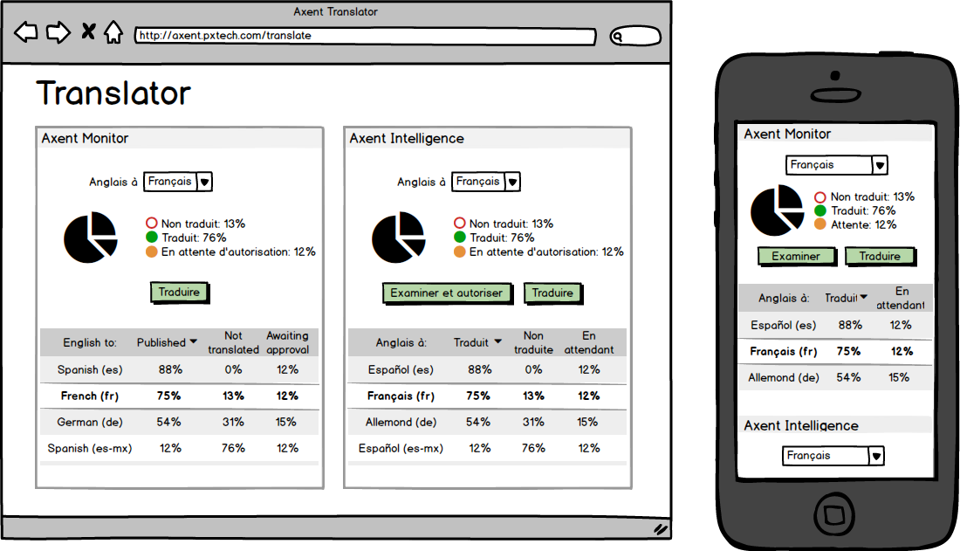

**Overview Screen**

* Simple status of the current users default ‘translate to’ language.
* 1 card per application
* Option to change language
* Buttons appear dependent on users permissions
* Languages shown in league table
* Limited use case for translating on mobile. Review and authorisation a possibility.
* All options set in this screen to allow the main app to be simple and focused.

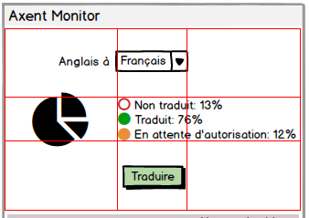

Panel proportion based on the ~~Scottish flag~~ golden ratio. 1:1.618

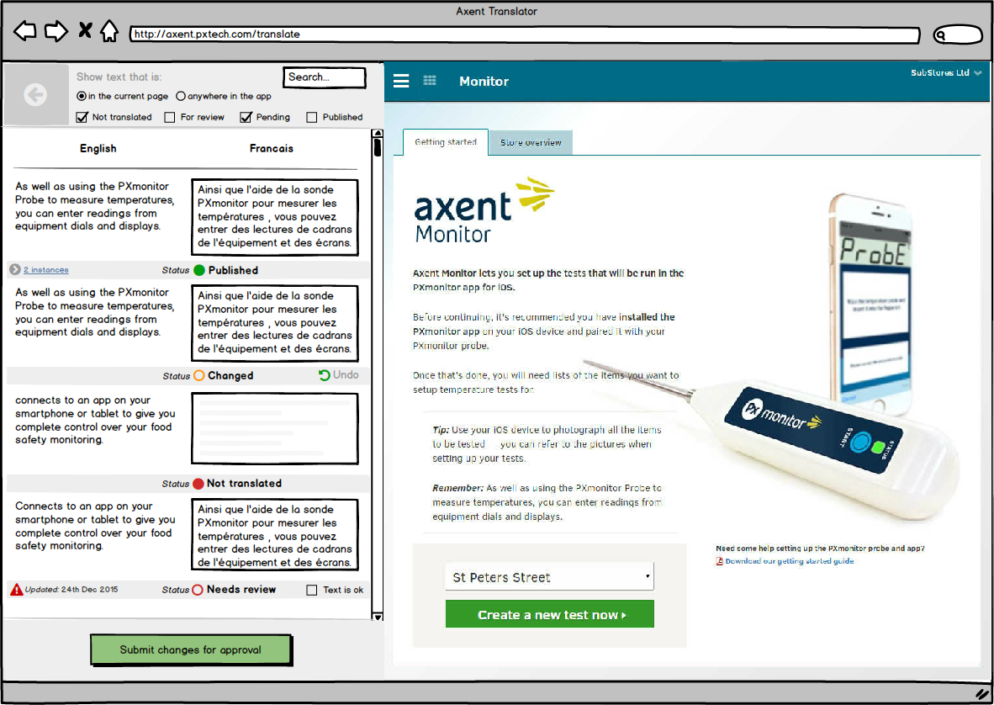

**Main application – Translate mode**

* Window split 1:2 (potentially responsive to be 1:1 at lower resolution)
* Left panel has fixed header with filters, fixed footer with save button. Centre panel has the text content with metadata relating to each items current status. Text nodes on the left have the same order as they appear in the DOM on the right app panel.

