UBER EXPETITIONARY ANALYSIS

INTRIDUCTION:

Uber is a globally recognized transportation technology company founded in 2009. It revolutionized the way people hail rides by creating a mobile app that connects riders with drivers. Uber's platform allows users to request various types of transportation services, from standard car rides to shared rides, luxury vehicles, and more, all at the touch of a button. Uber operates in numerous cities around the world and has had a significant impact on the transportation industry by providing a convenient and accessible alternative to traditional taxis and public transportation.

PURPOSE:

1. \*Ride Hailing\*: Uber allows people to easily request rides through its mobile app, providing a more convenient alternative to traditional taxis or public transportation.

2. \*Efficiency\*: Uber aims to make transportation more efficient by connecting riders with available drivers, reducing wait times and optimizing routes.

3. \*Accessibility\*: Uber strives to make transportation accessible to a broader audience, including those who may have difficulty finding or using traditional taxi services.

4. \*Variety of Services\*: Uber offers various service options, including standard rides, shared rides, luxury vehicles, and more, to meet different transportation needs.

5. \*Income for Drivers\*: Uber provides opportunities for individuals to earn income as independent drivers, giving them flexibility in their work schedules.

6. \*Reducing Car Ownership\*: By providing a reliable ride-sharing service, Uber contributes to the concept of reducing car ownership, which can lead to reduced traffic congestion and environmental benefits.

7. \*Innovation\*: Uber is known for its innovative approach to transportation technology, exploring new avenues such as autonomous vehicles and food delivery services.

PROBLEM DEFINITION AND DESIGN:

EMPATHY MAP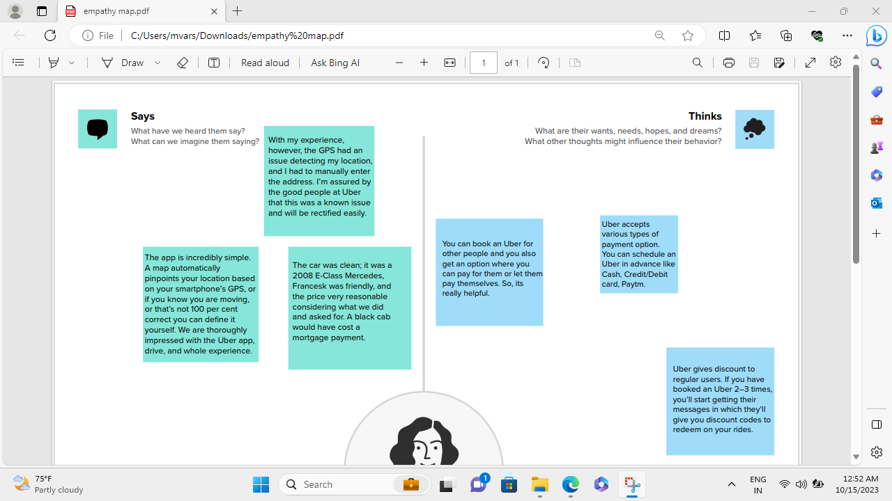

RESULT

ADVANTAGES:

1. \*Convenience\*: Easy access to rides via a mobile app.

2. \*Cost-Effective\*: Competitive pricing often compared to traditional taxis.

3. \*Variety of Services\*: Options for different vehicle types and services.

4. \*Real-time Tracking\*: Users can track their rides in real-time.

5. \*Cashless Transactions\*: Payments are handled through the app.

6. \*Safety Features\*: Driver and trip details are available before the ride.

7. \*Driver Ratings\*: Allows feedback and driver accountability.

8. \*Reduced Need for Car Ownership\*: Encourages carpooling and reduces congestion.

9. \*Global Availability\*: Services offered in numerous cities worldwide Advantages and disadvantages:

Disadvantages

1. \*Safety Concerns\*: Occasional safety issues with drivers and riders.

2. \*Surge Pricing\*: Prices can increase during high-demand times.

3. \*Driver Income Instability\*: Drivers may not have stable income.

4. \*Lack of Employee Benefits\*: Drivers are often classified as independent contractors without benefits.

5. \*Regulatory Challenges\*: Faces legal and regulatory issues in some regions.

6. \*Impact on Traditional Taxis\*: Can negatively affect traditional taxi businesses.

7. \*Privacy Concerns\*: Uber collects user data, which raises privacy questions.

8. \*Environmental Impact\*: Can contribute to increased traffic congestion and emissions.

Applications:

. \*Ride-Sharing\*: The primary application of Uber is for individuals to request rides from drivers using the mobile app.

2. \*Food Delivery\*: UberEats is an application of Uber that delivers food from local restaurants to customers' doors.

3. \*Freight and Logistics\*: Uber Freight connects shippers and carriers to streamline the movement of goods.

4. \*Business Travel\*: Uber for Business provides companies with transportation solutions for their employees.

5. \*Uber Health\*: This service is used to coordinate transportation for patients to medical appointments, serving healthcare providers and facilities.

6. \*Uber for Education\*: Some educational institutions use Uber to provide safe transportation for students.

7. \*Grocery Delivery\*: Uber has partnered with grocery stores for grocery delivery services.

8. \*Electric Bicycles and Scooters\*: In some cities, Uber offers electric bicycles and scooters for short trips.

9. \*Air Travel\*: Some airports have partnered with Uber to offer transportation services for travelers.

10. \*Car Rentals\*: In some regions, Uber allows users to rent cars for extended periods.

These applications demonstrate Uber's versatility in providing transportation and delivery solutions across various industries and needs.

Conclusion:

Uber has had a profound impact on the way people access transportation services. It has transformed the industry by providing a convenient and efficient platform for ride-sharing and delivery services. Uber's innovation and global reach have made it a prominent player in the modern transportation landscape, although it has faced challenges and controversies along the way. Its success lies in its ability to adapt to evolving market demands and expand its services beyond ride-sharing, offering solutions for food delivery, logistics, and more. As the company continues to evolve and adapt to changing trends, Uber remains a significant force in the world of urban mobility and on-demand services.

Future scope:

Uber's future scope may include autonomous vehicles, electric and sustainable transportation, urban air mobility (UAM), last-mile delivery, international expansion, public transportation integration, new mobility services, technology advancements, regulatory adaptations, and diversification.