Note: The programming of the AFAD Handheld is a 2 stage process

1. Programming the images into the SPI FLASH using the Flash Center PC application
2. Programming the device firmware using the Flash Magic PC application

**SPI FLASH images**

Requirements:

1. Total Phase USB Cheetah SPI programming apter
2. Total Phase Flash Center application
3. Srec file to be loaded into the Handheld pcb

Plug the Cheetah SPI programmer into connector (J4) on the Handheld. The connector is keyed so it can only be oriented in one way

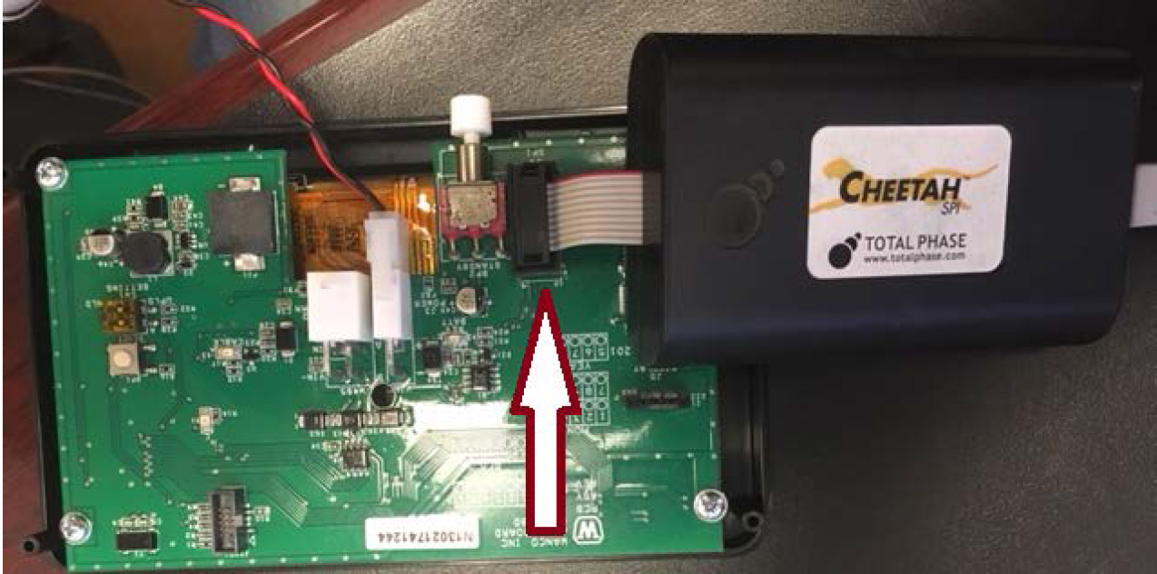

During the programming operation one or two buttons will have to be held down

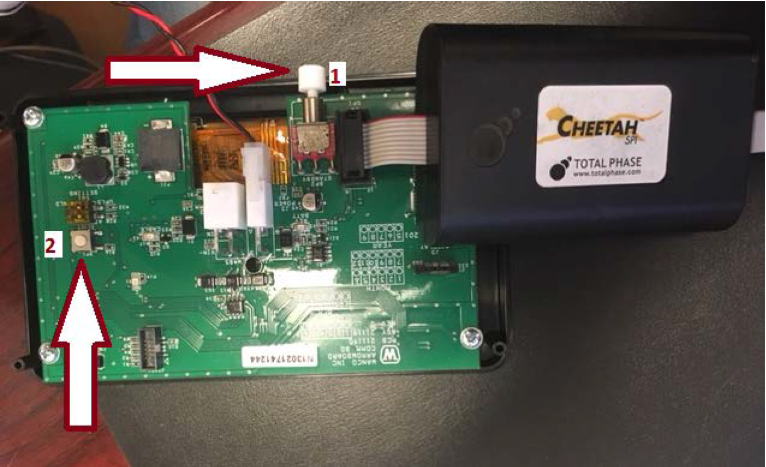

1. The Power button will have to be held down while the srec file is being loaded
2. The Reset button will have to be held down if the firmware file (step 2) has previously been loaded into the handheld pcb. A running program will interfere with the FLASH memory while it is being programmed by the Cheetah device

Open up the Total Phase Flash Center PC application

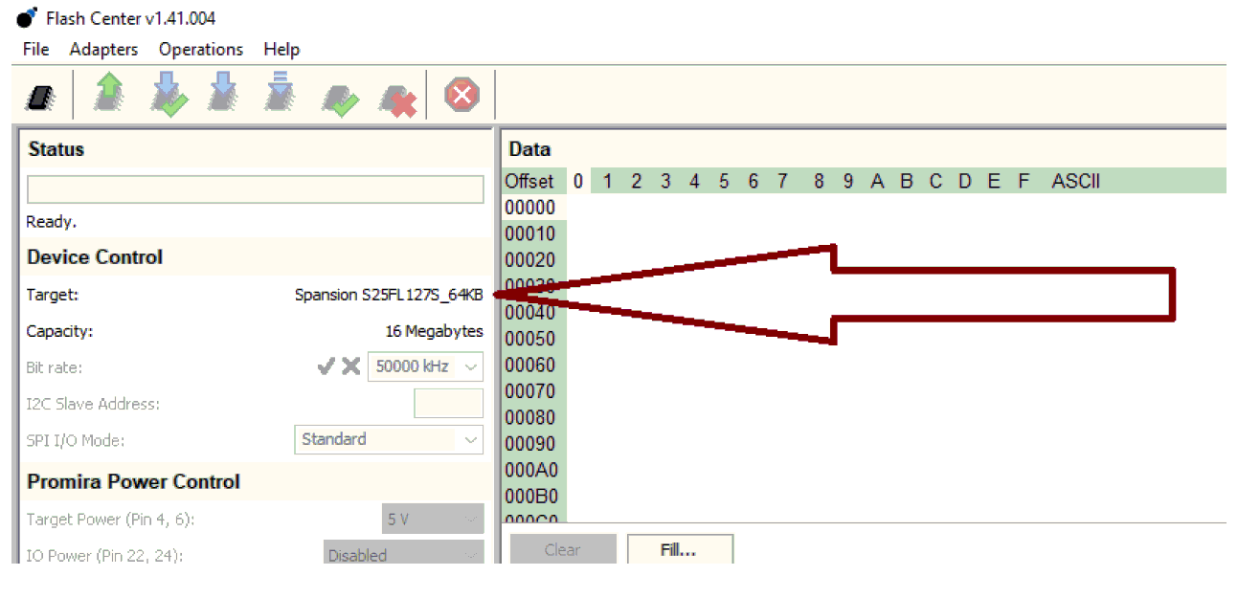

The target in the Device Control window should show ‘Spansion S25FL_127S_64KB’. If it does not show up as the target then go to the top menu bar and then go to the ‘Operations’ menu and then ‘Choose Target’.

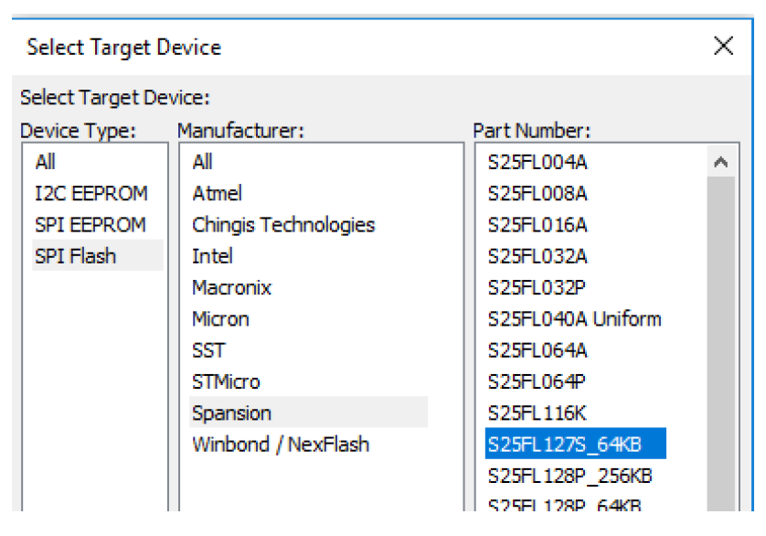

Select ‘SPI Flash’, ‘Spansion’, and then ‘S25FL_127S_64KB’

Go to the top menu bar and select ‘Adapters’ and then ‘Add Adapters’. The Total Phase USB Cheetah programmer should be displayed. Click ‘Add’

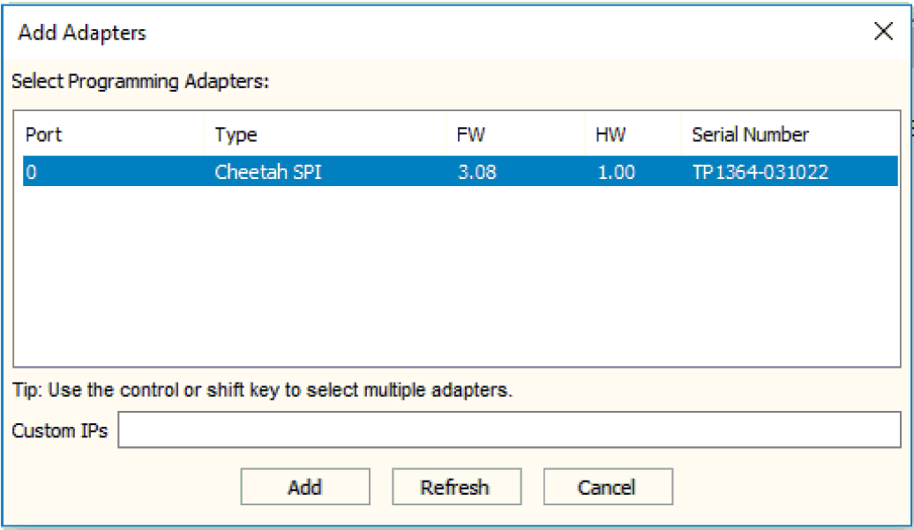

Go to the top menu bar and select ‘File’ and then ‘Load File’. **Make sure that the File type in the selection box is Srecord, not hex!** Select the current released file and click ‘Open’

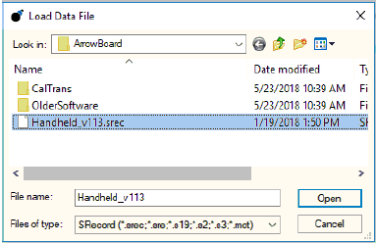

Click the down button with the green check mark. This will perform a file download and then a verification operation

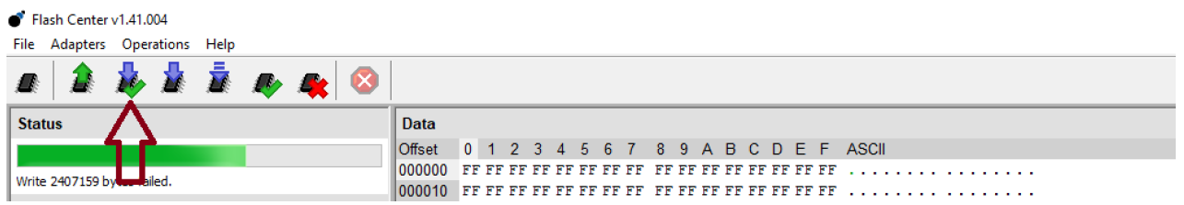

The progress bar in the Adapter window will show ‘Erase’

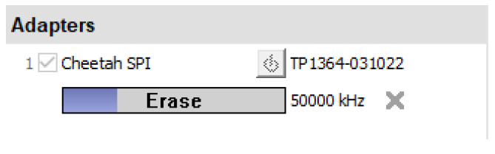

The progress bar will then proceed to show ‘Write’

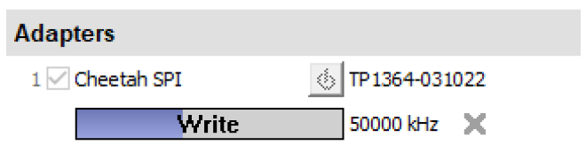

Finally, is the srec file has been successfully loaded and verified, the progress bar in the Adapter window will show ‘Verify succeeded’

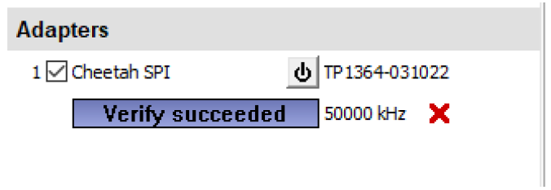

**If any errors occur during the program/verify process, then ensure that the power and reset buttons were pressed down (see page 2)**