Requirements:

1. PCU pcb
2. PCU hex file
3. Flash Magic PC application
4. ISP programming adapter

Plug the ISP Programming Adapter into the PCU pcb (as shown). Ensure the ground pin on the programming adapter board aligns with the programming connect or (J18) on the PCU pcb

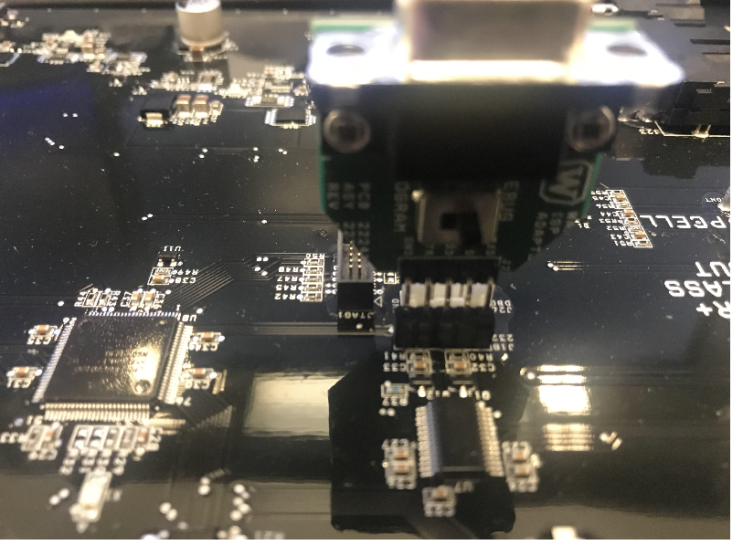

Connect the programming adapter pcb to the serial communications cable on your PC. Open up the Flash Magic programming application

Depending on the version of Flash Magic that you are using (it is of no consequence) the screen will appear as below

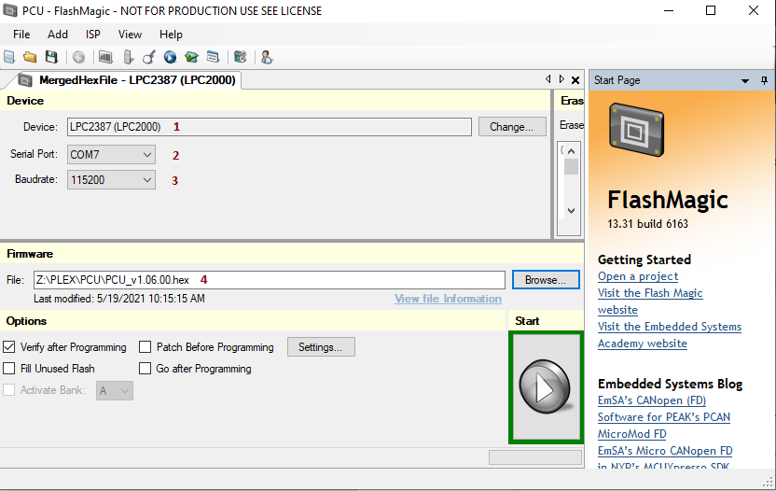

1. Select the device (micorontroller): LPC2366
2. Select the serial port on your PC that is connected to the programming adapter pcb
3. Select the baud rate
4. Select the hex file to be loaded into the board

The program will begin loading the firmware into the PCU



The program will start the verification process immediately after the firmware is completely loaded into the pcb



If the verification is okay the Flash Magic application may show a success message or just blank the progress bar (depending on the version of Flash Magic is being used). However, an error message will be displayed if there are any errors in the program and verify cycle.