Introduction
- The paper aimed to assess how manipulating the light spectrum (i.e., RGB, RB, WF) during growth may regulate the photosynthetic activity and fruit bioactive compound synthesis in ‘Microtom’ to improve plant physiological performance and fruit nutritional value.
- The bigger picture is using controlled environment cultivation as an alternative to regular cultivation practices which reduces the overuse of resources required for plant growth in harsh conditions and alleviates the risks that plants growth faces in open field cultivation such as droughts, floods, pest attacks, and frost.
- The plants were cultivated under three light quality regimes (treatments): red-green-blue LEDs (RGB), red-blue LEDs (RB) and white fluorescent lamps (FL), from sowing to fruit ripening
- There are 3 different levels applied to each factor: RGB, RB, WF
- Factors (independent variables) are divided into 4 different categories and the factors under each category are:
Morphological & functional | Gas exchanges & photochemistry
- Height  - Leaf number  - Fruit number  - Flower number  - Fruit weight  - SB/EB, LB/EB, and FB/EB  - LA, SLA  - LDMC  - RWC | - fpsii  - NPQ  - Fv/Fm  - AN  - gs, gm  - Vcmax
Pigments & proteins | Fruits
- CHL a+b  - CAR x+c  - CHL a/b  - D1  - Rubisco | - AsA  - CAT  - SOD  - Antiox capacity  - Polyphenols

- There are 5 plants (experimental units) and each assigned each of the 3 light treatments = 15 observations units per factor.
- This implies the use of replication design because each of the same treatments is applied on multiple experimental units (plants).
- These could be measures put in place to avoid confounding:
“Plant growth was followed from sowing to fruit ripening up to 100 DAS (days after sowing) under the following environmental conditions:
- photosynthetic photon flux density (PPFD) 300 ± 5 mmol photons m−2 s −1 for each light treatment
- day/night air temperature 24/18 C
- relative air humidity 60–70%
- photoperiod of 12 h.
- Plants were irrigated to pot capacity with tap water at a 2-day interval to reintegrate the water loss for evapotranspiration.
- Every 2 weeks, plants were fertilized with Hoagland’s solution ”

The experiment appears to be a ‘screening’ experiment as there are:
- Multiple factors (variables) all with only 3 levels each
- The focus appears to be narrowing down on the factors that most affect the plants’ physiological performance and nutritional value. Each of these characteristics have their respective factors(variables)
- The experiment and report also do not look into the interactions between the different factors, which leads me to lean more towards it being a ‘screening’ and not ‘full’ experiment

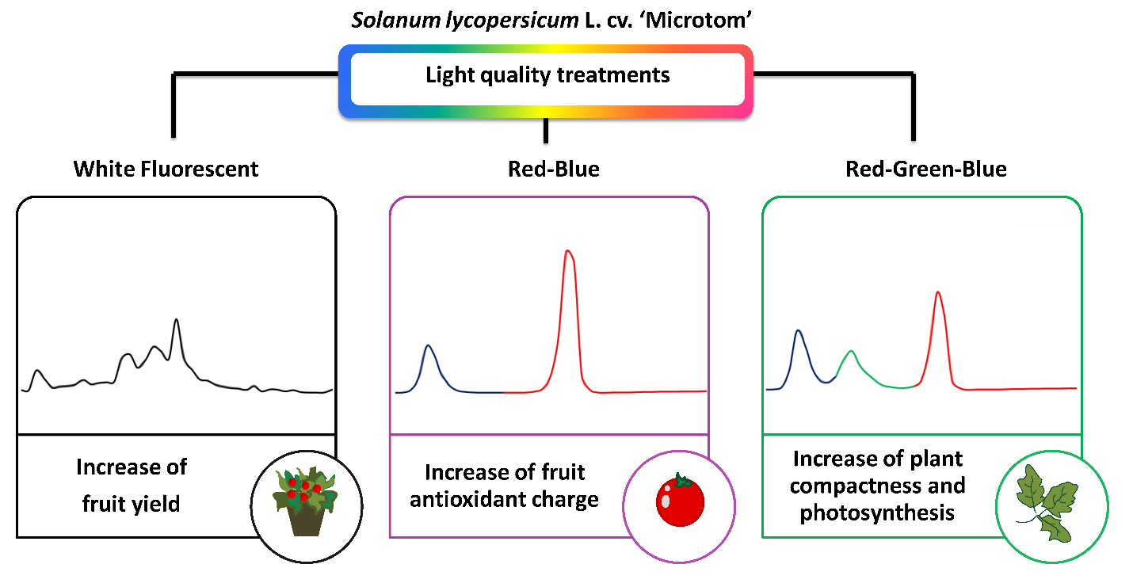
(Not full) “conceptual” diagram
Extend diagram to include the response or main aim of the experiment, as the output
- Some of their key findings include:
- Compared to FL, RGB and RB regimes reduced height and increased leaf number and specific leaf area, enhancing plant dwarf growth
- The RGB regime improved photosynthesis and stomatal conductance despite lower biomass, favoring Rubisco synthesis and carboxylation rate than RB and FL regimes
- The RB light produced plants with fewer flowers and fruits with a lower ascorbic acid amount but the highest polyphenol content, antioxidant capacity and SOD and CAT activities.
- The high percentage of the green wavelength in the RGB regime promoted photosynthesis and reduced plant reproductive capacity compared to FL and RB
- The RB regime was the best in favoring the production of health-promoting compounds in tomato berries

Analysis
Summarise the methodology section from the main report into the main points that describe how the experiment was conducted
For data description + Handling:
- The data is a raw dataset, there is no mention of redaction and the number of observations and factors mentioned matches the information provided
- I am thinking about changing the format of the dataset to have them as single rows and columns with all the data, then have each column represent a variable. This is what I will then use for my analysis

The effect of the different light quality treatments on the investigated parameters was assessed by applying a one-way analysis of variance (ANOVA):
- Check the attached dataset to see how the data can be used for ANOVA analysis either in Excel or if possible, R.
- Try and replicate their analysis

Discussion
Reflect on their methods and analysis and whether it was adequate to answer the question they set out to answer. Highlight some of the issues with their reporting, e.g., I would’ve liked if their ANOVA summary or results were shown or if they had a link to their code
The study and dataset were easily accessible
Make any recommendations for my study/original at the end

