Automated Investment Data Pipeline & Dashboard
Project Overview | Tso-Chien Lin | Mar – Apr 2026

1. Pipeline Flowchart
The pipeline runs fully automated every weekday at 06:00 AM. Task Scheduler triggers Power Automate Desktop, which runs the Python script, writes output to Excel, and sends a daily email report.
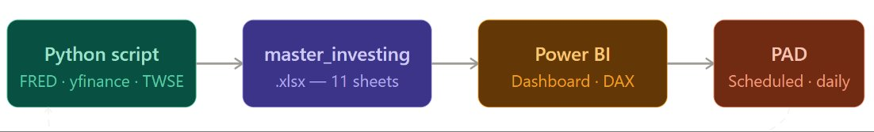
Fig 1. End-to-end pipeline: Python → Excel → Power BI, orchestrated by Power Automate Desktop

2. Power BI Dashboard
Interactive dashboard built on top of the Excel workbook using measures function. Covers macro KPI cards (CPI, CPE, unemployment, nonfarm payrolls), VIX gauge, U.S. Treasury yield rates, forex rates, equity valuation scatter plots (P/E, P/B), and SEC 13F institutional holdings by fund.
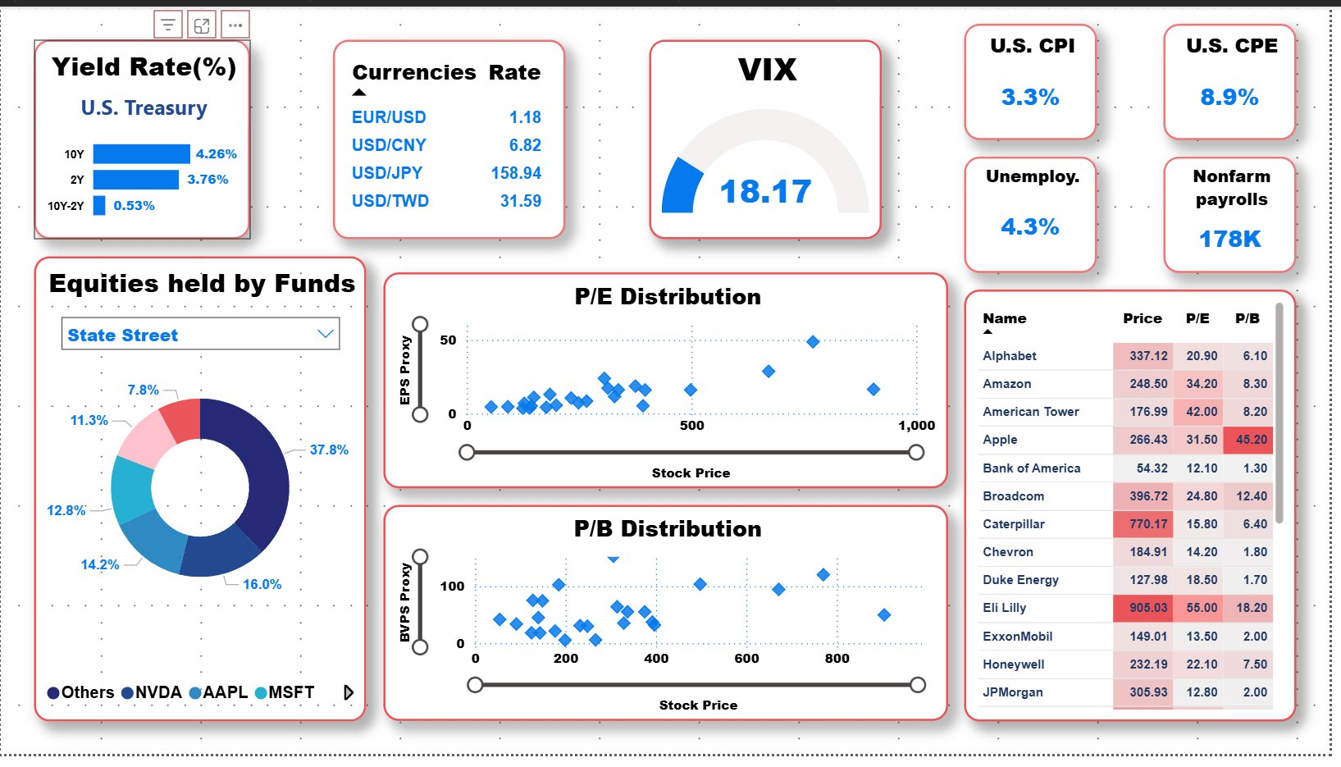
Fig 2. Power BI dashboard — macro indicators, equity valuation, and institutional holdings

3. Excel Workbook (master_investing.xlsx)
11-sheet workbook updated daily by the Python pipeline. The Momentum sheet shows the macro scorecard with regime signal (Risk-ON / Neutral / Risk-OFF) and key rate indicators with trend direction.
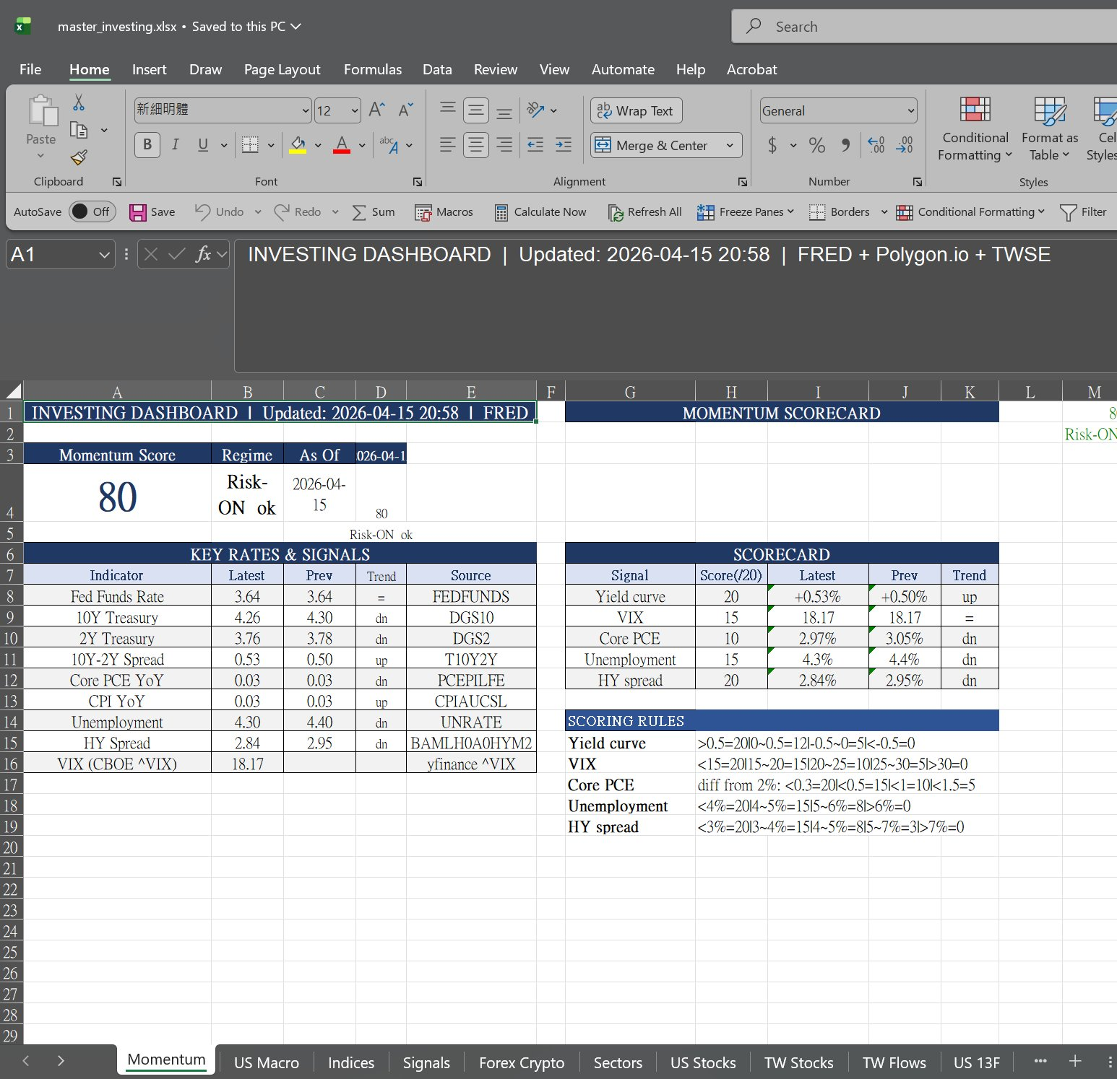
Fig 3. Momentum sheet — macro scorecard, key rates & signals, and scoring rules

4. Windows Task Scheduler
Task Scheduler triggers the Power Automate Desktop flow daily at 06:00 AM via a cmd.exe command. The Triggers tab shows the daily schedule; the Actions tab shows the PAD workflow URI being called.
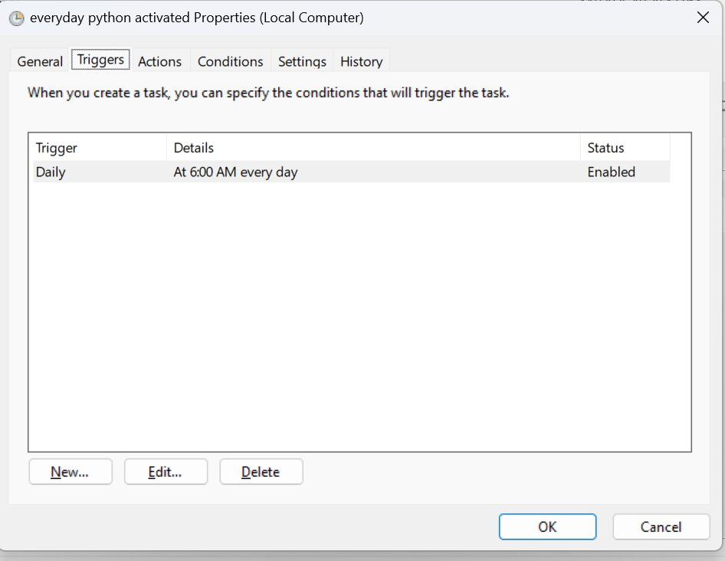  Fig 4a. Task Scheduler — Triggers tab (daily at 06:00 AM) | 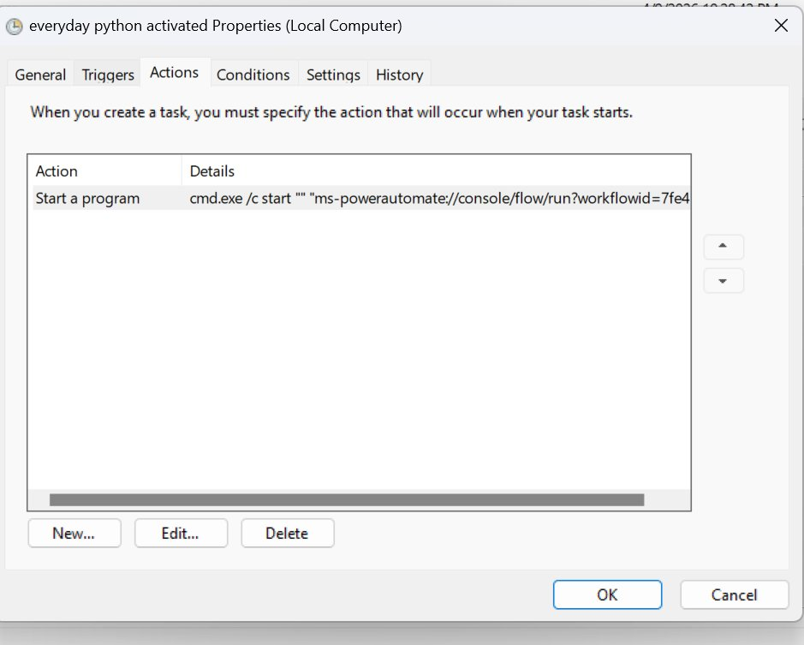  Fig 4b. Task Scheduler — Actions tab (launches PAD flow via cmd.exe)

5. Power Automate Desktop Flow
The PAD flow is structured into a Main block and four subflows (Block1–Block5). Main sets path variables and calls each subflow in sequence. Block1 handles recipient validation, Block2 runs the Python script with error handling, Block4 composes and sends the daily email via Outlook, and Block5 displays a completion notification.

5a. Main — variable setup & subflow orchestration
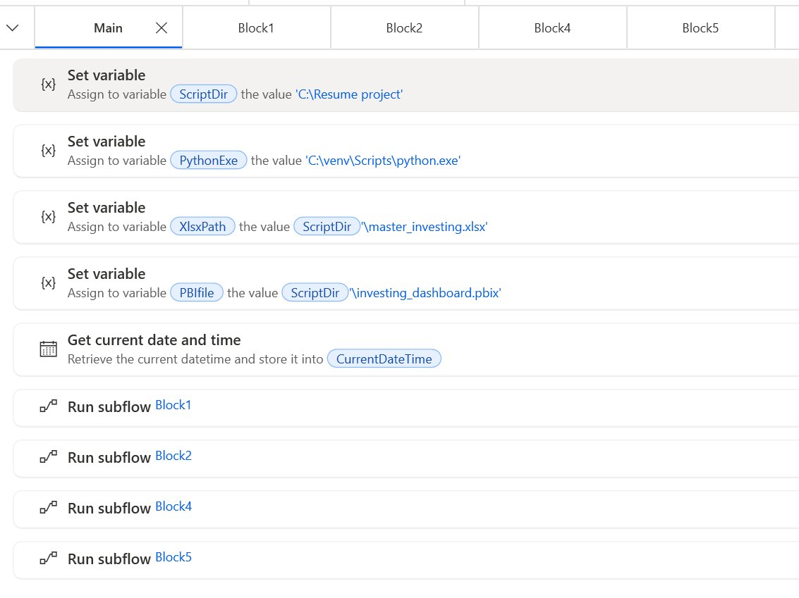
Fig 5a. PAD Main — sets ScriptDir, PythonExe, XlsxPath, PBIfile variables, then runs Block1 → Block2 → Block4 → Block5

5b. Block1 — recipient validation
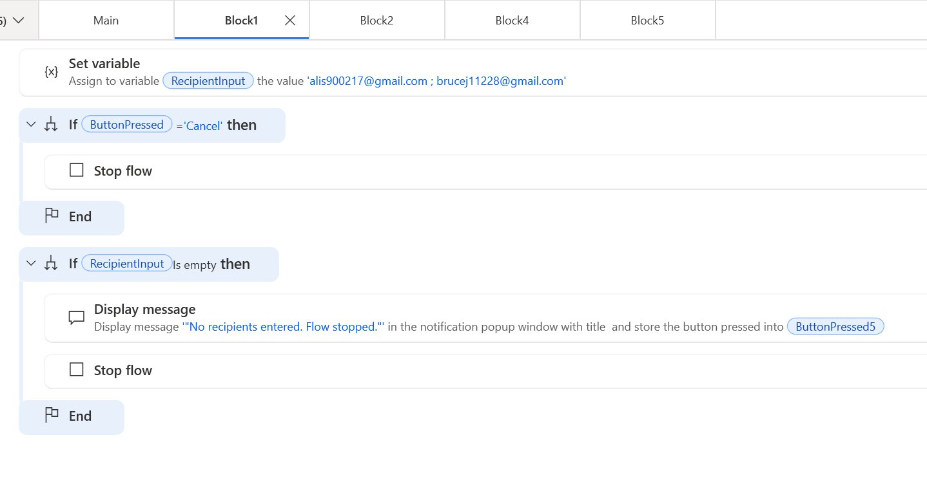
Fig 5b. Block1 — validates email recipient input; stops flow if cancelled or empty

5c. Block2 — Python script execution
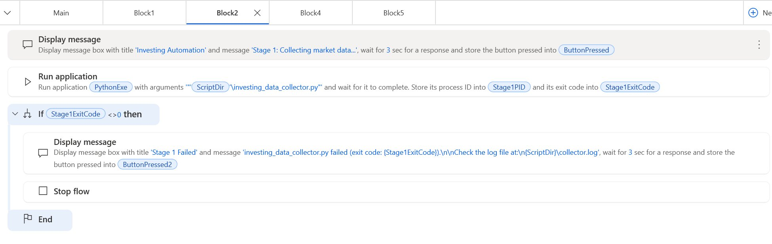
Fig 5c. Block2 — runs investing_data_collector.py; checks exit code and stops flow on failure

5d. Block4 — email report dispatch
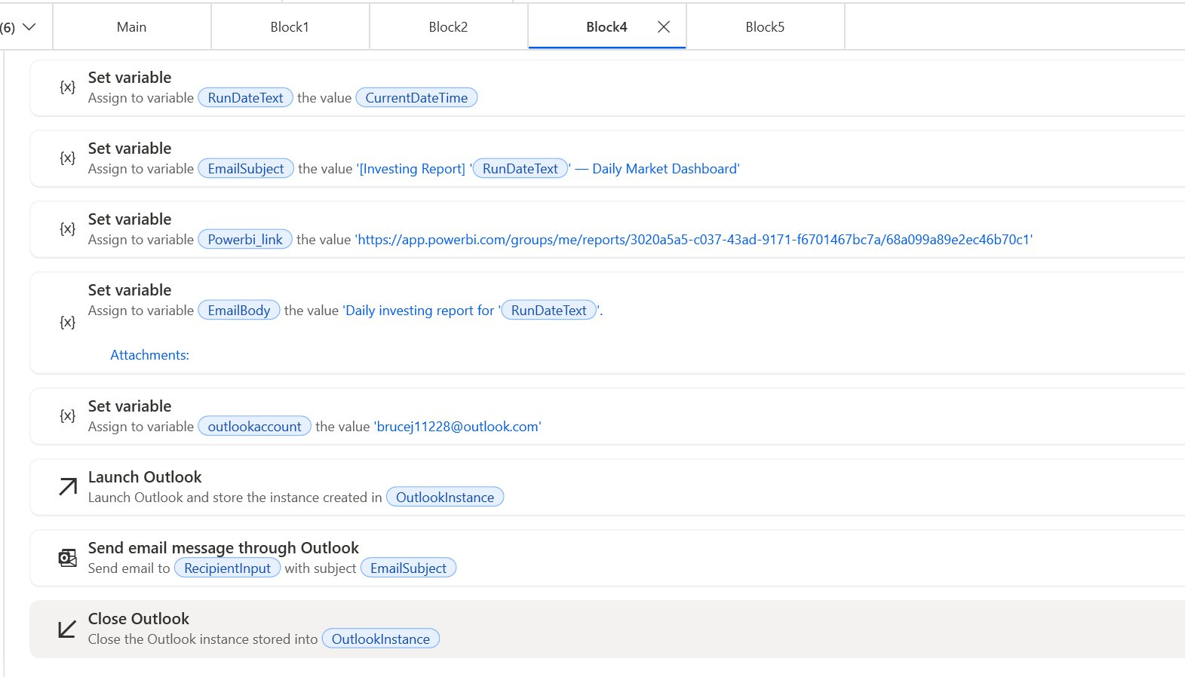
Fig 5d. Block4 — composes daily email with date-stamped subject and Power BI link, sends via Outlook

5e. Block5 — completion notification
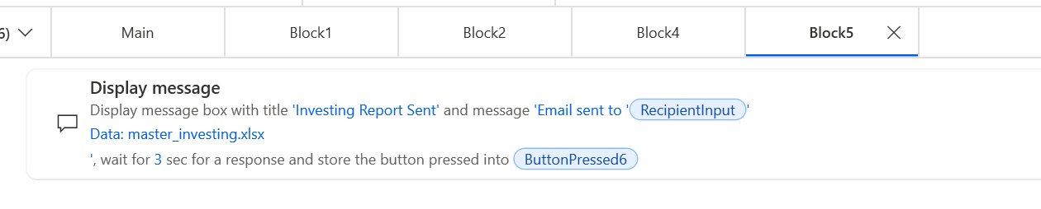
Fig 5e. Block5 — displays success message confirming email sent and Excel attachment

