Implementation of Partial ambiguity resolution (PAR) based on decorrelation transformation (Wang and Feng 2013). It is programed by C and Matlab language. The C version is based on [RTKLIB](http://www.rtklib.com/) and compatible with it. While Matlab version is based on [LAMBDA](http://gnss.curtin.edu.au/research/lambda-and-ps-lambda-software-packages/), which is for debugging and comprehending.

An example is provided in **mytest.m**.

1. If you want to use the C version, you should put **PAR_LAMBDA.c** and **PAR_LAMBDA.h** to RTKLIB. Then, add a function declaration in **rtklib.h** 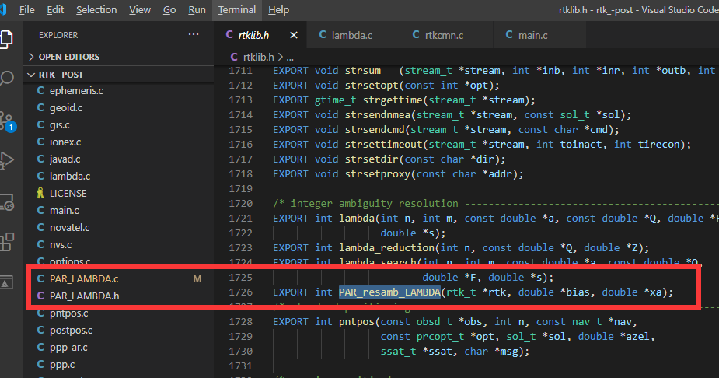
2. Call it in **rtkpos.c**. 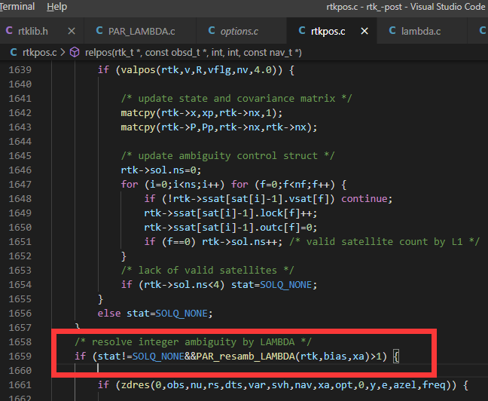
3. You can also adjust some parameters to make it optimal. 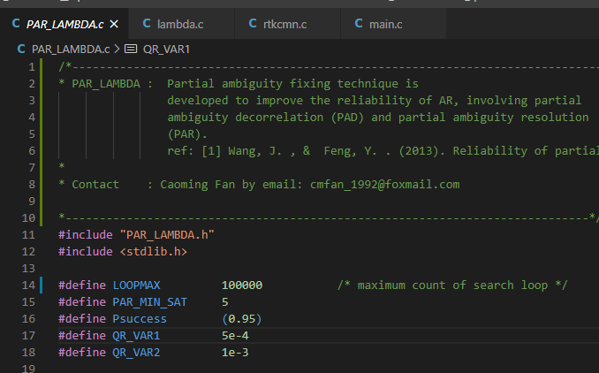

Any question? Please Email [cmfan_1992@foxmail.com](mailto:cmfan_1992@foxmail.com)

Wang J, Feng Y (2013) Reliability of partial ambiguity fixing with multiple GNSS constellations. Journal of Geodesy87: 1-14. doi: 10.1007/s00190-012-0573-4