# Homework 3

## Matlab

Description:

1 we implemented basic rrt algorithm in matlab env, see code RRT.m, execution demo result see figure 1.

2 we also implemented informed_rrt_star algorithm in matlab. It is not a complete version of informed_rtt, we just change the sample algorithm by samping from a ellipse shape area instead of the whole map, but it should be enough to have shown the power of informed_rrt, see the execution result of figure2 . we seperated code into ellipse_sample.md and informedRRTstar.m

3 RRT_star.m is just created for debug purpose, where most of code in it is same with informedRRTstar.m

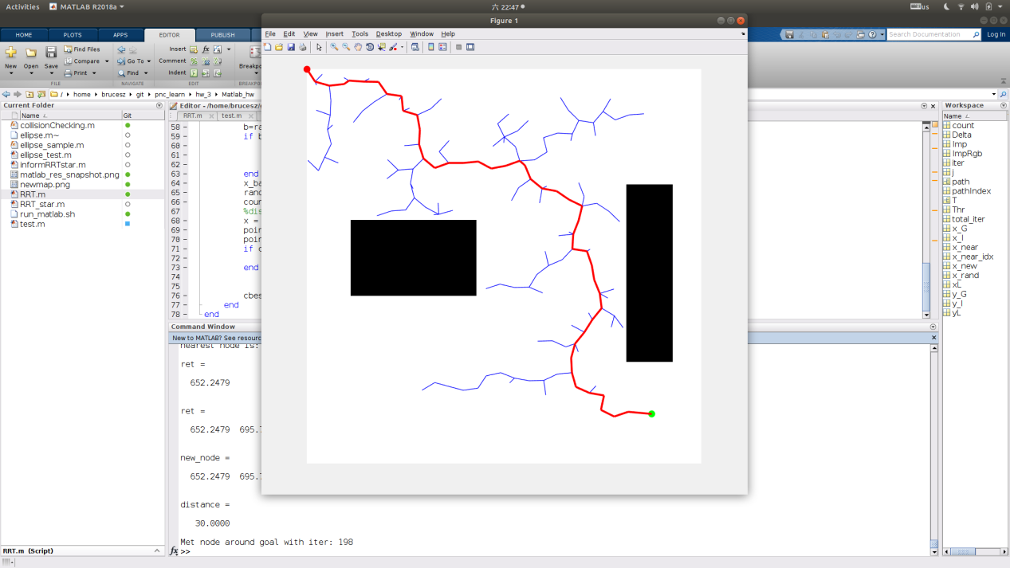

Figure1

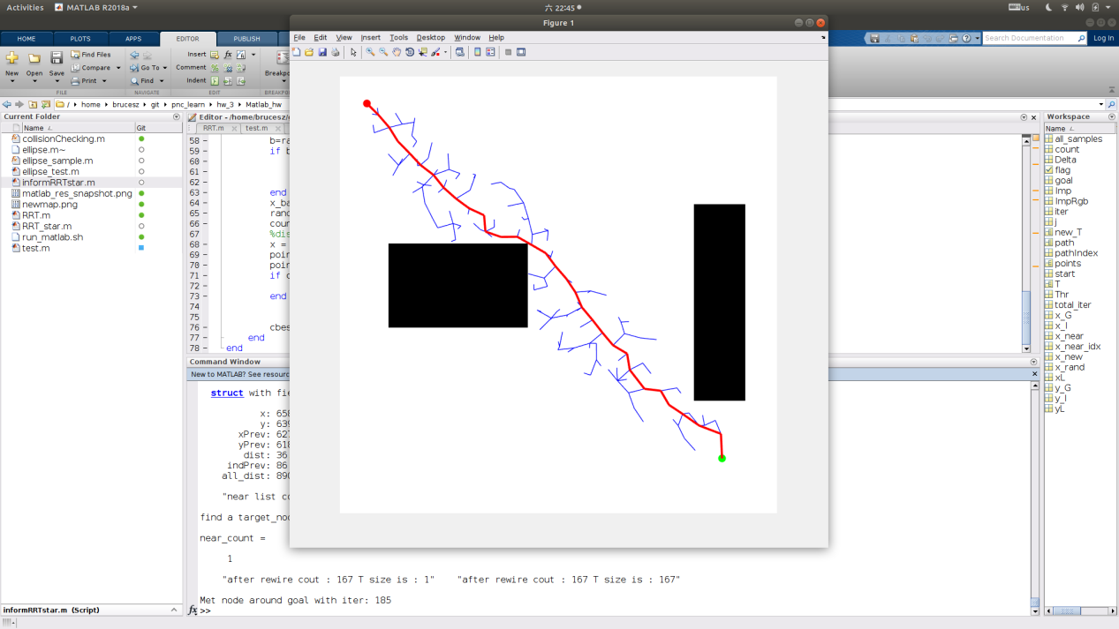 Figure 2

## Ros

### Description:

1 we implemented the code needed to call ompl according to the guide of comments , all 7 places of change .

2 changing planning algorithm is very easy (from rrt to rrt_star, to informed_rrt_star). Just changing line between 196-198 is enough. Figure 3 show the demo result of rrt algorithm; Figure4 and figure5 shows the demo result of rrt_star from two angles of view; Figure 6 and figure7 show the demo result of informed_rrt_star from two angles of view .

3 results shows that the path generated by informed_rrt is more close to the obstacle which means the length of path can be more short.

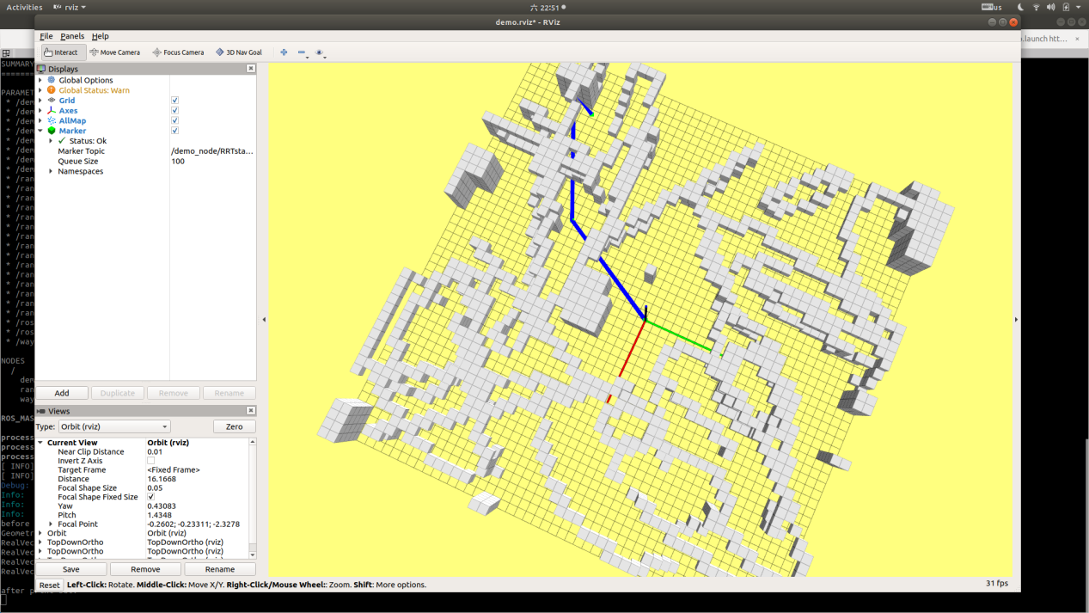

Figure 3

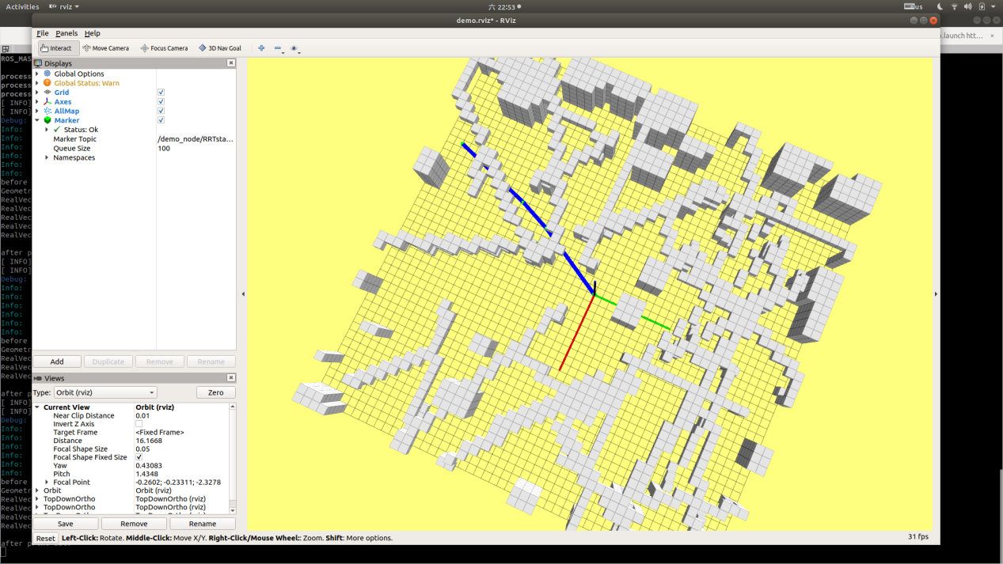

Figure 4

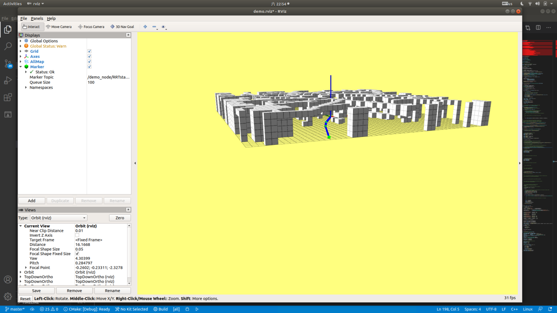

Figure 5

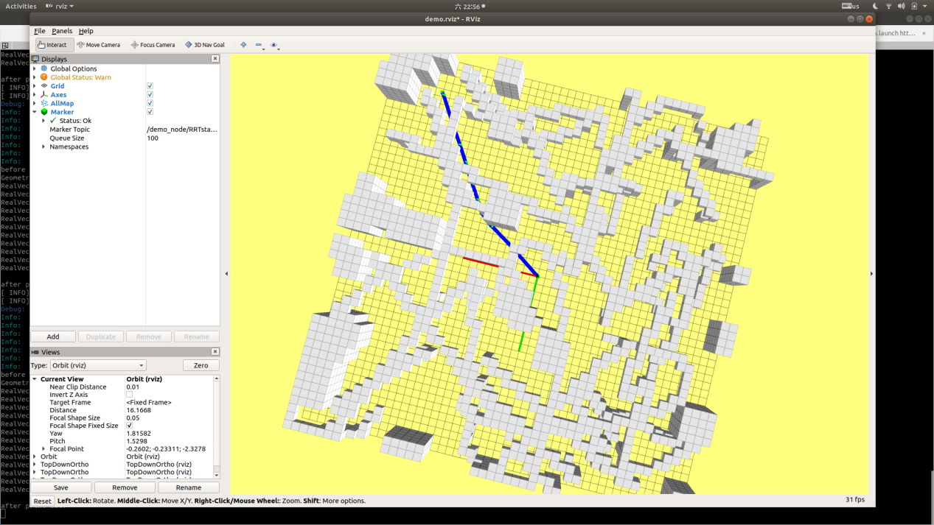

Figure 6

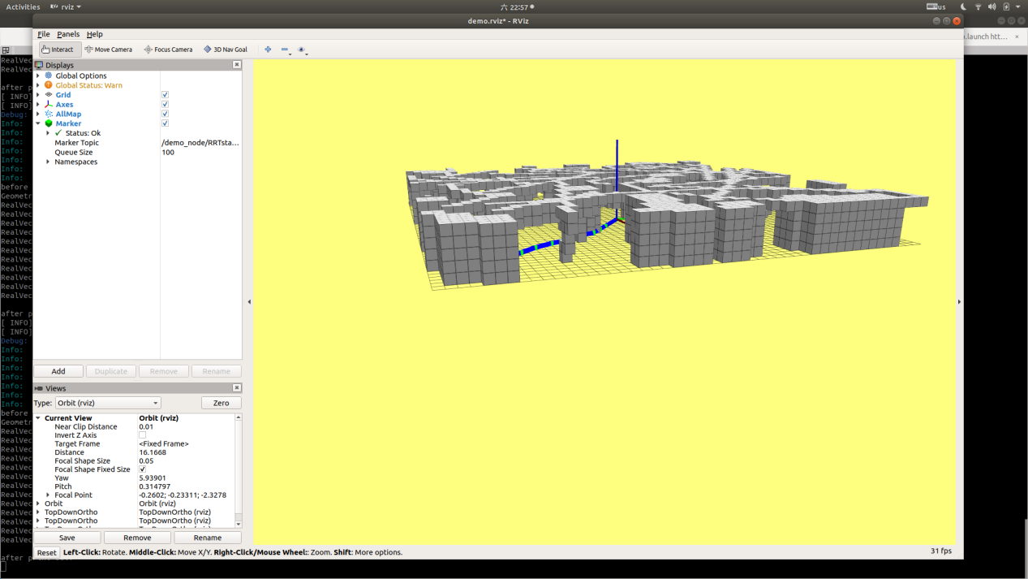

Figure 7