Lesion site determines recovery: neuroendocrine stress signaling and the cellular requirements for hair regrowth
Authors: [TO COMPLETE]
Affiliations: [TO COMPLETE]
Corresponding author: [TO COMPLETE]
Running title: Lesion site and follicular recovery

Abstract
Neuroendocrine stress signals do not produce a single hair disorder. They produce at least four anatomically separable lesions: withdrawal of niche support to a retained epithelial source, necrosis of transit-amplifying progeny, depletion of the melanocyte stem cell source, and loss of immune control over the stem cell compartment. Our central claim is that the site of the lesion, rather than the identity of the mediator or the intensity of the exposure, determines which recovery is achievable: support withdrawal permits spontaneous regrowth once the inhibitory environment is removed, progeny necrosis permits regrowth but leaves the regenerated bulb vulnerable to later immune attack, source depletion forecloses regeneration until a replacement source is supplied, and loss of immune control makes output contingent on continued immune suppression. We develop this lesion-site principle across glucocorticoid, corticotropin-releasing hormone, and adrenergic pathways, and use it to resolve two apparently contradictory findings: glucocorticoid receptor signaling suppresses regeneration in dermal papilla cells yet supports it in regulatory T cells, and interleukin-15 protects follicular epithelium yet sustains pathogenic lymphocytes. The principle also predicts the clinical pattern seen on randomized baricitinib withdrawal in severe alopecia areata, where most selected responders lose benefit without continued therapy. We derive from it two concrete human studies that would test whether pretreatment lesion assignment predicts durable hair and pigment output, and a discriminating experiment that would establish whether the two recently described murine routes to follicular autoimmunity are one mechanism acting at two lesion depths. Lesion site, not exposure history, is the actionable variable.
Keywords: neuroendocrine stress signaling; hair follicle regeneration; hair follicle stem cells; dermal papilla; immune privilege; hair pigmentation

Graphical abstract
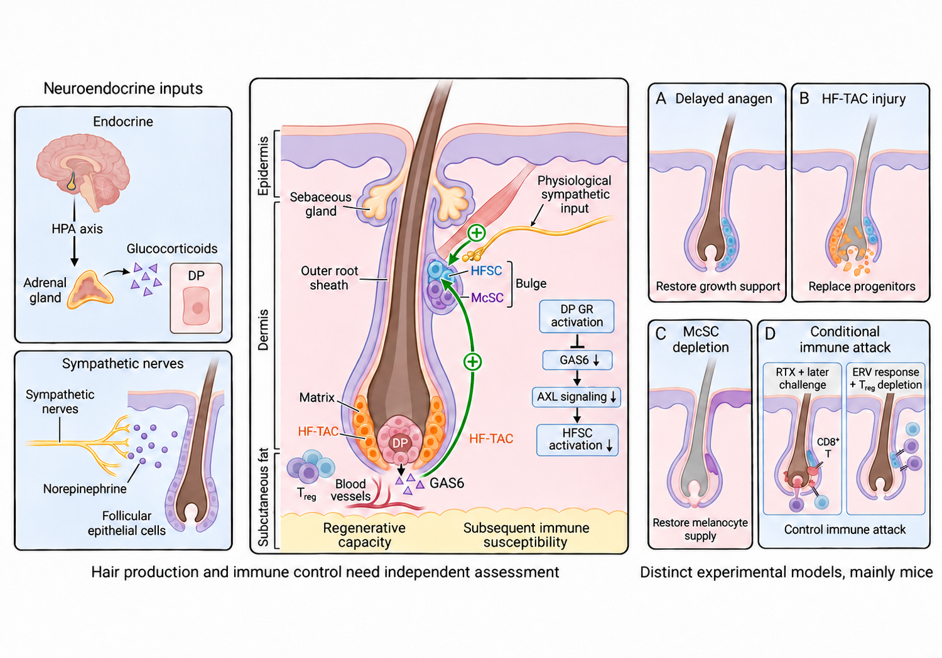
Neuroendocrine signals act at four separable sites — niche support, transit-amplifying progeny, the melanocyte stem cell source, and immune control of the stem cell compartment — and each site permits a different recovery.

Box 1. Terms used in this review
These four terms are used strictly as defined here and are not interchangeable.
Lesion site. The cell population in which the initiating neuroendocrine effect is demonstrated by a cell-specific perturbation, not the population in which a downstream change is observed.
Regenerative reserve. Stem and progenitor cells that survive the initiating perturbation, identified by marker retention. Reserve is a measured quantity of surviving cells. It is not a demonstration of function and not, in this review, an established predictor of outcome.
Lineage competence. The capacity of surviving cells to generate the appropriate progeny in a named assay. Competence is always reported with the assay that measured it.
Productive contribution. Observed participation of those progeny in hair shaft or pigment production.

1 Introduction
Neuroendocrine stress signals reach the hair follicle through several routes and act on several cells. The hair follicle is both a source and a target of these mediators^{1,2}, brain–skin communication integrates neural, endocrine, and immune responses³, isolated human follicles respond to corticotropin-releasing hormone (CRH) and synthesize cortisol⁴, and sympathetic pathways connect environmental input to follicular activation⁵. Cutaneous CRH and urocortin signaling carries additional immune and pigmentary functions⁶. This much is settled.
What is not settled, and what this review addresses, is why the same class of signal produces outcomes as different as transient shedding, permanent graying, and treatment-dependent autoimmune hair loss. The answer we develop is that these outcomes are determined by lesion site. Glucocorticoid receptor (GR) signaling illustrates the point directly: in dermal papilla (DP) cells it suppresses growth support, while in regulatory T cells (Tregs) it supports regeneration^{7,8}. The mediator is identical; the consequence is opposite; the difference is the receiving cell. The same logic resolves the divergent reports on interleukin-15 (IL-15), which protects follicular epithelium but sustains pathogenic lymphocytes^{9,10}.
Four lesion sites recur across the experimental literature, and each carries a distinct recovery requirement. Withdrawal of DP support restricts activation of an epithelial source that remains intact, so removing the inhibition restores output⁷. Necrosis of hair follicle transit-amplifying cells (HF-TACs) destroys producing progeny while sparing most hair follicle stem cells (HFSCs), so output returns but the regenerated bulb is subsequently vulnerable to immune attack¹¹. Depletion of melanocyte stem cells (McSCs) removes the source of new bulb melanocytes, so pigmentation cannot resume until a replacement source is identified¹². Loss of regulatory control converts an adrenergically responsive HFSC state into a target of destructive autoimmunity, so output depends on sustained immune suppression¹³. Epithelial HFSCs supply producing progeny, and DP signals, sympathetic input, and Tregs together regulate their activation^{8,14,15}.
The clinical corollary is that regrowth and durable regrowth are different endpoints with different cellular prerequisites. In severe alopecia areata (AA), randomized baricitinib withdrawal led to loss of benefit in most selected responders, whereas continuation usually maintained it¹⁶. We treat that result as the clinical signature of a lesion in immune control rather than in the regenerative source: the tissue can produce hair, but only while attack is suppressed.
Existing reviews cover clinical stress associations and local mechanisms¹⁷, and follicular niche and regeneration biology^{18,19}. Our contribution is the lesion-site principle itself, and its use to generate testable predictions. Sections 2 and 3 establish the clinical constraints that any mechanistic account must satisfy and then assign each experimental finding to a lesion site. Sections 4 and 5 convert the assignment into intervention timing — protection before dysfunction, rescue after an established deficit, maintenance of an achieved response — and into two human studies that would test the principle's predictive value. Tables 1 and 2 summarize the evidence and the next development decision for each strategy.

1.1 Scope and evidence selection
This narrative review covers glucocorticoid, CRH, adrenergic, and related neuroimmune effects on follicular activation, cell survival, pigment production, and immune injury. Clinical disorders and general regeneration studies are included where they define a recovery requirement or an intervention window. Thematic Europe PMC searches used a publication-date cutoff of October 20, 2026, combining hair follicle or alopecia with stress, glucocorticoid, corticotropin, adrenergic or sympathetic signaling, regeneration, autophagy, or immune regulation; full search strings, retrieval dates, and record counts are provided as Supplementary Material. Known-item PubMed and publisher checks supplemented retrieval. We prioritized cell-specific perturbations linked to a production endpoint, because only those studies assign a lesion site. Selection was question-driven and full-text access varied. Broader clinical stress associations are reviewed elsewhere^{17,20}.

2 Clinical constraints on any mechanistic account
Human data rarely identify a lesion site. What they do is constrain which mechanistic accounts remain admissible, and this section states those constraints.

2.1 Exposure cannot be dated reliably, and cumulative cortisol is not a diagnostic
Clinical attribution in telogen effluvium (TE) turns on the interval between exposure and shedding, reconstructed from preceding illness, medication, nutritional change, and psychological events^{21,22}. A pediatric series and a retrospective cohort of 2,851 women identify febrile illness, low ferritin, and reported psychological triggers as co-occurring antecedents^{23,24}. Retrospective AA studies likewise report stressful events before onset, with recall and inconsistent stress definitions limiting interpretation^{25,26}. Two observations sharpen the constraint. Distress at presentation can follow hair loss rather than precede it²⁷, and in AA perceived stress cannot be inferred from clinical severity^{28,29}; in healthy women, examination stress accompanied hair-parameter changes that stayed largely within the physiological range²⁸. Histories taken after shedding begins therefore cannot identify the initiating exposure.
Hair cortisol concentration was expected to solve this. A meta-analysis of 66 independent studies and 10,289 participants found concentrations 22% higher in stress-exposed groups, with a larger difference during ongoing stress, no significant difference after past exposure, inconsistent associations with perceived stress and mood disorders, and substantial sensitivity to hair treatment and sampling³⁰. The assay adds an endocrine measure of ongoing exposure. It supplies no diagnostic cutoff, and it quantifies neither cortisol at DP cells nor the share of local follicular production. Constraint 1: exposure intensity is not a usable clinical variable; lesion site must be measured in tissue.

2.2 Psychiatric comorbidity is real, and shared susceptibility is immune rather than endocrine
Depression and AA are associated bidirectionally, including depression recorded before AA onset and psychiatric diagnoses after it^{31–33}. These studies establish a clinical burden that warrants psychiatric assessment alongside hair outcomes. They identify no follicular mechanism, and depression and perceived stress are distinct exposures.
Genetic analyses locate the shared component. Mendelian randomization estimates rest on instrumental-variable assumptions³⁴ and differ in direction across analyses^{35,36}, but the depression–AA overlap was largely confined to the major histocompatibility complex (MHC) region in one study³⁷, and AA susceptibility loci implicate Treg regulation, human leukocyte antigen (HLA), and NKG2D ligands³⁸. Shared susceptibility is therefore immune, not an acquired neuroendocrine exposure. Patient-reported benefit tracks visible output in overlapping trial populations, where regrowth and its duration relate to quality of life, emotional symptoms, and daily limitations^{39–44}. Constraint 2: in AA, the inherited contribution sits in immune control, which is also where sustained output is won or lost.

2.3 Human follicles show retained cells with reduced productive contribution
Human androgenetic alopecia (AGA) is the clearest human example of a lesion that spares the source. Paired scalp samples contain keratin 15 (K15)-high cells in bald areas but fewer CD200-high/ITGA6-high and CD34-high progenitor populations⁴⁵, which places the deficit in activation, progeny generation, and tissue support rather than in HFSC survival. Age-associated COL17A1 proteolysis provides the contrasting case, in which HFSC fate change and elimination remove the cells themselves⁴⁶.
Local hormone responsiveness gives an entry point. Dihydrotestosterone induces DKK1 in balding DP cells, and DKK1 neutralization attenuates epithelial growth inhibition and death⁴⁷; in organ culture from 18 male AGA donors, caffeine attenuates selected responses to concurrent CRH exposure over 120 hours⁴⁸. The latter demonstrates protection during imposed exposure, not reversal of established miniaturization. Serial caliber and density measurements, not a stress history, will determine whether psychological stress accelerates miniaturization or superimposes shedding on an already miniaturizing scalp.
Lichen planopilaris (LPP) marks the boundary beyond which lesion site stops mattering. A mouse epithelial PPARγ-deletion model produces scarring alopecia⁴⁹, human LPP shows bulge immune-privilege failure⁵⁰ and inflammation around the stem cell niche⁵¹, and partial ex vivo reversal of an epithelial–mesenchymal transition signature shows that surviving tissue remains responsive⁵². Once follicles are destroyed, reconstruction rather than recovery is required. Consistently, in a predominantly chronic-AA series of 331 patients, more severe histopathological grades were associated with poorer treatment responses⁵³. Constraint 3: marker retention in human scalp is common, so a mechanistic account must specify which function is lost, not merely which cells persist.

2.4 Treatment dependence is measurable, and it is the clinical signature of the immune-control lesion
BRAVE-AA1 provides the randomized test. The Severity of Alopecia Tool (SALT) scores scalp hair loss from 0 to 100, with lower scores indicating less loss. At week 52, 154 adults with severe AA who achieved SALT ≤20 were rerandomized to continue their original baricitinib dose or withdraw to placebo. Through week 152, benefit-loss events, defined as >20-point absolute SALT worsening from week 52, occurred in 24/30 patients withdrawn from 4 mg and 8/10 withdrawn from 2 mg, versus 6/85 and 2/29 continuing¹⁶. Retreatment was permitted, so these are events during follow-up rather than hair-loss prevalence at week 152 (Figure 1B).
The result establishes treatment dependence in most selected responders. Under the lesion-site principle it also carries a mechanistic reading: tissue capable of producing hair is held hostage to continued immune suppression, which is the expected signature of a lesion in immune control rather than in the regenerative source. That reading is a prediction, and Section 5.3 states how to test it. Phenotype-specific measurements make such tests possible — shedding and cycle timing in TE, caliber and density in AGA, scalp coverage in AA, pigment output in graying (Figure 1A) — and each maps onto a tissue question about surviving cells, their competence, and immune injury (Figure 1C).
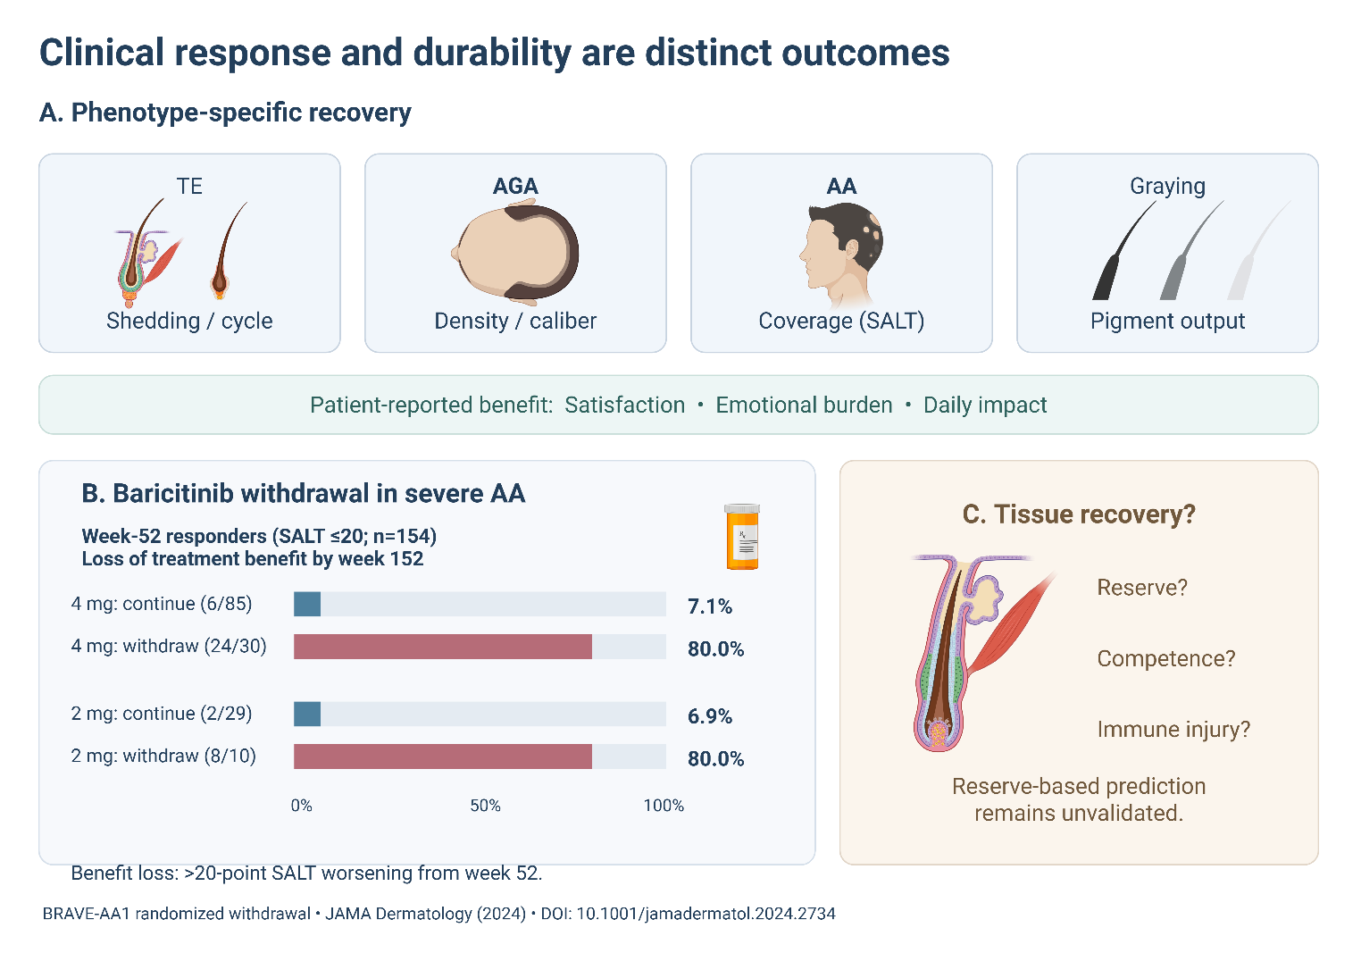
Figure 1. Clinical outcomes and treatment dependence. (A) TE, AGA, AA, and graying require distinct hair outcomes and complementary patient-reported measures. (B) BRAVE-AA1 week-52 responders continued baricitinib or withdrew; bars report benefit-loss events through week 152, defined as >20-point SALT worsening from week 52. Retreatment was permitted, later observations were censored, missing data were handled by last observation carried forward, and patient-reported outcomes were not collected during withdrawal. (C) Tissue questions following regrowth, by lesion site. SALT, Severity of Alopecia Tool; TE, telogen effluvium; AGA, androgenetic alopecia; AA, alopecia areata¹⁶.

3 Cell-specific lesions produced by neuroendocrine signals
Experimental design sets the meaning of a regenerative response, and this bears directly on lesion assignment. Anagen produces the shaft, catagen regresses the lower follicle, and telogen is a relatively quiescent phase before the next anagen. Mouse experiments commonly synchronize growth by depilation or cycle-stage selection, with established morphological staging⁵⁴; human follicles have their own criteria⁵⁵, scalp follicles cycle asynchronously, and organ culture follows anagen shaft production over days⁵⁶, with donor characteristics, dissection, culture conditions, and readouts shaping the result⁵⁷. Anagen entry demonstrates activation; continued shaft elongation tests the performance of producing tissue. Because multiple follicles come from one donor, human inference requires donor-level analysis.

3.1 Lesion site I: withdrawal of niche support to a retained epithelial source
Human follicles contain a functional local endocrine system. Isolated scalp follicles respond to CRH, produce cortisol, and show glucocorticoid feedback without systemic connections⁴. DP cultures identify CRH-associated cell-cycle arrest and oxidative stress, and attenuation of glucocorticoid effects by 11β-hydroxysteroid dehydrogenase type 1 inhibition^{58,59}; serum from restrained rats inhibits human DP-cell growth⁶⁰. DP cells are thus a demonstrated target.
DP-derived WNT regulators carry the signal to the epithelium. Dexamethasone induces DKK1, and DKK1 neutralization attenuates inhibition of human shaft elongation⁶¹; DP experiments also show reduced SFRP2 and increased SFRP3, whose growth effects differ⁶². Neutralization places DKK1 inside the functional response to pharmacological glucocorticoid exposure.
The decisive assignment comes from the mouse corticosterone–GAS6 pathway, which locates the block upstream of epithelial activation and in the niche. Corticosterone acts through DP GR to lower growth arrest-specific 6 (GAS6) and restrict AXL-dependent HFSC activation⁷. Local adeno-associated virus (AAV)-mediated Gas6 expression promotes anagen during continuing stress or corticosterone exposure, and anagen also resumes after withdrawal of a three-week hormone regimen⁷. Local Gas6 bypasses deficient niche support; withdrawal removes the inhibitory environment. Both routes restore output, which is the defining property of this lesion site: the epithelial source is intact and competent, and output returns when support is restored or inhibition lifted.
GR signaling in a different cell reverses the sign of the effect. Treg-specific GR deletion impairs mouse regeneration, and GR cooperation with FOXP3 supports TGF-β3 production and HFSC SMAD2/3 activation⁸; Jagged1–Notch signaling and CXCR4-dependent positioning add further Treg-mediated support^{15,63}, consistent with the reparative functions of skin Tregs⁶⁴. Cell selectivity is therefore not a refinement of GR-directed therapy but its central design constraint, since broad receptor inhibition would hit suppression and support together.
CRH acts at the same site through impaired cell maintenance. Mouse stress and CRH models link impaired growth to CRHR–mTOR–ULK1 changes and to responses to receptor- or autophagy-directed intervention⁶⁵, and in human DP culture a 12-hour CRH exposure lowers LC3-II and Beclin-1, raises p62, and precedes apoptosis assessed at 72 hours, with PTEN overexpression and rapamycin implicating PI3K–AKT–mTOR signaling⁶⁶. After 18 days of restraint, whole-skin LC3-II and Beclin-1 are instead elevated and decline with tempol or neurokinin-1 receptor (NK1R) blockade as cycling normalizes⁶⁷. These results are not in conflict: whole skin pools epithelial, stromal, and immune populations, and the experiments differ in exposure duration, sampling time, and cycle state. They are also not decisive about mechanism, because static marker abundance is compatible with increased autophagosome formation or impaired clearance, and tandem fluorescent LC3 with acidification and degradation controls is required to measure flux⁶⁸. We therefore treat CRH-responsive maintenance signaling as a demonstrated contributor to DP dysfunction and autophagic flux as unmeasured. Epithelial maintenance matters in its own right: ATG5 silencing in matrix and precortical keratinocytes increases matrix apoptosis and accelerates catagen in human organ culture⁶⁹, extending the endocrine account from initiation of growth to survival of producing tissue.

3.2 Lesion site II: necrosis of producing progeny
Neural signaling controls several effector circuits rather than one dose–response continuum, and the circuits differ in lesion site. Physiological sympathetic signaling supports timely mouse anagen through HFSC-intrinsic β2-adrenergic receptor (ADRB2) activity¹⁴. A repeated resiniferatoxin (RTX) regimen — RTX is an agonist of transient receptor potential vanilloid 1 (TRPV1) — and restraint inhibit depilation-induced growth and reduce cell-cycle programs in Lgr5-positive HFSCs⁷⁰, although the supporting cAMP experiments used HaCaT cells and so did not localize the intracellular mechanism to HFSCs. Sensory TRPV1 activation can also initiate growth through a calcitonin gene-related peptide (CGRP)-dependent macrophage–fibroblast circuit⁷¹. Neural identity, stimulus schedule, and starting cycle state differ across these studies, and no shared intensity threshold linking physiological adrenergic support to these opposing responses has been measured.
Strong sympathetic activation produces a qualitatively different lesion. In restraint and RTX models, norepinephrine-associated calcium surges cause HF-TAC necrosis while sparing most HFSCs¹¹. Follicular Adrb2 deletion protects against RTX injury, and surviving follicles subsequently regenerate shaft-producing progeny¹¹ (Figure 2D). HF-TAC-derived Sonic hedgehog (SHH) normally sustains regenerative feedback⁷², and a noise-exposure model identifies EGR1-dependent repression of Shh through a stress-responsive enhancer, linking impaired mitogenic signaling to bulb dystrophy⁷³. This is the second lesion site: the source survives, the producing compartment is destroyed, and output resumes — but, as Section 3.4 shows, the regenerated compartment acquires a new vulnerability.
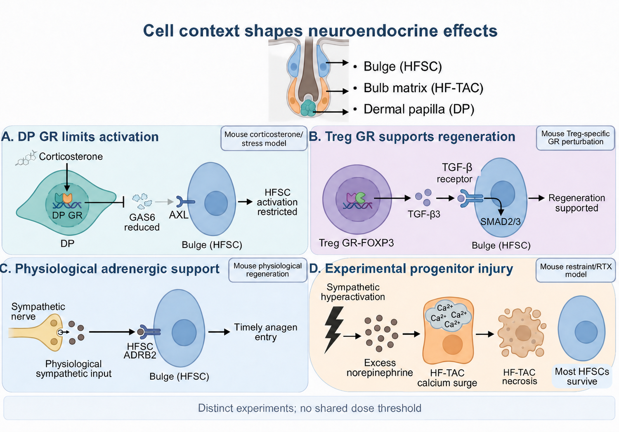
Figure 2. Cell-specific hormonal and neural effects on regeneration. (A) Mouse corticosterone activates DP GR, suppressing GAS6 support for AXL-dependent HFSC activation. (B) In a separate regeneration model, Treg GR and FOXP3 support TGF-β3–SMAD2/3 signaling. (C) Physiological sympathetic input supports anagen through HFSC ADRB2. (D) Experimental sympathetic hyperactivation produces calcium surges and HF-TAC necrosis while sparing most HFSCs. DP, dermal papilla; GR, glucocorticoid receptor; HFSC, hair follicle stem cell; Treg, regulatory T cell; ADRB2, β2-adrenergic receptor; HF-TAC, hair follicle transit-amplifying cell^{7,8,11,14}.

3.3 Lesion site III: depletion of the pigment source
Pigmentation requires that McSCs both persist and reach the growing follicle, and these are separable failures. Foundational mouse and human work linked graying to defective McSC maintenance, with Bcl2 deficiency accelerating selective McSC apoptosis in the niche⁷⁴. Imaging then showed reversible differentiation as McSCs move between hair-germ and upper niche compartments before generating mature bulb melanocytes, and showed that aging increases McSC retention in the telogen bulge, limiting contribution to bulb melanocyte regeneration¹². Profiling identifies heterogeneous quiescent states and age-associated retention of deeply quiescent populations^{75,76}. Aging therefore restricts recruitment while cells persist.
Adrenergic hyperactivation instead removes the source. Excess norepinephrine–ADRB2 signaling drives McSC proliferation, differentiation, and migration out of the niche, and unpigmented shafts emerge during the subsequent growth phase, when new bulb melanocytes would be supplied⁷⁷; RTX-induced graying also occurs in Mc1r-mutant mice, making melanocortin-1 receptor activity dispensable here⁷⁸. This distinction is the clinical crux. Retention outside the productive route is in principle correctable by recruitment; depletion requires a replacement source.
Human data confirm responsiveness and document renewed output without identifying the responsible cells. Norepinephrine induces ectopic differentiation in cultured follicles, attenuated by β2-adrenergic blockade⁷⁹, and independent shaft mapping records repigmentation, including transitions aligned with retrospectively reported life stress⁸⁰ (Figure 3D). Pigment output additionally depends on melanogenic activity and niche support: CRH and urocortin modulate the human follicular pigmentary unit⁸¹, serotonergic interventions normalize pigmentary responses in stressed mice⁸², DP Sox2 deletion alters pigment type and melanogenic signaling⁸³, and stress-associated inflammatory populations with CXCL16/CXCR6 changes implicate an altered microenvironment⁸⁴. Loss of pigment is thus a shared endpoint of at least three distinct lesions, and only sampling the precursor compartment distinguishes them.
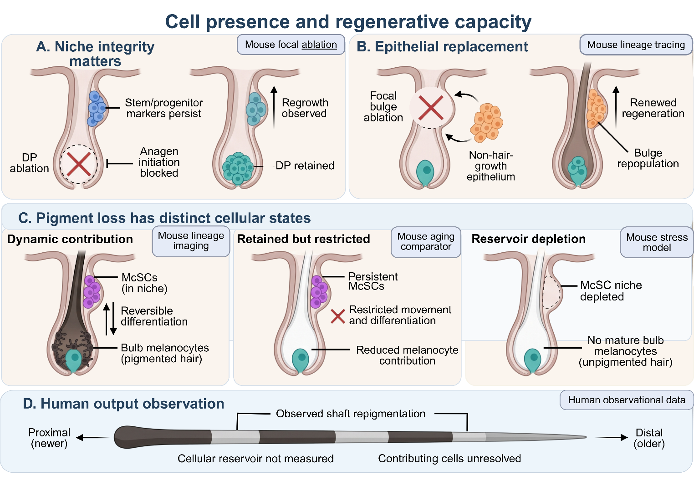
Figure 3. Surviving cells and their contribution to regeneration. (A) DP ablation prevents mouse growth initiation; limited progeny injury with an intact DP permits recovery. (B) Focal bulge ablation allows conditional recruitment of other epithelium. (C) Pigment studies show reversible McSC states between hair germ and upper niche, age-associated restriction of contribution, and stress-induced depletion followed by unpigmented growth. (D) Human shafts record resumed pigmentation without sampling the cellular reservoir. DP, dermal papilla; McSC, melanocyte stem cell^{12,77,80,85,86}.

3.4 Lesion site IV: loss of immune control over the stem cell compartment

3.4.1 Injury-initiated priming spares the source
The RTX model assigns opposing net roles to antigen priming and macrophage activity after progenitor injury. Macrophages engulf follicular debris while conventional type 1 dendritic cells (cDC1s) transport material to draining lymph nodes¹¹. CD8+ T cells from RTX-exposed Batf3-deficient donors fail to induce hair-bulb attack after transfer into Rag1-deficient recipients¹¹, identifying Batf3-dependent priming consistent with cDC1 involvement. Macrophage depletion increases subsequent attack capacity, indicating a net protective role for the retained myeloid cells, though engulfment alone does not prove that debris clearance is the protective step.
Macrophage function is stage-specific, and conflating stages has produced apparent contradiction. In a stress model with norepinephrine-responsive inflammatory programs, depletion attenuates IL-18/IL-1β-associated injury⁸⁷; in RTX-exposed donors, it increases later transferable autoreactivity¹¹. Inflammatory activity during the initial lesion and protective regulation of later priming are compatible, and differences in stimulus, depletion schedule, targeted populations, and lesion burden prevent attribution to a single macrophage function. Efferocytosis limits inflammation by removing apoptotic cells⁸⁸, and HFSCs clear apoptotic neighbors during physiological renewal⁸⁹, but neither precedent establishes the mechanism of protection after necrotic HF-TAC injury. What matters for therapy is the function and stage being measured, not macrophage abundance.
After recovery and re-entry into a subsequent anagen, separate inflammatory challenge with lipopolysaccharide or ultraviolet exposure elicited CD8+ infiltration and renewed bulb injury, while Rag1-deficient mice were protected¹¹. Most HFSCs had survived the initial exposure, and the later attack predominantly affected the bulb. Regrowth and retained attack capacity therefore coexist.

3.4.2 Imposed loss of regulatory control reaches the source
The neural/Treg model makes loss of regulatory control the condition that converts neural responsiveness into HFSC attack. Transient Treg depletion during anagen permits CD8+-mediated HFSC destruction, whereas depletion during telogen does not¹³. Sympathetic denervation prevents disease, and psychological stress or optogenetic sympathetic activation renders telogen follicles susceptible when Tregs are independently depleted¹³. Physiological anagen neural activity thus supplies the susceptible tissue state while imposed Treg loss permits progression: a conditional mechanism, not sufficiency of psychological stress.
HFSC-intrinsic ADRB2 promotes endogenous retrovirus (ERV) reactivation within this state. Deleting Aim2, encoding the DNA sensor absent in melanoma 2 (AIM2), or inhibiting ERV reverse transcription reduces attack during Treg depletion; cDC1 depletion also protects follicles, and ERV peptide–MHC tetramers identify antigen-reactive skin CD8+ cells¹³. Cell-restricted deletions, however, do not localize the relevant AIM2 activity: keratinocyte deletion reduces CD8+ accumulation without significantly improving hair-shaft retention, and cDC1-specific deletion improves neither endpoint¹³.
Antiviral and regulatory programs maintain follicular integrity more broadly. SETDB1 experiments link antiviral responses to progenitor replication stress and impaired regeneration⁹⁰; skin-restricted Treg perturbation and IL-2 receptor studies support niche protection, human AA samples show altered FOXP3+CD39+ populations and repertoires^{91,92}, and lymphocyte perturbation demonstrates protective Treg activity in mouse AA⁹³. Human repertoire changes are not equivalent to experimental Treg removal, which is why this model's relationship to human AA remains a question rather than a conclusion (Figure 4).
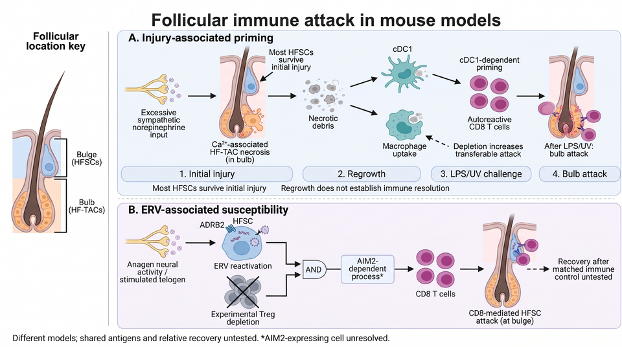
Figure 4. Two experimental routes to immune attack. (A) Mouse RTX injury causes HF-TAC necrosis and Batf3-dependent priming; regrowth precedes inflammatory challenge and predominantly bulb-directed attack, and macrophage depletion increases transferable autoreactivity. (B) An ADRB2–ERV-associated HFSC state permits AIM2-dependent attack after independent Treg depletion; the asterisk marks the unresolved AIM2-expressing cell. RTX, resiniferatoxin; HF-TAC, hair follicle transit-amplifying cell; cDC1, conventional type 1 dendritic cell; HFSC, hair follicle stem cell; ADRB2, β2-adrenergic receptor; ERV, endogenous retrovirus; Treg, regulatory T cell^{11,13}.

3.4.3 One mechanism at two lesion depths: our position and the experiment that would test it
These two models are usually presented as alternative routes to follicular autoimmunity. We propose instead that they describe one neural mechanism acting at two lesion depths, separated by whether regulatory control is intact at the moment of injury. Both begin with adrenergic signaling in follicular epithelium, both require cDC1-dependent priming, and both end in CD8+-mediated attack. They differ in what the attack reaches. With regulatory control intact, injury is confined to HF-TACs, priming is partly restrained by retained myeloid cells, and attack after later challenge is bulb-directed, leaving the HFSC source available (Figure 4A). With regulatory control removed, the same adrenergic input renders the HFSC compartment itself antigenic through ERV reactivation, and attack reaches the source (Figure 4B). On this reading, Treg status is the depth switch, and the apparent disagreement about the target follows from the immune context of the experiment rather than from two distinct diseases.
The prediction is directly testable. RTX injury should be delivered to anagen-synchronized mice with and without transient Treg depletion, at matched lesion burden, with three endpoints: HFSC survival by CD34 and K15 quantification, frequency of ERV tetramer-reactive skin CD8+ cells, and shaft production in the following cycle. Our model predicts that Treg depletion converts RTX injury from a bulb-restricted to an HFSC-directed lesion, and that ERV tetramer-reactive cells appear only in the depleted arm. The competing model — two independent routes — predicts that RTX injury remains bulb-restricted regardless of Treg status and that ERV reactivity remains specific to the neural/Treg protocol. A single experiment therefore separates the accounts, and the result determines whether an intervention aimed at priming would also protect the stem cell compartment. Until it is done, neither route has been assigned to a stage of human AA.

3.5 How attack is sustained once established
Local neuroimmune signals shape the inflammatory environment in which attack persists. Mouse experiments implicate substance P (SP) and nerve growth factor in premature catagen and perifollicular inflammation^{94–97}. In human follicle culture, SP induces regression and mast-cell degranulation, and CRH both promotes degranulation and increases mast-cell numbers through epithelial stem cell factor^{98,99}, extending the response from mediator release to control of local cell abundance. In AA, lesions show increased SP/NK1R staining despite no significant serum SP difference, and SP activates NF-κB and IL-6 in outer root sheath cells¹⁰⁰; SP increases mast-cell and cytotoxic readouts in established mouse AA¹⁰¹; and a study of 54 patients and 66 controls found increased monocyte CRHR1 with CRH-induced CD86 responses¹⁰². Serum measurement therefore misses local pathway activity, and peripheral-cell responsiveness does not localize the follicular lesion.
Immune privilege is the tissue-level defense. In human follicles, interferon-γ (IFN-γ) induces MHC class I and antigen-processing machinery in matrix epithelium, while immune privilege limits natural killer cell attack^{103,104}, through reduced antigen presentation, CD200-associated inhibitory signals, and a local immunoregulatory environment¹⁰⁵. Experimental AA links epithelial JAK1/2–STAT1 and lymphocyte JAK1/3–STAT5 through IFN-γ/IL-15 feedback⁹, with recruitment and T-cell receptor studies implicating trafficking and antigen recognition^{106,107}, and spontaneous mouse and scalp-xenograft models establishing immune dependencies under their induction conditions¹⁰⁸. Restoring immune privilege is an established therapeutic objective¹⁰⁹.
IL-15 shows why a target must be specified by cell and context, not by molecule. Recombinant IL-15 protects human follicular immune privilege through IL-15Rα-dependent epithelial effects and promotes regrowth in a scalp-xenograft model¹⁰, whereas experimental AA identifies IL-15 support for pathogenic lymphocytes⁹. Ligand presentation, receptor context, and inflammatory exposure are the testable explanations, and the practical consequence is that IL-15-directed therapy must be assessed for epithelial protection and lymphocyte inhibition separately. Human AA profiling identifies inflammatory programs and resident-memory-associated populations whose presence does not by itself explain recurrence^{110,111}.

3.6 Surviving architecture sets the ceiling on recovery
Regeneration requires viable producing tissue as well as an activatable source, and proliferation markers do not establish either. Mouse survival, metabolic, and mesenchymal perturbations define contributions to HFSC viability, activation, and niche support^{112–116}. In human anagen culture, mitochondrial pyruvate carrier inhibition by UK-5099 activates the integrated stress response and arrests proliferation, and cotreatment with the inhibitor ISRIB partly restores Ki-67 positivity while matrix apoptosis persists¹¹⁷. Marker recovery can therefore coexist with ongoing injury in the tissue that makes the shaft.
Architecture also determines access to replacement cells. Focal DP ablation prevents growth initiation despite retained epithelial markers, whereas limited progeny injury with an intact DP permits recovery; after focal bulge ablation, epithelium that ordinarily does not support growth can be recruited^{85,86}. Human DP spheroids recover part of their lost inductive activity when tested in skin grafted to immunodeficient mice¹¹⁸. These results establish conditional regenerative plasticity (Figure 3A,B), and they also bound it: the contributions appear when tissue support is preserved, which is precisely what widespread inflammatory destruction removes.

4 Treatment opportunities and barriers to clinical use
Development requires matching a localized deficit to an intervention delivered at an effective, controllable exposure. Each strategy below is assessed by lesion site, by the stage at which treatment began, and by the barriers to safe follicular delivery. Table 2 states the next development decision.

4.1 Restoring niche support after endocrine inhibition
GAS6 addresses lesion site I, and its development depends on identifying follicles in which reduced local support actually limits production. The mouse mechanism provides a defined target, but no clinical subgroup with demonstrated GAS6-limited growth exists, and the efficacy endpoint is sustained shaft output after a documented deficit.
Delivery control is the principal obstacle. AAV exposure is difficult to titrate or terminate, and Gas6 overexpression prolongs HFSC proliferation into full anagen⁷, so assessment must include cycle progression and cell survival alongside output. Microneedles deliver intact proteins into human skin ex vivo¹¹⁹; achieving active GAS6 exposure in the responding compartment further depends on protein stability, delivery depth, tissue retention, and target engagement, and repeated protein dosing versus sustained expression impose different demands for manufacture, monitoring, and reversibility.
Astressin-B provides the field's clearest post-deficit rescue. In corticotropin-releasing factor (CRF)-overexpressing mice with visible alopecia, five daily injections produced regrowth quantified through eight weeks, with persistence up to four months reported qualitatively¹²⁰. Treatment began after the deficit, unlike most CRH and autophagy protocols, which intervene before or during injury^{65,66}. Human follicles respond to CRHR-antagonistic compounds¹²¹, and neurotensin studies report growth and DP-transcription effects¹²². Serotonin increases shaft elongation during six-day human follicle culture at 100 µM¹²³, a pharmacological response in viable tissue that still requires a tolerable exposure and a post-deficit benefit.

4.2 Protecting progeny from neural injury
Adrenergic blockade addresses lesion site II but must respect physiological growth support, since ADRB2 activity supports timely HFSC activation¹⁴. Immediate survival is therefore an incomplete endpoint; later progenitor or pigment-lineage contribution and normal cycle progression determine whether protected cells produce hair.
Human β-receptor data remain preliminary and lack an agonist–antagonist comparison. Twenty participants with increased shedding received vehicle then topical propranolol for 15–20 days each, with declining shedding and no reported local reactions¹²⁴; separately, 68 men with AGA received topical isoproterenol for six months and improved from baseline without a randomized vehicle comparator¹²⁵. Altered K15 immunostaining after isoproterenol is a treatment-associated marker response, distinct from the retention of K15-high populations measured in paired scalp samples⁴⁵, and neither observation establishes productive contribution.
Delivery must achieve active drug exposure in the responding compartment with limited systemic exposure. Particle-associated dye retention demonstrates follicular deposition¹²⁶, but bulge and bulb drug concentrations require pharmacokinetic measurement, and cardiovascular tolerability remains relevant to topical β-receptor modulation. For prevention there is a further practical barrier: the exposure interval must be recognized before injury, whereas patients present with shedding already under way.

4.3 Limiting immune attack while preserving repair
Myeloid interventions address lesion site IV but must distinguish growth restraint, inflammatory injury, and immune priming. Macrophage-derived oncostatin M maintains HFSC quiescence in resting mouse follicles¹²⁷, and the depletion studies in Section 3.4.1 add a temporal constraint, since reducing initial injury and limiting later attack are different outcomes. Broad depletion obscures both. The informative target is a defined macrophage signal whose inhibition preserves material handling, cycle progression, and subsequent hair production.
Cell therapy has produced the strongest post-deficit immune result. Expanded autologous Vδ2-positive FOXP3-positive γδ Tregs, injected before or after experimental AA induction in human scalp xenografts on immunodeficient mice, prevented onset and promoted regrowth in established lesions¹²⁸. Product persistence, follicular trafficking, unwanted immune suppression, manufacturing cost, and reproducible potency are the development barriers, and function in an intact immune system is untested. Soluble CD83 offers a mechanistic alternative, with blood and scalp observations, human follicle and epithelial experiments, therapeutic effects in mouse AA, and indoleamine 2,3-dioxygenase-dependent Treg activation, but no clinical efficacy data¹²⁹. Small uncontrolled IL-2 studies ask whether regulatory support adds durability after immune-directed treatment: three of four patients receiving sequential tofacitinib and low-dose IL-2 maintained remission for 11–20 months after cessation¹³⁰, and another pilot reported partial regrowth in four of five patients¹³¹. Neither isolates an IL-2 effect.
Human organ experiments identify short-term immunomodulatory responses that do not yet speak to output. Farudodstat given one day before resident T-cell stimulation prevents regional MHC increases without significantly reducing total CD3 counts, with principal MHC analyses using follicles from three donors in hydrocortisone- and insulin-containing medium¹³²; these endpoints do not separate altered T-cell function or localization from epithelial responsiveness. CGRP produces timing-dependent effects before or after IFN-γ¹³³, and IL-15 has the contrasting epithelial and lymphocyte effects discussed above^{9,10}. The therapeutic question throughout is whether the selected immune response can be modified while shaft production continues.

4.4 Clinical responses and treatment dependence in alopecia areata
Immune-directed kinase inhibition produces clinical benefit in defined populations^{134–136}, and an exploratory substudy of 46 participants receiving ritlecitinib, brepocitinib, or placebo at baseline and weeks 12 and 24 related inflammatory and hair-keratin changes to clinical outcomes¹³⁷. Because these agents influence several immune and regenerative processes at once, attributing benefit to a particular maintenance circuit requires cell-localized functional evidence.
Negative and heterogeneous outcomes show that nonresponse cannot be assigned a cellular cause from the clinical endpoint. Topical ruxolitinib, IL-12/IL-23 neutralization, and tested deucravacitinib regimens did not establish benefit^{138–140}; exploratory biomarker and transcriptomic studies suggest response heterogeneity^{141–143}; and dose-ranging studies show that exposure and duration affect classification^{144,145}. Distinguishing insufficient delivery or pathway modulation from disease beyond an intervention's reach requires measurement of follicular drug activity and tissue response.
Long-term extension estimates depend on treatment exposure, analysis method, and cohort selection^{146,147}. Randomized dose reduction or withdrawal tests treatment dependence, whereas retrospective tapering describes outcomes under clinical dose changes^{16,148,149}. These comparisons address maintenance of an achieved response (Figure 5), and continued suppression balances sustained coverage against cumulative exposure, adverse effects, monitoring, cost, and patient preference.

5 Testing the lesion-site principle in patients

5.1 What has to be shown
Most cell-specific causal evidence reviewed here comes from mice, so the principle's clinical value rests on whether lesion site can be assigned in patients and whether the assignment predicts output. Tape-strip RNA signatures detect AA-associated activity but, being superficial, cannot be assigned to deeper compartments¹⁵⁰. Human K15, CD34, and nestin staining characterizes populations¹⁵¹ and clonogenic assays test proliferative potential¹⁵², but neither demonstrates that appropriate progeny contribute to output; human follicle imaging follows epithelial movement and fiber growth¹⁵³, and mouse lineage imaging resolves pigment-cell contribution¹². Sections 5.2 and 5.3 therefore specify two studies rather than restating the general need for paired tissue work.

5.2 Study 1: does pretreatment lesion assignment predict durable response in alopecia areata?
Design. Prospective cohort embedded in a randomized withdrawal design, 150 adults with severe AA (SALT ≥50) starting a JAK inhibitor. Two 4-mm scalp biopsies at baseline, one at the lesional margin and one from clinically uninvolved scalp, with a third optional biopsy at week 24 in consenting participants. Matched follicles or parallel specimens accommodate destructive assays.
Lesion assignment. Each participant is assigned by prespecified criteria to a reserve-intact or reserve-reduced stratum using quantitative immunofluorescence for CD34, CD200/ITGA6, and K15 in the bulge, with bulge MHC-I and CD200 for privilege status and CD8+ density for active injury. Assignment is made blind to outcome.
Endpoints. Primary, SALT ≤20 at week 36. Secondary, benefit-loss events after randomized withdrawal at week 52, as in BRAVE-AA1¹⁶.
Positive result. Adding the bulge reserve index to a model containing SALT score, disease duration, cycle stage, prior treatment, and week-36 response improves prediction of post-withdrawal benefit loss by a prespecified increment in area under the curve of at least 0.05, with calibration maintained. A negative result is equally informative: it would show that in established AA, immune control rather than measurable reserve governs durability, which is the prediction our principle makes for lesion site IV.
Why this size. With roughly 70–80% of selected responders losing benefit on withdrawal¹⁶, 150 enrolled patients yield approximately 80 randomized responders, sufficient to detect a reserve-index hazard ratio near 2.0 at 80% power. Patient- and donor-level clustering must be modeled explicitly.

5.3 Study 2: can pigment lesion site be assigned in people, and does it predict reversal?
Design. Case–control with longitudinal follow-up, 60 adults with recent-onset localized graying and 60 age- and sex-matched controls, sampled at baseline and 12 months.
Measurements. Quantitative segmental shaft mapping of pigmentation along individual hairs, as established in human greying and reversal studies⁸⁰, paired with plucked anagen follicles analyzed by immunofluorescence for MITF, SOX10, and KIT, scored separately in the bulge and the bulb. Contemporaneous dated stressor records are collected prospectively rather than reconstructed.
Assignment. Depletion is defined as reduced bulge McSC counts; retention outside the productive route is defined as preserved bulge counts with reduced bulb melanocytes^{12,77}.
Positive result. The two patterns are separable in human scalp, and repigmentation over 12 months occurs predominantly in the retention group. This would establish in people the distinction that currently rests on mouse data, and would identify the subgroup in which recruitment-directed therapy could work and the subgroup requiring a replacement source.

5.4 Residual mechanistic questions
Two questions bear directly on target selection and are stated as experiments rather than gaps. Whether ERV-reactive CD8+ cells recognize RTX-injured follicles, and whether a common necessary step links the two initiation routes, is answered by the matched-burden experiment specified in Section 3.4.3^{11,13}. Whether macrophage protection operates through clearance specifically is answered by cell-preserving manipulation of uptake rather than by depletion, which establishes only a net effect¹¹. Any claim that the routes interact requires a defined endpoint and a joint effect departing from a prespecified additive expectation. Where outcomes are similar despite different source abundance, functional thresholds, replacement sources, or compensatory support remain live explanations, which is why a measured cellular difference is a candidate predictor to be evaluated rather than an assumed cause.
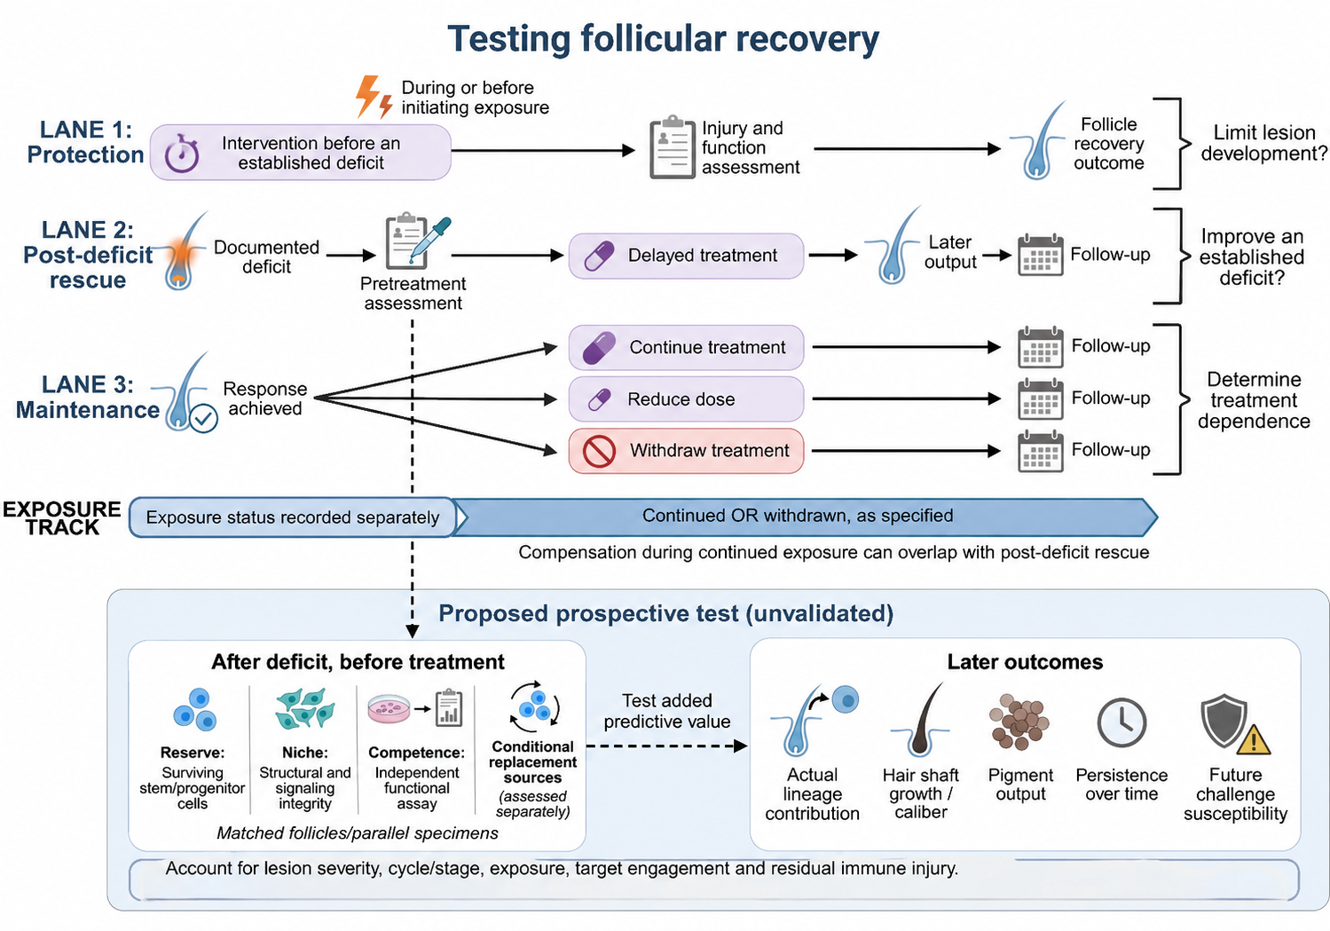
Figure 5. Proposed research agenda: intervention timing and the matching recovery test. Protection begins before a deficit, post-deficit rescue follows documented dysfunction, and maintenance is tested after an achieved response, with initiating exposure recorded separately from treatment continuation, reduction, or withdrawal. The lower section sets out the prospective comparison specified in Section 5.2, relating pretreatment reserve, niche integrity, and assay-specific competence to later output, with conditional replacement sources considered separately from cells surviving the initial perturbation. This agenda is proposed, not validated^{7,16,85,86}.

6 Conclusions
Neuroendocrine signals act at four separable sites, and the site determines what recovery is possible. Withdrawal of DP support restricts activation of an intact epithelial source, and output returns when support is restored or inhibition lifted. HF-TAC necrosis destroys producing progeny while sparing the source, so hair regrows — but the regenerated bulb can be attacked after inflammatory challenge. McSC depletion removes the cells needed for pigmentation, so recovery depends on a replacement source. Loss of regulatory control exposes the HFSC compartment itself, making output contingent on sustained immune suppression. Randomized baricitinib withdrawal shows that most selected severe-AA responders need continued treatment to hold their response¹⁶, which is what the fourth lesion predicts.
The principle earns its place only if it predicts. We have therefore specified what would confirm or refute it: a matched-burden injury experiment that decides whether the two murine autoimmunity routes are one mechanism at two lesion depths, and two human studies that test whether pretreatment lesion assignment predicts durable hair and pigment output. If pretreatment lesion site predicts durability, treatment selection follows from tissue measurement rather than from exposure history. If it does not, the field will have learned that in established disease immune control is the only variable that matters — which is itself a result worth having.

Declarations
Acknowledgements: [TO COMPLETE]
Author contributions: [TO COMPLETE]
Competing interests: [TO COMPLETE]
Funding: [TO COMPLETE]
Data availability: No new data were generated. Sources supporting the review are cited in the article. Full search strings, retrieval dates, and record counts are provided as Supplementary Material.
Figure preparation and use of artificial intelligence: Figures 1–5 and the graphical abstract were prepared in BioRender.com as vector originals. Generative artificial intelligence was used to assist language and structural revision of the text. [AUTHORS: confirm that no figure submitted for publication was produced or modified by a generative image model, and that each figure exists as an editable vector original; see editorial note 1.] Publication licences and figure-specific credits: [TO COMPLETE]

References
1. Paus, R., Langan, E. A., Vidali, S., Ramot, Y. & Andersen, B. Neuroendocrinology of the hair follicle: principles and clinical perspectives. Trends Mol Med 20, 559–570 (2014).
2. Slominski, A. T. et al. Key role of CRF in the skin stress response system. Endocr Rev 34, 827–884 (2013).
3. Paus, R., Theoharides, T. C. & Arck, P. C. Neuroimmunoendocrine circuitry of the "brain–skin connection". Trends Immunol 27, 32–39 (2006).
4. Ito, N. et al. Human hair follicles display a functional equivalent of the hypothalamic-pituitary-adrenal axis and synthesize cortisol. FASEB J 19, 1332–1334 (2005).
5. Fan, S. M.-Y. et al. External light activates hair follicle stem cells through eyes via an ipRGC-SCN-sympathetic neural pathway. Proc Natl Acad Sci U S A 115, E6880–E6889 (2018).
6. Kauser, S., Slominski, A., Wei, E. T. & Tobin, D. J. Modulation of the human hair follicle pigmentary unit by corticotropin-releasing hormone and urocortin peptides. FASEB J 20, 882–895 (2006).
7. Choi, S. et al. Corticosterone inhibits GAS6 to govern hair follicle stem-cell quiescence. Nature 592, 428–432 (2021).
8. Liu, Z. et al. Glucocorticoid signaling and regulatory T cells cooperate to maintain the hair-follicle stem-cell niche. Nat Immunol 23, 1086–1097 (2022).
9. Xing, L. et al. Alopecia areata is driven by cytotoxic T lymphocytes and is reversed by JAK inhibition. Nat Med 20, 1043–1049 (2014).
10. Suzuki, T. et al. Interleukin-15 is a hair follicle immune privilege guardian. J Autoimmun 145, 103217 (2024).
11. Scott-Solomon, E. et al. Stress-induced sympathetic hyperactivation drives hair follicle necrosis to trigger autoimmunity. Cell 189, 252-271.e19 (2026).
12. Sun, Q. et al. Dedifferentiation maintains melanocyte stem cells in a dynamic niche. Nature 616, 774–782 (2023).
13. Cui, J. et al. A two-hit mechanism triggers autoimmune hair loss. Nature 658, 1310–1318 (2026).
14. Shwartz, Y. et al. Cell types promoting goosebumps form a niche to regulate hair follicle stem cells. Cell 182, 578-593.e19 (2020).
15. Ali, N. et al. Regulatory T cells in skin facilitate epithelial stem cell differentiation. Cell 169, 1119-1129.e11 (2017).
16. King, B. et al. Baricitinib withdrawal and retreatment in patients with severe alopecia areata: the BRAVE-AA1 randomized clinical trial. JAMA Dermatol 160, 1075–1081 (2024).
17. O'Sullivan, J. D. B. et al. The impact of perceived stress on the hair follicle: towards solving a psychoneuroendocrine and neuroimmunological puzzle. Front Neuroendocrinol 66, 101008 (2022).
18. Zhang, B. & Chen, T. Local and systemic mechanisms that control the hair follicle stem cell niche. Nat Rev Mol Cell Biol 25, 87–100 (2024).
19. Yue, Z., Yang, F., Zhang, J., Li, J. & Chuong, C.-M. Regulation and dysregulation of hair regeneration: aiming for clinical application. Cell Regen 11, 22 (2022).
20. Bai, J. Q. A. et al. The role of psychological stress in hair loss: a review. JAAD Reviews 7, 9–19 (2026).
21. Chien Yin, G. O., Siong-See, J. L. & Wang, E. C. E. Telogen effluvium — a review of the science and current obstacles. J Dermatol Sci 101, 156–163 (2021).
22. Jimeno Ortega, I. & Stefanato, C. M. Telogen effluvium: a 360 degree review. Ital J Dermatol Venerol 158, 457–466 (2023).
23. Chen, V., Strazzulla, L., Asbeck, S. M. & Bellodi Schmidt, F. Etiology, management, and outcomes of pediatric telogen effluvium: a single-center study in the United States. Pediatr Dermatol 40, 120–124 (2023).
24. Karakoyun, Ö., Ayhan, E. & Yıldız, İ. Retrospective review of 2851 female patients with telogen effluvium: a single-center experience. J Cosmet Dermatol 24, e70037 (2025).
25. Taheri, R., Behnam, B., Tousi, J. A., Azizzade, M. & Sheikhvatan, M. R. M. Triggering role of stressful life events in patients with alopecia areata. Acta Dermatovenerol Croat 20, 246–250 (2012).
26. Fhager, J., Örmon, K., Svensson, Å. & Sjöström, K. J. M. Life events preceding alopecia areata onset — a descriptive retrospective cohort study focusing on strain. Clin Cosmet Investig Dermatol 19, 567911 (2026). [AUTHORS: verify volume and page; see editorial note 2.]
27. Fişek Izci, N., Aksoy, B. & Aktaş, E. Significant impact of telogen effluvium on quality of life, depression, anxiety and stress: a prospective case-control study. Eur J Dermatol 35, 300–306 (2025).
28. Peters, E. M. J. et al. Hair and stress: a pilot study of hair and cytokine balance alteration in healthy young women under major exam stress. PLoS One 12, e0175904 (2017).
29. Huang, J. et al. Latent profiles of perceived stress and their predictors in alopecia areata: a cross-sectional study. Int J Dermatol https://doi.org/10.1111/ijd.70516 (2026).
30. Stalder, T. et al. Stress-related and basic determinants of hair cortisol in humans: a meta-analysis. Psychoneuroendocrinology 77, 261–274 (2017).
31. Vallerand, I. A. et al. Assessment of a bidirectional association between major depressive disorder and alopecia areata. JAMA Dermatol 155, 475–479 (2019).
32. Wang, D., Luo, W., Deng, P., Huang, Y. & Lu, J. Depression and incident alopecia areata and atopic dermatitis: a prospective cohort study. JAAD Int 27, 163–165 (2026).
33. Mostaghimi, A., Soliman, A. M., Li, C., Barqawi, Y. K. & Grada, A. Immune-mediated and psychiatric comorbidities among patients newly diagnosed with alopecia areata. JAMA Dermatol 160, 945–952 (2024).
34. Sanderson, E. et al. Mendelian randomization. Nat Rev Methods Primers 2, 6 (2022).
35. Yu, N. & Guo, Y. Association between alopecia areata, anxiety, and depression: insights from a bidirectional two-sample Mendelian randomization study. J Affect Disord 350, 328–331 (2024).
36. Hu, C. et al. Causal link of distinct mental disorders with androgenetic alopecia and alopecia areata: a bidirectional two-sample Mendelian randomization study. Clin Cosmet Investig Dermatol 18, 1727–1736 (2025).
37. Foo, J. C. et al. Exploring the overlap between alopecia areata and major depressive disorder: epidemiological and genetic perspectives. J Eur Acad Dermatol Venereol 37, 1547–1555 (2023).
38. Petukhova, L. et al. Genome-wide association study in alopecia areata implicates both innate and adaptive immunity. Nature 466, 113–117 (2010).
39. Winnette, R., Banerjee, A., Sikirica, V., Peeva, E. & Wyrwich, K. Characterizing the relationships between patient-reported outcomes and clinician assessments of alopecia areata in a phase 2a randomized trial of ritlecitinib and brepocitinib. J Eur Acad Dermatol Venereol 36, 602–609 (2022).
40. Sinclair, R. et al. Patient-reported satisfaction with hair regrowth in a study of ritlecitinib in alopecia areata: results from ALLEGRO-2b/3. Dermatology 240, 767–777 (2024).
41. Piraccini, B. M. et al. Scalp hair regrowth is associated with improvements in health-related quality of life and psychological symptoms in patients with severe alopecia areata: results from two randomized controlled trials. J Dermatolog Treat 34, 2227299 (2023).
42. Craiglow, B. et al. Improvement in measures of quality of life and symptoms of anxiety and depression in patients with severe alopecia areata achieving sustained scalp hair regrowth with baricitinib. Dermatol Ther (Heidelb) 14, 1959–1968 (2024).
43. Sinclair, R. et al. Patient-reported hair loss and its impacts as measured by the Alopecia Areata Patient Priority Outcomes instrument in patients treated with ritlecitinib: the ALLEGRO phase 2b/3 randomized clinical trial. Am J Clin Dermatol 26, 109–119 (2025).
44. Law, E. H. et al. Improvement in patient-reported emotional symptoms and activity limitations due to hair loss in patients with alopecia areata treated with ritlecitinib: additional analyses from ALLEGRO-2b/3. Int J Dermatol 65, 526–534 (2026).
45. Garza, L. A. et al. Bald scalp in men with androgenetic alopecia retains hair follicle stem cells but lacks CD200-rich and CD34-positive hair follicle progenitor cells. J Clin Invest 121, 613–622 (2011).
46. Matsumura, H. et al. Hair follicle aging is driven by transepidermal elimination of stem cells via COL17A1 proteolysis. Science 351, aad4395 (2016).
47. Kwack, M. H. et al. Dihydrotestosterone-inducible dickkopf 1 from balding dermal papilla cells causes apoptosis in follicular keratinocytes. J Invest Dermatol 128, 262–269 (2008).
48. Fischer, T. W. et al. New effects of caffeine on corticotropin-releasing hormone (CRH)-induced stress along the intrafollicular classical hypothalamic-pituitary-adrenal (HPA) axis (CRH-R1/2, IP3-R, ACTH, MC-R2) and the neurogenic non-HPA axis (substance P, p75NTR and TrkA) in ex vivo human male androgenetic scalp hair follicles. Br J Dermatol 184, 96–110 (2021).
49. Karnik, P. et al. Hair follicle stem cell-specific PPARgamma deletion causes scarring alopecia. J Invest Dermatol 129, 1243–1257 (2009).
50. Harries, M. J. et al. Lichen planopilaris is characterized by immune privilege collapse of the hair follicle's epithelial stem cell niche. J Pathol 231, 236–247 (2013).
51. Chen, Q. et al. Single-cell sequencing combined with spatial transcriptomics reveals the characteristics of follicle-targeted inflammation patterns in primary cicatricial alopecia. Cell Biosci 15, 102 (2025).
52. Imanishi, H. et al. Epithelial-to-mesenchymal stem cell transition in a human organ: lessons from lichen planopilaris. J Invest Dermatol 138, 511–519 (2018).
53. Hong, J.-W. et al. The contributory roles of Th17 lymphocyte and cytotoxic T lymphocyte at the hair bulge region as well as the hair bulb area in chronic alopecia areata patients. Ann Dermatol 29, 156–166 (2017).
54. Müller-Röver, S. et al. A comprehensive guide for the accurate classification of murine hair follicles in distinct hair cycle stages. J Invest Dermatol 117, 3–15 (2001).
55. Oh, J. W. et al. A guide to studying human hair follicle cycling in vivo. J Invest Dermatol 136, 34–44 (2016).
56. Philpott, M. P., Green, M. R. & Kealey, T. Human hair growth in vitro. J Cell Sci 97, 463–471 (1990).
57. Langan, E. A., Philpott, M. P., Kloepper, J. E. & Paus, R. Human hair follicle organ culture: theory, application and perspectives. Exp Dermatol 24, 903–911 (2015).
58. Lee, E. Y. et al. The local hypothalamic-pituitary-adrenal axis in cultured human dermal papilla cells. BMC Mol Cell Biol 21, 42 (2020).
59. Lee, S. E., Lee, E. Y., Kang, S. J. & Lee, S. H. 11β-hydroxysteroid dehydrogenase type 1 inhibition attenuates the adverse effects of glucocorticoids on dermal papilla cells. Yonsei Med J 58, 1204–1210 (2017).
60. Shin, H. et al. Acute stress-induced changes in follicular dermal papilla cells and mobilization of mast cells: implications for hair growth. Ann Dermatol 28, 600–606 (2016).
61. Kwack, M. H. et al. Dickkopf-1 is involved in dexamethasone-mediated hair follicle regression. Exp Dermatol 26, 952–954 (2017).
62. Hamida, O. B., Kim, M. K. & Kwack, M. H. The role of dexamethasone in mediating the contradictory effects of Wnt antagonists SFRP2 and SFRP3 on human hair follicle growth. Sci Rep 13, 16504 (2023).
63. Cohen, J. N. et al. Regulatory T cells in skin utilize the Cxcr4-Cxcl12 axis to promote hair follicle regeneration. Cell Rep 44, 116467 (2025).
64. Boothby, I. C., Cohen, J. N. & Rosenblum, M. D. Regulatory T cells in skin injury: at the crossroads of tolerance and tissue repair. Sci Immunol 5, eaaz9631 (2020).
65. Liang, W. et al. Psychological stress induces hair regenerative disorders through corticotropin-releasing hormone-mediated autophagy inhibition. Biochem Biophys Res Commun 699, 149564 (2024).
66. Liang, W. et al. Corticotropin-releasing hormone inhibits autophagy by suppressing PTEN to promote apoptosis in dermal papilla cells. Ann Med 57, 2490823 (2025).
67. Wang, L. et al. Oxidative stress and substance P mediate psychological stress-induced autophagy and delay of hair growth in mice. Arch Dermatol Res 307, 171–181 (2015).
68. Kimura, S., Noda, T. & Yoshimori, T. Dissection of the autophagosome maturation process by a novel reporter protein, tandem fluorescent-tagged LC3. Autophagy 3, 452–460 (2007).
69. Parodi, C. et al. Autophagy is essential for maintaining the growth of a human (mini-)organ: evidence from scalp hair follicle organ culture. PLoS Biol 16, e2002864 (2018).
70. Wang, X. et al. Intensive stress impedes hair follicle growth through triggering cell cycle arrest of hair follicle stem cells. FASEB J 39, e70460 (2025).
71. Ben-Shaanan, T. L. et al. Dermal TRPV1 innervations engage a macrophage- and fibroblast-containing pathway to activate hair growth in mice. Dev Cell 59, 2818-2833.e7 (2024).
72. Hsu, Y.-C., Li, L. & Fuchs, E. Transit-amplifying cells orchestrate stem cell activity and tissue regeneration. Cell 157, 935–949 (2014).
73. Chen, Z. et al. Convergence of external and internal stressors on a stress-responsive enhancer of the Sonic hedgehog gene to induce hair disorders. Proc Natl Acad Sci U S A 123, e2529339123 (2026).
74. Nishimura, E. K., Granter, S. R. & Fisher, D. E. Mechanisms of hair graying: incomplete melanocyte stem cell maintenance in the niche. Science 307, 720–724 (2005).
75. Palmer, J. W. et al. Molecular heterogeneity of quiescent melanocyte stem cells revealed by single-cell RNA-sequencing. Pigment Cell Melanoma Res 37, 480–495 (2024).
76. Palmer, J. W. et al. Quiescence and aging of melanocyte stem cells and a novel association with programmed death-ligand 1. iScience 27, 110908 (2024).
77. Zhang, B. et al. Hyperactivation of sympathetic nerves drives depletion of melanocyte stem cells. Nature 577, 676–681 (2020).
78. Zhang, B. et al. Melanocortin 1 receptor is dispensable for acute stress induced hair graying in mice. Exp Dermatol 30, 572–577 (2021).
79. Rachmin, I. et al. Stress-associated ectopic differentiation of melanocyte stem cells and ORS amelanotic melanocytes in an ex vivo human hair follicle model. Exp Dermatol 30, 578–587 (2021).
80. Rosenberg, A. M. et al. Quantitative mapping of human hair greying and reversal in relation to life stress. eLife 10, e67437 (2021).
81. Paus, R., Sevilla, A. & Grichnik, J. M. Human hair graying revisited: principles, misconceptions, and key research frontiers. J Invest Dermatol 144, 474–491 (2024).
82. Wu, H.-L. et al. 5-HT1A/1B receptors as targets for optimizing pigmentary responses in C57BL/6 mouse skin to stress. PLoS One 9, e89663 (2014).
83. Ng, K. J. et al. Sox2 in the dermal papilla regulates hair follicle pigmentation. Cell Rep 40, 111100 (2022).
84. Cao, X. et al. Comprehensive single-cell transcriptomics reveals different destinies of melanocytes and dynamic changes of immune microenvironment in a psychological stress-induced leukoderma and leukotrichia mouse model. Mol Med 31, 186 (2025).
85. Rompolas, P. et al. Live imaging of stem cell and progeny behaviour in physiological hair-follicle regeneration. Nature 487, 496–499 (2012).
86. Rompolas, P., Mesa, K. R. & Greco, V. Spatial organization within a niche as a determinant of stem-cell fate. Nature 502, 513–518 (2013).
87. Xiao, X. et al. M1 polarization of macrophages promotes stress-induced hair loss via interleukin-18 and interleukin-1β. J Cell Physiol 239, e31181 (2024).
88. Doran, A. C., Yurdagul, A. & Tabas, I. Efferocytosis in health and disease. Nat Rev Immunol 20, 254–267 (2020).
89. Stewart, K. S. et al. Stem cells tightly regulate dead cell clearance to maintain tissue fitness. Nature 633, 407–416 (2024).
90. Lyu, Y. et al. Stem cell activity-coupled suppression of endogenous retrovirus governs adult tissue regeneration. Cell 187, 7414-7432.e26 (2024).
91. Cohen, J. N. et al. Regulatory T cells in skin mediate immune privilege of the hair follicle stem cell niche. Sci Immunol 9, eadh0152 (2024).
92. Hamed, F. N. et al. Alopecia areata patients show deficiency of FOXP3+CD39+ T regulatory cells and clonotypic restriction of Treg TCRβ-chain. PLoS One 14, e0210308 (2019).
93. Lee, E. Y. et al. Functional interrogation of lymphocyte subsets in alopecia areata using single-cell RNA sequencing. Proc Natl Acad Sci U S A 120, e2305764120 (2023).
94. Arck, P. C. et al. Stress inhibits hair growth in mice by induction of premature catagen development and deleterious perifollicular inflammatory events via neuropeptide substance P-dependent pathways. Am J Pathol 162, 803–814 (2003).
95. Liu, N. et al. Chronic restraint stress inhibits hair growth via substance P mediated by reactive oxygen species in mice. PLoS One 8, e61574 (2013).
96. Peters, E. M. J. et al. Neurogenic inflammation in stress-induced termination of murine hair growth is promoted by nerve growth factor. Am J Pathol 165, 259–271 (2004).
97. Arck, P. C. et al. Mast cell deficient and neurokinin-1 receptor knockout mice are protected from stress-induced hair growth inhibition. J Mol Med (Berl) 83, 386–396 (2005).
98. Peters, E. M. J. et al. Probing the effects of stress mediators on the human hair follicle: substance P holds central position. Am J Pathol 171, 1872–1886 (2007).
99. Ito, N. et al. Corticotropin-releasing hormone stimulates the in situ generation of mast cells from precursors in the human hair follicle mesenchyme. J Invest Dermatol 130, 995–1004 (2010).
100. Kim, C. et al. Role of substance P in regulating micro-milieu of inflammation in alopecia areata. Ann Dermatol 34, 270–277 (2022).
101. Siebenhaar, F. et al. Substance P as an immunomodulatory neuropeptide in a mouse model for autoimmune hair loss (alopecia areata). J Invest Dermatol 127, 1489–1497 (2007).
102. Guo, H.-W. et al. Increased CRHR1 expression on monocytes from patients with AA enables a pro-inflammatory response to corticotrophin-releasing hormone. Exp Dermatol 33, e15182 (2024).
103. Ito, T. et al. Collapse and restoration of MHC class-I-dependent immune privilege: exploiting the human hair follicle as a model. Am J Pathol 164, 623–634 (2004).
104. Ito, T. et al. Maintenance of hair follicle immune privilege is linked to prevention of NK cell attack. J Invest Dermatol 128, 1196–1206 (2008).
105. Bertolini, M., McElwee, K., Gilhar, A., Bulfone-Paus, S. & Paus, R. Hair follicle immune privilege and its collapse in alopecia areata. Exp Dermatol 29, 703–725 (2020).
106. Dai, Z. et al. CXCR3 blockade inhibits T cell migration into the skin and prevents development of alopecia areata. J Immunol 197, 1089–1099 (2016).
107. Dai, Z. et al. Single-cell analysis of temporal immune cell dynamics in alopecia areata reveals a causal role for clonally expanded CD8+ T cells in disease. Cell Rep 44, 115798 (2025).
108. Gilhar, A., Schrum, A. G., Etzioni, A., Waldmann, H. & Paus, R. Alopecia areata: animal models illuminate autoimmune pathogenesis and novel immunotherapeutic strategies. Autoimmun Rev 15, 726–735 (2016).
109. Paus, R., Bulfone-Paus, S. & Bertolini, M. Hair follicle immune privilege revisited: the key to alopecia areata management. J Investig Dermatol Symp Proc 19, S12–S17 (2018).
110. Hu, B. D. et al. Comprehensive single-cell transcriptomic profiling of the scalp from patients with moderate-to-severe alopecia areata. J Allergy Clin Immunol 157, 1099–1113 (2026).
111. Kageyama, R., Ito, T., Kurihara, K., Fujiyama, T. & Honda, T. Possible involvement of skin-resident memory T cells in refractory chronic alopecia areata. Exp Dermatol 35, e70212 (2026).
112. Chin, H. S. et al. MCL-1 safeguards activated hair follicle stem cells to enable adult hair regeneration. Nat Commun 16, 2829 (2025).
113. Flores, A. et al. Lactate dehydrogenase activity drives hair follicle stem cell activation. Nat Cell Biol 19, 1017–1026 (2017).
114. Sibony-Benyamini, H., Aamar, E. & Enshell-Seijffers, D. Hdac1 and Hdac2 regulate the quiescent state and survival of hair-follicle mesenchymal niche. Nat Commun 14, 4820 (2023).
115. Harshuk-Shabso, S., Dressler, H., Niehrs, C., Aamar, E. & Enshell-Seijffers, D. Fgf and Wnt signaling interaction in the mesenchymal niche regulates the murine hair cycle clock. Nat Commun 11, 5114 (2020).
116. Oshimori, N. & Fuchs, E. Paracrine TGF-β signaling counterbalances BMP-mediated repression in hair follicle stem cell activation. Cell Stem Cell 10, 63–75 (2012).
117. Pye, D. et al. Activation of the integrated stress response in human hair follicles. PLoS One 19, e0303742 (2024).
118. Higgins, C. A., Chen, J. C., Cerise, J. E., Jahoda, C. A. B. & Christiano, A. M. Microenvironmental reprogramming by three-dimensional culture enables dermal papilla cells to induce de novo human hair-follicle growth. Proc Natl Acad Sci U S A 110, 19679–19688 (2013).
119. Sun, W. et al. Polyvinylpyrrolidone microneedles enable delivery of intact proteins for diagnostic and therapeutic applications. Acta Biomater 9, 7767–7774 (2013).
120. Wang, L. et al. CRF receptor antagonist astressin-B reverses and prevents alopecia in CRF over-expressing mice. PLoS One 6, e16377 (2011).
121. Nam, Y. J. et al. CRH receptor antagonists from Pulsatilla chinensis prevent CRH-induced premature catagen transition in human hair follicles. J Cosmet Dermatol 19, 3058–3066 (2020).
122. Chen, L. et al. Neurotensin counteracts hair growth inhibition induced by chronic restraint stress. Exp Dermatol 33, e14990 (2024).
123. Kageyama, T., Seo, J., Yan, L., Hamano, S. & Fukuda, J. Serotonin activates dermal papilla cells and promotes hair growth. Sci Rep 15, 24525 (2025).
124. Zhu, M. et al. A single-center clinical trial evaluating topical propranolol for preventing stress-induced hair loss. FASEB J 38, e70191 (2024).
125. Zhang, J. et al. Therapeutic potential of isoproterenol in androgenetic alopecia: activation of hair follicle stem cells via the PI3K/AKT/β-catenin signaling pathway. Stem Cell Res Ther 16, 306 (2025).
126. Lademann, J. et al. Nanoparticles — an efficient carrier for drug delivery into the hair follicles. Eur J Pharm Biopharm 66, 159–164 (2007).
127. Wang, E. C. E., Dai, Z., Ferrante, A. W., Drake, C. G. & Christiano, A. M. A subset of TREM2+ dermal macrophages secretes oncostatin M to maintain hair follicle stem cell quiescence and inhibit hair growth. Cell Stem Cell 24, 654-669.e6 (2019).
128. Keren, A. et al. Toward cell-based therapy of alopecia areata: autologous human Vδ2+ Foxp3+ γδTreg cells restore hair-follicle immune privilege and promote hair regrowth in human alopecia areata models ex vivo and in vivo. J Invest Dermatol 146, 2128-2146.e8 (2026).
129. Wan, S., Li, Y., Liu, X. & Song, X. Soluble CD83 reverses alopecia areata via indoleamine 2,3-dioxygenase-mediated regulatory T cell activation. Br J Dermatol 195, 806–817 (2026).
130. Huang, J. et al. Sequential immunotherapy with tofacitinib and low-dose IL-2 induces sustained remission in alopecia areata: a proof-of-concept monocentric study. QJM 119, 128–133 (2026).
131. Castela, E. et al. Effects of low-dose recombinant interleukin 2 to promote T-regulatory cells in alopecia areata. JAMA Dermatol 150, 748–751 (2014).
132. Piccini, I. et al. Resident T cell activation leads to human hair follicle immune privilege loss ex vivo, which is prevented by the DHODH inhibitor farudodstat: relevance for alopecia areata. Front Med (Lausanne) 13, 1810644 (2026).
133. Kinori, M. et al. Calcitonin gene-related peptide (CGRP) may award relative protection from interferon-γ-induced collapse of human hair follicle immune privilege. Exp Dermatol 21, 223–226 (2012).
134. King, B. et al. Two phase 3 trials of baricitinib for alopecia areata. N Engl J Med 386, 1687–1699 (2022).
135. King, B. et al. Efficacy and safety of ritlecitinib in adults and adolescents with alopecia areata: a randomised, double-blind, multicentre, phase 2b-3 trial. Lancet 401, 1518–1529 (2023).
136. King, B. et al. Efficacy and safety of deuruxolitinib, an oral selective Janus kinase inhibitor, in adults with alopecia areata: results from the phase 3 randomized, controlled trial (THRIVE-AA1). J Am Acad Dermatol 91, 880–888 (2024).
137. Guttman-Yassky, E. et al. Ritlecitinib and brepocitinib demonstrate significant improvement in scalp alopecia areata biomarkers. J Allergy Clin Immunol 149, 1318–1328 (2022).
138. Olsen, E. A., Kornacki, D., Sun, K. & Hordinsky, M. K. Ruxolitinib cream for the treatment of patients with alopecia areata: a 2-part, double-blind, randomized, vehicle-controlled phase 2 study. J Am Acad Dermatol 82, 412–419 (2020).
139. Ortolan, L. S. et al. IL-12/IL-23 neutralization is ineffective for alopecia areata in mice and humans. J Allergy Clin Immunol 144, 1731-1734.e1 (2019).
140. King, B. et al. Deucravacitinib, an oral, selective, allosteric tyrosine kinase 2 inhibitor, in patients with alopecia areata: efficacy and safety results of a phase II, multicentre, randomized, double-blinded, placebo-controlled trial. Br J Dermatol 195, 211–221 (2026).
141. Renert-Yuval, Y. et al. Scalp biomarkers during dupilumab treatment support Th2 pathway pathogenicity in alopecia areata. Allergy 78, 1047–1059 (2023).
142. Guttman-Yassky, E. et al. Phase 2a randomized clinical trial of dupilumab (anti-IL-4Rα) for alopecia areata patients. Allergy 77, 897–906 (2022).
143. Kennedy Crispin, M. et al. Safety and efficacy of the JAK inhibitor tofacitinib citrate in patients with alopecia areata. JCI Insight 1, e89776 (2016).
144. King, B. et al. Phase 2 randomized, dose-ranging trial of CTP-543, a selective Janus kinase inhibitor, in moderate-to-severe alopecia areata. J Am Acad Dermatol 87, 306–313 (2022).
145. Ko, J. M. et al. Clinical outcomes for uptitration of baricitinib therapy in patients with severe alopecia areata: a pooled analysis of the BRAVE-AA1 and BRAVE-AA2 trials. JAMA Dermatol 159, 970–976 (2023).
146. Senna, M. et al. Long-term efficacy and safety of ritlecitinib in adults and adolescents with alopecia areata: 3-year results from the ALLEGRO phase 2b/3 and ALLEGRO-LT phase 3 clinical studies. Am J Clin Dermatol 27, 1091–1105 (2026).
147. Senna, M. et al. Maintenance of long-term efficacy with continuous baricitinib treatment in patients with severe alopecia areata: 3-year results from BRAVE-AA1 and BRAVE-AA2. J Am Acad Dermatol 94, 1126–1133 (2026).
148. Huang, J. et al. Sustaining treatment response in alopecia areata through tofacitinib dose tapering: a single-center retrospective study. J Am Acad Dermatol 94, 1144–1150 (2026).
149. King, B. et al. Outcomes of down-titration in patients with severe scalp alopecia areata initially treated with baricitinib 4 mg: week 152 data from BRAVE-AA2. J Am Acad Dermatol 92, 299–306 (2025).
150. Mochón-Jiménez, C. et al. Non-invasive scalp tape-strip RNA sequencing captures disease activity and treatment-response signatures in alopecia areata. Allergy 81, 2923–2932 (2026).
151. Hoang, M. P., Keady, M. & Mahalingam, M. Stem cell markers (cytokeratin 15, CD34 and nestin) in primary scarring and nonscarring alopecia. Br J Dermatol 160, 609–615 (2009).
152. Ohyama, M. et al. Characterization and isolation of stem cell-enriched human hair follicle bulge cells. J Clin Invest 116, 249–260 (2006).
153. Tissot, N. et al. Mapping cell dynamics in human ex vivo hair follicles suggests pulling mechanism of hair growth. Nat Commun 16, 10267 (2025).
Table 1 Lesion site, established effect, and what each study does not show
Lesion site | Setting and intervention timing | Established effect | What is not shown
I. Niche support | Mouse endocrine inhibition; GAS6 during inhibition, hormone withdrawal tested separately | Anagen is promoted during inhibition, and cycle entry resumes after hormone removal⁷ | Delayed GAS6 rescue after an established deficit was not tested
I. Niche support | CRF-overexpressing mice; five-day astressin-B course after visible alopecia | Regrowth quantified through eight weeks, with persistence to four months reported qualitatively¹²⁰ | The cellular mediator and longer-term quantitative durability
II. Producing progeny | Mouse RTX injury; injury, regrowth, then inflammatory challenge | Hair production resumes, and later challenge elicits T-cell-dependent bulb injury¹¹ | Spontaneous relapse, or a human relapse mechanism
III. Pigment source | Mouse pigment-lineage stress; neural or receptor intervention before or during exposure | McSCs and subsequent pigment output are preserved⁷⁷ | Replenishment after established loss
III. Pigment source | Human shaft observations; retrospective segment reconstruction, no assigned exposure withdrawal | Gray-to-pigmented transitions demonstrate renewed pigment output⁸⁰ | The responsible cells were not sampled; causal exposure withdrawal
IV. Immune control | Mouse neural/Treg model; disease induction with independent Treg depletion | ERV reverse-transcription inhibition and global AIM2 loss reduce attack, and cDC1 depletion protects follicles¹³ | The relevant AIM2-expressing cell, and comparative post-attack recovery
IV. Immune control | Severe-AA responders; continuation versus randomized withdrawal after week 52 | Continuation preserves clinical benefit more often than withdrawal¹⁶ | Cellular reserve was not measured
Rows are grouped by lesion site as defined in Box 1. Reserve denotes surviving stem and progenitor cells, not proven functional contribution or conditional replacement sources; the grouping reflects lesion site and study purpose, not evidence-quality grades. DP, dermal papilla; HFSC, hair follicle stem cell; McSC, melanocyte stem cell; CRF, corticotropin-releasing factor; RTX, resiniferatoxin; ERV, endogenous retrovirus; AIM2, absent in melanoma 2; cDC1, conventional type 1 dendritic cell; Treg, regulatory T cell; AA, alopecia areata.
Table 2 Development decisions for interventions, by lesion site
Strategy (lesion site) | Present evidence | Next decision
Endocrine growth support — I. Niche support | Mouse mechanistic and post-deficit studies; human follicle pharmacology^{7,120,121} | Does the corresponding human deficit respond with sustained shaft output at controllable follicular exposure while preserving physiological Treg GR function⁸?
Adrenergic intervention — II. Producing progeny | Mouse mechanisms; short sequential shedding and uncontrolled AGA pilots^{11,14,77,124,125} | Can an identified human injury state be targeted within an actionable window, with later productive contribution, normal cycle progression, and acceptable cardiovascular tolerability?
Priming and clearance — II → IV transition | Mouse injury and transfer studies, in which macrophage depletion increases later attack¹¹ | Can priming be limited while regrowth is preserved, with clearance-specific protection distinguished from other macrophage functions?
ERV/AIM2 modulation — IV. Immune control | Mouse induction mechanism, with endpoint-dependent conditional-deletion results¹³ | Does a corresponding human state respond after onset with preserved HFSC function and output, without impairing antiviral or regenerative programs⁹⁰?
Regulatory and epithelial immune support — IV. Immune control | Human follicle and scalp-xenograft models^{10,128}; small uncontrolled clinical observations^{130,131} | Does regulatory support add sustained output under intact immunity, with a stable deliverable product, preserved epithelial protection, and no added cytotoxic support^{8,9,91}?
Established AA control — IV. Immune control | Randomized clinical efficacy and withdrawal studies^{16,134–136} | Do tissue measures improve prediction of sustained benefit beyond severity, exposure, and achieved immune control, with continuation, dose reduction, and withdrawal assessed separately (Section 5.2)?
Present evidence is identified by study design. Each next decision specifies a test of development readiness, not a treatment recommendation. GAS6, growth arrest-specific 6; GR, glucocorticoid receptor; ERV, endogenous retrovirus; AIM2, absent in melanoma 2; Treg, regulatory T cell; HFSC, hair follicle stem cell; AGA, androgenetic alopecia; AA, alopecia areata.

Editorial notes for the authors — delete before submission
1. Figures. The previous version disclosed that the graphical abstract and Figures 2 and 5 were revised with a generative image model. Many journals in this range prohibit generative-AI-created or AI-modified figures outright. Regenerate all affected panels in BioRender or another vector tool, then keep only the language-assistance disclosure and delete the bracketed instruction in the Declarations.
2. Reference 26. Volume 19 with page 567911 in Clin Cosmet Investig Dermatol is internally inconsistent; confirm against the publisher record.
3. Reference renumbering. References were reordered to match the new citation sequence, and the former reference 15 (Paus, Sevilla & Grichnik) is now 81, cited in Section 3.3. Re-run the reference manager against the final text before submission.
4. Front matter. Authors, affiliations, corresponding author, acknowledgements, contributions, competing interests, and funding remain to be completed.
5. Supplementary Material. Search strings, retrieval dates, and per-database record counts are now promised in Sections 1.1 and the data statement; this file must be produced.
6. References added. None. The gap flagged at review — human clinical dermatology and pigment biology — is not closed by this revision, and 10–20 further primary human references would strengthen Sections 2.3 and 3.3.

