EnviroSat
Nano-Satellite
Nano-satelite Technology Demonstration Platform

A Complete Build & Integration Guide

Version 1.0 · 2026 · KSA

Table of Contents
Chapter :1
Introduction 6
What Is EnviroSat? 6
Why Build EnviroSat? 6
How Does It Work? 7
What Should We Consider Throughout This Project? 8
Power Management 8
Pin and Bus Conflicts 8
Wireless Interference 8
Operating Environment 8
Software Reliability 8
Data Integrity 8
Project Goals 9
System Overview 10
Benefits, Impacts, and End Users 10
Benefits 10
Impacts 10
End Users 11
Example Application: Urban Air Quality Monitor 12
Planning, Cost & Gathering Components 13
Requirements: 13
Bill of Materials 13
Tools Required 16
Essential Tools 16
Budget Tiers 16
Checklist 17
Workspace 18
Anti-Static Precautions 18
Workspace Layout 18
Software Requirements 18
Receiving and Inspecting Components 19
The System 20
The Complete System at a Glance 20
Three-Board Architecture 24
Physical Connections Between Boards 25
Data Flow Through the System 27
Power Flow Through the System 28
Wireless Systems Overview 29
Complete GPIO Pin Usage Map 31
GPIO Conflicts Resolution Guide 33
I2C Address Map 34
One Complete Data Cycle 35
System Limitations and Known Constraints 37
System Validation Checklist 38
Main Components Assembly 39
Grove Base Hat for Raspberry Pi 39
What It Is and Why It Matters 39
Built-In ADC 40
Before You Plug It In 40
Assembly Steps 42
Expected Data from the Grove Base Hat 43
How It Adds Up to the Whole System 43
Maintenance 43
Conflict Handling 43
Pimoroni Enviro+ HAT 44
What It Is and Why It Matters 44
Assembly Steps 46
Expected Data from Each Sensor 47
Temperature Correction 48
How the Enviro+ Adds Up to the Whole System 48
Maintenance 48
Conflict Handling 49
How Grove and Enviro+ Simplify the Entire Build 50
Board 1 Verification 51
NRF24L01+ Transceiver (2.4 GHz) 52
What It Is 52
Connections 53
WiFi HaLow Heltec HT-HC01P (915 MHz) 54
What It Is 54
NRF24L01 vs WiFi HaLow 55
TB6612FNG Motor Shield 56
What It Is and Why It Matters 56
Key Specifications 56
GPIO Pin Assignments 57
Wiring the TB6612FNG 58
What to Expect 59
Maintenance 59
Magnetic Coil 60
What It Is and Why It Matters 60
Coil Specifications 60
Wire Gauge Reference Table 61
Winding Guide 61
How the Magnetic Coil Fits Into the System 63
BOM Entries for Magnetic Coil 63
Subsystems 64
6.1 Power Supply Subsystem 64
What It Does 64
Components and Their Roles 64
Power Budget 65
Command and Data Handling Subsystem 66
What It Does 66
The Data Cycle What Happens Every 60 Seconds 66
Data Storage Format 66
Commands the Satellite Accepts 66
Sensor Subsystem 68
What It Does 68
Environmental Sensors 68
State Sensors 69
Sensor Fusion 69
Communication Subsystem 70
What It Does 70
The Communication Layers 70
Every Transmission Contains 70
Ground Station Subsystem 72
What It Does 72
On-Board Computer 73
Setting Up the Raspberry Pi 73
Enabling Interfaces 74
Installing All Dependencies 75
Installing the HaLow Driver 76
What Each Script Does 76
Automating Startup 77
Structure 79
Enclosure Option 80
3D Printed 80
Internal Layout Principles 82
Integration Test Before Sealing 82
Resources 84
GitHub Repository 84
Official Component Documentation 85
Recommended Videos 85
Raspberry Pi Setup and Fundamentals 85
Sensors and Hardware 86
Wireless Communication 86
Satellite Engineering Context 86
Python Programming 87
About Us 88
The Mission 88
Acknowledgements 88
Contact and Contributions 89
Terms of Use 90
The Licence in Plain Terms 90
Safety and Liability 90
Radio Frequency Compliance 91

Introduction

What Is EnviroSat?
EnviroSat is a nano-satellite a very small, low-cost satellite built from off-the-shelf electronics that can be assembled, programmed, and tested by students and beginners without any prior space-industry experience. It is roughly the size of a shoebox and weighs well under one kilogram, yet it carries a full suite of sensors, multiple wireless communication systems, a camera, and a complete power management system.

The name comes from its two core purposes: environmental sensing (Enviro) and demonstrating that satellite technology is accessible to everyone (Sat). EnviroSat is built around the Raspberry Pi 3B+, a credit-card-sized computer that most students already know, combined with a set of add-on boards and modules that handle everything from measuring air quality to communicating over distances of several kilometres.

KEY POINT | A nano-satellite is simply a satellite that is very small and lightweight. EnviroSat is not launched into space it is a ground-based technology demonstration platform that uses the same hardware, software, and communication principles that real satellites use. This makes it the perfect learning tool before engaging with actual space missions.

Why Build EnviroSat?
Space technology has historically been the exclusive domain of large governments and billion-dollar agencies. That is rapidly changing. The miniaturization of electronics means that the core capabilities of a satellite sensing the environment, processing data, communicating wirelessly, maintaining power can now be demonstrated for a few hundred dollars using components available online.
There are several compelling reasons to build a project like EnviroSat:

Reason | What It Means
Hands-on learning | Reading about satellites is one thing. Building one teaches electronics, programming, physics, and engineering simultaneously in a way that no textbook can match.
Real skills | Every component you wire up and every script you run maps directly to skills used in aerospace, IoT, robotics, and embedded systems industries.
Low cost | Unlike traditional space projects that cost millions, EnviroSat uses affordable consumer hardware. The full build costs less than a mid-range smartphone.
Accessible technology | No specialized lab, no expensive software licenses, no prior degree required. A basic understanding of electronics and some patience is enough to get started.
Community contribution | Environmental data collected by projects like this can contribute to citizen science databases, air quality monitoring networks, and climate research.
Career pathway | Universities and aerospace companies increasingly look for candidates who have built real systems, not just studied theory. EnviroSat is that portfolio piece.

How Does It Work?
EnviroSat is organised into three physical boards that are assembled together. Each board handles a specific part of the system. Think of it like a team each member has their own job, but they all work together toward the mission.

Board | What It Does | Key Components
Board 1: Core | The brain. Runs all software, reads sensors, controls the system. | Raspberry Pi 3B+, Grove Base Hat, Enviro+ sensor array
Board 2: Power & Imaging | Keeps everything running and captures images. | UPS HAT, 18650 batteries, Arducam dual-camera, IMU
Board 3: Communications | Sends and receives data wirelessly over short and long distances. | WiFi HaLow, NRF24L01 transceiver

The three boards connect through the Raspberry Pi's 40-pin GPIO header (a standard row of electronic pins that allows add-on boards to talk to the Pi). The Grove Base Hat simplifies this further by turning those pins into easy plug-and-play sockets called Grove ports. Instead of soldering wires, you simply plug in cables. This is one of the key design decisions that makes EnviroSat beginner-friendly.
Software is written in Python, one of the most widely taught programming languages.
The Pi runs a full Linux operating system.

What Should We Consider Throughout This Project?

Power Management
Every component draws current. The Raspberry Pi, the sensors, the radios, the camera they all need power, and they need stable power. Running too many components at full power simultaneously can cause the system to reset or behave unpredictably. Understanding how much power each component draws and managing that carefully is one of the most important skills in embedded systems engineering.

Pin and Bus Conflicts
The Raspberry Pi has a finite number of communication pins. Some components share the same communication bus (I2C, SPI, UART). When two components try to use the same pin at the same time, one or both will fail. This guide maps every pin carefully and flags known conflicts so you can plan around them.

Wireless Interference
EnviroSat uses three different wireless systems operating on different frequencies: WiFi HaLow at 915MHz, and the NRF24L01 at 2.4GHz. Running multiple radios simultaneously requires careful antenna placement and software scheduling to avoid them interfering with each other.

Operating Environment
Electronic components have temperature limits, humidity tolerances, and vibration sensitivities. While EnviroSat is a ground-based demonstration platform, the Raspberry Pi and many of its modules are designed for indoor use. If you plan to deploy EnviroSat outdoors, weatherproofing and enclosure design become important considerations.

Software Reliability
A satellite cannot be rebooted by hand once deployed. Good software practice means writing scripts that recover gracefully from errors, restart automatically after a crash, and save data safely before shutting down. This guide includes scripts with these principles built in.

Data Integrity
Sensor data is only useful if it is accurate and complete. This means calibrating sensors, handling missing readings, and storing data in a structured format that can be retrieved and analysed later. We cover this in the programming section.

Project Goals
EnviroSat has a clear set of goals that guided every hardware and software decision in this guide. Understanding these goals helps you understand why certain choices were made and how to adapt the project for your own needs.

Goal | Description
Technology Demonstration | Show that satellite-grade capabilities can be achieved with affordable, off-the-shelf hardware.
Environmental Sensing | Collect real-world data including temperature, humidity, pressure, air quality, and particulate matter.
Multi-Band Communication | Demonstrate three different wireless technologies operating on the same platform.
Navigation Awareness | Track position and orientation using GPS and IMU.
Dual Imaging | Capture and switch between two camera feeds.
Power Resilience | Operate continuously from battery with graceful shutdown on low power.
Beginner Accessibility | Be buildable and understandable by someone with no prior satellite experience.

System Overview
EnviroSat is a modular, three-board nano-satellite demonstration platform built around the Raspberry Pi 3B+ single-board computer, integrating environmental sensing, multi-band wireless communication, satellite navigation, dual-camera imaging, and resilient battery-backed power management into a compact, student-accessible system.

Board 1 forms the processing core, pairing the Raspberry Pi with the Seeed Studio Grove Base Hat, which converts the Pi's 40-pin GPIO header into simple plug-in Grove ports. The Pimoroni Enviro+ HAT, which provides a complete environmental sensor array covering temperature, humidity, pressure, light, proximity, gas, and particulate matter on a single board.

Board 2 handles power resilience and imaging, combining an 18650-based UPS HAT for uninterruptible battery backup with an Arducam UC-444 dual-camera adapter and the MPU-9250/6500 inertial measurement unit for attitude sensing.

Board 3 is the communications stack, hosting a WiFi HaLow module for long-range IP networking, and an NRF24L01 transceiver for short-range 2.4GHz links all sharing a single 915MHz antenna infrastructure alongside the u-blox NEO-M8M GPS receiver. The complete system powered by the Pi UPS HAT which manages the 18650 battery cells and a solar/USB input, with the LiPo providing auxiliary storage managed directly by the UPS HAT's onboard circuitry, with software running on Raspberry Pi OS in Python, communicating with a ground station for data visualisation and remote commanding.

Benefits, Impacts, and End Users

Benefits
- Complete hands-on exposure to satellite subsystem engineering in a single affordable build
- No specialised tools or lab equipment required
- Fully open-source software stack
- Modular architecture means any single component can be upgraded, replaced, or studied independently
- Direct relevance to in-demand career skills: embedded systems, IoT, wireless communications, Python programming
- Real environmental data output; the system produces genuinely useful sensor readings, not simulated data

Impacts
- Educational impact: Bridges the gap between classroom theory and practical engineering for science and technology students at all levels.
- Community impact: Environmental data logged by multiple deployed units can contribute to local air quality monitoring and climate awareness programmes.
- Industry impact: Demonstrates the viability of CubeSat-style development methodologies for small organisations and institutions that cannot afford traditional satellite programmes.
- Innovation impact: Showcases sub-1GHz WiFi HaLow as a practical long-range IoT communication technology still novel enough that hands-on experience with it is genuinely differentiating.

End Users
User Group | How They Use EnviroSat
Secondary school students | Introduction to electronics, programming, and systems thinking through a compelling space-themed project
University engineering students | Hands-on satellite subsystem design project for embedded systems, aerospace, or electrical engineering programmes
Hobbyists and makers | A structured, well-documented platform for experimenting with sensors, radios, and single-board computers
STEM educators and teachers | A classroom demonstration tool that makes abstract satellite concepts tangible and exciting
Early-career engineers | A portfolio project demonstrating multi-subsystem integration experience to prospective employers
Space enthusiast groups | A low-cost entry point into CubeSat-style technology without the regulatory and launch overhead

Example Application: Urban Air Quality Monitor
SCENARIO | Imagine deploying three EnviroSat units across a secondary school campus one near the car park, one in the garden, and one inside the science block.  Each unit continuously measures temperature, humidity, pressure, and particulate matter (PM2.5 and PM10).  Every 60 seconds, each unit transmits its readings wirelessly via NRF24L01 transceiver to a central ground station laptop running a simple Python dashboard.  Students can watch air quality change in real time as cars arrive in the morning, compare indoor versus outdoor readings, and correlate weather data with pollution levels.  The GPS module timestamps and geo-tags every reading. The dual cameras capture time-lapse images of the sky. The UPS HAT ensures the units keep running even during a brief power cut.  At the end of a school term, students have a rich dataset they can analyse, visualise, and present all collected by hardware they built themselves.

The same platform, with minor software changes, could be redeployed to monitor a school greenhouse, track equipment in a maker lab, or serve as a node in a community weather station network.

Planning, Cost & Gathering Components

Requirements:
EnviroSat requires three categories of things: components (the electronic parts), tools (for assembly), and a setup environment (a laptop, internet connection, and microSD card for the Raspberry Pi operating system).

GOOD TO KNOW | After getting Board 1 (the core processing board) operational, builders may gradually add Boards 2 and 3. This method spreads the expense over time and greatly simplifies troubleshooting.

Bill of Materials
The table below lists every component in the complete EnviroSat build. Prices are approximate and in US dollars based on typical online retail pricing.

Component | Qty | Unit Price (USD) | Total (USD) | Board
BOARD 1 Core Processing
Raspberry Pi 3B+ | 1 | $35 | $35 | B1
Seeed Studio Grove Base Hat | 1 | $8 | $8 | B1
Pimoroni Enviro+ HAT | 1 | $45 | $45 | B1
32GB microSD card (Class 10) | 1 | $8 | $8 | B1
USB power supply (5V/2.5A) | 1 | $10 | $10 | B1
BOARD 2 Power & Imaging
Pi UPS HAT (18650 support) | 1 | $25 | $25 | B2
18650 Li-ion batteries (3.7V) | 2 | $8 | $16 | B2
Arducam UC-444 Dual Camera Adpt | 1 | $30 | $30 | B2
Camera module OV5647 (5MP) | 2 | $10 | $20 | B2
MPU-9250/6500 IMU (Grove) | 1 | $12 | $12 | B2
3.7V LiPo battery (2000mAh+) | 1 | $12 | $12 | B2
Solar panel (5V USB output) | 1 | $15 | $15 | B2
BOARD 3 Communications
Heltec HT-HC01P WiFi HaLow and Interface | 2 | $35 | $70 | B3
Mini PCIe to USB Adapter | 1 | $6 | $6 | B3
NRF24L01 Adapter Module and adapter | 2 | $10 | $20 | B3
u-blox NEO-M8M GPS (Grove) | 1 | $30 | $30 | B3
2.6dBi SMA 915MHz Antenna 195mm | 2 | $8 | $16 | B3
CABLES, CONNECTORS & HARDWARE
Grove 4-pin cables (pack of 10) | 1 | $6 | $6 | All
Grove to DuPont jumper wires | 1 | $5 | $5 | All
M2.5 standoff/spacer set | 1 | $5 | $5 | All
USB-A to USB-A cable (short) | 2 | $3 | $6 | B3
TOTAL ESTIMATED COST |  |  | ~$499

NOTE ON PRICING | The WiFi HaLow setup (2× HT-HC01P modules + 2× debug boards) accounts for roughly $90 of the total the most expensive single line item. If budget is tight this can be deferred, NRF24L01 cover all essential wireless communication needs for initial testing. The two HaLow modules are needed together: one for the satellite (station) and one for the ground station (access point).

All components are available from mainstream electronics retailers.

TIP | AliExpress is significantly cheaper than Western retailers for most passive components, cables, antennas, adapters, and the NRF24L01 modules. The trade-off is shipping time, allow 2–4 weeks. For your first order, buy the critical active components (Pi, Enviro+, GPS) from reliable local suppliers, and order everything else from AliExpress to save cost.

Tools Required
The EnviroSat build is designed to minimise soldering. The Grove Base Hat system uses plug-in cables for most connections. However, a few connections particularly the motor driver power pins and the NRF24L01 adapter do require soldering header pins.

Essential Tools
Tool | Purpose | Cost (approx)
Laptop or desktop computer | Running Raspberry Pi Imager, SSH terminal, code editor | Already owned
microSD card reader | Flashing the Pi OS image to the microSD card | $5–$10 or built-in
Soldering iron (30–40W) | Attaching pin headers to motor driver and a few breakout boards | $15–$30
Solder (60/40 or lead-free) | Joining header pins | $5–$10
Small Phillips screwdriver | M2.5 standoff screws for board mounting | $3–$5
Multimeter | Checking voltages and continuity before powering up | $10–$20
Tweezers | Handling small components and JST connectors | $3–$5

Checklist
Check | What to Verify
Raspberry Pi model | This documentation is for the Pi 3B+. A Pi 4 will also work but some GPIO and camera notes differ slightly.
Antenna connector type | The SMA antennas use SMA Male connectors (center pin). Do NOT buy RP-SMA antennas as they will not electrically connect.
HaLow frequency region | The HT-HC01P operates at 902–928MHz. This is the US/Australia band. European users need the 868MHz variant.
18650 battery polarity | Some cheap 18650 cells have non-standard polarity. Buy from Samsung or LG and verify before inserting.
JST connector polarity | LiPo batteries from non-Adafruit sources may have reversed JST connectors. Always check.
Camera compatibility | The Arducam UC-444 works with OV5647 (5MP) and IMX219 (8MP). Do NOT mix types both cameras must be the same model.
NRF24L01 adapter | Aquire the NRF24L01 with its dedicated adapter module not bare. The adapter provides stable 3.3V power and filter capacitors that prevent dropped packets.
Grove cable length | Standard Grove cables are 20cm. For Board 3 routing you may want some 30cm or 50cm cables order a few longer ones.
microSD card speed | Class 10 or UHS-I minimum. Slow cards cause Pi OS instability. Sandisk or Samsung recommended.
WiFi HaLow quantity | You need TWO complete HaLow setups (2 modules + 2 debug boards) one for the satellite, one for the ground station.

Workspace
A well-organised workspace makes the build significantly easier and reduces the risk of damaging components through static, accidental shorts, or dropped screws.

Anti-Static Precautions
The Raspberry Pi, IMU, GPS module, and most radio modules are sensitive to static electricity. A small static discharge invisible to you can permanently damage these components. Before handling them:
- Touch a grounded metal object (a radiator, a metal desk leg, or any earthed appliance) to discharge static before picking up any bare PCB
- Work on a wooden or plastic surface not on metal
- Keep boards in their anti-static bags until you are ready to use them
- Do not slide boards around on fabric surfaces

Workspace Layout
- Clear a flat surface at least 60cm × 60cm
- Keep a small tray or bowl nearby for screws and small components they roll off desks easily
- Have your laptop open beside the build surface for reference
- Lay out all components for a board before starting that board this prevents mid-build scrambling
- Keep the soldering iron on a stand away from your components when not in use

SAFETY | The 18650 batteries and LiPo cells used in EnviroSat store significant energy. Never short-circuit battery terminals. Never puncture, crush, or expose batteries to heat. If a battery becomes swollen, discoloured, or hot stop immediately, place it outdoors, and dispose of it safely at a battery recycling point. Do not put damaged LiPo cells in household waste.

Software Requirements
Before the first component arrives, set up these tools on your laptop. All of them are free.

Software | Purpose | Download
Raspberry Pi Imager | Flashes the Pi OS onto the microSD card | raspberrypi.com/software
VS Code (or any editor) | Writing and editing Python scripts | code.visualstudio.com
Real VNC | SSH terminal to connect to the Pi over the network | Realvnc.com
Angry IP Scanner | Finds the Pi's IP address on your local network | angryip.org
FileZilla (optional) | Transfers files between your laptop and the Pi over SFTP | filezilla-project.org

FIRST THING TO DO | Flash your microSD card with Raspberry Pi OS (64-bit, full version with desktop) using Raspberry Pi Imager. During the Imager setup, pre-configure your WiFi network name and password, enable SSH, and set the username to 'envirosat' and password to 'Envirosat+'. This means your Pi will be accessible over the network the moment it first boots no monitor or keyboard needed.

Receiving and Inspecting Components
When your components arrive, do not plug anything in immediately. Take time to inspect each item ensuring met standards.

The System

Understanding how the complete EnviroSat system fits together is key. This section gives you the architecture, the connections, the data flows, and the power paths, so that assembly begins in the subsequent Section, every step has context and purpose.

The Complete System at a Glance

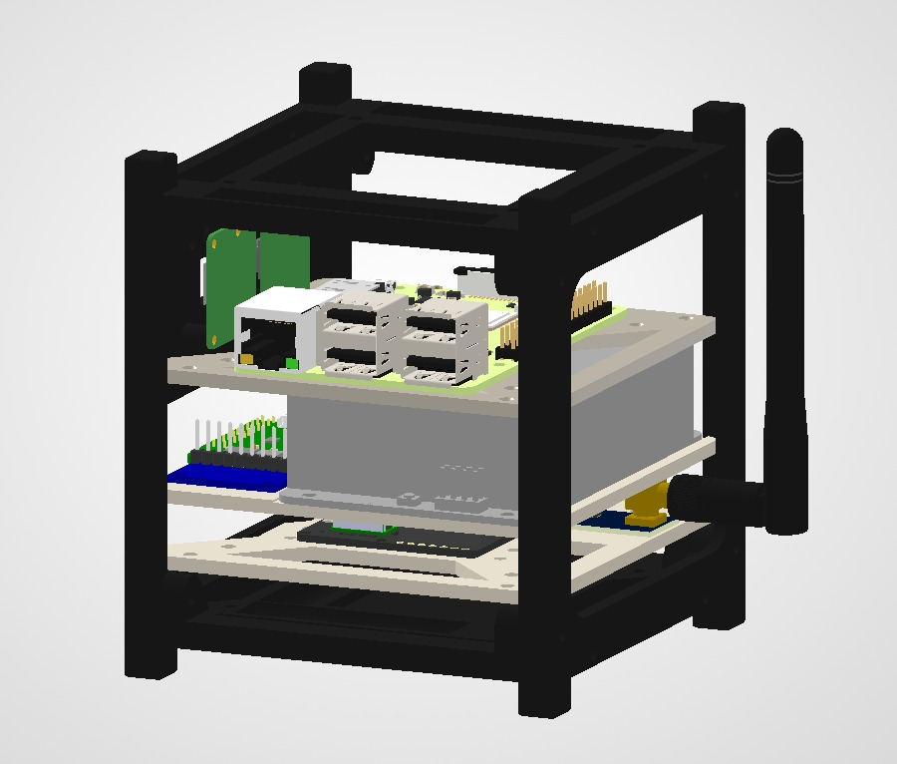
Assembled EnviroSat System All Three Boards Integrated

Board 1 (the core processing board) sits at the bottom of the stack with the Raspberry Pi 3B+ as its foundation. The Grove Base Hat is mounted directly on top of the Pi, and the Pimoroni Enviro+ sensor board is plugged onto the Grove Base Hat.
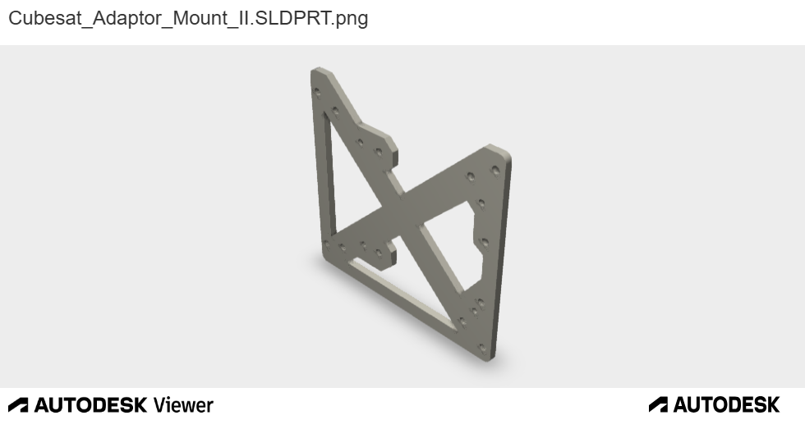

Board 2 (power and imaging) is positioned above or beside Board 1, with the UPS HAT and its 18650 battery compartment providing the energy backbone, the Arducam dual-camera adapter pointing outward, and the IMU sitting on one of the Grove I2C ports.
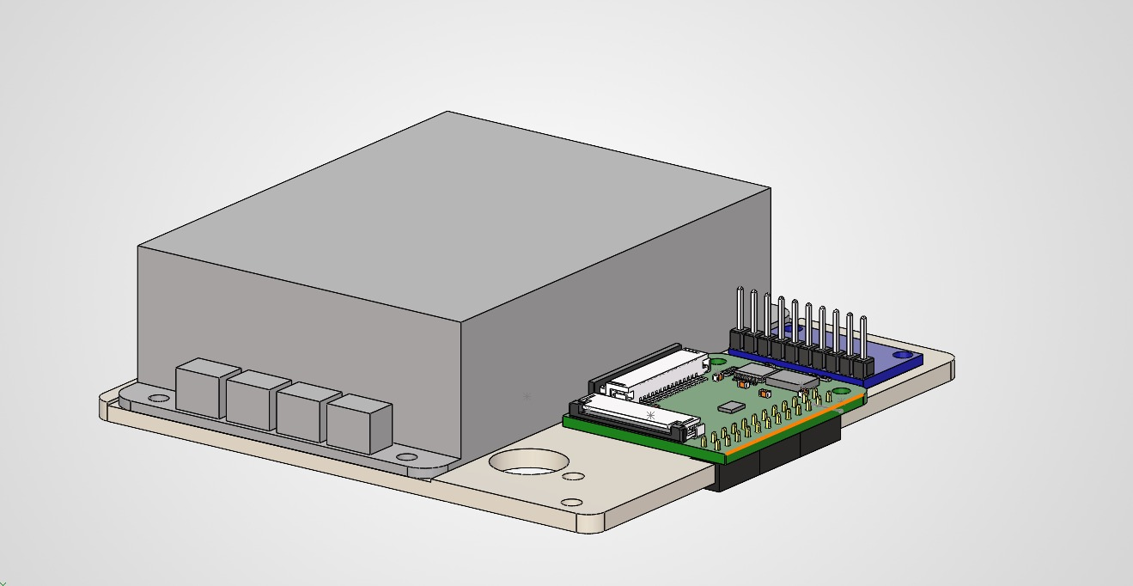

Board 3 (the communications stack) houses the wireless modules the WiFi HaLow connected via USB, the NRF24L01 on a Grove DuPont adapter, and the GPS module on the Grove UART port. The 915MHz SMA antenna extend from Board 3 from HaLow.
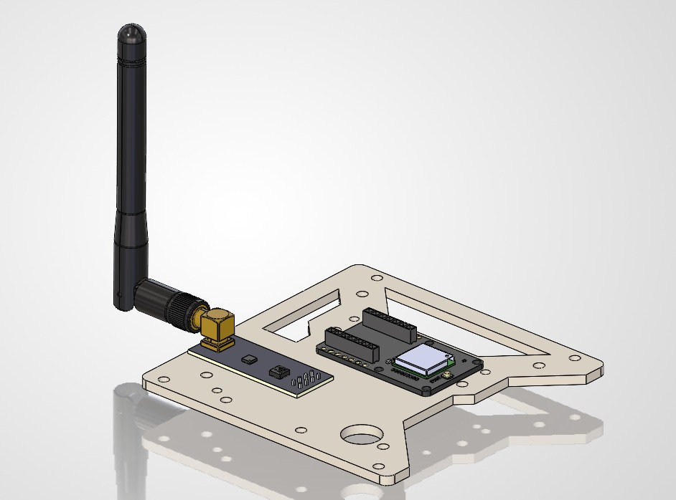

Three-Board Architecture
EnviroSat's three-board architecture is not arbitrary but reflects three natural groupings of function that also happen to make assembly, testing, and troubleshooting much easier. Each board can be built, tested, and verified independently before being joined to the others.

Board | Primary Role | Key Components
Board 1 Core Processing | The brain of the system. Runs all software, reads all sensors directly attached to it, and coordinates every other board. | Raspberry Pi 3B+ Grove Base Hat Pimoroni Enviro+
Board 2 Power & Imaging | Keeps the system alive on battery power and captures imagery and motion data. | Pi UPS HAT 18650 batteries Arducam UC-444 Dual cameras MPU-9250/6500 IMU
Board 3 Communications | Transmits and receives data wirelessly across three different radio technologies and acquires GPS position. | WiFi HaLow HT-HC01P, NRF24L01+ NEO-M8M GPS

WHY THREE BOARDS? | Separating the system into functional boards mirrors real satellite engineering practice. Real CubeSats are built from subsystem modules EPS (Electrical Power System), OBC (On-Board Computer), COMMS (Communications), ADCS (Attitude Determination and Control). EnviroSat uses the same conceptual separation, scaled down to student-friendly hardware. This means every skill you practise here maps directly to professional satellite engineering methodology.

Physical Connections Between Boards
All three boards connect to the Raspberry Pi either through its 40-pin GPIO header or through its USB ports. No component requires a direct connection between boards that bypasses the Pi the Pi is the hub that everything connects through.

ENVIROSAT CONNECTION ARCHITECTURE
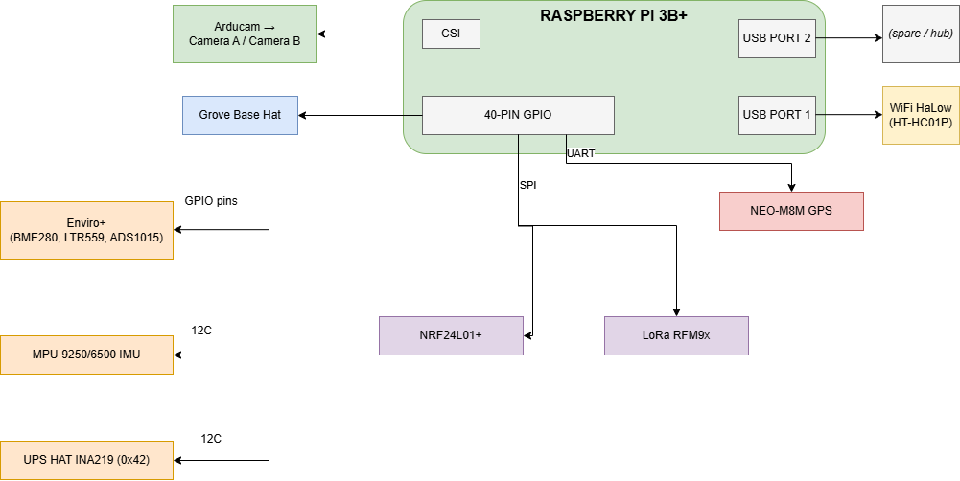

Every Grove cable is a standardised 4-wire connector: power (3.3V), ground, and two signal wires. The colour coding is always the same yellow is the primary signal, white is the secondary signal, red is power, black is ground. This consistency means you can connect any Grove module to any Grove port without worrying about which way round it goes.

Connection Type | What Uses It | Number of Pins Used | Speed
I2C (via Grove ports) | Enviro+, IMU, Arducam, UPS HAT, TB6612FNG | 2 signal (GPIO 2 + 3) | 400 kHz
SPI (via GPIO breakout) | Enviro+ LCD, NRF24L01+ | 4 shared + 1 CS each | Up to 10 MHz
UART (via Grove UART) | NEO-M8M GPS | 2 signal (GPIO 14 + 15) | 9600 baud
USB | WiFi HaLow HT-HC01P | Pi USB port (no GPIO) | USB 2.0 (480 Mbps)
CSI (camera ribbon) | Arducam UC-444 → cameras | Pi CSI port (22-pin FFC) | MIPI CSI-2
40-pin HAT (direct) | Grove Base Hat, UPS HAT (stacking header) | Up to 26 GPIO pins | Varies

Data Flow Through the System
Understanding how data moves through EnviroSat helps you understand why each component matters. A sensor reading goes through several steps before it is useful collection, processing, formatting, storage, and transmission. The diagram below traces the full journey of a single data cycle.

ENVIROSAT DATA FLOW DIAGRAM
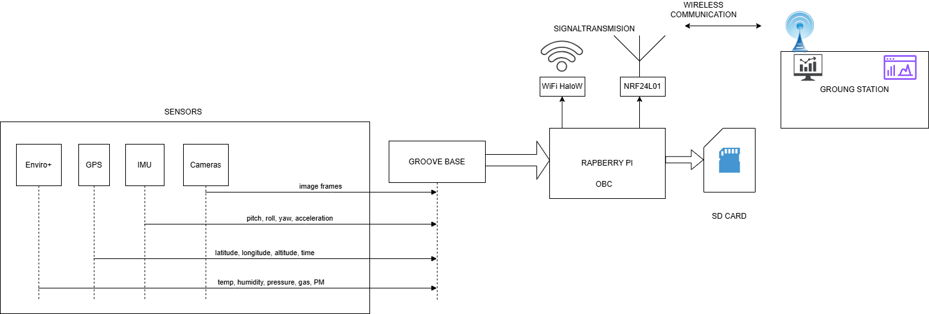

KEY INSIGHT | The microSD card acts as a black-box flight recorder. Even if all three wireless links fail simultaneously, every sensor reading is still being written to the local log file on the Pi's microSD card. This redundancy is standard practice in satellite design never depend on a single data path.

Power Flow Through the System
Power management is one of the most critical aspects of any satellite. EnviroSat uses a layered power system with two input sources, a boost converter, a battery backup, and a UPS HAT giving it multiple levels of protection against power failure.

ENVIROSAT POWER FLOW
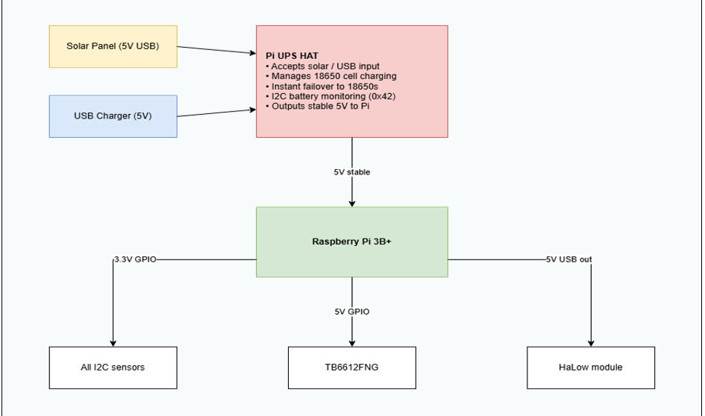

Power Stage | Voltage | Role | Failure Behaviour
Solar panel | 5V USB | Primary charging source outdoors | Stops charging no impact on system if 18650 cells have charge
USB charger | 5V USB | Primary charging source indoors / bench | Stops charging UPS HAT seamlessly switches to 18650 cells
Pi UPS HAT | 5V out | Accepts solar/USB input · Charges 18650 cells · Provides stable 5V output to Pi · Reports battery voltage and current via I2C at address 0x42 | If both input and cells fail: Pi loses power. The safe shutdown script detects falling voltage via I2C and executes a graceful shutdown before power is lost.
18650 cells (×2) | 3.7V | Battery reserve fully managed by UPS HAT circuitry | If depleted: UPS HAT signals low battery over I2C Pi executes safe shutdown
Raspberry Pi 3.3V rail | 3.3V | Regulatd 3.3V for all GPIO-connected sensors and radios | If Pi crashes: all sensors stop. A software watchdog process can trigger a reboot.

POWER TIP | The NRF24L01 can draw up to 300 mA in burst always power it through its dedicated adapter module, never from the Pi's 3.3V GPIO rail directly.  The TB6612FNG motor shield and magnetic coil draw approximately 200 mA per active coil channel at 5V. Use the Pi's 5V GPIO rail or a separate motor supply rail. Avoid sourcing coil current from the 3.3V rail coil current spikes can reset the Pi.

Wireless Systems Overview
EnviroSat carries two independent wireless communication systems. Each operates on a different frequency and serves a different purpose. They are designed to complement each other, if one fails or is out of range, the others can still carry data.

Radio System | Frequency | Range | Speed | Primary Use in EnviroSat | Sets required
WiFi HaLow (HT-HC01P) | 902–928 MHz | 1–2 km | Up to 32.5 Mbps | High-bandwidth data link images, large sensor logs, SSH remote access | 2
NRF24L01+ | 2.4 GHz | ~100 m | 2 Mbps | Short-range high-speed link bench testing, close-proximity commands | 2

In a typical session, NRF24L01 handles all bench work when the satellite and ground station are within a few metres of each other. WiFi HaLow handles full-data sessions when you need to transfer images, pull log files, or SSH into the satellite over distance. The two radios operate on different frequencies and do not interfere with each other.

ANTENNA NOTE | The HaLow module (HT-HC01P) requires a 915 MHz SMA antenna. Attach the antenna before powering the module operating the transmitter without a connected antenna can damage the RF circuitry. The NRF24L01 has a built-in PCB antenna and does not require any external antenna connection.

Complete GPIO Pin Usage Map
The Raspberry Pi has 40 physical pins on its GPIO header. Not all of them are general-purpose I/O - some are fixed power pins, some are dedicated to specific communication buses.
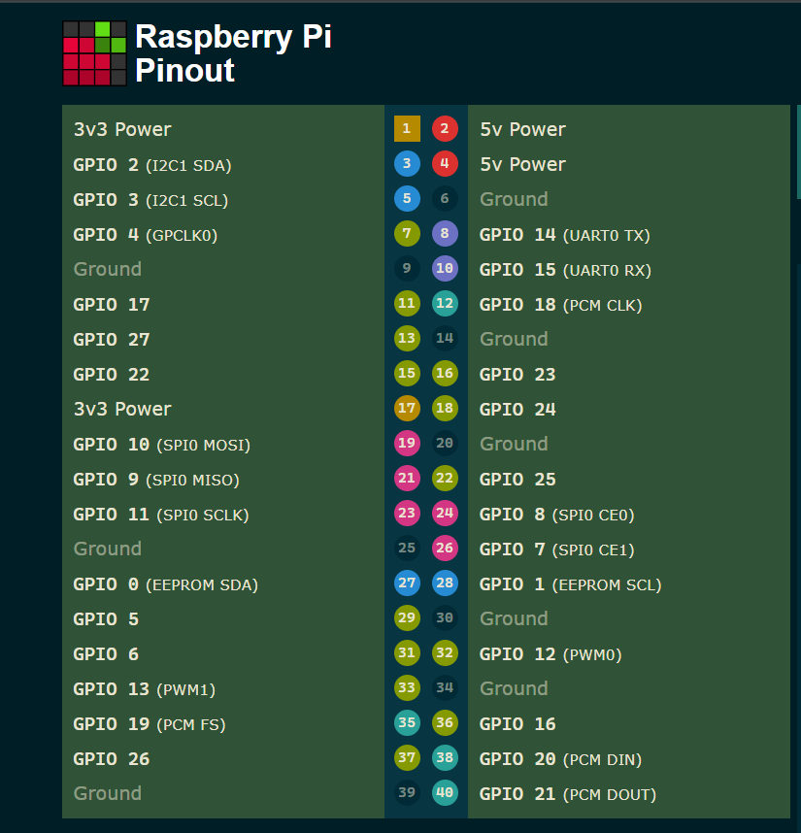
The table below maps every pin used by EnviroSat so you can see at a glance what connects where and where the known conflicts are. Conflicts are highlighted in orange and resolved immediately below.

GPIO (BCM) | Physical Pin | Used By | Function | Conflict?
3.3V (power) | Pin 1 | Grove Base Hat / all 3.3V sensors | 3.3V supply rail | No
5V (power) | Pin 2/4 | Pi UPS HAT output / TB6612FNG motor supply | 5V supply rail | No
GPIO 2 (SDA) | Pin 3 | All I2C devices (shared bus) | I2C data | No I2C is address-based
GPIO 3 (SCL) | Pin 5 | All I2C devices (shared bus) | I2C clock | No I2C is address-based
GPIO 4 (SEL) | Pin 7 | Arducam UC-444 | Camera A/B select signal | No
GPIO 8 (CE0) | Pin 24 | NRF24L01 CSN / Enviro+ LCD | SPI CS dual use | ⚠ Manage CS lines carefully in software
GPIO 9 (MISO) | Pin 21 | All SPI devices | SPI shared MISO | No CS lines separate devices
GPIO 10 (MOSI) | Pin 19 | All SPI devices | SPI shared MOSI | No CS lines separate devices
GPIO 11 (SCK) | Pin 23 | All SPI devices / Arducam OE | SPI clock / Output Enable | ⚠ Verify OE timing does not clash with SPI activity
GPIO 12 (PWM0) | Pin 32 | TB6612FNG ENA | PWM Motor A speed control | No
GPIO 13 (PWM1) | Pin 33 | TB6612FNG ENB | PWM Motor B speed control | No
GPIO 14 (TXD) | Pin 8 | NEO-M8M GPS | UART TX Pi → GPS | No serial console must be disabled in raspi-config
GPIO 15 (RXD) | Pin 10 | NEO-M8M GPS | UART RX GPS → Pi | No serial console must be disabled
GPIO 17 | Pin 11 | TB6612FNG Motor IN1 AND UPS HAT power-fail signal | Motor A direction 1 / Power-fail monitoring input | ⚠ CONFLICT resolved below
GPIO 18 | Pin 12 | TB6612FNG Motor IN2 | Motor A direction 2 | No
GPIO 22 | Pin 15 | TB6612FNG Motor IN4 | Motor B direction 2 | No freed when LoRa was removed from design
GPIO 23 | Pin 16 | MPU-9250/6500 IMU | IMU interrupt pin | No
GPIO 24 | Pin 18 | TB6612FNG Motor IN1 (reassigned here) | Motor A direction 1 post-conflict resolution pin | No
GPIO 25 | Pin 22 | NRF24L01 IRQ (optional) | NRF24L01 data-ready interrupt | No
GPIO 27 | Pin 13 | TB6612FNG Motor IN3 AND UPS HAT online status | Motor B direction 1 / UPS online status input | ⚠ CONFLICT resolved below
GPIO 26 | Pin 37 | TB6612FNG Motor IN3 (reassigned here) | Motor B direction 1 post-conflict resolution pin | No
GND | Pin 6 | All components | Common ground | No all components share ground

GPIO Conflicts Resolution Guide
Two conflicts exist in the default component pin assignments. Both involve TB6612FNG motor direction pins sharing a GPIO with a UPS HAT monitoring signal. The fix is the same in both cases: move the motor pin to an unused GPIO and update one line in the motor control Python script.

Conflict | Pin | Components Clashing | Recommended Resolution
Conflict 1 | GPIO 17 (Pin 11) | TB6612FNG Motor IN1 AND UPS HAT power-fail signal | Move Motor IN1 to GPIO 24 (Pin 18) it is otherwise unused. Update the motor control script to reference GPIO 24 for IN1. GPIO 17 stays dedicated to UPS HAT power-fail monitoring via I2C polling in safe_shutdown.py.
Conflict 2 | GPIO 27 (Pin 13) | TB6612FNG Motor IN3 AND UPS HAT online status signal | Move Motor IN3 to GPIO 26 (Pin 37) it is otherwise unused. Update the motor control script. GPIO 27 stays with UPS HAT online status monitoring. Both signals are INPUT-only so sharing is technically possible, but physical reassignment to GPIO 26 is cleaner and avoids ambiguity.

IMPORTANT | The conflicts above do not stop the system from working they are simply cases where two components share the same default pin. Resolving them is a one-time task done before wiring Board 3. The fix is always the same pattern: move one component to an unused pin and update one line in the relevant Python script. Both resolutions are reflected in the GPIO table above.

I2C Address Map
The I2C bus is shared between all three Grove I2C ports on the Grove Base Hat. Every device on this bus must have a unique address. The table below lists every I2C device in EnviroSat and its address confirm all addresses are unique before powering up.

I2C Address | Device | Board | Notes
0x04 | Grove Base Hat MCU (STM32) | B1 | Hat's own microcontroller handles the 12-bit ADC for all analog Grove ports
0x0C | AK8963 Magnetometer | B2 | Internal to MPU-9250 only not present on the MPU-6500 variant
0x14 | TB6612FNG Grove Motor Driver | B3 | I2C address used by the Grove I2C variant of the TB6612FNG driver
0x23 | LTR-559 Light / Proximity | B1 | On Enviro+ HAT
0x36 | UPS HAT | B2 | Some UPS HAT boards use 0x36 instead of 0x42 check your specific module documentation
0x42 | UPS HAT INA219 (Waveshare) | B2 | Battery voltage and current monitoring Waveshare default address
0x49 | ADS1015 ADC | B1 | On Enviro+ HAT reads the three MICS6814 gas sensor channels
0x68 | MPU-9250 / 6500 IMU | B2 | AD0 pin LOW (default address). Pull AD0 HIGH to use alternate address 0x69 if needed
0x70 | Arducam UC-444 Multiplexer | B2 | I2C camera switch controller selects Camera A or Camera B for CSI output
0x76 | BME280 Temperature / Humidity / Pressure | B1 | On Enviro+ HAT

NO CONFLICTS | All ten I2C addresses are unique. There are no address conflicts in the default EnviroSat configuration. The only address variant to be aware of is the UPS HAT Waveshare boards use 0x42, others may use 0x36. Check your specific UPS HAT documentation and update the address constant in the power monitoring script accordingly.

One Complete Data Cycle
To make the system architecture concrete, here is a walkthrough of exactly what happens during a single 60-second data collection and transmission cycle from the moment the sensors are read to the moment the data appears on the ground station screen.

Step | What Happens | Component Involved | Time
1 | Python scheduler triggers a sensor read cycle | Raspberry Pi (software) | t = 0s
2 | BME280 returns temperature, humidity, and pressure over I2C | Enviro+ HAT → GPIO 2/3 | ~5 ms
3 | LTR-559 returns light level and proximity reading over I2C | Enviro+ HAT → GPIO 2/3 | ~5 ms
4 | ADS1015 returns gas sensor voltages (CO, NO₂, NH₃) over I2C | Enviro+ ADS1015 → GPIO 2/3 | ~10 ms
5 | MPU-9250 returns accelerometer, gyroscope, and magnetometer data over I2C | IMU → GPIO 2/3 | ~5 ms
6 | GPS serial port is read NMEA sentence parsed for lat / lon / altitude / time | NEO-M8M → GPIO 14/15 | ~100 ms
7 | All readings assembled into a single timestamped JSON data packet | Raspberry Pi (software) | ~1 ms
8 | Packet written to log file on microSD card | Raspberry Pi (file system) | ~10 ms
9 | If WiFi HaLow link is active: full JSON packet sent to ground station over IP (UDP/MQTT) | HT-HC01P → USB | ~50 ms
10 | If HaLow is not yet available: packet is queued in memory and sent when the link re-establishes | Raspberry Pi (software) | —
11 | Ground station Python script receives packet, parses JSON, and updates live dashboard display | Ground station software | ~10 ms
12 | Pi sleeps until the next 60-second cycle begins | Raspberry Pi (software) | ~59 s

System Limitations and Known Constraints

Limitation | Detail | Workaround or Mitigation
Not space-rated | No radiation hardening, thermal vacuum testing, or vibration qualification. Ground demonstration only. | Not applicable by design. For an actual launch, every component would be replaced with space-qualified equivalents.
One camera at a time | The Arducam UC-444 physically switches between Camera A and Camera B. True simultaneous dual-camera capture is not possible. | Use alternating capture mode. For most use cases, designate one camera as primary and switch only when the alternate view is specifically needed.
GPS cold start delay | First satellite fix after power-on takes 30–90 seconds outdoors. No fix is possible indoors without a clear sky view. | Always power up near a window or outdoors for initial testing. After the first fix, warm start times are much shorter.
HaLow association time | WiFi HaLow takes 1–3 minutes to associate after boot significantly slower than standard WiFi. | Build a wait/retry loop into the startup script. Do not assume HaLow is ready immediately after the Pi boots.
SPI bus sharing | NRF24L01 and the Enviro+ LCD share the SPI bus. Only one device can be active at a time. | Use separate CS lines. Keep all inactive CS lines pulled HIGH before activating any single SPI device.
No real-time OS | Raspberry Pi OS is not a real-time operating system. Timing-sensitive operations may have millisecond-scale jitter. | For IMU attitude applications, run the IMU read loop in a dedicated Python thread using time.sleep() with drift correction.
microSD wear | Continuous high-frequency writes shorten microSD card lifespan. | Buffer readings in memory and write in batches. Use a high-endurance card SanDisk Max Endurance or equivalent.
UPS HAT output current | The UPS HAT output is rated for the Raspberry Pi's normal load. Avoid peaking all components simultaneously. | Stagger high-current events in your scheduler keep coil activation separate from large radio transmission windows.

System Validation Checklist
Item | What to Verify
All components sourced | Every item has been received and inspected including TB6612FNG motor shields, soft iron rod, and AWG 32 wire for the magnetic coil
microSD flashed | Raspberry Pi OS (64-bit) flashed using Raspberry Pi Imager with WiFi credentials, SSH enabled, username: envirosat, password: Envirosat+
Pi boots successfully | Pi powers on, connects to WiFi, and is accessible via SSH
I2C and SPI enabled | raspi-config used to enable I2C and SPI. UART enabled with serial console disabled (required for GPS on GPIO 14/15).
GPIO conflict plan noted | Resolved pins chosen Motor IN1 → GPIO 24, Motor IN3 → GPIO 26.
Laptop tools installed | Raspberry Pi Imager, a code editor (VS Code recommended), and an SSH client installed on your laptop
Grove cables laid out | Sufficient Grove cables available. Some Board 3 connections may need 30 cm or 50 cm cables check routing before ordering.
Antistatic precautions understood | Workspace prepared on a non-conductive surface.

Main Components Assembly

This section walks you through the assembly of the two most foundational components of
Board 1: the Grove Base Hat and the Pimoroni Enviro+ HAT.
These two boards are the reason the rest of the build is beginner-friendly together, they turn the Raspberry Pi's complex GPIO header into a simple, plug-and-play sensor platform. Understanding them thoroughly before moving on will make every subsequent section easier.

HOW THIS SECTION WORKS | Each component is introduced with: what it is and why it matters → what needs to be done before plugging it in → how to connect it → what data to expect from it → how it fits into the broader system → maintenance needed → any conflicts to watch for. Work through each component fully before moving to the next.

Grove Base Hat for Raspberry Pi

Grove Base Hat for Raspberry Pi  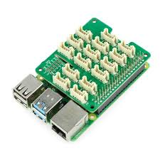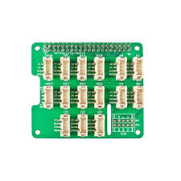  Seeed Studio 40-pin GPIO expansion with Grove port system | Board 1

What It Is and Why It Matters
The Grove Base Hat is an add-on board that plugs directly onto the Raspberry Pi's 40-pin GPIO header. Its job is to make connecting sensors and modules much simpler by converting the Pi's raw electrical pins into standardised Grove ports small, colour-coded 4-pin sockets that accept Grove cables with a single click.
Without the Grove Base Hat, connecting each sensor to the Pi requires identifying individual pin numbers, selecting the right voltage levels, and wiring each connection manually a process prone to mistakes and easily damaged components. With the Grove Base Hat, you simply identify which type of port a sensor needs (I2C, UART, digital, analog, or PWM) and plug in the cable. The hat handles all the electrical routing.

Grove Port Type | Count on Hat | What Connects Here | GPIO Pins Used
I2C | 3 ports | All I2C sensors: Enviro+ internals, IMU, GPS, Arducam, UPS HAT | GPIO 2 (SDA), GPIO 3 (SCL) all three ports share the same bus
UART | 1 port | NEO-M8M GPS module | GPIO 14 (TX), GPIO 15 (RX)
PWM | 1 port | Motor driver enable pins (ENA/ENB) | GPIO 12 (PWM0), GPIO 13 (PWM1)
Digital | 6 ports | Motor direction pins, miscellaneous GPIO control | D5, D16, D18, D22, D24, D26
Analog | 4 ports | Any analog Grove sensor (via built-in 12-bit ADC) | Internal STM32 MCU → I2C to Pi
SWD | 1 port | Firmware update for the Hat's MCU not used in normal operation | Internal only

Built-In ADC
The Raspberry Pi has no built-in analog-to-digital converter it cannot read analog voltages directly. The Grove Base Hat solves this with an onboard STM32 microcontroller that provides a 12-bit, 8-channel ADC. Any analog Grove sensor plugged into the four analog ports is read by this ADC and the result is passed to the Pi over I2C. This means the Pi can effectively read analog sensors without any additional hardware.

Before You Plug It In
IMPORTANT | The Grove Base Hat operates at 3.3V. Never connect a 5V Grove module to any Grove port on this hat it will damage both the hat and the Raspberry Pi. Check the voltage specification of every Grove module before connecting it. All modules used in EnviroSat are 3.3V compatible.

Preparation Step | What to Do | Why
Check Pi GPIO header | Inspect all 40 pins for bends or damage before attaching the hat | A bent pin can short two pins together and damage the Pi when the hat is pressed down
Enable I2C | Boot Pi, open Terminal, run: sudo raspi-config → Interface Options → I2C → Enable | I2C must be enabled in software before any I2C Grove module will respond
Enable SPI | In raspi-config → Interface Options → SPI → Enable | SPI is needed for LoRa and the Enviro+ LCD
Disable serial console | raspi-config → Interface Options → Serial Port → Shell: NO → Hardware: YES | The Pi uses GPIO 14/15 for a debug console by default this must be freed for GPS
Power off Pi | Run sudo shutdown -h now and wait for the green LED to stop blinking before proceeding | Never attach or remove HATs while the Pi is powered always power off first

Assembly Steps
STEP  1 | Position the Hat  Hold the Grove Base Hat above the Raspberry Pi, aligning the 40-pin female header on the underside of the hat with the 40-pin male header on the Pi.  The USB ports and ethernet port of the Pi should face the same direction as the Grove port labels on the Hat.  Do not press down yet just hold it in position and visually confirm all pins are aligned.

STEP  2 | Press Down Evenly  Using both thumbs, press down gently but firmly on the corners of the Hat not the centre.  Apply even pressure so the Hat slides down squarely. You should feel and hear a small click as each pin row seats.  Check that the gap between the Hat and the Pi is uniform all the way around no one side should sit higher than the other.  Do not rock the Hat if it is not going on straight, lift it fully off and start again.

STEP  3 | Verify Seating  Visually inspect all four sides of the 40-pin header connection.  No pins should be visibly bent outward or protruding at an angle.  The Hat should sit flat and parallel to the Pi board with a gap of approximately 8mm.

STEP  4 | Secure with Standoffs  Attach M2.5 standoffs through the mounting holes on the corners of the Grove Base Hat, threading down into the Pi's mounting holes.  Finger-tight is sufficient do not overtighten or you may crack the PCB.  Standoffs prevent the hat from flexing and protect the GPIO connection from mechanical stress.

STEP  5 | Power On and Verify  Power on the Pi and SSH in from your laptop.  Run: sudo i2cdetect -y 1  You should see address 0x04 appear in the grid this is the Grove Base Hat's own STM32 microcontroller confirming the hat is seated correctly and I2C is working.  If 0x04 does not appear: power off, reseat the hat, and try again.

Expected Data from the Grove Base Hat
The Grove Base Hat itself does not produce sensor data it is a routing board. The verification output is simply confirmation that its MCU is visible on the I2C bus at address 0x04. Any Grove sensor you subsequently connect will then appear at its own I2C address in the i2cdetect grid.

How It Adds Up to the Whole System
Every sensor, every radio module, and every actuator in EnviroSat reaches the Raspberry Pi through the Grove Base Hat. The three I2C ports connect the environmental sensors, IMU, camera adapter, and UPS HAT. The UART port connects the GPS. The PWM port connects the motor driver speed control. The digital ports connect the motor driver direction pins. Without the Grove Base Hat, each of these connections would require individual jumper wires to specific Pi GPIO pins a fragile, error-prone arrangement. With it, each connection is a single, click-in cable that is physically impossible to connect backwards.

Maintenance
- Inspect the 40-pin header connection every time the system is opened pins can work loose over time if the system is moved frequently
- Keep Grove port sockets free of dust a soft brush or compressed air can clean them gently
- Do not bend Grove cables at sharp angles close to the socket this stresses the connector
- If a Grove device stops being detected, reseat its cable at both ends before suspecting a hardware fault

Conflict Handling
GROVE I2C BUS CONFLICT | All three Grove I2C ports share the same two GPIO pins (GPIO 2 and GPIO 3). This means all I2C devices are on the same bus simultaneously. I2C is designed for this each device has a unique address and the Pi talks to them individually using those addresses. No special handling is needed as long as every device has a different I2C address.  The only risk is if two devices share the same I2C address. The EnviroSat I2C address map in Section 3.8 confirms there are no conflicts in the default configuration.

Pimoroni Enviro+ HAT

Pimoroni Enviro+ HAT  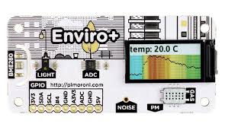  All-in-one environmental sensor array with LCD display | Board 1 Core

What It Is and Why It Matters
The Enviro+ is a single board that provides six different environmental sensors plus a colour LCD display, all in one package that plugs directly onto the Pi's 40-pin header on top of the Grove Base Hat. Instead of buying, wiring, and individually configuring six separate sensor boards, you get all of them in a single unit with a single library.

Sensor | I2C / Bus | What It Measures | Typical Output
BME280 | I2C 0x76 | Temperature, barometric pressure, relative humidity | 23.4°C / 1013 hPa / 45% RH
LTR-559 | I2C 0x23 | Ambient light level and proximity | 1497 Lux / proximity 0–255
MICS6814 | via ADS1015 | Carbon monoxide (reducing), nitrogen dioxide (oxidising), ammonia (NH3) | Resistance values in Ohms baseline relative
ADS1015 | I2C 0x49 | Analog-to-digital converter for MICS6814 | 12-bit readings for 3 gas channels
PMS5003 | UART | Particulate matter: PM1.0, PM2.5, PM10 | µg/m³ and particle count per 0.1L
MEMS Mic | I2S | Ambient noise level | Amplitude values relative noise measurement
0.96" LCD | SPI | 160×80 colour IPS display output only | Displays any image or text rendered via Pillow library

NOTE ON STACKING | The Enviro+ plugs onto the same 40-pin GPIO header as the Grove Base Hat. This works because the Grove Base Hat uses a stacking header a tall header that passes all 40 pins upward for the next board to use. The Enviro+ then plugs onto the top of that stacking header.  The order from bottom to top is: Raspberry Pi → Grove Base Hat → Enviro+.

Preparation Step | What to Do | Why
Install Python library | Run the install script see Step 1 below | The Enviro+ requires several Python libraries that are not pre-installed on Pi OS
Enable I2C and SPI | Already done for Grove Base Hat confirm both are enabled in raspi-config | Enviro+ uses both I2C (sensors) and SPI (LCD)
Enable I2S | Add dtoverlay=googlevoicehat-soundcard to /boot/config.txt only if using mic | The MEMS microphone uses the I2S audio interface
PMS5003 precaution | If using the particulate sensor, connect it BEFORE powering the Pi | Hot-plugging the PMS5003 cable while Pi is on causes an immediate reboot
LCD protective film | Peel the green-tabbed protective film off the LCD screen after assembly | The film looks like the screen is blank easy to mistake for a fault if left on
Power off Pi | Always power off before attaching the Enviro+ | Same rule as Grove Base Hat never hot-plug a HAT

Assembly Steps
STEP  1 | Install the Enviro+ Python Library  With the Pi running (before attaching the Enviro+ board), SSH in and run:  git clone https://github.com/pimoroni/enviroplus-python  cd enviroplus-python  ./install.sh  When prompted about virtual environment setup, select Yes.  When installation completes, run: sudo reboot  The install script automatically enables I2C, SPI, and disables the serial console.

STEP  2 | Power Off the Pi  Run: sudo shutdown -h now  Wait for the green activity LED on the Pi to stop blinking completely before proceeding.  Disconnect the Pi's power supply.

STEP  3 | Attach the Enviro+ to the Stacking Header  The Enviro+ has a female 40-pin header on its underside.  Align it carefully over the tall stacking header pins protruding from the top of the Grove Base Hat.  Press down evenly with both thumbs same technique as attaching the Grove Base Hat.  The Enviro+ should sit flat and parallel, with no pins visibly misaligned.

STEP  4 | Connect PMS5003 Particulate Sensor (if using)  Find the small JST-style connector port on the underside of the Enviro+ board, labelled PM.  Connect the PMS5003 cable it only fits one way. Do not force it.  Route the sensor cable so the PMS5003 faces outward from the board stack.  This must be done BEFORE powering the Pi on.

STEP  5 | Power On and Run First Test  Reconnect power and SSH into the Pi.  Activate the virtual environment: source ~/.virtualenvs/pimoroni/bin/activate  Navigate to examples: cd enviroplus-python/examples  Run the weather test: python weather.py  You should see temperature, pressure, and humidity readings scrolling in the terminal.  If readings appear, the Enviro+ is working correctly.

STEP  6 | Verify All Sensors on I2C Bus  Run: sudo i2cdetect -y 1  You should see all of the following addresses in the grid:  0x04 Grove Base Hat MCU  0x23 LTR-559 light/proximity sensor  0x49 ADS1015 ADC (for gas sensor)  0x76 BME280 temperature/pressure/humidity  If any address is missing, check the Enviro+ is fully seated on the stacking header.  The LCD (SPI) and microphone (I2S) will not appear in i2cdetect they use different buses.

Expected Data from Each Sensor
Sensor | Expected Output | What Normal Looks Like
BME280 | Temperature, Pressure, Humidity printed every second | ~20–30°C indoors. Note: reads 3–8°C high due to Pi CPU heat, this is normal
LTR-559 | Lux value and proximity integer | Indoors: 100–500 Lux. Cover sensor: drops to near 0.  Hand nearby: proximity rises
MICS6814 | Reducing, Oxidising, NH3 resistance values in Ohms | Takes 10+ minutes to stabilise.  Values drift down initially then level off normal
PMS5003 | PM1.0, PM2.5, PM10 in µg/m³ plus particle counts | Clean indoor air: PM2.5 under 10 µg/m³. Near a road or smoke: rises significantly
LCD | Coloured rectangle displayed on the tiny screen | If nothing shows: peel the protective film it looks exactly like a blank screen
All-in-one | All sensor data cycling on the LCD with tap-to-switch | Tap the LTR-559 proximity sensor to cycle through different sensor views on screen

Temperature Correction
The BME280 sensor sits close to the Pi's CPU, which generates significant heat. This means raw temperature readings are typically 3–8°C higher than actual air temperature. The Enviro+ library includes a compensated temperature example that corrects for this:

How the Enviro+ Adds Up to the Whole System
The Enviro+ is EnviroSat's primary scientific instrument. Every data packet transmitted to the ground station begins with a timestamp and a set of Enviro+ readings. The temperature, humidity, and pressure data provides the environmental context for all other measurements. The gas sensor detects air quality changes. The particulate sensor is the most mission-critical sensor for outdoor deployment, providing real-world air pollution data. The LCD serves as a local display so the system's status can be read at a glance without needing a connected laptop.

Maintenance
- The BME280 sensor is calibrated at the factory no periodic recalibration is needed
- The MICS6814 gas sensor has a warm-up period of 10 minutes each time power is applied factor this into your data logging scripts by discarding the first 10 minutes of gas readings after boot
- The PMS5003 has an internal fan if it becomes very dusty, it can be gently cleaned by blowing compressed air through the inlet
- The LCD does not require maintenance but will burn-in if the same image is displayed for very long periods cycle the display content or blank it when not in use
- The protective film on the LCD should be left on during assembly and storage only peel it when you are ready for final deployment

Conflict Handling
Potential Conflict | Description | Resolution
UART PMS5003 vs GPS | The PMS5003 particulate sensor also uses UART internally (connected to the Enviro+ board directly, not the Grove UART port). It uses a separate internal UART channel it does NOT conflict with the GPS on GPIO 14/15. | No action required these are different UART interfaces. The PMS5003 uses the Pi's secondary UART, not the primary one used by the GPS Grove port.
I2S microphone vs PWM audio | The MEMS microphone uses I2S. The Pi's hardware PWM also overlaps with the I2S clock on some models. | The MEMS mic is optional. If you are not using it, do not enable the I2S dtoverlay. This avoids any potential conflict with PWM-based motor control.
Temperature reading high | CPU heat inflates BME280 temperature readings by 3–8°C. | Apply the factor = 2.25 compensated-temperature correction described above. Calibrate against a reference thermometer.

How Grove and Enviro+ Simplify the Entire Build
It is worth pausing here to appreciate what these two boards have achieved for the rest of the build. Before you have connected a single additional component, you already have:

Capability Already Available | How It Was Achieved
Temperature, pressure, humidity measurement | BME280 on Enviro+ no wiring, no calibration, no extra hardware
Light level and proximity sensing | LTR-559 on Enviro+ same
Air quality / gas sensing | MICS6814 + ADS1015 on Enviro+ same
Particulate matter measurement (PM2.5, PM10) | PMS5003 on Enviro+ single cable connector
Local colour display | 0.96" LCD on Enviro+ driven by the same library
3 × I2C expansion ports | Grove Base Hat plug any I2C sensor with a single cable
1 × UART expansion port | Grove Base Hat GPS connects here with a single cable
1 × PWM expansion port | Grove Base Hat motor speed control connects here
12-bit analog input (4 channels) | Grove Base Hat built-in ADC no extra hardware needed
Stable 3.3V for all connected modules | Grove Base Hat all ports are voltage-regulated at 3.3V

Board 1 Verification
Before moving on to Board 2 assembly, confirm every item in this checklist. Each item can be checked with a simple command or a visual inspection.

Check | How to Verify | Result
Grove Base Hat seated | Visual inspection and: sudo i2cdetect -y 1 | Address 0x04 visible in the grid
I2C enabled | sudo raspi-config → Interface Options → I2C | Shows as Enabled
SPI enabled | sudo raspi-config → Interface Options → SPI | Shows as Enabled
Serial console disabled | sudo raspi-config → Interface Options → Serial Port | Shell = No, Hardware = Yes
Enviro+ library installed | source ~/.virtualenvs/pimoroni/bin/activate && python -c 'import bme280' | No import error
BME280 detected on I2C | sudo i2cdetect -y 1 | Address 0x76 visible
LTR-559 detected on I2C | sudo i2cdetect -y 1 | Address 0x23 visible
ADS1015 detected on I2C | sudo i2cdetect -y 1 | Address 0x49 visible
Temperature reading returns | cd enviroplus-python/examples && python weather.py | Temperature, pressure, humidity values print
LCD lights up | python lcd.py | Coloured box appears on the small screen
Temperature correction applied | python compensated-temperature.py | Calibrated temperature approximately matches room temperature

ALL GREEN? | If every item above shows the expected result, Board 1 is complete and fully verified. The core processing platform is working. You are ready to move on to Board 2 power management and imaging. If any item is not passing, revisit the relevant step in 4.1 or 4.2 before continuing.

NRF24L01+ Transceiver (2.4 GHz)

NRF24L01+ with Adapter Module  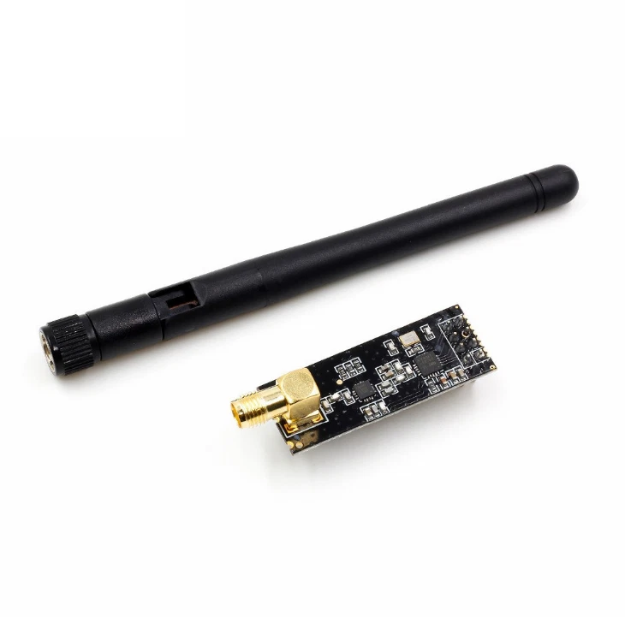  Short-range 2.4 GHz transceiver for bench testing and close-range links | Board 3 Comms

What It Is
The NRF24L01+ is a small, inexpensive 2.4 GHz radio transceiver made by Nordic Semiconductor. At under five dollars it is one of the most widely used radio modules in student electronics projects worldwide fast, reliable at short range, and straightforward to program in Python.
Where LoRa sacrifices speed for range, the NRF24L01 works in the opposite direction: it transfers data at up to two megabits per second hundreds of times faster than LoRa but its effective range is around one hundred metres outdoors and drops significantly indoors.
In EnviroSat the NRF24L01 serves a specific role: close-range communication during development and bench testing. When you are sitting at a desk with the satellite and a laptop one metre apart, there is no need to fire up the LoRa radio for every test. The NRF24L01 handles short-range sessions efficiently, preserving battery life during the build and testing phase.

CRITICAL USE THE ADAPTER MODULE | The NRF24L01 must be powered through its dedicated adapter module not directly from the Pi's 3.3V GPIO pin. The Pi's GPIO rail is not filtered tightly enough for reliable NRF24L01 operation. Without the adapter's onboard voltage regulator and filter capacitors, the radio drops packets constantly and behaves erratically. This is the most common cause of NRF24L01 failure in student builds. The adapter costs about two dollars always include it.

Connections
NRF24L01 Pin | Connects To | Function
VCC | Adapter 3.3V (via adapter only) | Power never connect directly to Pi GPIO 3.3V
GND | Pi Pin 6 | Ground
CE | GPIO 17 Pin 11 | Chip Enable switches between transmit and receive mode
CSN | GPIO 8 Pin 24 | Chip Select activates this device on SPI bus
SCK | GPIO 11 Pin 23 | SPI clock
MOSI | GPIO 10 Pin 19 | SPI data in
MISO | GPIO 9 Pin 21 | SPI data out
IRQ | GPIO 25 Pin 22 | Optional interrupt alerts Pi when data arrives

WiFi HaLow Heltec HT-HC01P (915 MHz)

HT-HC01P WiFi HaLow  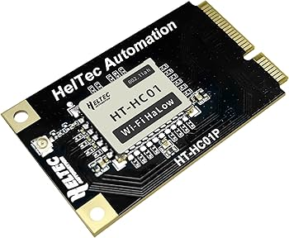  Long-range IEEE 802.11ah WiFi at sub-1 GHz full IP networking over distance | Board 3 Comms

What It Is
WiFi HaLow is a version of WiFi that operates at 915 MHz instead of the usual 2.4 or 5 GHz. The lower frequency travels much further (up to one to two kilometres) and penetrates walls far better than standard WiFi. It is slower than regular WiFi but fast enough to transfer images and large sensor datasets comfortably.
What makes HaLow fundamentally different from LoRa is that it runs standard IP networking. The satellite appears as a device on a network (just like a phone or laptop). You can SSH into it from the ground station, copy files, run a web server on it, or stream camera images.
LoRa cannot do any of this since it only handles small packets.
HaLow gives you a full wireless network connection at distances normally associated with LoRa.
The HT-HC01P connects to the Raspberry Pi entirely over USB it uses zero GPIO pins and appears as a standard USB network adapter. Once the driver is installed it behaves exactly like a wireless network card.

TWO MODULES REQUIRED | WiFi HaLow needs two modules one as an Access Point (ground station) and one as a Station (satellite). A single module cannot do anything useful alone. Order two complete sets: 2x HT-HC01P modules and 2x debug boards. Both must have the driver installed.

NRF24L01 vs WiFi HaLow

Situation | Radio | Reason
Bench testing satellite 1 metre from ground station | NRF24L01 | Fast, low power, no need for long range during development
Need to SSH into satellite or pull down camera images | WiFi HaLow | Only HaLow provides full IP networking at this range
Battery low minimise radio power draw | NRF24L01 | HaLow draws the most current disable first when conserving power
Updating Python code on satellite remotely | WiFi HaLow | SSH and SCP over HaLow is exactly like accessing any networked Pi

TB6612FNG Motor Shield
TB6612FNG Motor Shield  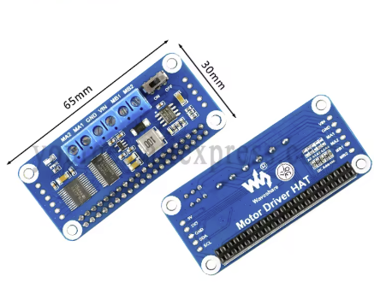 | Board 3

The motor shield is a Board 3 Bottom component and fits logically after the communication hardware.

What It Is and Why It Matters
The TB6612FNG is a dual H-bridge motor driver. An H-bridge is a circuit that allows a microcontroller to drive a motor in both directions (forward and backward) and at variable speed using PWM. The TB6612FNG can control two motors simultaneously, making it ideal for a two-wheel drive platform.
Unlike the older L293D motor driver, the TB6612FNG uses MOSFETs rather than bipolar transistors, which means significantly lower power dissipation, higher efficiency, and much lower voltage drop between the supply and the motor. This matters for a battery-powered system every milliamp saved extends mission time.
In EnviroSat, the TB6612FNG drives the magnetic coil actuator windings. Two units are included in the build for redundancy and to allow independent control of multiple actuator channels.

Key Specifications
Parameter | Value
Motor driver type | Dual H-bridge (MOSFET-based)
Operating voltage (VM) | 2.5V to 13.5V (motor supply)
Logic voltage (VCC) | 2.7V to 5.5V (Pi's 3.3V compatible)
Continuous output current | 1.2A per channel
Peak output current | 3.2A per channel (for brief start-up)
Standby current | ~0 µA in standby mode
PWM frequency | Up to 100 kHz
Interface | I2C (Grove variant) or direct GPIO (GPIO 12, 13 for PWM; reassigned GPIO 24, 25, 26 for direction)
Protection | Built-in thermal shutdown and overcurrent protection
Footprint | SOP-24 / Grove breakout module

GPIO Pin Assignments
The TB6612FNG direction pins use the GPIO assignments
Signal | GPIO (BCM) | Physical Pin | Notes
Motor A PWM (ENA) | GPIO 12 | Pin 32 | Hardware PWM speed control for Motor A
Motor B PWM (ENB) | GPIO 13 | Pin 33 | Hardware PWM speed control for Motor B
Motor IN1 | GPIO 24 | Pin 18 | Reassigned from GPIO 17 (conflict with UPS HAT)
Motor IN2 | GPIO 18 | Pin 12 | Motor A direction pin 2
Motor IN3 | GPIO 26 | Pin 37 | Reassigned from GPIO 27 (conflict with UPS status)
Motor IN4 | GPIO 25 | Pin 22 | Reassigned from GPIO 22
STBY (standby) | 3.3V | Pin 1 | Tie HIGH to enable driver. Pull LOW to put in standby.

Wiring the TB6612FNG
Step | What to Do | Notes
1 Motor supply | Connect VM pin to external battery positive (not Pi 5V). Connect GND to shared ground. | Motor supply must be separate from Pi supply to prevent current spikes rebooting the Pi
2 Logic supply | Connect VCC to Pi 3.3V (Pin 1). Connect GND to Pi GND. | Logic voltage from Pi is fine 3.3V is within VCC range
3 PWM connections | GPIO 12 → ENA. GPIO 13 → ENB. Use Grove PWM cable or DuPont wires to Grove hat PWM port. | ENA and ENB control speed. LOW = stopped, HIGH = full speed, PWM = variable speed
4 Direction pins | GPIO 24 → IN1. GPIO 18 → IN2. GPIO 26 → IN3. GPIO 25 → IN4. Use DuPont wires from GPIO breakout. | IN1/IN2 control Motor A direction. IN3/IN4 control Motor B direction.
5 STBY pin | Connect STBY to 3.3V. When STBY is LOW the entire driver is in standby and motors are off. | Can be software-controlled via a GPIO pin for power saving if needed
6 Motor outputs | AO1/AO2 → Coil A terminals. BO1/BO2 → Coil B terminals. | Swap AO1 and AO2 to reverse motor direction in hardware if needed

What to Expect
With the driver wired and powered, a simple Python test should spin the connected coil or motor. For the magnetic coil: set IN1 HIGH and IN2 LOW (or vice versa) and set ENA HIGH. The coil will energise. Reversing IN1 and IN2 reverses the current direction through the coil, reversing the magnetic polarity. PWM on ENA controls how strongly the coil is driven.

Maintenance
- The TB6612FNG runs warm during sustained coil operation; ensure airflow around the module is not blocked
- Do not exceed 1.2A continuous per channel; the 25Ω coil at 5V draws 200mA, well within limits
- Always connect motor supply before enabling the driver; floating VM causes unpredictable behaviour
- If both coils are active simultaneously, total current draw is ~400mA on the motor supply rail.

Magnetic Coil

What It Is and Why It Matters
The magnetic coil is an electromagnetic actuator when current flows through the wound wire around the soft iron core, it creates a controllable magnetic field. This gives EnviroSat a simple mechanism for demonstrating attitude control concepts: by changing the current direction through the coil, the magnetic polarity flips; by changing current magnitude via PWM, the field strength is varied.
In satellite engineering, magnetic torquers (also called magnetorquers) are used on small satellites for attitude determination and control. They interact with Earth's magnetic field to produce torques that can rotate the satellite. EnviroSat's magnetic coil is a simplified version of this concept, demonstrating the same fundamental electromagnetic principle.

Coil Specifications
Parameter | Value
Core material | Soft iron rod
Core diameter | 4 mm
Core length | 50 mm
Wire gauge | AWG 32 (0.202 mm diameter, enamelled)
Approximate turns | ~3,100 turns
Target resistance | 25 Ohms
Operating current | 200 mA (at 5V through 25Ω)
Operating voltage | 5V (from motor supply via TB6612FNG)
Core prep | Kapton tape or clear tape wrap one layer

Wire Gauge Reference Table
The table below shows three gauge options with the wire length and approximate turns needed to reach 25Ω resistance on a 4mm core. AWG 32 is the recommended choice for this build.
Wire Gauge | Resistance per Metre | Metres Needed for 25Ω | Turns (approx. on 4mm rod) | Recommended?
AWG 32 (0.202mm) | ~0.54 Ω/m | 46 metres | ~3,100 | YES this build
AWG 30 (0.254mm) | ~0.34 Ω/m | 74 metres | ~4,900 | Possible more turns, harder to wind
AWG 34 (0.160mm) | ~0.86 Ω/m | 29 metres | ~1,900 | Possible fewer turns but wire is fragile

Winding Guide
Wind the coil in a controlled session do not rush. The multimeter resistance check method means you do not need to count every turn.
Step | What to Do | Notes
1.Prepare the rod | Wrap the 4mm soft iron rod in one layer of Kapton tape or clear tape along its entire 50mm length. | The tape insulates the core from the wire and protects the enamel coating from abrasion during winding
2.Start winding | Leave approximately 10cm of wire as a tail this will be the first terminal for connecting to the TB6612FNG. Begin winding tightly, layer by layer, along the rod. | Keep even tension throughout. Loose winding reduces inductance and wastes space.
3.The multimeter trick | Every 10 metres of wire, scrape the enamel coating from a small spot on the wire using sandpaper or a craft knife. Touch your multimeter probes to this spot and the start tail. Read the resistance. | You are measuring cumulative resistance as you wind. You do not need to count turns the resistance tells you how much wire you have used.
4.Stop at 25 Ohms | When the multimeter reads 25Ω, stop winding. Leave approximately 10cm of wire as the second terminal. | 25Ω at 5V gives exactly 200mA operating current well within TB6612FNG limits and a comfortable continuous load for the power supply.
5.Secure the winding | Wrap the outermost layer of wire in a final layer of Kapton tape or clear tape to prevent unwinding. Tie or tape the terminals so they cannot work loose. | Label the two terminals polarity determines which way the magnetic field points when current flows. Mark terminal A and terminal B.
6.Connect to TB6612FNG | Solder terminal A to AO1 on the TB6612FNG. Solder terminal B to AO2. The driver will switch polarity by reversing the current direction. | Use heat-shrink tubing over the soldered connections to prevent shorts.
7.Verify resistance | Before powering up, measure resistance across the two terminals with the multimeter. Should read 25Ω ± 2Ω. | A reading significantly lower than 25Ω suggests a short between layers recheck the insulation.

SAFETY | The coil operating at 200mA will become warm during sustained use. This is normal. If the coil becomes too hot to touch comfortably (> 60°C), stop current immediately and allow it to cool. This indicates the resistance is lower than expected (more current flowing) verify with the multimeter. Ensure the enamel wire has not been damaged during winding.

How the Magnetic Coil Fits Into the System
The magnetic coil is driven by the TB6612FNG, which is commanded by the Raspberry Pi via GPIO. A Python script controls coil polarity (forward/reverse) and current magnitude (PWM duty cycle on ENA). The IMU (MPU-9250/6500) can be used to monitor the effect of the coil's magnetic field. The magnetometer readings change as the coil is energised and de-energised, demonstrating electromagnetic principles in real time.

BOM Entries for Magnetic Coil
Component | Specification | Source
Soft iron rod | D4mm × 50mm length | Hardware store / metal supplier
AWG 32 enamelled wire | 0.202mm diameter, ~50m+ reel | Electronics supplier / AliExpress
Kapton tape | ~25mm wide roll | Electronics supplier / Amazon

Subsystems

A satellite is a set of subsystems, each performing a defined function, each depending on the others. EnviroSat has five subsystems. This section explains each one as a complete functional unit: what it does, what it contains, how it behaves, and what happens when it fails.

6.1 Power Supply Subsystem

Electrical Power System (EPS)  Collecting, storing, managing, and distributing power across the entire satellite | All Boards

What It Does
The power supply subsystem keeps every other component running with clean, stable voltage at all times including during transitions between input sources and triggers a safe shutdown before the batteries are fully depleted. Without it, everything else stops working.

Components and Their Roles
Component | Role
Solar panel (5V USB) | Primary charging source outdoors. Connects to the PowerBoost USB input. When sunlight is sufficient, the Pi runs directly from solar and the LiPo charges simultaneously.
3.7V LiPo battery | Energy store for the PowerBoost. Capacity determines off-grid runtime. A 2000 mAh cell gives roughly 1.5 hours under typical load; a 5200 mAh cell gives 4 to 5 hours.
Pi UPS HAT | Secondary backup for the Pi specifically. Uses two 18650 cells. Monitors its own battery via I2C and signals the Pi when power is about to fail, giving software time to shut down cleanly.

Power Budget
Component | Typical Draw | Notes
Raspberry Pi 3B+ idle | ~400 mA | Background processes only
Raspberry Pi 3B+ under load | ~700 mA | Running camera and all scripts simultaneously
Enviro+ (all sensors active) | ~50 mA | Includes PMS5003 fan
NRF24L01 transmitting | ~15 mA | Very low designed for battery devices
WiFi HaLow active | ~300 mA | Highest draw of the three radios
GPS module | ~25 mA | Continuous while acquiring or tracking
IMU (MPU-9250/6500) | ~4 mA | Negligible
Cameras during capture | ~250 mA | Only during active image or video acquisition
Typical operation total | ~900 mA | Pi + sensors + GPS every 60 seconds
Peak load total | ~1.4 A | Pi + NRF240L + cameras avoid this simultaneously

Command and Data Handling Subsystem

On-Board Computer  Collecting, timestamping, storing, and acting on data and commands | Board 1

What It Does
The Command and Data Handling subsystem is the software layer running on the Raspberry Pi. It reads all sensors on a regular schedule, assembles readings into structured records, stores them on the microSD card, and acts on commands received from the ground station.

The Data Cycle What Happens Every 60 Seconds
Stage | What Happens | Timing
Scheduler fires | Python timer triggers a sensor read cycle | t = 0
Sensor reads | All I2C sensors, UART GPS, and SPI devices queried in sequence | t + 0 to 2 s
Data assembly | All readings collected into a single record with a GPS timestamp | t + 2 s
Local storage | Record written as a JSON line to the session log file on microSD | t + 2 s
HaLow transmit | If HaLow link is active, full packet also sent over UDP | t + 3 s
Sleep | Pi and sensors idle until next cycle | t + 3 s to t + 60 s

Data Storage Format
Every reading is stored in JSON Lines format one complete record per line, human-readable, and importable directly into Python, Excel, or any data analysis tool. Files are named with the date and time of first boot so no session overwrites another. A 32 GB microSD at one reading per minute will take decades to fill storage is not a constraint.

Commands the Satellite Accepts
Command | Code | Effect
Ping | 01 | Satellite replies with current battery level, uptime, and sensor health
Increase read rate | 02 | Changes collection interval from 60 seconds to 10 seconds
Decrease read rate | 03 | Returns to 60-second interval conserves power
Capture image | 04 | Triggers still capture from the active camera
Switch camera | 05 | Toggles between Camera A and Camera B on the Arducam adapter
Safe shutdown | 06 | Initiates controlled shutdown sequence remotely
Status report | 07 | Returns full subsystem health report over NRF24L01

Sensor Subsystem

Sensor Subsystem  The complete suite of instruments measuring the environment and the satellite's own state | Boards 1 & 2

What It Does
The sensor subsystem is the reason EnviroSat exists. Every other subsystem power, computing, communication, structure exists to support it. The sensor subsystem answers the core question: what is the satellite actually observing?
EnviroSat's sensors fall into two groups: environmental sensors that measure the world outside, and state sensors that measure the satellite's own condition.

Environmental Sensors
Sensor | Measures | Why It Matters
BME280 | Temperature, pressure, humidity | Core weather data. Pressure predicts weather changes 24 to 48 hours ahead. Humidity matters for electronics reliability in outdoor deployments.
LTR-559 | Light level, proximity | Tracks day and night cycles. Detects cloud cover. Proximity can signal whether the unit has been enclosed or covered.
MICS6814 | CO, NO2, NH3 gases | Air quality fingerprinting. Each gas has a distinct source profile traffic, agriculture, industrial processes. Values are relative to a baseline established at startup.
PMS5003 | PM1.0, PM2.5, PM10 | Fine and coarse particulate pollution the most health-relevant air quality metric. Values directly comparable to WHO and national air quality standards.
MEMS microphone | Ambient noise level | Acoustic pollution mapping useful in urban environments for identifying high-noise zones correlated with other pollutant readings.

State Sensors
Sensor | Measures | Why It Matters
MPU-9250/6500 IMU | 3-axis acceleration, rotation rate, magnetic heading | Tells the satellite whether it is level, tilting, or being physically moved. Essential for any application requiring orientation awareness or motion detection.
NEO-M8M GPS | Latitude, longitude, altitude, speed, time | Geotags every sensor reading. Provides the authoritative timestamp for the entire data record. A reading without a position is far less useful than one with it.
Arducam cameras | Still images and video from two camera positions | Visual ground truth a photograph confirms what the sensors are measuring. Time-lapse sequences document environmental change over a deployment period.
UPS HAT INA219 | Battery voltage and charge/discharge current | Power state awareness the satellite monitors its own energy level and can adjust transmit frequency or trigger shutdown based on battery state.

Sensor Fusion
The most valuable insights from EnviroSat come from combining readings rather than examining each sensor in isolation. A rise in PM2.5 combined with a drop in light level and a temperature inversion identified by the BME280 tells a far richer story than PM2.5 alone. GPS coordinates turn a time series into a map. IMU data reveals whether a spike was caused by the environment or by the satellite being physically moved. EnviroSat logs all sensors in the same timestamped record specifically to enable this kind of combined analysis.

Communication Subsystem
Communication Subsystem COMMS  Three-layer wireless architecture for telemetry, data transfer, and commanding | Board 3

What It Does
The communication subsystem carries sensor data from the satellite to the ground station and carries commands from the operator back to the satellite. It is what transforms a standalone data-logging box into a remotely monitored and controlled system.

The Communication Layers
Layer | Technology | Range | Use Case | When Active
Data Link | WiFi HaLow | 1 – 2 km | Image transfers, SSH access, large log downloads, live streams | On demand when in range
Near-Field | NRF24L01+ | ~100 m | Development, bench testing, close-proximity commands | During bench work

Every Transmission Contains
Field | Example | Purpose
Timestamp | 2026-03-05T14:32:01Z | UTC time from GPS authoritative reference for all data
Satellite ID | ES-01 | Identifies the source unit essential when multiple EnviroSat units are deployed
Temperature | 23.4 C | BME280 compensated reading
Pressure | 1013.2 hPa | Barometric pressure
Humidity | 44.8 % | Relative humidity
PM2.5 | 8.3 ug/m3 | Fine particulate matter
GPS lat / lon | 51.5074 / -0.1278 | Current position in decimal degrees
Battery voltage | 3.82 V | LiPo voltage from UPS HAT INA219
Signal strength | RSSI -72 dBm | Received signal level used to analyse link quality and range
Flags | 0x00 | Status byte bits indicate sensor errors, low battery, acknowledged commands

Ground Station Subsystem

Ground Station  Receiving, displaying, logging, and commanding the operator interface | External

What It Does
The ground station receives data from the satellite, displays it in a readable format, stores it locally, and provides the interface through which commands are sent back. It is intentionally simple; a second Raspberry Pi or laptop with a matching receivers connected and a Python script running.

Component | Purpose
Raspberry Pi or laptop | Runs the ground station software any computer capable of running Python is sufficient
HT-HC01P HaLow (optional) | Second HaLow module configured as Access Point enables full IP networking when satellite is within range
ground_station.py script | Receives and parses packets, displays live values, logs to CSV, accepts command input
dashboard.py (optional) | Browser-based live display shows current readings, graphs, and a command panel

SCOPE NOTE | The ground station in EnviroSat is intentionally minimal. Its job is to receive data and send basic commands. Advanced visualisation, database integration, or web dashboards are straightforward extensions to build on top of the ground station scripts.

On-Board Computer

The On-Board Computer is the Raspberry Pi 3B+ running Raspberry Pi OS. This section takes you from a blank microSD card to a fully operational satellite brain.

Setting Up the Raspberry Pi

STEP  1 | Download Raspberry Pi Imager  Go to raspberrypi.com/software on your laptop and download the Raspberry Pi Imager for your system Windows, macOS, or Linux. Install and open it.

STEP  2 | Select the Operating System  In Imager click Choose OS.  Select: Raspberry Pi OS (64-bit) the full version with desktop.  This is the recommended version for EnviroSat.

STEP  3 | Pre-Configure Before Writing Critical  Click the gear icon (settings) before writing.  Set hostname to: envirosat  Enable SSH use password authentication  Username: envirosat  Password: Envirosat+  Enter your WiFi network name and password  Set your timezone and country  Click Save. These settings mean the Pi is reachable over your network from the moment it first boots no monitor or keyboard needed.

STEP  4 | Write to microSD  Insert the microSD card into your laptop.  Click Choose Storage and select the card.  Click Write. This takes 3 to 10 minutes.  Eject the card and insert it into the slot on the underside of the Pi.

STEP  5 | Connect via SSH  Power on the Pi and wait 90 seconds.  On your laptop open a terminal (or PuTTY on Windows) and run: ssh envirosat@envirosat.local  Password: Envirosat+  You are now connected to the Pi over WiFi. If envirosat.local does not resolve, use Angry IP Scanner to find the Pi's IP address and connect with: ssh envirosat@<IP address>

Enabling Interfaces
Three hardware interfaces must be enabled before any sensor or radio will respond. Run this once after first boot.

STEP  1 | Open raspi-config  Run: sudo raspi-config  A blue configuration menu appears. Navigate with arrow keys, select with Enter.

STEP  2 | Enable I2C, SPI, and Serial  Interface Options → I2C → Enable  Interface Options → SPI → Enable  Interface Options → Serial Port → Login shell: NO, Hardware: YES  This frees GPIO 14 and 15 for the GPS module by disabling the debug console that uses them by default.  Select Finish and reboot when prompted.

STEP  3 | Enable the Camera  After reboot: sudo raspi-config  Interface Options → Camera → Enable  Finish and reboot again.  The CSI camera port is now active for the Arducam adapter.

Installing All Dependencies
UPDATE FIRST | Before installing anything run:  sudo apt update && sudo apt upgrade -y  this takes a few minutes and prevents version conflicts during installation.

Library | Install Command | What It Provides
Enviro+ suite | git clone https://github.com/pimoroni/enviroplus-python && cd enviroplus-python && ./install.sh | All Enviro+ sensors BME280, LTR-559, MICS6814, PMS5003, LCD
smbus2 | pip3 install smbus2 | General I2C communication for devices without dedicated libraries
RPi.GPIO | pip3 install RPi.GPIO | Control of individual GPIO pins motors, camera select, power signals
pyrf24 | pip3 install pyrf24 | NRF24L01 radio driver
pynmea2 | pip3 install pynmea2 | GPS NMEA sentence parser converts raw GPS text into usable coordinates
pyserial | sudo apt install python3-serial | Serial communication for GPS UART
mpu9250-jmdev | pip3 install mpu9250-jmdev | MPU-9250/6500 IMU driver
picamera2 | sudo apt install python3-picamera2 | Camera control still images and video capture
HaLow driver | git clone https://github.com/MorseMicro/morse_driver.git && cd morse_driver && make && sudo make install | WiFi HaLow kernel module

Installing the HaLow Driver
The HaLow driver is a kernel module, it integrates into the operating system rather than running as a Python library. After running the install steps above:
- Load it: sudo modprobe morse
- Make it load on every boot: echo 'morse' | sudo tee -a /etc/modules
- Reboot: sudo reboot
- Confirm it worked: ip link show, a new interface beginning with wlan should appear when the HaLow module is connected via USB

What Each Script Does
Script | What It Does | Run Where
main.py | Master script starts all other scripts as background tasks and keeps the system running. The only script to launch at startup. | Satellite automated on boot
sensors.py | Reads all Enviro+ sensors every cycle and returns values as a structured record. Does not transmit or store purely collects. | Called by main.py
gps.py | Reads the serial port connected to the GPS, parses NMEA sentences, and returns current coordinates and UTC time. | Called by main.py
imu.py | Reads the MPU-9250/6500 every 500 milliseconds and returns acceleration, rotation rate, and magnetic heading. | Called by main.py
camera.py | Selects a camera over I2C, captures a still image with a timestamped filename, and returns the filename. | Called by main.py on schedule or command
power_monitor.py | Monitors the LBO pin and UPS battery voltage. Triggers safe shutdown when battery is critically low. | Called by main.py on boot background thread
logger.py | Appends each data record as a JSON line to the current session log file. Handles file naming and write verification. | Called by main.py after each cycle
ground_station.py | Receives transmitted packets, displays live readings in the terminal, logs to CSV, and accepts command input. | Ground station computer

Automating Startup
For any real deployment the satellite must start collecting data automatically the moment it is powered on no SSH connection, no manual script launch. A systemd service file handles this.

STEP  1 | Create the Service File  Run: sudo nano /etc/systemd/system/envirosat.service  Enter the following:  [Unit]  Description=EnviroSat Main Service  After=network.target  [Service]  User=envirosat  WorkingDirectory=/home/envirosat/envirosat  ExecStart=/home/envirosat/.virtualenvs/pimoroni/bin/python main.py  Restart=on-failure  RestartSec=10  [Install]  WantedBy=multi-user.target  Save with Ctrl+X, then Y, then Enter.

STEP  2 | Enable and Start the Service  Run: sudo systemctl enable envirosat  Run: sudo systemctl start envirosat  Check status: sudo systemctl status envirosat  You should see 'active (running)' in green.  The satellite will now start automatically on every boot.  To stop manually: sudo systemctl stop envirosat

RESTART ON FAILURE | The line Restart=on-failure means the operating system automatically restarts the main script if it crashes for any reason, after a 10-second pause. This is the software equivalent of a hardware watchdog essential for any unattended deployment where you cannot reboot manually.

Structure

The structure subsystem is the physical container that holds everything together. In a real satellite this would be a precision-machined, space-qualified frame. In EnviroSat it is an enclosure that protects the electronics, allows antennas to point outward, and makes the system portable and deployable.

Structural Requirements
Requirement | Why It Matters | Design Response
Hold all boards securely | Vibration from handling or wind can loosen boards and break connections. | M2.5 standoffs through all board mounting holes, fixed to a base plate
Allow antennas to extend externally | Antennas enclosed in metal or dense material are attenuated or blocked. | Antenna ports or external SMA bulkhead connectors at top or sides
Allow PMS5003 to sample air freely | The particulate sensor has an intake and exhaust fan both must face open air. | Mesh window or slot on the enclosure face aligned with the sensor
Protect against dust and moisture | Outdoor exposure without protection damages electronics within hours. | Enclosed design with gasket or IP-rated housing; sensor ports remain accessible
Allow USB and charging access | Charging input, microSD, and HaLow USB must be reachable without disassembly. | Cutouts or panel-mount connectors at base or side
Portable size and weight | The unit must be hand-carried, pole-mounted, or vehicle-attached easily. | Target under 400g total, footprint under 150mm x 120mm

Enclosure Option

3D Printed
A custom 3D printed enclosure is the most flexible option and is well within reach of anyone with access to a school or library printer. It can be designed with exactly the right cutouts for antennas, the PMS5003 vent, USB ports, and mounting points. Print files are available in the Resources section.
Aspect | Recommendation
Material | PLA for indoor or sheltered use;  ASA for outdoor use handles temperature and brief moisture exposure better
Wall thickness | 2.0 mm minimum thinner walls flex and can stress board connections
Print infill | 25% for walls; 40% for the base plate which carries the standoff load
Finish | Sand and paint with acrylic paint to improve weather resistance
Hardware | M2.5 x 8mm screws for board standoffs; M3 heat-set inserts for the lid for repeatable assembly

FULL STRUCTURE
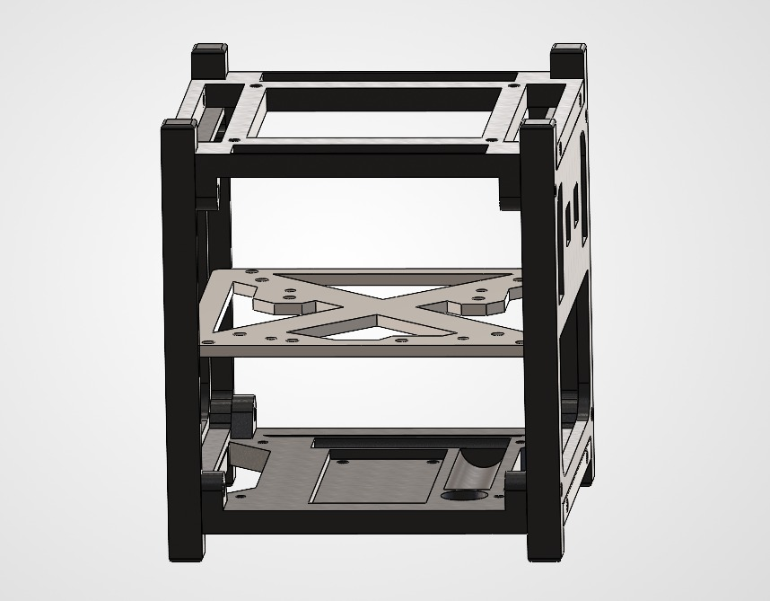
Board 1


Board 2
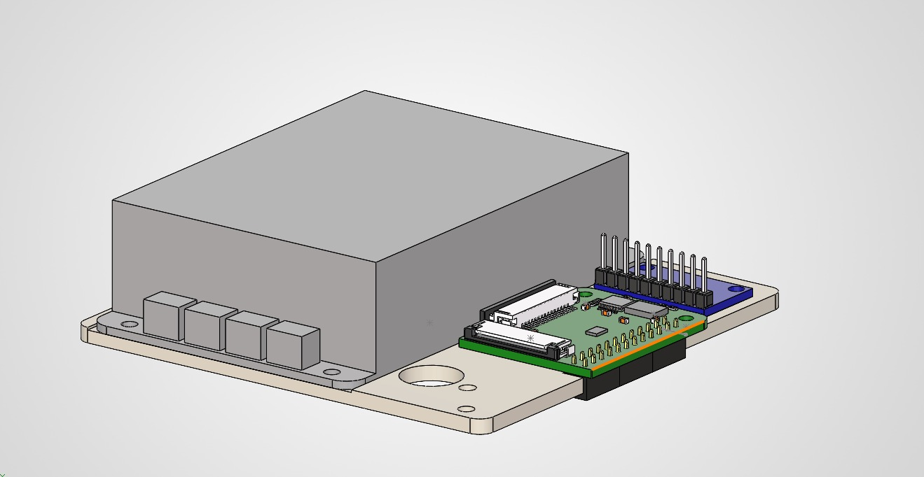
Board 3
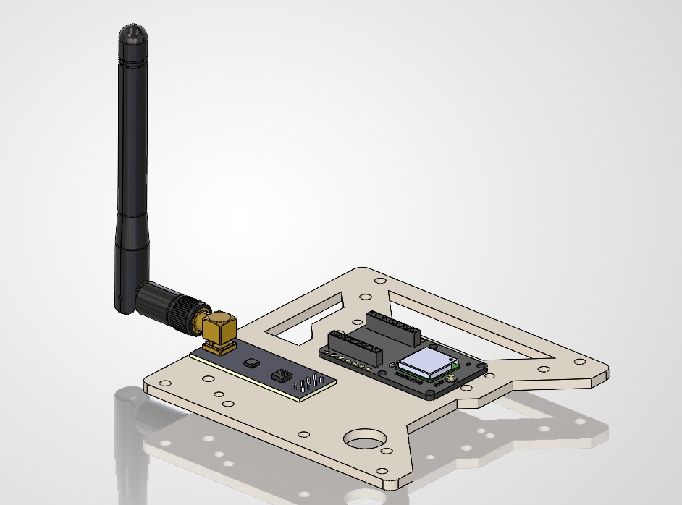

Internal Layout Principles
Principle | Implementation
Board stack at the centre | The Pi, Grove Base Hat, and Enviro+ stack mounts at the centre or base of the enclosure through the Pi's four corner holes using M2.5 standoffs
Antennas exit at the top | SMA bulkhead connectors at the highest point maximise radio line of sight. Keep the LoRa radio to antenna cable as short as possible.
Batteries at the base | LiPo and UPS HAT batteries add weight low good for stability. Keep them away from the BME280 which reads high near heat sources.
PMS5003 faces a vent | Mount with the intake aligned to a mesh window. Air must flow freely through the sensor.
GPS faces the sky | The NEO-M8M antenna element needs an unobstructed sky view. Inside plastic is fine; inside metal is not.
Cable tie mounts for routing | Small adhesive cable tie pads route Grove cables cleanly against the walls, preventing contact with sensor pins or board edges.

Integration Test Before Sealing
Test | Method | Pass Condition
All I2C devices present | sudo i2cdetect -y 1 | Addresses visible: 0x04, 0x23, 0x42, 0x49, 0x68, 0x70, 0x76
GPS NMEA receiving | sudo cat /dev/serial0 | NMEA sentences scrolling $GNGGA and $GNRMC lines appear
HaLow associated | Wait 2 minutes then: iwconfig | HaLow interface shows an associated AP SSID
NRF24L01 link | Run nrf_test.py on both ends simultaneously | Test message received on both sides
Camera A and B | python camera.py --cam 0 then --cam 1 | Two image files created with visually different content
IMU data flowing | python imu.py | Non-zero accelerometer, gyroscope, and magnetometer values printed
Power failover | Unplug USB charger while running | System continues without rebooting seamless switchover to battery
Safe shutdown trigger | Lower LBO threshold temporarily in power_monitor.py | Pi executes shutdown sequence within 10 seconds

TEST WITH THE LID OFF | Run all nine tests before sealing the enclosure. Troubleshooting after the lid is on requires disassembly. Five minutes of testing now saves an hour later.

Resources

All software is open source. All videos are freely available on YouTube.
Links were current at time of writing (if one has moved, search the title directly).

GitHub Repository
REPOSITORY | All EnviroSat code is at:  github.com/bruceboge/nano-satelite

File or Folder | Contents
main.py | Master startup script
/scripts/sensors.py | Enviro+ sensor reading
/scripts/gps.py | GPS NMEA parsing
/scripts/imu.py | IMU reading
/scripts/camera.py | Dual camera capture and switching
/scripts/nrf_tx.py | NRF24L01 transmit
/scripts/power_monitor.py | LBO monitor and safe shutdown
/scripts/logger.py | JSON Lines data logging
/ground_station/ground_station.py | Ground station receiver and display
/ground_station/dashboard.py | Browser-based live dashboard
/install/install.sh | One-command dependency installer
/install/envirosat.service | Systemd auto-start service file
/structure/envirosat_enclosure.stl | 3D print file for recommended enclosure
/structure/enclosure_assembly.pdf | Printed enclosure assembly guide

Official Component Documentation
Component | Official Documentation
Raspberry Pi 3B+ | raspberrypi.com/documentation
Grove Base Hat | wiki.seeedstudio.com/Grove_Base_Hat_for_Raspberry_Pi
Pimoroni Enviro+ | github.com/pimoroni/enviroplus-python
Pi UPS HAT (Waveshare) | waveshare.com/wiki/UPS_HAT
Arducam UC-444 | docs.arducam.com/Raspberry-Pi-Camera/Multi-Camera-CamArray
MPU-9250/6500 | invensense.tdk.com search MPU-9250
NRF24L01+ | nordicsemi.com search nRF24L01+
u-blox NEO-M8M GPS | u-blox.com search NEO-M8 series
Heltec HT-HC01P HaLow | heltec.org/wifi-halow
Morse Micro HaLow Driver | github.com/MorseMicro/morse_driver

Recommended Videos

Raspberry Pi Setup and Fundamentals
Title | Channel | Why Watch It
Raspberry Pi First Time Setup | Raspberry Pi Foundation | Official setup guide Imager, SSH, and raspi-config covered clearly
I2C on Raspberry Pi Explained | Gary Explains | Best plain-language explanation of the I2C bus directly relevant to EnviroSat sensor connections
How to Use SSH Full Beginner Guide | NetworkChuck | Everything needed to connect to and work with the Pi remotely
SPI Bus on Raspberry Pi | Core Electronics | Covers SPI, chip select lines, and how multiple devices share one bus

Sensors and Hardware
Title | Channel | Why Watch It
Pimoroni Enviro+ Walkthrough | Pimoroni | Official demo of every sensor explains what each reading means in context
How GPS Works Interactive Guide | Bartosz Ciechanowski | Visual animation explaining how GPS satellites determine position
MPU-6050 IMU with Raspberry Pi | Makers in Motion | Practical IMU setup directly applicable to the MPU-9250 used in EnviroSat
LiPo Battery Safety What You Need to Know | James Bruton | Essential safety information for first-time users of LiPo cells

Wireless Communication
Title | Channel | Why Watch It
NRF24L01 with Raspberry Pi Tutorial | Electronoobs | Step-by-step wiring and Python code for the NRF24L01
What Is WiFi HaLow? 802.11ah Explained | Semtech | Technical overview of HaLow's advantages over standard WiFi bands

Satellite Engineering Context
Title | Channel | Why Watch It
How CubeSats Work | NASA Goddard | Official NASA explanation of CubeSat design every subsystem discussed maps directly to EnviroSat
Building a Student CubeSat Documentary | ESA | Real student team going through the same process EnviroSat teaches at a smaller scale
How Satellites Communicate | Scott Manley | Clear explanation of the signal path from satellite to ground station
Attitude Determination and Control ADCS | Space Innovations | Explains what IMU data is used for in real spacecraft operation

Python Programming
Title | Channel | Why Watch It
Python for Everybody | freeCodeCamp.org | The most recommended free Python course complete beginner to capable in one resource
Python GPIO with Raspberry Pi | Raspberry Pi Foundation | Official guide to controlling hardware pins with Python
Reading Sensors with Python | Tech With Tim | Practical patterns for reading and processing sensor data directly applicable
JSON in Python Quick Guide | Corey Schafer | JSON is the data format used throughout EnviroSat logging and communication

About Us

EnviroSat was built by a small team driven by a straightforward observation: satellite technology is becoming accessible, but the documentation that would allow makers to build something genuinely meaningful has been slow to follow.

EnviroSat is a real technical system built on real satellite engineering principles. But it is also designed to be understood and assembled by someone who has never held a circuit board. Every decision in its architecture the Grove Base Hat, the Enviro+ sensor suite, the modular three-board layout, Python as the programming language was made to lower the barrier to entry without cutting corners on what gets built.

The Mission
The long-term goal is for EnviroSat to become a platform that maker communities around the world can build and deploy contributing to distributed environmental monitoring while teaching satellite engineering from the ground up.
Everyone who completes an EnviroSat build gains hands-on experience in embedded systems, wireless communications, power management, sensor integration, data handling, and software engineering. These are among the most in-demand skills in engineering and technology today, and they are best acquired by building something that actually works.

Acknowledgements
EnviroSat draws on the work of several open-source hardware and software communities:
- The Raspberry Pi Foundation for making capable single-board computing genuinely accessible to students and educators worldwide
- Pimoroni for the Enviro+ HAT and its well-written Python library
- Seeed Studio for the Grove ecosystem, which turns the wiring complexity of GPIO electronics into manageable plug-and-play connections
- Adafruit Industries for the PowerBoost 1000C and RFM9x breakout, and for the quality of their open learning documentation
- Morse Micro for developing the HaLow kernel driver and releasing it under an open licence
- Every student and engineer who has asked and answered questions in public forums that collective knowledge is the foundation every project like this is built on

Contact and Contributions
Questions, corrections, and contributions to the documentation or code are welcome via the GitHub repository. Raise an issue or submit a pull request.
For direct enquiries use the contact form on the project website.
SHARE YOUR BUILD | If you build an EnviroSat we would like to know about it. Where did you deploy it? What did you measure? What did you change or improve? These accounts help improve the guide and give future builders something concrete to aim for. Tag your build in GitHub Discussions.

Terms of Use
EnviroSat is an open-source project released under a licence designed to keep it free, shareable, and non-commercial.

The Licence in Plain Terms
You CAN | You CANNOT | You MUST
Use for any educational or personal project | Sell this documentation or code, or include it in a commercial product without written permission | Credit EnviroSat as the source when sharing or publishing work based on this material
Modify the code and documentation for your own project | Remove attribution notices from documentation or code files | Share any modified versions under the same licence
Share with students, colleagues, or online communities | Use the EnviroSat name to imply endorsement of a product or service | Make clear when your version differs from the original
Translate into other languages | Patent anything derived directly from this work | Include a link to the original repository when distributing adaptations
Use in coursework, competitions, and publications | Hold the EnviroSat team liable for any outcome of building or deploying a system based on this documentation

Safety and Liability
Building electronics involves real risks: electrical hazards, battery fires, radio emissions, and mechanical hazards from tools. This documentation is provided as an educational guide. The EnviroSat team makes no warranty about its fitness for any particular purpose.

BUILDER RESPONSIBILITY | The person building and operating any EnviroSat system is solely responsible for its safe construction, use, and disposal. Always work under appropriate supervision if you are a student or minor. Follow all LiPo battery safety precautions. Verify that radio transmission at 915 MHz is permitted under licence-free regulations in your country before deploying.

Radio Frequency Compliance
Region | Status | Notes
United States | Licence-free under FCC Part 15 | EnviroSat hardware operates well within power limits
Australia | Licence-free under ACMA Class Licence | Same band and power limits as US
Canada | Licence-free under ISED RSS-Gen | Verify current ISED regulations for your application
European Union | 868 MHz band used 915 MHz is restricted | European builders must use 868 MHz versions of all radio modules
United Kingdom | 868 MHz band check Ofcom regulations | Post-Brexit regulations follow EU band plan for this range
Other regions | Verify locally before operating | Check your national spectrum management authority

Thank you for building EnviroSat. Every system built from this guide is evidence that satellite technology belongs in the hands of students, educators, and curious people everywhere.
We hope it teaches you something real, starts a conversation, and inspires what comes next.

