Joint Face Detection and Alignment using Multi-task Cascaded Convolutional Networks

Kaipeng Zhang, Zhanpeng Zhang, Zhifeng Li, *Senior Member, IEEE*, and Yu Qiao, *Senior Member, IEEE*

***Abstract—*Face detection and alignment in unconstrained en- vironment are challenging due to various poses, illuminations and occlusions. Recent studies show that deep learning approaches can achieve impressive performance on these two tasks. In this paper, we propose a deep cascaded multi-task framework which exploits the inherent correlation between detection and alignment to boost up their performance. In particular, our framework leverages a cascaded architecture with three stages of carefully designed deep convolutional networks to predict face and land- mark location in a coarse-to-fine manner. In addition, we propose a new online hard sample mining strategy that further improves the performance in practice. Our method achieves superior ac- curacy over the state-of-the-art techniques on the challenging FDDB and WIDER FACE benchmarks for face detection, and AFLW benchmark for face alignment, while keeps real time per- formance.**

***Index Terms*—Face detection, face alignment, cascaded con- volutional neural network**

1. INTRODUCTION

F

ACE detection and alignment are essential to many face applications, such as face recognition and facial expression analysis. However, the large visual variations of faces, such as occlusions, large pose variations and extreme lightings, impose

great challenges for these tasks in real world applications.

The cascade face detector proposed by Viola and Jones [2] utilizes Haar-Like features and AdaBoost to train cascaded classifiers, which achieves good performance with real-time efficiency. However, quite a few works [1, 3, 4] indicate that this kind of detector may degrade significantly in real-world applications with larger visual variations of human faces even with more advanced features and classifiers. Besides the cas- cade structure, [5, 6, 7] introduce deformable part models

Copyright (c) 2015 IEEE. Personal use of this material is permitted. How- ever, permission to use this material for any other purposes must be obtained from the IEEE by sending a request to [pubs-permissions@ieee.org.](mailto:pubs-permissions@ieee.org)

K.-P. Zhang, Z.-F. Li and Y. Qiao are with Shenzhen Institutes of Advanced Technology, Chinese Academy of Sciences, Shenzhen 518055, China. E-mail: kp.zhang@siat.ac.cn; zhifeng.li@siat.ac.cn; [yu.qiao@siat.ac.cn](mailto:yu.qiao@siat.ac.cn)

Z.-P. Zhang is with the Department of Information Engineering, The Chi- nese University of Hong Kong, Hong Kong. E-mail: [zz013@ie.cuhk.edu.hk](mailto:zz013@ie.cuhk.edu.hk)

This work was funded by External Cooperation Program of BIC, Chinese Academy of Sciences (172644KYSB20160033, 172644KYSB20150019),

Shenzhen Research Program (KQCX2015033117354153, JSGG20150925164 740726, CXZZ20150930104115529, CYJ20150925163005055, and JCYJ201

60510154736343), Guangdong Research Program (2014B050505017 and 2015B010129013), Natural Science Foundation of Guangdong Province (2014A030313688) and the Key Laboratory of Human Machine Intelli- gence-Synergy Systems through the Chinese Academy of Sciences.

(DPM) for face detection and achieve remarkable performance. However, they are computationally expensive and may usually require expensive annotation in the training stage. Recently, convolutional neural networks (CNNs) achieve remarkable progresses in a variety of computer vision tasks, such as image classification [9] and face recognition [10]. Inspired by the significant successes of deep learning methods in computer vision tasks, several studies utilize deep CNNs for face detec- tion. Yang *et al*. [11] train deep convolution neural networks for facial attribute recognition to obtain high response in face regions which further yield candidate windows of faces. However, due to its complex CNN structure, this approach is time costly in practice. Li *et al*. [19] use cascaded CNNs for face detection, but it requires bounding box calibration from face detection with extra computational expense and ignores the inherent correlation between facial landmarks localization and bounding box regression.

Face alignment also attracts extensive research interests. Researches in this area can be roughly divided into two cate- gories, regression-based methods [12, 13, 16] and template

fitting approaches [14, 15, 7]. Recently, Zhang *et al*. [22] proposed to use facial attribute recognition as an auxiliary task to enhance face alignment performance using deep convolu- tional neural network.

However, most of previous face detection and face alignment methods ignore the inherent correlation between these two tasks. Though several existing works attempt to jointly solve them, there are still limitations in these works. For example, Chen *et al.* [18] jointly conduct alignment and detection with random forest using features of pixel value difference. But, these handcraft features limit its performance a lot. Zhang *et al.*

[20] use multi-task CNN to improve the accuracy of multi-view face detection, but the detection recall is limited by the initial detection window produced by a weak face detector.

On the other hand, mining hard samples in training is critical to strengthen the power of detector. However, traditional hard sample mining usually performs in an offline manner, which significantly increases the manual operations. It is desirable to design an online hard sample mining method for face detection, which is adaptive to the current training status automatically.

In this paper, we propose a new framework to integrate these two tasks using unified cascaded CNNs by multi-task learning. The proposed CNNs consist of three stages. In the first stage, it produces candidate windows quickly through a shallow CNN. Then, it refines the windows by rejecting a large number of non-faces windows through a more complex CNN. Finally, it uses a more powerful CNN to refine the result again and output five facial landmarks positions. Thanks to this multi-task learning framework, the performance of the algorithm can be

TABLE I

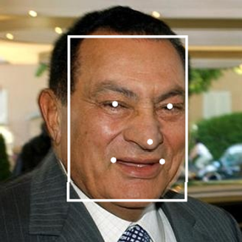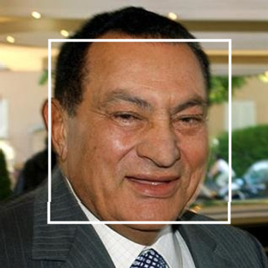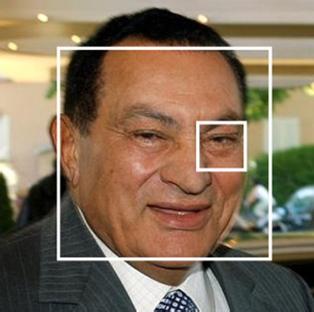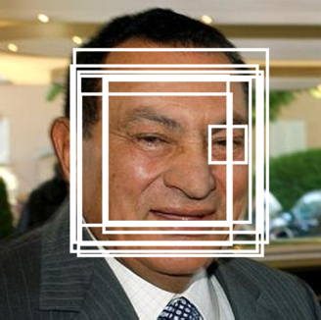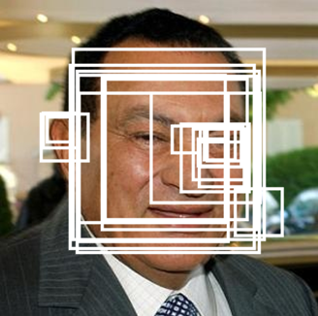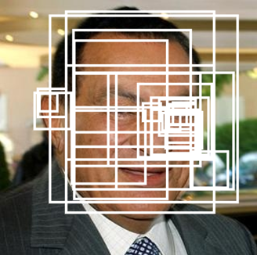

**Resize**

**Test image**

**Image pyramid**

**NMS &**

**Bounding box regression**

**Stage 1 P-Net**

**NMS &**

**Bounding box regression**

**Stage 2 R-Net**

**NMS &**

**Bounding box regression**

**Stage 3 O-Net**

COMPARISON OF SPEED AND VALIDATION ACCURACY OF OUR CNNS AND PREVIOUS CNNS [19]

Group CNN 300 × Forward

|  |  |  |
| --- | --- | --- |
|  | Propagation |  |
| 12-Net [19] | 0.038s | 94.4% |
| Group1  P-Net | 0.031s | 94.6% |
| 24-Net [19]  Group2 | 0.738s | 95.1% |
| R-Net | 0.458s | 95.4% |
| 48-Net [19]  Group3 | 3.577s | 93.2% |
| O-Net | 1.347s | 95.4% |

Validation Accuracy

Fig. 1. Pipeline of our cascaded framework that includes three-stage mul- ti-task deep convolutional networks. Firstly, candidate windows are produced through a fast Proposal Network (P-Net). After that, we refine these candidates in the next stage through a Refinement Network (R-Net). In the third stage, The Output Network (O-Net) produces final bounding box and facial land- marks position.

notably improved. The codes have been released in the project page1. The major contributions of this paper are summarized as follows: (1) We propose a new cascaded CNNs based frame- work for joint face detection and alignment, and carefully de- sign lightweight CNN architecture for real time performance.

(2) We propose an effective method to conduct online hard sample mining to improve the performance. (3) Extensive ex- periments are conducted on challenging benchmarks, to show significant performance improvement of the proposed approach compared to the state-of-the-art techniques in both face detec- tion and face alignment tasks.

1. APPROACH

In this section, we will describe our approach towards joint face detection and alignment.

1. *Overall Framework*

**Stage 2**: All candidates are fed to another CNN, called Re- fine Network (R-Net), which further rejects a large number of false candidates, performs calibration with bounding box re- gression, and conducts NMS.

**Stage 3**: This stage is similar to the second stage, but in this stage we aim to identify face regions with more supervision. In particular, the network will output five facial landmarks’ posi- tions.

1. *CNN Architectures*

In [19], multiple CNNs have been designed for face detec- tion. However, we notice its performance might be limited by the following facts: (1) Some filters in convolution layers lack diversity that may limit their discriminative ability. (2) Com- pared to other multi-class objection detection and classification tasks, face detection is a challenging binary classification task, so it may need less numbers of filters per layer. To this end, we reduce the number of filters and change the 5×5 filter to 3×3 filter to reduce the computing while increase the depth to get better performance. With these improvements, compared to the previous architecture in [19], we can get better performance with less runtime (the results in training phase are shown in Table I. For fair comparison, we use the same training and validation data in each group). Our CNN architectures are shown in Fig. 2. We apply PReLU [30] as nonlinearity activa- tion function after the convolution and fully connection layers (except output layers).

1. *Training*

We leverage three tasks to train our CNN detectors: face/non-face classification, bounding box regression, and facial landmark localization.

1. *Face classification:* The learning objective is formulated as a two-class classification problem. For each sample xi, we use the cross-entropy loss:

Ldet = −(ydet log(ei)+ (1 − ydet)(1 − log(ei))) (1)

The overall pipeline of our approach is shown in Fig. 1. i i i

Given an image, we initially resize it to different scales to build an image pyramid, which is the input of the following three-stage cascaded framework:

**Stage 1**: We exploit a fully convolutional network, called Proposal Network (P-Net), to obtain the candidate facial win- dows and their bounding box regression vectors. Then candi- dates are calibrated based on the estimated bounding box re- gression vectors. After that, we employ non-maximum sup- pression (NMS) to merge highly overlapped candidates.

1https://kpzhang93.github.io/MTCNN_face_detection_alignment/index.html

where ei is the probability produced by the network that in- dicates sample xi being a face. The notation ydet ∈ {0,1} denotes the ground-truth label.

1. *Bounding box regression:* For each candidate window, we predict the offset between it and the nearest ground truth (i.e., the bounding boxes’ left, top, height, and width). The learning objective is formulated as a regression problem, and we employ the Euclidean loss for each sample xi:

i

Lbos = ǁy^bos − ybosǁ2 (2)

i i i 2

where y^bos is the regression target obtained from the network and ybos is the ground-truth coordinate. There are four coor- dinates, including left top, height and width, and thus ybos ∈ ℝ4.

i

i

i

1. *Facial landmark localization:* Similar to bounding box

regression task, facial landmark detection is formulated as a regression problem and we minimize the Euclidean loss:

LSandnark = ǁy^Sandnark − ySandnarkǁ2 (3)

i i i 2

where y^Sandnark is the facial landmark’s coordinates obtained

i

Sandnark

in the forward propagation from all samples and select the top 70% of them as hard samples. Then we only compute the gra- dients from these hard samples in the backward propagation. That means we ignore the easy samples that are less helpful to strengthen the detector during training. Experiments show that this strategy yields better performance without manual sample selection. Its effectiveness is demonstrated in Section III.

1. EXPERIMENTS

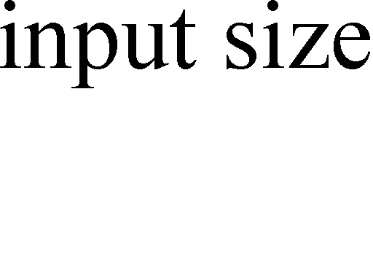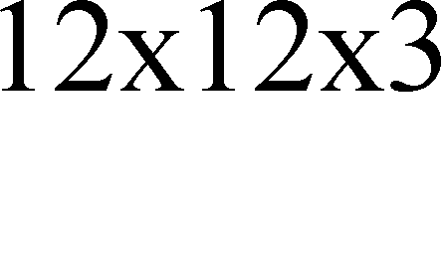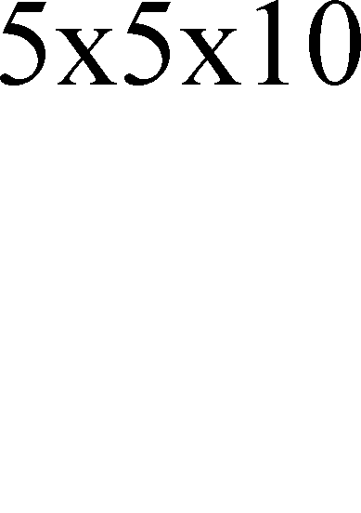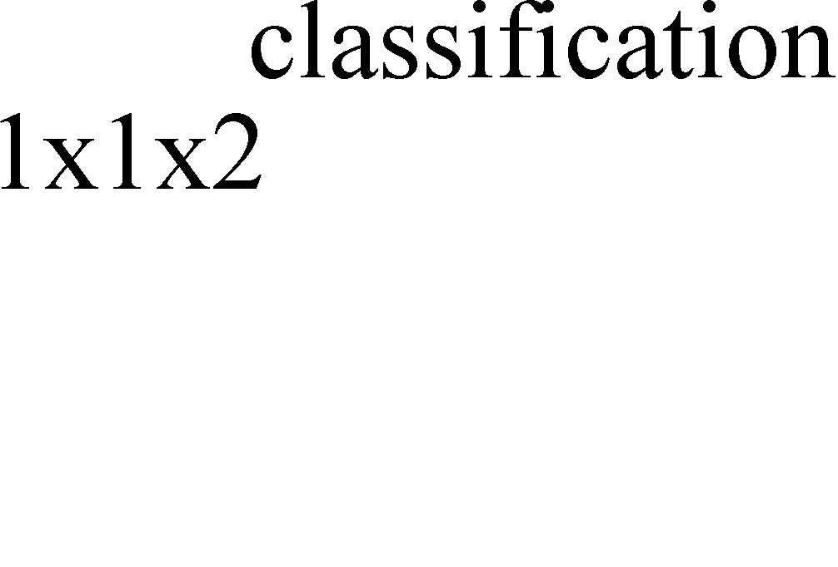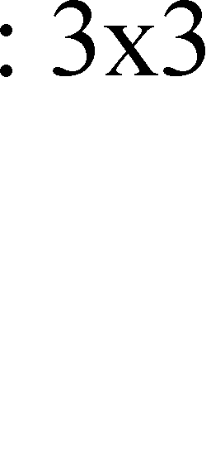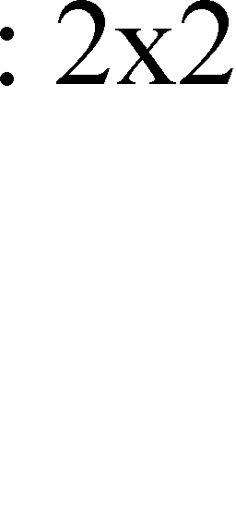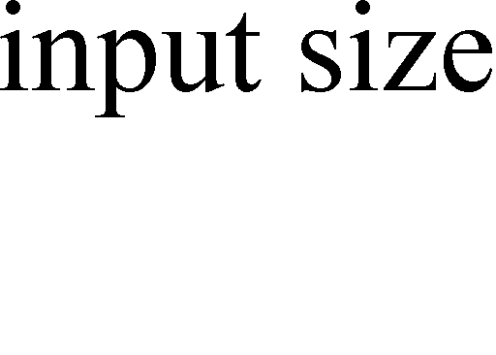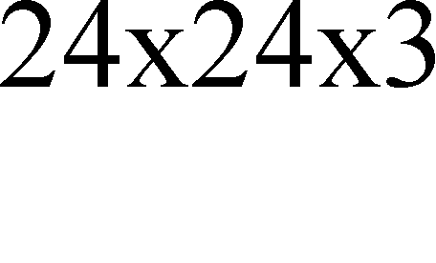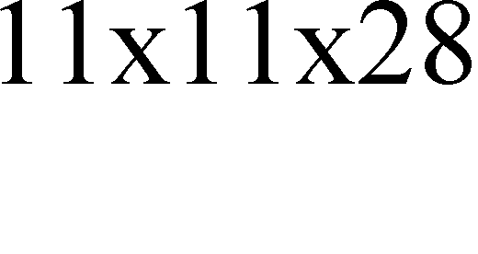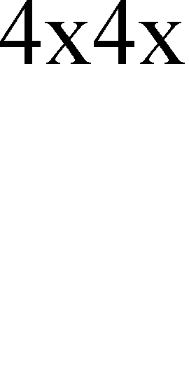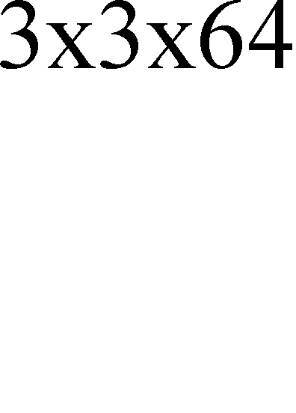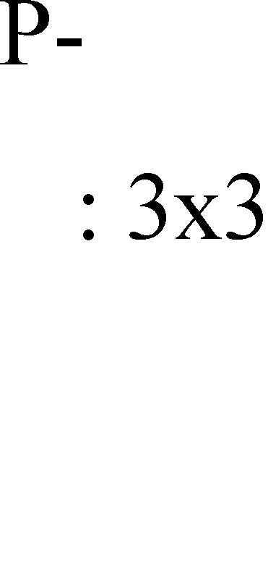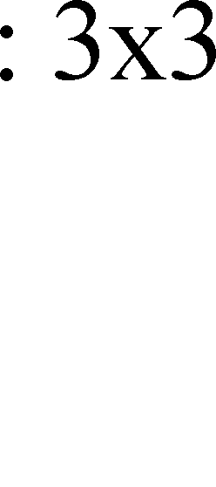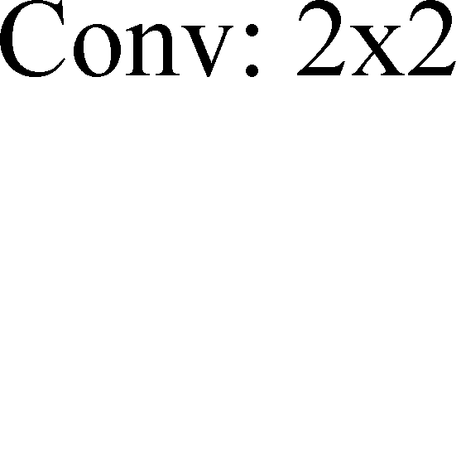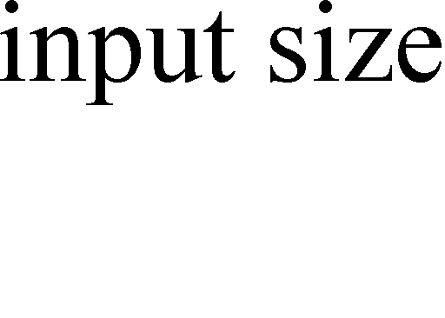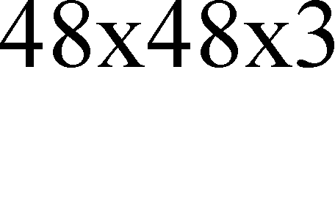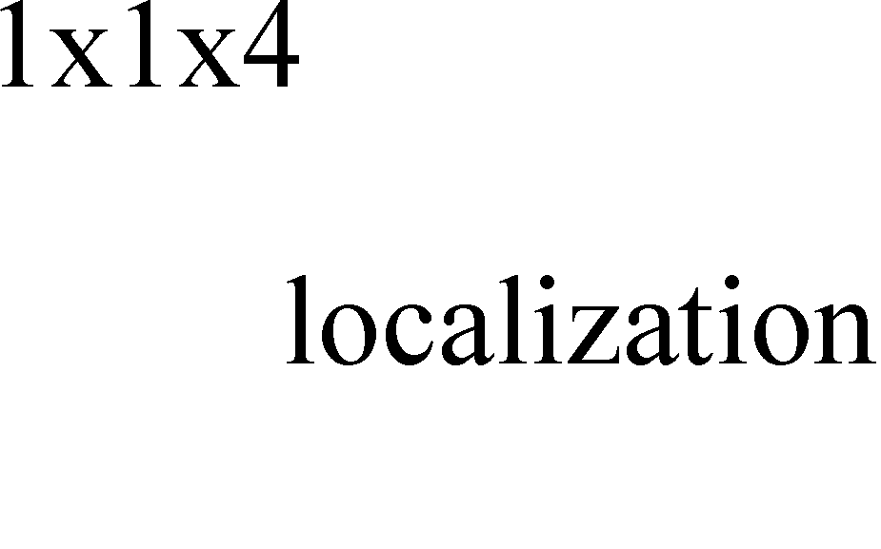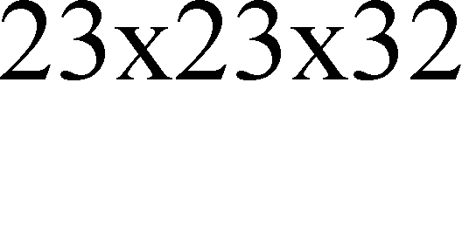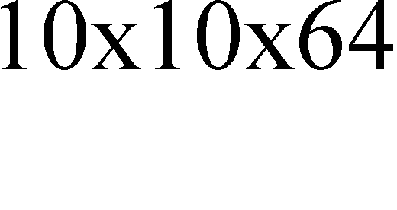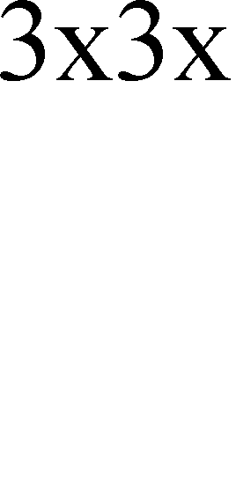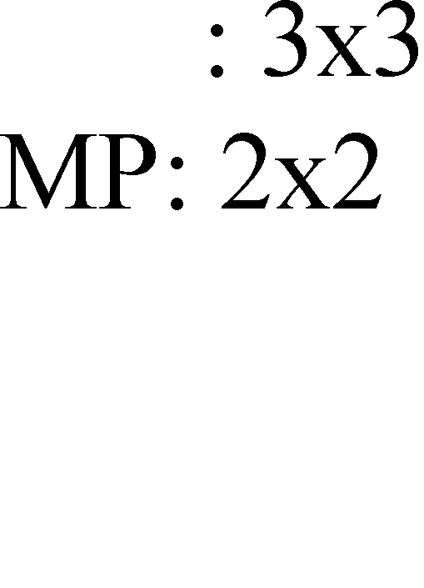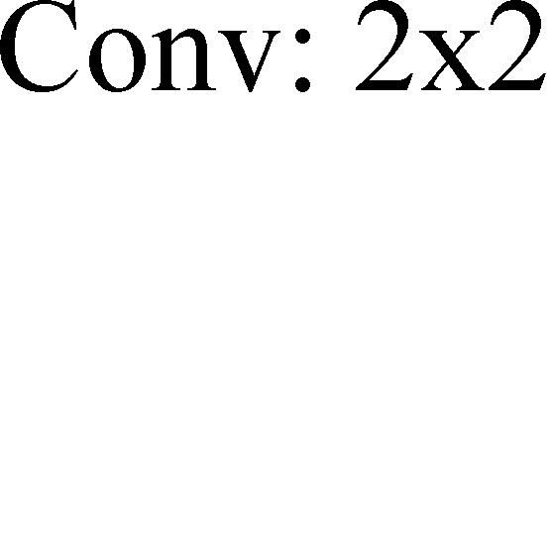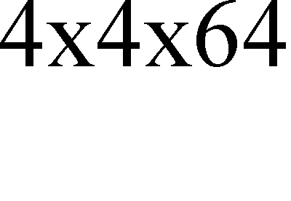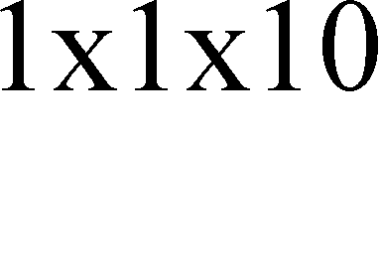

Fig. 2. The architectures of P-Net, R-Net, and O-Net, where “MP” means max pooling and “Conv” means convolution. The step size in convolution and pooling is 1 and 2, respectively.

In this section, we first evaluate the effectiveness of the proposed hard sample mining strategy. Then we compare our face detector and alignment against the state-of-the-art methods

in Face Detection Data Set and Benchmark (FDDB) [25],

from the network and yi

is the ground-truth coordinate

WIDER FACE [24], and Annotated Facial Landmarks in the

for the *i*-th sample. There are five facial landmarks, including left eye, right eye, nose, left mouth corner, and right mouth corner, and thus ySandnark ∈ ℝ10.

i

1. *Multi-source training:* Since we employ different tasks in

each CNN, there are different types of training images in the learning process, such as face, non-face, and partially aligned face. In this case, some of the loss functions (i.e., Eq. (1)-(3)) are not used. For example, for the sample of background region, we only compute Ldet, and the other two losses are set as 0. This can be implemented directly with a sample type indicator. Then the overall learning target can be formulated as:

i

Wild (AFLW) benchmark [8]. FDDB dataset contains the an- notations for 5,171 faces in a set of 2,845 images. WIDER FACE dataset consists of 393,703 labeled face bounding boxes in 32,203 images where 50% of them for testing (divided into three subsets according to the difficulty of images), 40% for training and the remaining for validation. AFLW contains the facial landmarks annotations for 24,386 faces and we use the same test subset as [22]. Finally, we evaluate the computational efficiency of our face detector.

1. *Training Data*

Since we jointly perform face detection and alignment, here

min ∑N

∑j∈{det,bos,Sandnark} αjþjLj

(4)

we use four different kinds of data annotation in our training

i=1

i i process: (i) Negatives: Regions whose the Intersec-

where N is the number of training samples and αj denotes on the task importance. We use (αdet = 1, αbos = 0.5, αSandnark = 0.5) in P-Net and R-Net, while (αdet = 1, αbos = 0.5, αSandnark = 1) in O-Net for more accurate

facial landmarks localization. þj ∈ {0,1} is the sample type indicator. In this case, it is natural to employ stochastic gradient descent to train these CNNs.

i

*5) Online Hard sample mining:* Different from conducting traditional hard sample mining after original classifier had been trained, we conduct online hard sample mining in face/non-face classification task which is adaptive to the training process.

In particular, in each mini-batch, we sort the losses computed

tion-over-Union (IoU) ratio are less than 0.3 to any ground-truth faces; (ii) Positives: IoU above 0.65 to a ground truth face; (iii) Part faces: IoU between 0.4 and 0.65 to a ground truth face; and (iv) Landmark faces: faces labeled 5 landmarks’ positions. There is an unclear gap between part faces and neg- atives, and there are variances among different face annotations. So, we choose IoU gap between 0.3 to 0.4. Negatives and pos- itives are used for face classification tasks, positives and part faces are used for bounding box regression, and landmark faces are used for facial landmark localization. Total training data are composed of 3:1:1:2 (negatives/ positives/ part face/ landmark face) data. The training data collection for each network is described as follows:

1

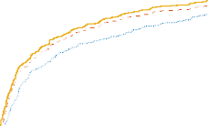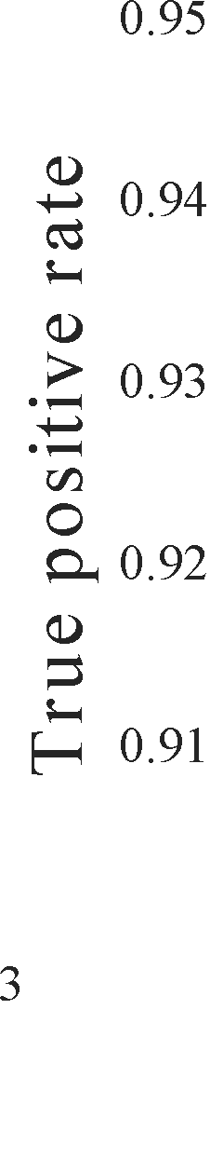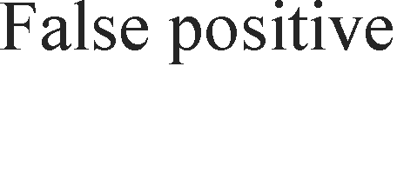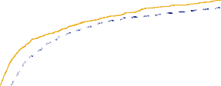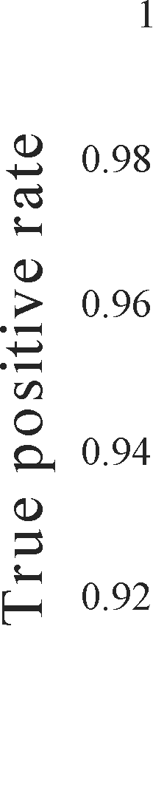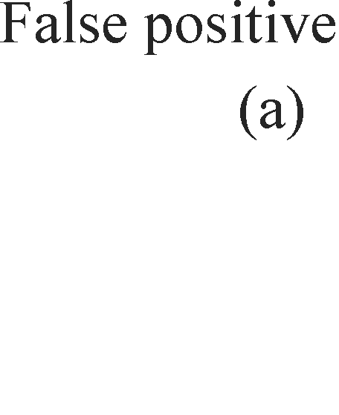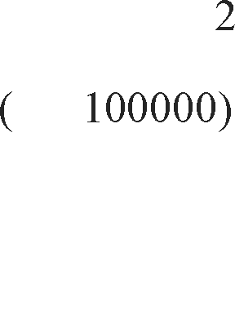

0.95

True positive rate

0.9

0.85

0.8

0.75

0.7

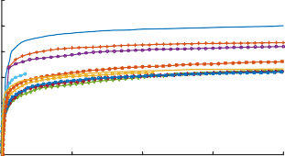0 500 1000 1500 2000

False positive

1

0.8



Ours-0.851

Faceness [11] -WIDER-0.716

Multiscale Cascade CNN [24] -0.711

ACF [1] -WIDER-0.695

Two-stage CNN [24] -0.657

Pr e cision

0.6

0.4

0.2

0

Fig. 3. (a) Detection performance of P-Net with and without online hard sample

Ours (0.9504)

DP2MFD [27] (0.9173)

CCF [26] (0.8590)

Faceness [11] (0.9098)

MultiresHPM [28] (0.8632)

CascadeCNN [19] (0.8567)

Yan [6] et al. (0.8615)

ACF-multiscale [1] (0.8607)

0 0.2 0.4 0.6 0.8 1

Recall

mining. (b) “JA” denotes joint face alignment learning in O-Net while “No JA” denotes do not joint it. “No JA in BBR” denotes use “No JA” O-Net for bounding box regression.

1. *P-Net:* We randomly crop several patches from WIDER FACE [24] to collect positives, negatives and part face. Then, we crop faces from CelebA [23] as landmark faces.
2. *R-Net:* We use the first stage of our framework to detect

faces from WIDER FACE [24] to collect positives, negatives and part face while landmark faces are detected from CelebA

1

0.8



Ours-0.820

Faceness [11] -WIDER-0.604

Multiscale Cascade CNN [24] -0.636

ACF [1] -WIDER-0.588

Two-stage CNN [24] -0.589

P r e c i s i o n

0.6

0.4

0.2

0

HeadHunter [5] (0.8808) Joint Cascade [18] (0.8667)

(a)

1



Ours-0.607

Faceness [11] -WIDER-0.315

Multiscale Cascade CNN [24] -0.400

ACF [1] -WIDER-0.290

Two-stage CNN [24] -0.304

0.8

P r e c i s i o n

0.6

0.4

0.2

0

1. Easy set

[23].

1. *O-Net:* Similar to R-Net to collect data but we use the first

0 0.2 0.4 0.6 0.8 1

Recall

1. Medium set

0 0.2 0.4 0.6 0.8 1

Recall

1. Hard set

two stages of our framework to detect faces and collect data.

1. *The effectiveness of online hard sample mining*

To evaluate the contribution of the proposed online hard

Fig. 4. (a) Evaluation on FDDB. (b-d) Evaluation on three subsets of WIDER FACE. The number following the method indicates the average accuracy.

TSPM ESR CDM Luxand RCPR SDM TCDCN Ours

sample mining strategy, we train two P-Nets (with and without online hard sample mining) and compare their performance on FDDB. Fig. 3 (a) shows the results from two different P-Nets on FDDB. It is clear that the online hard sample mining is beneficial to improve performance. It can bring about 1.5% overall performance improvement on FDDB.

25

20

mean error (%)

15

10

5

left eye right eye

nose left mouth corner

20

15

mean error (%)

|  |  |  |  |  |  |  |  |
| --- | --- | --- | --- | --- | --- | --- | --- |
| 15.9 | | | | | | | |
|  | 13. | 013. | 112.411.6 | | | | |
|  |  |  |  |  | 8. | 5 8. | 0  6.9 |

10

5

right mouth corner

1. *The effectiveness of joint detection and alignment*

To evaluate the contribution of joint detection and alignment, we evaluate the performances of two different O-Nets (joint facial landmarks regression learning and do not joint it) on FDDB (with the same P-Net and R-Net). We also compare the performance of bounding box regression in these two O-Nets. Fig. 3 (b) suggests that joint landmark localization task learning help to enhance both face classification and bounding box regression tasks.

1. *Evaluation on face detection*

To evaluate the performance of our face detection method, we compare our method against the state-of-the-art methods [1, 5, 6, 11, 18, 19, 26, 27, 28, 29] in FDDB, and the

state-of-the-art methods [1, 24, 11] in WIDER FACE. Fig. 4 (a)-(d) shows that our method consistently outperforms all the compared approaches by a large margin in both the bench- marks.

1. *Evaluation on face alignment*

In this part, we compare the face alignment performance of our method against the following methods: RCPR [12], TSPM [7], Luxand face SDK [17], ESR [13], CDM [15], SDM [21],

and TCDCN [22]. The mean error is measured by the distances between the estimated landmarks and the ground truths, and normalized with respect to the inter-ocular distance. Fig. 5 shows that our method outperforms all the state-of-the-art methods with a margin. It also shows that our method shows less superiority in mouth corner localization. It may result from the small variances of expression, which has a significant in-

Fig. 5. Evaluation on AFLW for face alignment

TABLE II

SPEED COMPARISON OF OUR METHOD AND OTHER METHODS

|  |  |  |
| --- | --- | --- |
| Method | GPU | Speed |
| Ours | Nvidia Titan Black | 99 FPS |
| Cascade CNN [19] | Nvidia Titan Black | 100 FPS |
| Faceness [11] | Nvidia Titan Black | 20 FPS |
| DP2MFD [27] | Nvidia Tesla K20 | 0.285 FPS |

fluence in mouth corner position, in our training data.

1. *Runtime efficiency*

Given the cascade structure, our method can achieve high speed in joint face detection and alignment. We compare our method with the state-of-the-art techniques on GPU and the results are shown in Table II. It is noted that our current im- plementation is based on un-optimized MATLAB codes.

1. CONCLUSION

In this paper, we have proposed a multi-task cascaded CNNs based framework for joint face detection and alignment. Ex- perimental results demonstrated that our methods consistently outperform the state-of-the-art methods across several chal- lenging benchmarks (including FDDB and WIDER FACE benchmarks for face detection, and AFLW benchmark for face alignment) while achieves real time performance for 640x480 VGA images with 20x20 minimum face size. The three main contributions for performance improvement are carefully de- signed cascaded CNNs architecture, online hard sample mining strategy, and joint face alignment learning.

REFERENCES

1. B. Yang, J. Yan, Z. Lei, and S. Z. Li, “Aggregate channel features for multi-view face detection,” in IEEE International Joint Conference on Biometrics, 2014, pp. 1-8.
2. P. Viola and M. J. Jones, “Robust real-time face detection. International journal of computer vision,” vol. 57, no. 2, pp. 137-154, 2004
3. M. T. Pham, Y. Gao, V. D. D. Hoang, and T. J. Cham, “Fast polygonal integration and its application in extending haar-like features to improve object detection,” in IEEE Conference on Computer Vision and Pattern Recognition, 2010, pp. 942-949.
4. Q. Zhu, M. C. Yeh, K. T. Cheng, and S. Avidan, “Fast human detection using a cascade of histograms of oriented gradients,” in IEEE Computer Conference on Computer Vision and Pattern Recognition, 2006, pp. 1491-1498.
5. M. Mathias, R. Benenson, M. Pedersoli, and L. Van Gool, “Face detection without bells and whistles,” in European Conference on Computer Vision, 2014, pp. 720-735.
6. J. Yan, Z. Lei, L. Wen, and S. Li, “The fastest deformable part model for object detection,” in IEEE Conference on Computer Vision and Pattern Recognition, 2014, pp. 2497-2504.
7. X. Zhu, and D. Ramanan, “Face detection, pose estimation, and landmark localization in the wild,” in IEEE Conference on Computer Vision and Pattern Recognition, 2012, pp. 2879-2886.
8. M. Köstinger, P. Wohlhart, P. M. Roth, and H. Bischof, “Annotated facial landmarks in the wild: A large-scale, real-world database for facial land- mark localization,” in IEEE Conference on Computer Vision and Pattern Recognition Workshops, 2011, pp. 2144-2151.
9. A. Krizhevsky, I. Sutskever, and G. E. Hinton, “Imagenet classification with deep convolutional neural networks,” in Advances in neural infor- mation processing systems, 2012, pp. 1097-1105.
10. Y. Sun, Y. Chen, X. Wang, and X. Tang, “Deep learning face representa- tion by joint identification-verification,” in Advances in Neural Infor- mation Processing Systems, 2014, pp. 1988-1996.
11. S. Yang, P. Luo, C. C. Loy, and X. Tang, “From facial parts responses to face detection: A deep learning approach,” in IEEE International Confer- ence on Computer Vision, 2015, pp. 3676-3684.
12. X. P. Burgos-Artizzu, P. Perona, and P. Dollar, “Robust face landmark estimation under occlusion,” in IEEE International Conference on Com- puter Vision, 2013, pp. 1513-1520.
13. X. Cao, Y. Wei, F. Wen, and J. Sun, “Face alignment by explicit shape regression,” International Journal of Computer Vision, vol 107, no. 2, pp. 177-190, 2012.
14. T. F. Cootes, G. J. Edwards, and C. J. Taylor, “Active appearance models,” IEEE Transactions on Pattern Analysis and Machine Intelligence, vol. 23, no. 6, pp. 681-685, 2001.
15. X. Yu, J. Huang, S. Zhang, W. Yan, and D. Metaxas, “Pose-free facial landmark fitting via optimized part mixtures and cascaded deformable shape model,” in IEEE International Conference on Computer Vision, 2013, pp. 1944-1951.
16. J. Zhang, S. Shan, M. Kan, and X. Chen, “Coarse-to-fine auto-encoder networks (CFAN) for real-time face alignment,” in European Conference on Computer Vision, 2014, pp. 1-16.
17. Luxand Incorporated: Luxand face SDK, <http://www.luxand.com/>
18. D. Chen, S. Ren, Y. Wei, X. Cao, and J. Sun, “Joint cascade face detection and alignment,” in European Conference on Computer Vision, 2014, pp. 109-122.
19. H. Li, Z. Lin, X. Shen, J. Brandt, and G. Hua, “A convolutional neural network cascade for face detection,” in IEEE Conference on Computer Vision and Pattern Recognition, 2015, pp. 5325-5334.
20. C. Zhang, and Z. Zhang, “Improving multiview face detection with mul- ti-task deep convolutional neural networks,” IEEE Winter Conference on Applications of Computer Vision, 2014, pp. 1036-1041.
21. X. Xiong, and F. Torre, “Supervised descent method and its applications to face alignment,” in IEEE Conference on Computer Vision and Pattern Recognition, 2013, pp. 532-539.
22. Z. Zhang, P. Luo, C. C. Loy, and X. Tang, “Facial landmark detection by deep multi-task learning,” in European Conference on Computer Vision, 2014, pp. 94-108.
23. Z. Liu, P. Luo, X. Wang, and X. Tang, “Deep learning face attributes in the wild,” in IEEE International Conference on Computer Vision, 2015, pp. 3730-3738.
24. S. Yang, P. Luo, C. C. Loy, and X. Tang, “WIDER FACE: A Face Detec- tion Benchmark”. arXiv preprint arXiv:1511.06523.
25. V. Jain, and E. G. Learned-Miller, “FDDB: A benchmark for face detec- tion in unconstrained settings,” Technical Report UMCS-2010-009, Uni- versity of Massachusetts, Amherst, 2010.
26. B. Yang, J. Yan, Z. Lei, and S. Z. Li, “Convolutional channel features,” in IEEE International Conference on Computer Vision, 2015, pp. 82-90.
27. R. Ranjan, V. M. Patel, and R. Chellappa, “A deep pyramid deformable part model for face detection,” in IEEE International Conference on Bio- metrics Theory, Applications and Systems, 2015, pp. 1-8.
28. G. Ghiasi, and C. C. Fowlkes, “Occlusion Coherence: Detecting and Localizing Occluded Faces,” arXiv preprint arXiv:1506.08347.
29. S. S. Farfade, M. J. Saberian, and L. J. Li, “Multi-view face detection using deep convolutional neural networks,” in ACM on International Conference on Multimedia Retrieval, 2015, pp. 643-650.
30. K. He, X. Zhang, S. Ren, J. Sun, “Delving deep into rectifiers: Surpassing human-level performance on imagenet classification,” in IEEE Interna- tional Conference on Computer Vision, 2015, pp. 1026-1034.