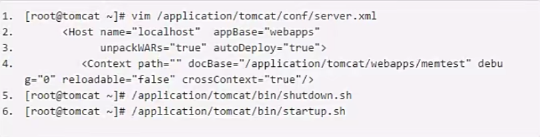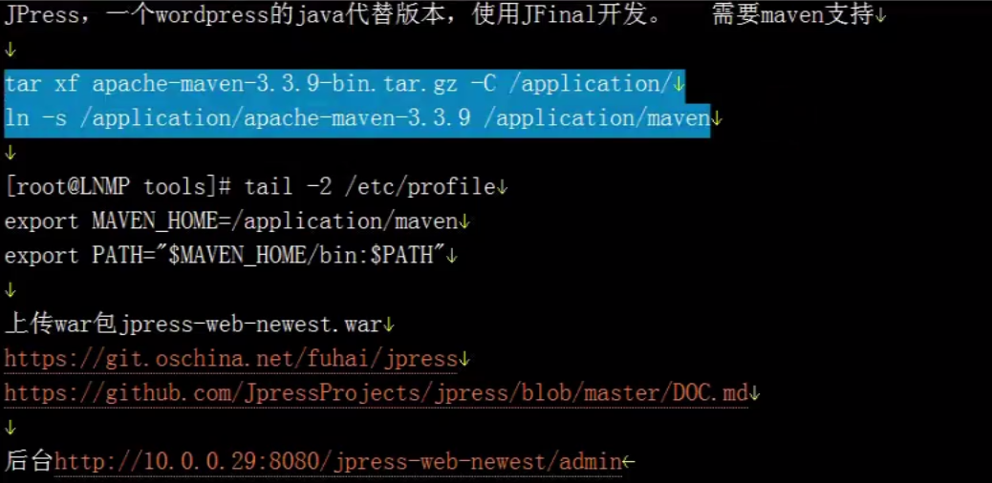

cd /application/tomcat/webapps/ROOT

jar -xf /usr/local/src/jpress-v4.2.0.war

<http://192.168.91.55:8080/install>

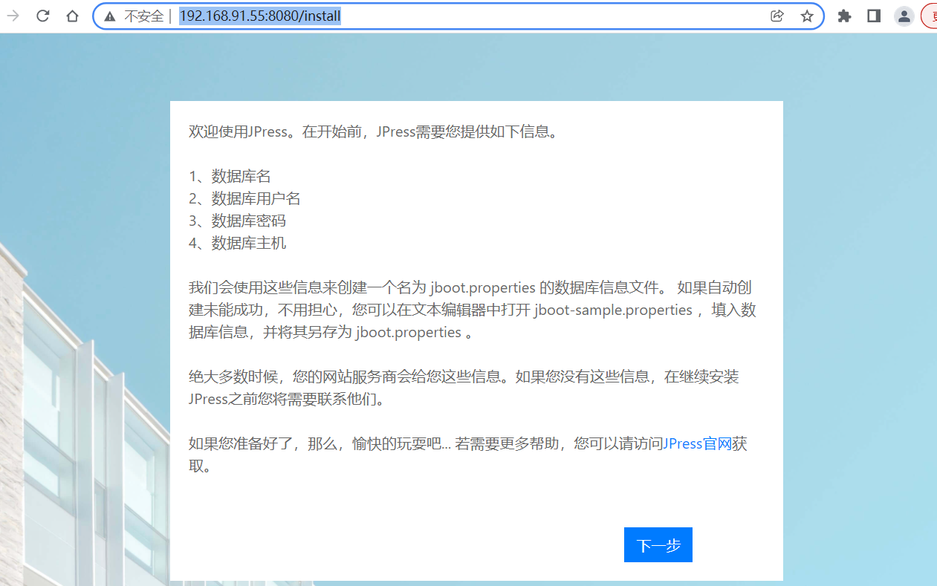

登陆数据库

mysql> garnt all priviliges on jpress.* to 'jpress'@'%' identified by '123.com';

mysql> flush privileges;

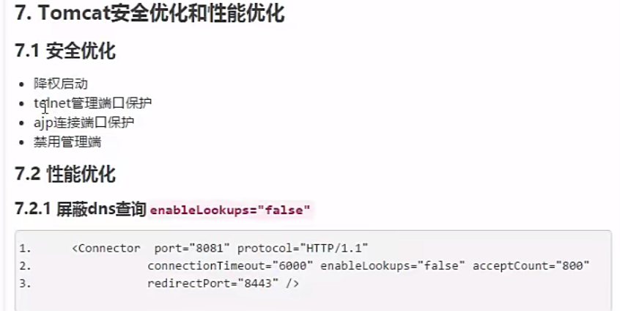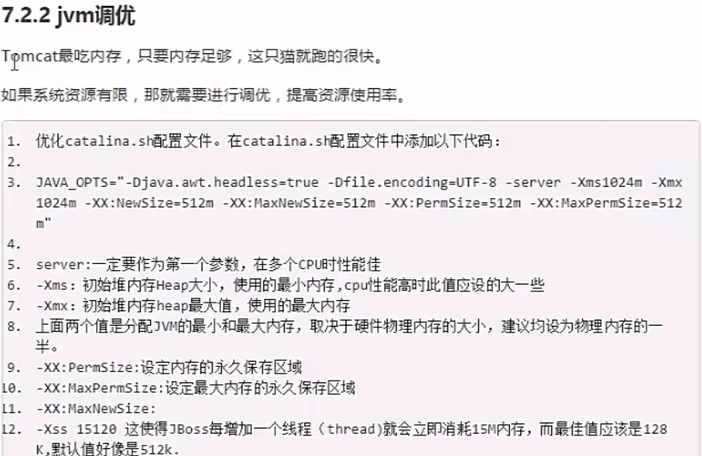



**需要注意的是 必须预留2G给系统用，不能全部分配给tomcat**