**位置 [jenkinslib](https://gitlab.itdance.cn/devops/jenkinslib/tree/master)/[src](https://gitlab.itdance.cn/devops/jenkinslib/tree/master/src)/[org](https://gitlab.itdance.cn/devops/jenkinslib/tree/master/src/org)/[devops](https://gitlab.itdance.cn/devops/jenkinslib/tree/master/src/org/devops)**

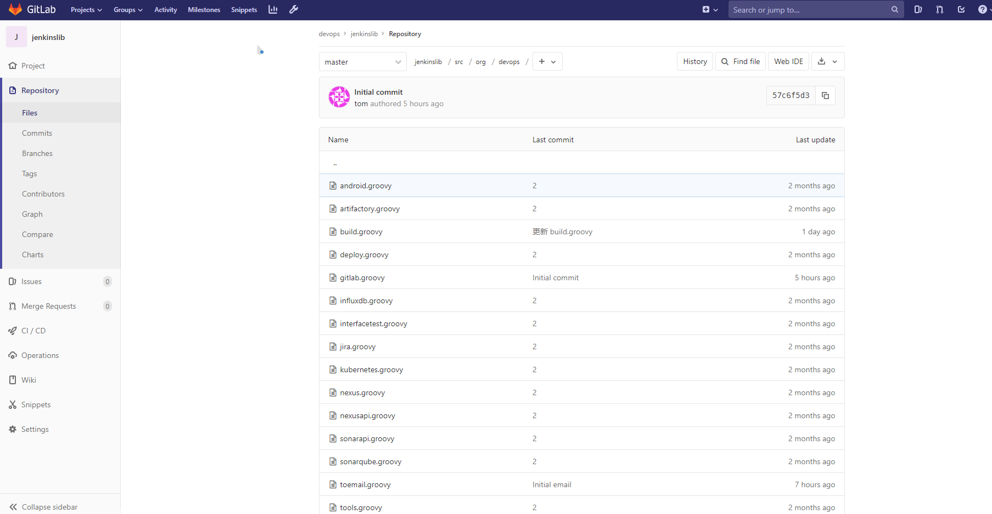

1 [build.groovy](https://gitlab.itdance.cn/devops/jenkinslib/blob/master/src/org/devops/build.groovy) 构建工具整合 如 mvn npm gradle ant

2 [deploy.groovy](https://gitlab.itdance.cn/devops/jenkinslib/blob/master/src/org/devops/deploy.groovy) 发布工具整合 如salt ansible

3 [tools.groovy](https://gitlab.itdance.cn/devops/jenkinslib/blob/master/src/org/devops/tools.groovy) 颜色输出

4 [gitlab.groovy](https://gitlab.itdance.cn/devops/jenkinslib/blob/master/src/org/devops/gitlab.groovy)

Jenkins构建状态通过api-token 封装http请求 返回给gitlab显示构建状态，如下图

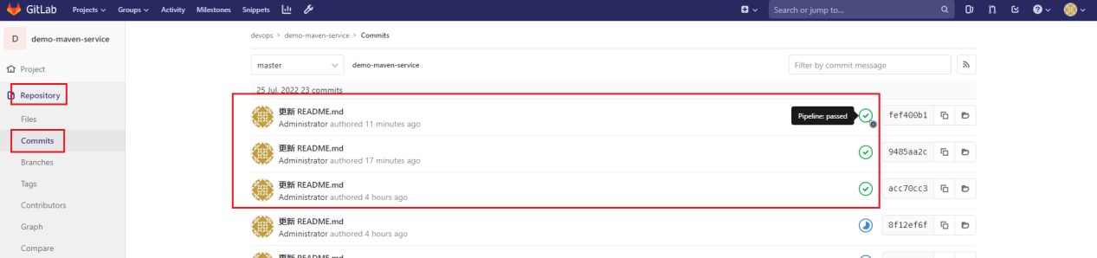

注意修改gitlab地址

def gitServer = "http://gitlab.itdance.cn/api/v4"

5 [toemail.groovy](https://gitlab.itdance.cn/devops/jenkinslib/blob/master/src/org/devops/toemail.groovy) Jenkins构建发送邮件通知

注意修改里面的Jenkins地址,这个只和邮件的图片显示有关。并不一定非要Jenkins地址。只要能够访问到这张图片都行。

<img src="http://jenkins.itdance.cn/static/0eef74bf/images/headshot.png">

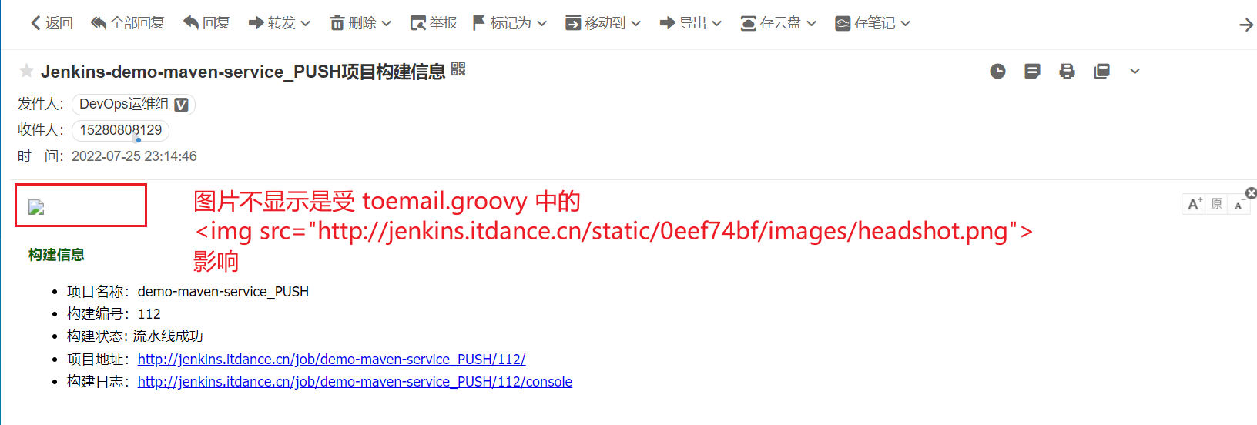

下图是正常显示

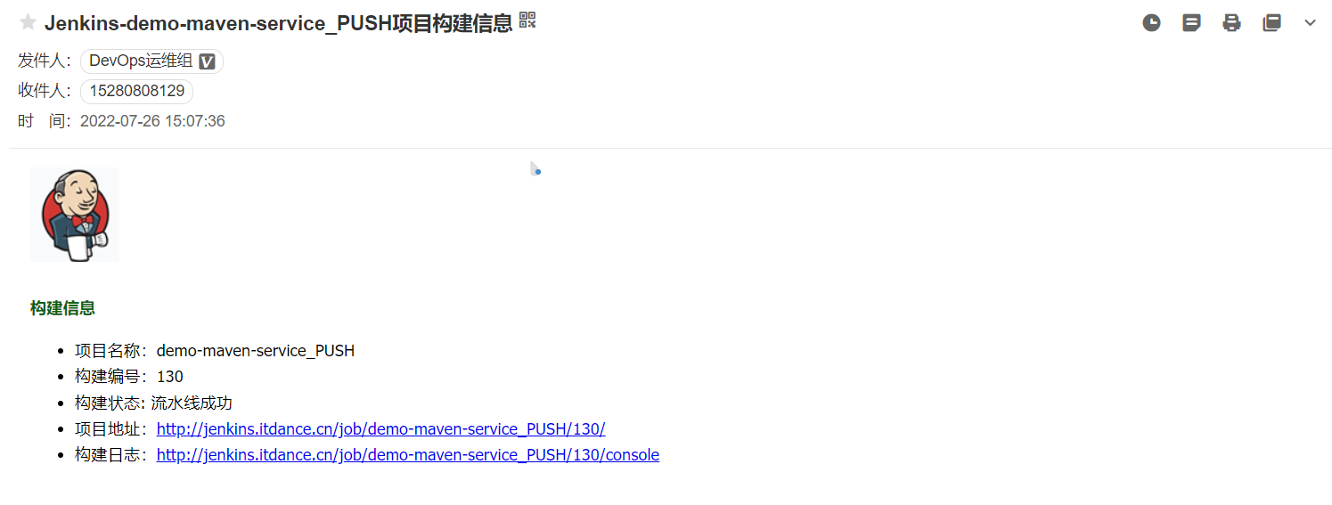



Jenkins代理配置参考

|  |
| --- |
| server {  listen 80;  server_name jenkins.itdance.cn;  access_log /data/nginx/logs/jenkins/access.log main;  charset utf-8;  location / {  proxy_pass http://192.168.91.11:8088;#设置主机头和客户端真实地址，以便服务器获取客户端真实IP  proxy_set_header Host $host;  proxy_set_header X-Real-Ip $remote_addr;  proxy_set_header X-Forwarded-For $remote_addr;  }  location /static/images { #代理图片  alias /var/www/html/static/images;  default_type application/octet-stream;  }  } |