|  |
| --- |
| #!groovy  pipeline{  agent { node { label "master"}}    stages{  stage("build"){  steps{  script{  mvnHome = tool "mvn"  sh "${mvnHome}/bin/mvn -v"  }  }  }  }  } |

Tools

**Input**

|  |
| --- |
| pipeline {  agent any  stages {  stage('Example') {  input {  message "Should we continue?"  ok "Yes, we should."  submitter "alice,bob"  parameters {  string(name: 'PERSON', defaultValue: 'Mr Jenkins', description: 'Who should I say hello to?')  }  }  steps {  echo "Hello, ${PERSON}, nice to meet you."  }  }  }} |

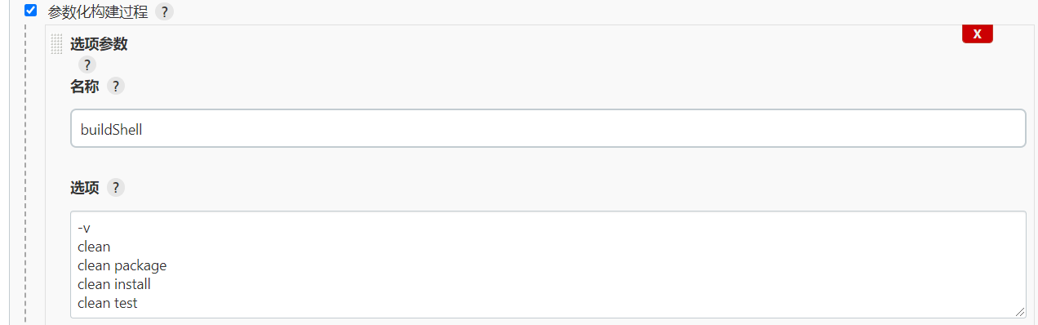

|  |
| --- |
| #!groovy  String buildShell = "${env.buildShell}"  pipeline{  agent { node { label "master"}}    stages{  stage("build"){  steps{  script{  mvnHome = tool "mvn"  sh "${mvnHome}/bin/mvn ${buildShell}"  }  }  }  }  } |

添加Gradle

|  |
| --- |
| #!groovy  String buildShell = "${env.buildShell}"  pipeline{  agent { node { label "master"}}    stages{  stage("GitBuild"){  steps{  script{  mvnHome = tool "mvn"  sh "${mvnHome}/bin/mvn ${buildShell}"  }  }  }  stage("GradleBuild"){  steps{  script{  gradleHome = tool "gradle"  sh "${gradleHome}/bin/gradle ${buildShell}"  }  }  }  }  } |