https://www.jianshu.com/p/39c2fa7979ec centos7源码方式安装配置keepalived

https://blog.51cto.com/13688462/2324055 Keepalived 高可用服务

https://blog.51cto.com/12173069/2120638 centos7下keepalived+nginx配置

https://blog.csdn.net/A_man_only/article/details/84994107 nginx负载均衡+keepalived三主（多主）配置

准备
- centos7.4
- keepalived-2.0.4
下载地址 - http://www.keepalived.org/download.html

安装
- 安装依赖
yum -y install openssl openssl-devel libnl* libnfnetlink-devel
- 下载源码
wget http://www.keepalived.org/software/keepalived-2.0.4.tar.gz
- 在/usr/local/src下解压
# 解压
tar -zxvf keepalived-2.0.4.tar.gz# 进入目录cd keepalived-2.0.4
# 创建安装目录
mkdir /usr/local/keepalived# 配置安装目录
./configure --prefix=/usr/local/keepalived/#编译
make && make install

如果 ./configure时出错，说明没有安装OpenSS依赖，参考文章开头的依赖安装
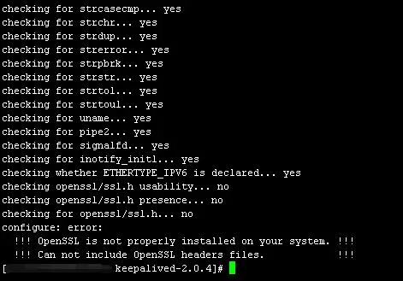
如果出现configure: error: libnfnetlink headers missing，说明没有安装OpenSS依赖，参考文章开头的依赖安装

安装好以后，/usr/local/keepalived/目录下结构：
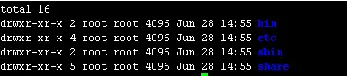

配置
- 开机启动
# 创建/etc/keepalived目录
mkdir /etc/keepalived# 拷贝文件到目录
cp /usr/local/keepalived/etc/keepalived/keepalived.conf /etc/keepalived/
cp /usr/local/keepalived/etc/sysconfig/keepalived /etc/sysconfig/
cp /usr/local/keepalived/sbin/keepalived /usr/sbin/# 这个从keepalived

源码目录复制，安装目录中没有
# keepalived启动脚本（源码目录下），放到/etc/init.d/目录下就可以使用service命令便捷调用
cp /usr/local/src/keepalived-2.0.4/keepalived/etc/init.d/keepalived /etc/rc.d/init.d/

# 开机启动
chkconfig keepalived on
service keepalived start|stop|restart|status

systemctl enable keepalived.service #设置开机自动启动
systemctl disable keepalived.service #取消开机自动启动
systemctl start keepalived.service #启动服务
systemctl restart keepalived.service #重启服务
systemctl stop keepalived.service #停止服务
systemctl status keepalived.service #查看服务状态

#查看keepalived进程
ps -ef | grep keepalived

配置文件说明
Keepalived的所有功能是配置keepalived.conf文件来实现的。
- 修改/usr/local/keepalived/etc/keepalived/keepalived.conf配置文件：
TODO。。。

常见问题
- 日志提示：WARNING - script '/etc/keepalived/check_nginx.sh' is not executable for uid:gid 0:0 - disabling.
原因：keepalived监控脚本没有执行权限
解决：chmod +x /etc/keepalived/check_nginx.sh
日志提示：/etc/keepalived/check_nginx.sh exited due to signal 15
解决：interval 5 #监控脚本的执行时间要大于advert_int（3秒不行就5秒）
advert_int 1 #心跳检查间隔时间

如果是配置文件出错，那么在执行监控脚本时会输出错误信息，所以要重定向到空
解决：/usr/local/openresty/nginx/sbin/nginx &>/dev/null

/etc/keepalived/keepalived.conf 颜色部分master和backup不一样的设置
global_defs {
router_id nginx_id_21 #MASTER和BACKUP不同
vrrp_mcast_group4 224.0.0.24 #指定vrrp的多播ipv4地址，默认是224.0.0.18
}
vrrp_script chk_nginx {
script "/opt/shell/check.sh"
interval 1
weight -15
}
vrrp_instance nginx_01 { #实例，一个vip一个实例
state MASTER #状态只有MASTER和BACKUP两种，并且要大写，MASTER为工作状态，BACKUP是备用状态
interface ens192
virtual_router_id 61 #虚拟路由标识，同一个vrrp_instance的MASTER和BACKUP的vitrual_router_id 是一致的
priority 150 #优先级，同一个vrrp_instance的MASTER优先级必须比BACKUP高
advert_int 1 #MASTER 与BACKUP 负载均衡器之间同步检查的时间间隔，单位为秒

authentication {
auth_type PASS
auth_pass caVrLF8C
}
virtual_ipaddress {
10.32.62.24 #虚拟ip地址，这个ip 必须与我们在lvs 客户端设定的vip 相一致
}
track_script {
chk_nginx
}
notify_master "/opt/shell/notify.sh master"
notify_backup "/opt/shell/notify.sh backup"
notify_fault "/opt/shell/notify.sh fault"
}

防火墙 centos7
https://www.cnblogs.com/xxoome/p/8621677.html
# 指定keepalived配置的网卡：enp0s3，固定的VRRP广播地址：224.0.0.18
firewall-cmd --direct --permanent --add-rule ipv4 filter INPUT 0 --in-interface ens192 --destination 224.0.0.0/8 --protocol vrrp -j ACCEPT

firewall-cmd --direct --permanent --add-rule ipv4 filter OUTPUT 0 --out-interface ens192 --destination 224.0.0.0/8 --protocol vrrp -j ACCEPT
firewall-cmd --reload

# 查看配置的规则
firewall-cmd --direct --get-rules ipv4 filter INPUT
firewall-cmd --direct --get-rules ipv4 filter OUTPUT

Centos6
-A INPUT -d 224.0.0.0/8 -j ACCEPT

